CONTENT

Question 1: Given an undirected graph G with a list of edges saved in the file input.txt. Write a program to traverse the graph in the DFS and count the number of connected components of the graph. The format of file output.txt:
The number of connected components of the graph
The list of vertices in the DFS

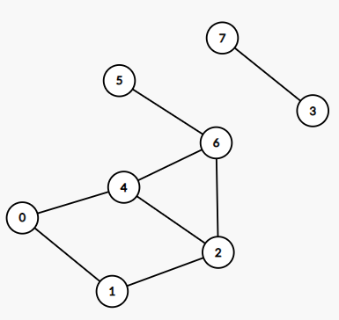
8 8
0 1
0 4
1 2
2 4
2 6
3 7
4 6
5 6
input.txt
2
0,1,2,4,6,5
3,7
output.txt

Question 2: Create a binary search tree for the sequence of numbers in the file input.txt.
Write a program to find a node in a tree, with the node given in the last line of the input.txt file.
- If the node is in the tree, the output format in the output.txt file is:
  - Length of the path
  - Nodes on the path, including the node to be found
- Otherwise, if the node does not exist in the tree, print the message "Node is not in the BST."

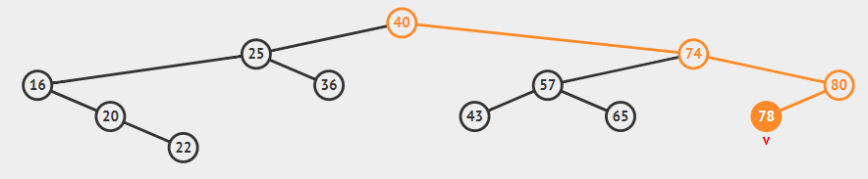

12
40 25 74 57 65 80 16 20 43 22 36 78
78
input.txt
3
40 74 80 78
output.txt

12
40 25 74 57 65 80 16 20 43 22 36 78
12
input.txt
Node is not in the BST.
output.txt

Question 3: Given an undirected graph G with a list of arcs saved in the file input.txt. Write a program to use Prim's algorithm to find the MST of the graph. The format of file output.txt:
The weight of MST
list of edges on the MST, each edge on one line

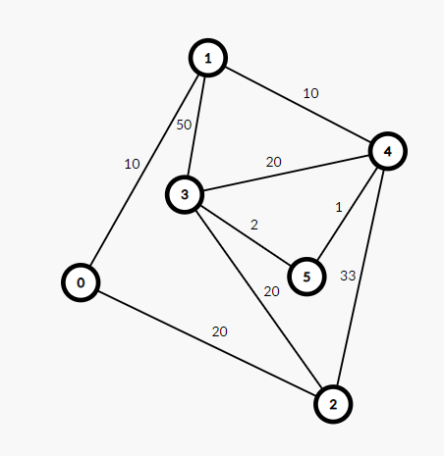
6 9
0 1 10
0 2 20
1 3 50
1 4 10
2 3 20
2 4 33
3 4 20
3 5 2
4 5 1
input.txt
43
1 0: 10
2 0: 20
3 5: 2
4 1: 10
5 4: 1
output.txt

