CONTENT

Question 1: Given an undirected graph G with a list of edges saved in the file input.txt.
Write a program to perform the neighbors of a vertex in the graph, this vertex is the last number on the first line. The format of file output.txt:
The number of neighbors
List of neighbor vertices

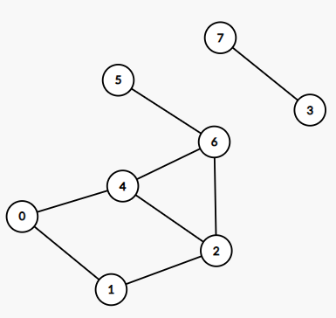
8 6
0 1 0 0 1 0 0 0
1 0 1 0 0 0 0 0
0 1 0 0 1 0 1 0
0 0 0 0 0 0 0 1
1 0 1 0 0 0 1 0
0 0 0 0 0 0 1 0
0 0 1 0 1 1 0 0
0 0 0 1 0 0 0 0
input.txt
3
2,4,5
output.txt

Question 2: Create a binary search tree for the sequence of numbers in the file input.txt.
Write a program to traverse Postorder in the tree. The output format in the output.txt file is:
List of nodes in Postorder traversal

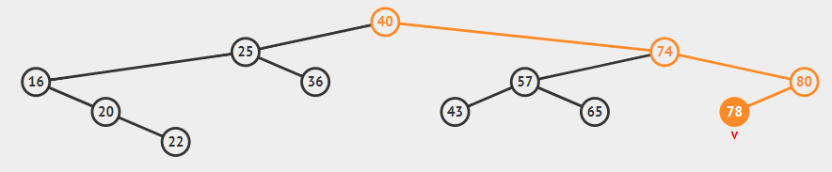

12
40 25 74 57 65 80 16 20 43 22 36 78

input.txt
22,20,16,36,25,43,65,57,78,80,74,40
output.txt

Question 3: Given an undirected graph G with a list of arcs saved in the file input.txt. Write a program to use Dijkstra's algorithm to find the shortest path from vertex x to vertex y of the graph, two vertices are the last terms in the first line, respectively. The format of file output.txt:
path length
List of vertices on the path

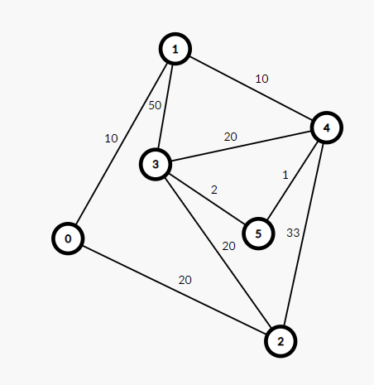
6 9 0 5
0 1 10
0 2 20
1 3 50
1 4 10
2 3 20
2 4 33
3 4 20
3 5 2
4 5 1
input.txt
21
0 1 4 5
output.txt

