**For the submission of your work:**

- Create a folder named **RollNo_Name_DBI202_PaperNo**, e.g. se01245_LongNT_DBI202_01. **Do not** create any subfolder in this folder. All file created will be located in the above folder.

- For each question, you are required to write a database script. Create a file with the name corresponding to the index of the question. For example, **for question 1**, we will create a file named **Q1.sql** and create a file **Q2.sql for question 2**. So, if you do 10 questions, your folder must contain **only** 10 files Q1.sql, Q2.sql, Q3.sql, Q4.sql, Q5.sql, Q6.sql, Q7.sql, Q8.sql, Q9.sql and Q10.sql.

- Do not use any commands having the database name such as create database, alter database, use [database name], *etc*.

- Your response must contain only necessary commands for answering the question. Do not include any other command.

- On completion, import your work by browsing to the above folder.

**- Note that:**

**+ You could use only SQL Server, SQL Server Management Studio, and paper or offline document in your computer.**

**+ If any of the previous requirements is not respected, your mark will be 0.**

**From the 2nd question**, you should use the database provided in the .sql file which has the following database diagram. Please, run the provided script to create tables and insert data into your database.

**Question 1:**

Create one database and then write SQL statements to create, in this database, all tables derived from the ERD given in the following picture with appropriate attributes, primary keys, foreign keys, and constrainsts.

NOTE that when creating the SQL commands as request, you MUST keep the name of tables, relationship, attributes and data type of attributes as SAME as given in the given ERD.

Attributes with underline belong to the Primary Key of each entity.

Attributes which reference to the primary key of another table must have the same name as the attributes in the primary key of the referencing table.

When submitting the responses for this question, submit only SQL statements for creating tables with corresponding keys and foreign keys. Do not use “create database”, “Alter database”, “use database_name” or any statements using database’s name in your submission.

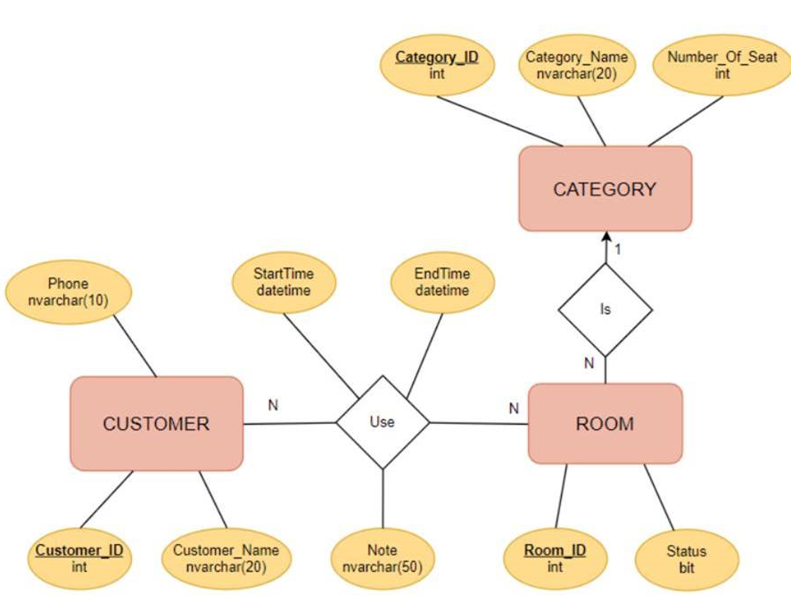

Picture 1.1

**Question 2:**

To display the ProductID, ProductName fileds along with the Discounted UnitPrice the category ‘Beverages’. Assume that there is a 20% discount on each of the items.

Picture 2.1

**Question 3:**

Display ProductID, ProductName, sum of sale Quantity, sum of amount (Quantity*UnitPrice) for of all products having the sum of sale Quantity greater than 1000 . The titles of the two new columns are changed to SumOfQty and SumOfAmount. Display the results in descending order of SumOfQty , then in descending order of SumOfAmountfor rows of the same SumOfQty as follows:

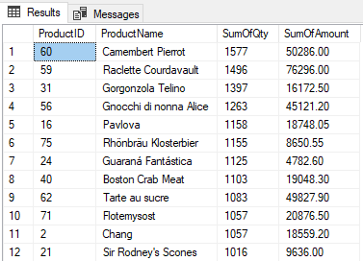

Picture 3.1

**Question 4:**

Displays the 4 customers with the largest total purchase value(sum of Quantity*UnitPrice) as follows:

Picture 4.1

**Question 5:**

Write a query to display products whose unit price is higher than the average price. Display the results in descending order of UnitPrice as follows:

Picture 5.1

**Question 6:**

Write a query to display information of orders placed by customer 'Queen Cozinha' in 05/1998, information includes OrderID, OrderDate, ProductName, CompanyName, and Amount=UnitPrice*Quantity.

Picture 6.1

**Question 7:**

The employee whose first name is 'Nancy' changes her email phone extension to '4567'. Write a command to update her extension.