

Final Examination

Practical Question Paper

DBI202

Database Systems_Các hệ cơ sở dữ liệu

Semester: SP24 |  |  | Curriculum Code: Software Engineering
Date: 16/3/2024 |  |  | Duration: 90 Minutes
 | Total Points: 10

Do not write on this question paper and return it to the Invigilator after the examination.

For the submission of your work:
- Create a folder named RollNo_Name_DBI202_PaperNo, e.g. SE01245_LongNT_DBI202_01. Do not create any subfolder in this folder. All file created will be located in the above folder.
- For each question, you are required to write a database script. Create a file with the name corresponding to the index of the question. For example, for question 1, we will create a file named Q1.sql and create a file Q2.sql for question 2. So, if you do 10 questions, your folder must contain only 10 files Q1.sql, Q2.sql, Q3.sql, Q4.sql, Q5.sql, Q6.sql, Q7.sql, Q8.sql, Q9.sql and Q10.sql.
- Do not use any commands having the database name such as create database, alter database, use [database name], etc.
- Your response must contain only necessary commands for answering the question. Do not include any other command. For example, if you are required to create a trigger/procedure, then your response should contain only commands for creating the corresponding trigger/procedure; all commands for testing the created trigger/procedure are forbidden.
- On completion, import your work by browsing to the above folder.
- Note that:
+ You could use only SQL Server, SQL Server Management Studio, and paper or offline document in your computer.

+ If any of the previous requirements is not respected, your mark will be 0.
From the 2nd question, you should use the database provided in the .sql file which has the following database diagram. Please, run the provided script to create tables and insert data into your database.

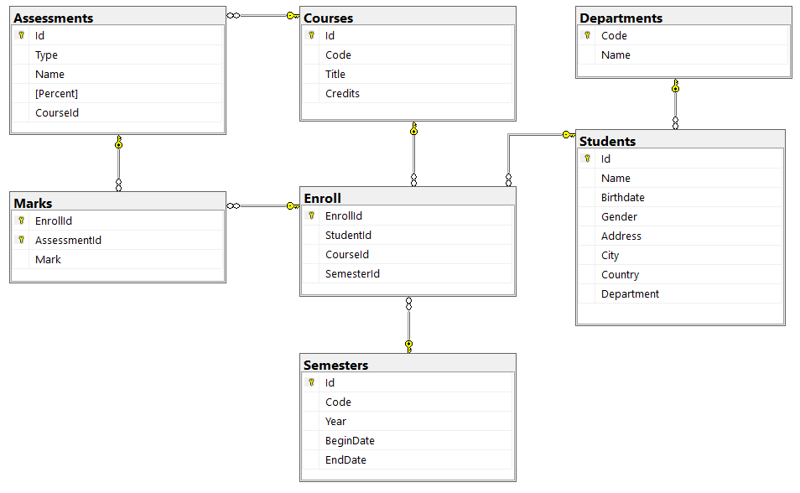

Question 1:
Create one database and then write SQL statements to create, in this database, all tables derived from the ERD given in the following picture with appropriate attributes, primary keys and foreign keys.
NOTE that when creating the SQL commands as request, you MUST keep the name of tables, relationship, attributes and data type of attributes as SAME as given in the given ERD.
Attributes with underline belong to the Primary Key of each entity.
Attributes which reference to the primary key of another table must have the same name as the attributes in the primary key of the referencing table.
When submitting the responses for this question, submit only SQL statements for creating tables with corresponding keys and foreign keys. Do not use “create database”, “Alter database”, “use database_name” or any statements using database’s name in your submission.

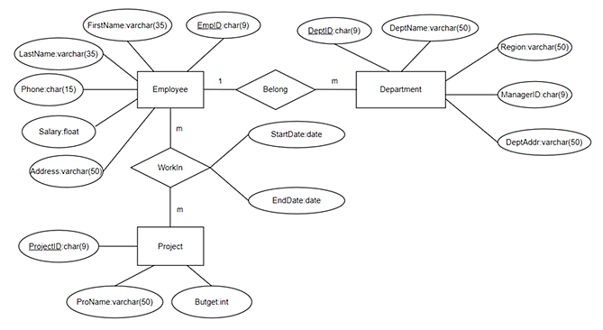
Picture 1.1
Question 2:
Write a query to show Coursid, Code, Title of all Courses which have code is DBI202.

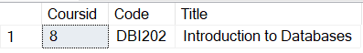
Picture 2.1

Question 3:
Write a query to select StudentId, Name, Gender, Country, Department of all Students having the id equal or greater than 70 and Department is AI as follows:
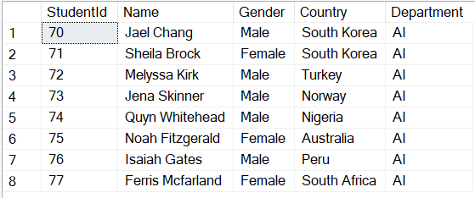
Picture 3.1
Question 4:
Write a query to find StudentId, StudentName, Mark, Department of all Students having the highest Mark in Department is SE. The result is ordered by StudentId.
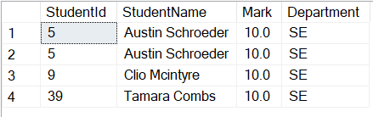
Picture 4.1
Question 5:
Write a query to display StudentId, StudentName, Code, Department, NumberOfStudents, where NumberOfStudents is the count of distinct Students enroll in Semesters Su2022 and Department is SE as follows:
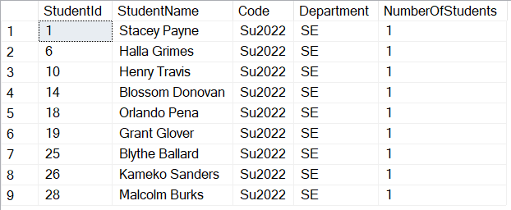
Picture 5.1
Question 6:
Write a query to find StudentId, StudentName, EnrollId, CodeName, Department, BeginDate of all Students with a EnrollId between 15 and 20 and Department is SE. The result is ordered by BeginDate descending.

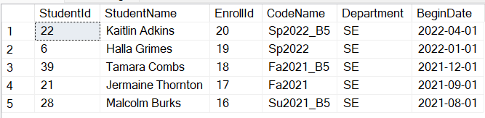
Picture 6.1
Question 7:
Write a query to find StudentId, StudentName, AssessmentID, Type, CourseId, Avg_Mark of all Students with Avg_Mark greater than or equal 9.8.

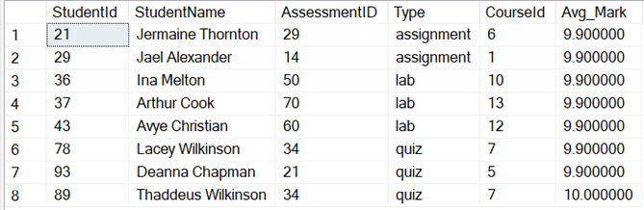
Picture 7.1
Question 8:
Create a trigger named trgDelayEndSemester for the update event to prevent the end date of the semester from occurring before the previously determined EndDate (The existing EndDate in the database). However, if the end date of the semester is specified to occur after the existing end date, it will take effect, and the data will be updated
For example, when the following statement is executed, the result will be as in the following figure:
UPDATE Semesters
SET EndDate = '2020-07-30'
WHERE Id =9
SELECT EndDate
FROM Semesters
WHERE Id =9

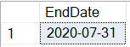
Picture 8.1
Question 9:
Create a procedure named prcgetDepartment to get the Name of an Student's Department base on Student’s name.
For example, when the following statement is executed, the result will be as in the following figure:
DECLARE @X varchar(50);
DECLARE @In varchar(100)= 'Kelly Dillard';
EXECUTE prcgetDepartment @In, @X OUTPUT;
SELECT @X AS Department

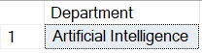
Picture 9.1
Question 10:
Find all students whose names are Stacey Payne from Italy and update country to VietNam.

