Owen Gallagher, Brian Park, Anh Vu

Dr. Rhodes

CS305 Software Models

13 February 2019

User’s Guide for **Slide & Connect**

**Game description**

**Purpose and essence**  
Both players want to make 4 in a row of their marker type on the board. The way to play is to choose which way the pieces fall (like the game 2048), but the objective is to get 4 in a row (like the game Connect 4). The board is now displayed using a GUI.

**Game Loop**

1. GameController places marker randomly (A/B, which alternate every iteration) on the grid (7x7 by default).
2. GameController displays current board.
3. Player (1/2 alternate) picks gravity direction (UP, DOWN, LEFT, RIGHT) via the direction buttons or arrow keys on the keyboard, or selects a game change (SAVE, LOAD, RESET).
4. GameController shifts all markers in gravity direction, or executes the game change.
5. Check:

if (4 in a row): **Player (1/2) wins**

else if (board is full): **Tie**

else: **Loop to step 1**

**Input**

UP – DOWN – LEFT – RIGHT – RESET – SAVE – LOAD – QUIT

**Input has now become buttons in the GUI. The keyboard arrows are also accepted direction inputs

Up Button – Move all markers upward

Down Button – Move all markers downward

Left Button – Move all markers to the left

Right Button – Move all markers to the right

Reset Button – Resets the GameController, which stores the state of the game, from

the configuration file.

Save Button – Stores the state of the game and uses XML formatting to store the

GameController Model in XML.

Load Button – Retrieves the state of the saved game in XML

Quit Button (Exit button of window) – Closes the program

Format: GUI Button - has to be one of the 8 buttons above.

**Output**

The board and the message, both within the main form. Errors are displayed with separate alert windows.

The message is displayed on the console and could be one of the following:

1. "Player <1/2>, pick another direction"
2. "Player <1/2> wins" or "tie".
3. “Resetting Game…”
4. “Saving Game…”
5. “Saved game begun at dd-mm-yyyy”
6. “Loading Game…”
7. “Loaded game begun at “dd-mm-yyyy”
8. “Quitting Game…”

The configuration file (.txt) includes:

1. Board Size //grid set as 7
2. Player 1 Char //Player 1 marker set as X
3. Player 2 Char //Player 2 marker set as O
4. How Many to Win //consecutive markers to win set as 4

*Everything in the configuration file can be changed.

Use Case Diagram

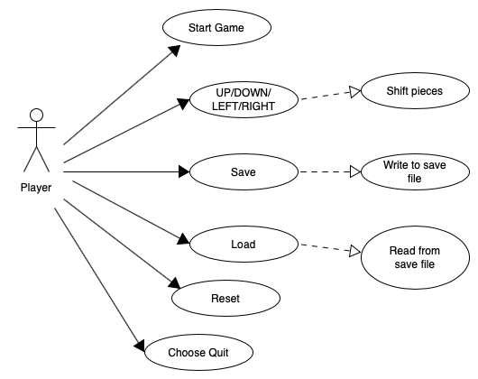

Activity Diagram

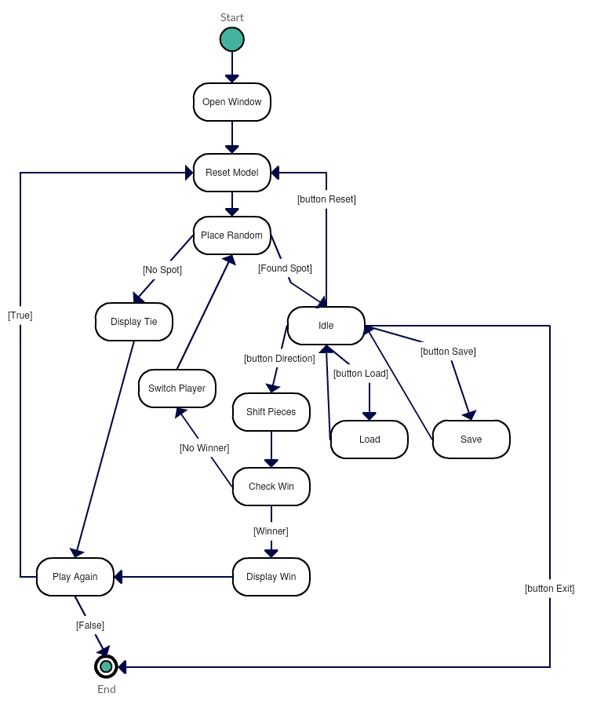

Data Flow Diagram

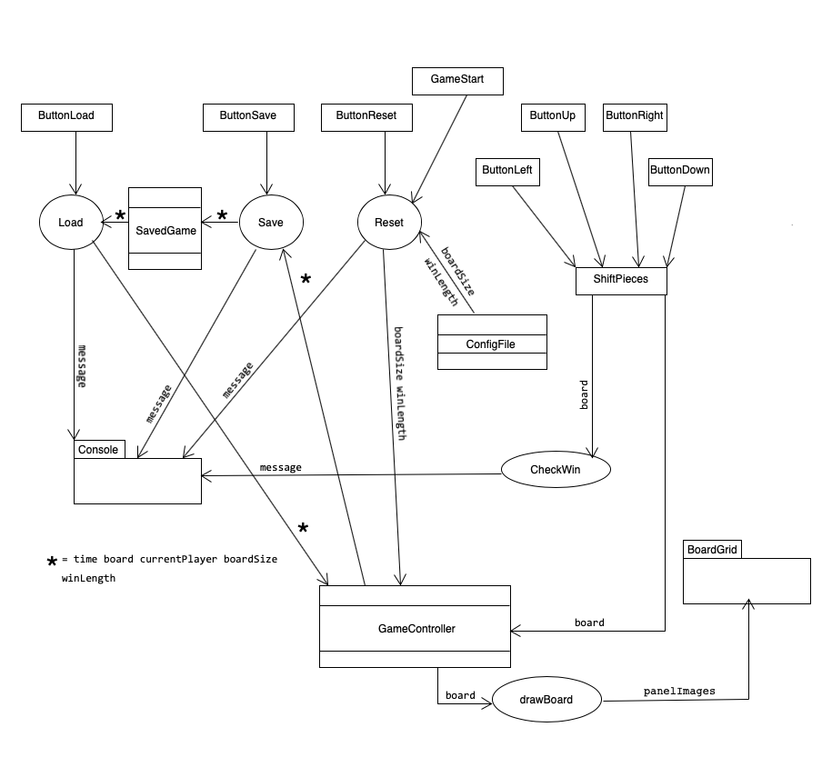

GUI Wireframe

