# Git Branching/Merging Guideline

Submit the screenshots of three exercises on your GitHub repository, under the “git_branch_merge” folder.

1. Go to <https://learngitbranching.js.org> and open tab “Main”: do the first four levels of the first section: Introduction Sequence.

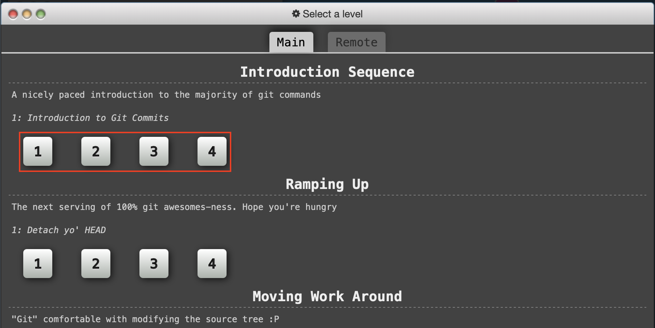

For this exercise, you should take a screenshot of the levels screen with four green tick marks for the finished levels.

1. Go to <https://learngitbranching.js.org> and open tab “Remote”: do the first eight levels of the first section: Push & Pull – Git Remotes!

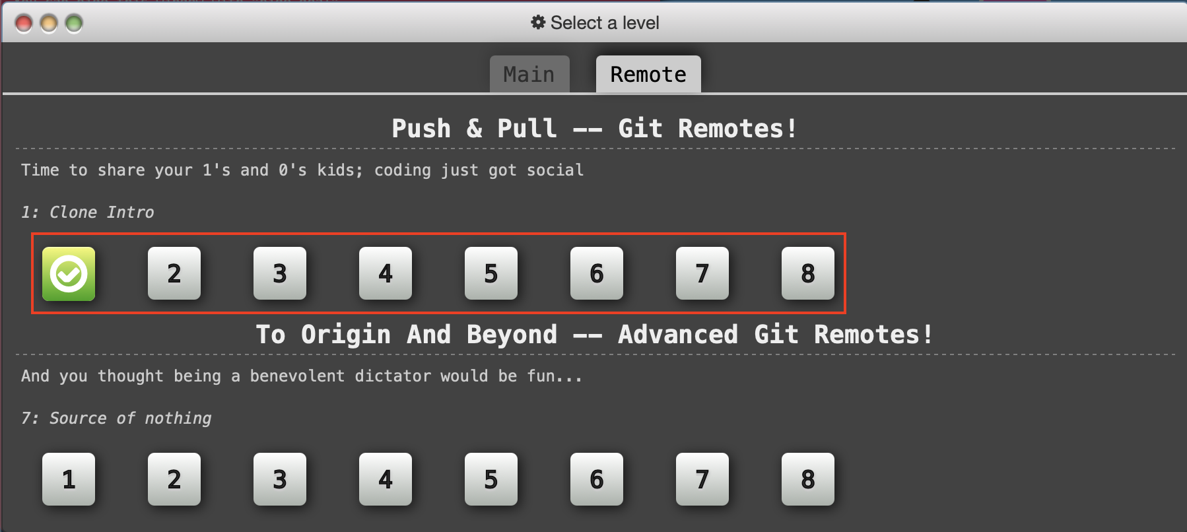

For this exercise, you should take a screenshot of the levels screen with eight green tick marks for the finished levels (like the first one here).

1. Go to <http://git-school.github.io/visualizing-git/>

Replicate the steps from the following tutorials into the repository using git commands:

Tutorials:

Part 1: <https://www.youtube.com/watch?v=QV0kVNvkMxc&list=PL4cUxeGkcC9goXbgTDQ0n_4TBzOO0ocPR&index=8>

Part 2:

<https://www.youtube.com/watch?v=XX-Kct0PfFc&list=PL4cUxeGkcC9goXbgTDQ0n_4TBzOO0ocPR&index=9>

* Before typing any command, you should enter your student id, like the following:

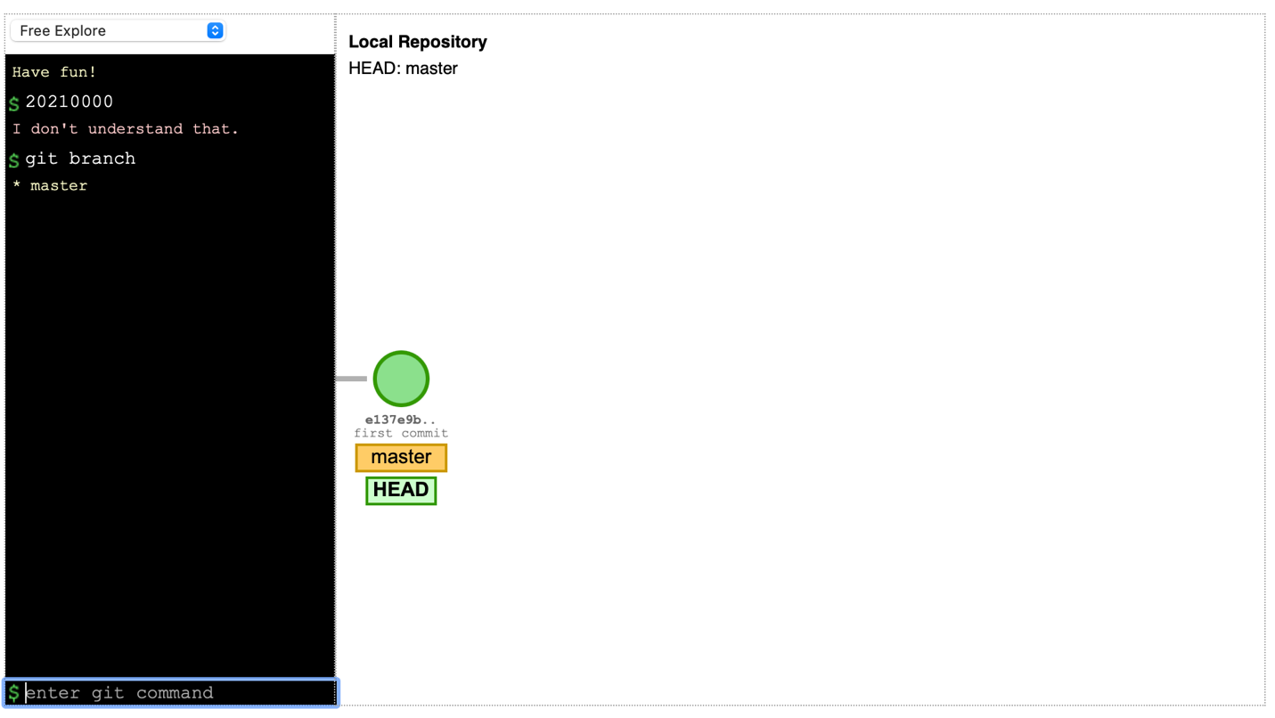

For this exercise, take a screenshot of both the repository visulisation and the command line interface (like the above picture) after you’ve finished. (You may take more than one picture of the command line interface if your commands are too long).