[CLIENT NAME]
AI Concierge Proposal
WhatsApp Chatbot on AWS (ECS + Amazon Bedrock)
Malaysia + Indonesia • Prepared April 2026

Scope: 24/7 AI-driven lead engagement, tour/trial booking, reminders, and follow-ups on WhatsApp, connected to [CRM Platform].
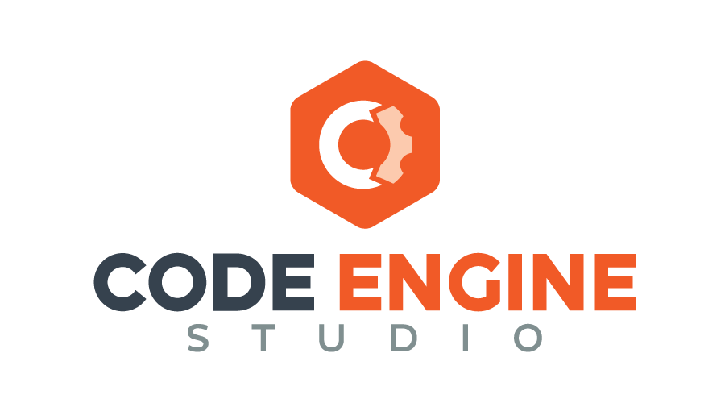

1. Executive Summary
[Client Name] needs every inbound lead to receive a WhatsApp response within 60 seconds, any hour of the day, in the lead’s own language. The AI concierge guides the prospect through booking a gym tour or trial class — without staff involvement.
We propose a hybrid approach: pre-written conversation flows handle the predictable ~85% of conversations (pricing, hours, booking). Amazon Bedrock’s AI only steps in when a question falls outside those flows (~15%). This keeps the core business process cheap, predictable, and always on.
The system runs on AWS ECS (Fargate) for the backend application and uses Amazon Bedrock for AI-powered responses. All code and intellectual property are transferred to [Client Name] at handover.

2. Business Use Case
[Client Name] operates gyms across Malaysia and Indonesia, runs Meta Ads that funnel leads into [CRM Platform], and uses a white-labelled mobile app on the same [CRM Platform] platform.
The gap today: leads arrive in [CRM Platform] but don’t get a fast, consistent, multilingual response. Staff aren’t available 24/7, response times lag, and qualified leads go cold before anyone reaches out.
This proposal covers the AI concierge layer that sits between [CRM Platform] and WhatsApp — picking up leads, engaging them in conversation, and booking tours or trials back into [CRM Platform] automatically.

What Success Looks Like
- Every lead gets a personalised WhatsApp message within 60 seconds, 24/7
- Prospects can book tours/trials without staff involvement
- Automated reminders reduce no-shows
- Follow-up messages re-engage leads who haven’t booked
- Supports English, Bahasa Melayu, and Bahasa Indonesia

3. User Flow
Here is what happens from the prospect’s perspective, end to end:
- A prospect sees a Meta Ad for [Client Name] and submits their contact info.
- [CRM Platform] receives the lead and notifies our system via webhook.
- Within 60 seconds, the prospect gets a WhatsApp message in their language.
- The prospect replies. The system checks: can I handle this with a pre-written flow? For common questions — booking, pricing, hours — the answer is yes. No AI is involved.
- For unusual or off-script messages (~15%), the message is escalated to Amazon Bedrock’s AI engine.
- The conversation continues — the system shows available time slots (from [CRM Platform]) and lets the prospect pick a time.
- The system books the appointment in [CRM Platform] and sends a confirmation.
- Reminders are sent 24 hours before and on the morning of the appointment.
- If the prospect doesn’t book, follow-up messages re-engage them over the following days.

4. Functional Components
Component | What It Does
WhatsApp Service | Connects to Meta’s WhatsApp Cloud API. Sends and receives messages, manages pre-approved templates, handles media, and tracks delivery status.
Lead Intake | Receives new leads from [CRM Platform] and Meta Ads. Guarantees a first message within 60 seconds. Filters out duplicates.
Conversation Flow Manager | Pre-built, guided conversation paths for booking, pricing, hours, and FAQs. Handles ~85% of messages without AI. Your team updates flows via a visual drag-and-drop editor.
AI Engine (Bedrock) | Handles the ~15% of messages that fall outside pre-built flows: unusual questions, objections, and off-script phrasing. Powered by Amazon Bedrock.
[CRM Platform] Connection | Reads available time slots and writes bookings back. Automatically retries if [CRM Platform] is slow or unavailable.
Reminder System | Sends reminders 24 hours before and on the morning of booked appointments. Retries if a message fails to send.
Follow-Up System | Sends periodic messages to leads who haven’t booked. Respects opt-out requests and avoids over-messaging.
Admin Dashboard | Web interface for [Client Name] staff: gym configuration, conversation viewer, flagged conversations, performance reports, and AI training data upload.
Privacy & Compliance | Consent capture on first message. Data export and deletion on request (PDPA/UU PDP). Conversation records retained for 24 months, then personal data is removed.

5. High-Level Architecture
The system is built as a set of services running on AWS ECS (Fargate) in the Singapore region. The key design principle is the hybrid approach: pre-built conversation flows handle the predictable majority of conversations, while Amazon Bedrock’s AI handles only the edge cases.

Why the Hybrid Approach Matters
Gym enquiries are predictable. About 85% of conversations fall into roughly six topics: pricing, hours, location, tours, trials, and general questions. These can be handled perfectly by pre-written flows — no AI required.
This matters because AI is the most expensive and least predictable part of the system. By keeping AI out of the main booking flow, you get:
- Guaranteed accuracy — pricing, hours, and policies are written by your team and never hallucinated
- Reliable language quality — BM/BI responses are written by native speakers, not generated by AI
- Predictable costs as you scale — 4,500 to 20,000 leads/month barely changes AI costs
- Resilient to AI outages — if Bedrock goes down, the 85% handled by flows keeps working

How Each Component Connects
The data flow works as follows:
WhatsApp User → message arrives via Meta’s WhatsApp Cloud API → webhook triggers the ECS backend → the Flow Manager checks if it can handle the message with a pre-written response → if yes (~85%), it replies directly → if not (~15%), it escalates to Amazon Bedrock for an AI-generated reply → the reply is sent back through WhatsApp → the conversation and booking data are stored in Amazon RDS → logs and media go to Amazon S3 → CloudWatch monitors everything.

6. Infrastructure on AWS
AWS Service | Role | Why This Choice
ECS (Fargate) | Runs the backend application: webhook handler, flow manager, [CRM Platform] integration, scheduler | Serverless containers — no servers to manage, auto-scales with demand, pay only for what you use
Amazon Bedrock | AI engine for the ~15% of messages flows can’t handle | Fully managed AI service. No model hosting needed. Pay-per-request. Supports Claude models with strong multilingual capability.
Amazon RDS | Stores leads, conversations, bookings, flow configs, admin data | Managed database with automated backups and failover. PostgreSQL.
Amazon S3 | Stores conversation logs, media files, database backups | Virtually unlimited, low-cost storage with built-in encryption.
CloudWatch | Monitoring, alerting, logs | Centralised visibility. Alerts if response times exceed thresholds or errors spike.
ALB | Load balancer for incoming webhooks and admin dashboard | Distributes traffic across ECS tasks. Handles SSL termination.

Region: ap-southeast-1 (Singapore). Can be changed to Jakarta at kickoff if preferred.

7. Architecture Diagram
The diagram below shows how each component connects. The green-shaded Flow Manager handles ~85% of messages without AI. Only the purple-shaded path (~15%) reaches Amazon Bedrock.
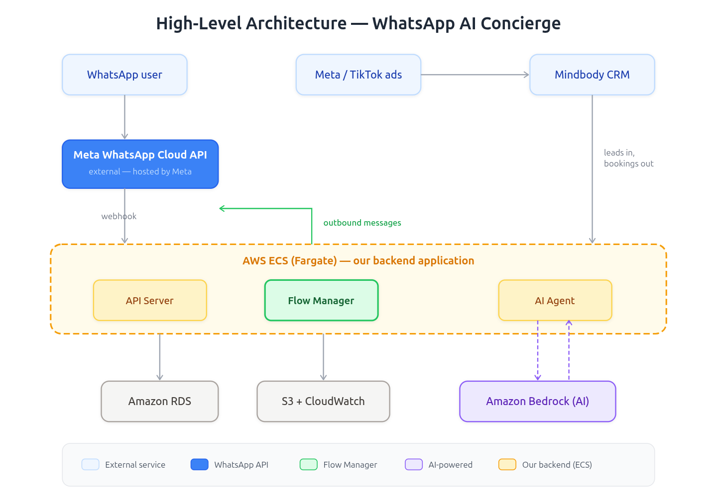

Diagram Walk-Through
Top row (light blue): Incoming leads from three sources — WhatsApp users, Meta/TikTok Ads, and [CRM Platform] CRM.
Blue box: All WhatsApp messages pass through the Meta WhatsApp Cloud API (external, hosted by Meta).
Orange dashed box (AWS ECS): The backend application runs three services: the API Server receives webhooks, the Flow Manager orchestrates conversation logic, and the AI Agent handles intelligent responses.
Green highlight: The Flow Manager is the central orchestrator that routes messages and manages conversation flows.
Purple dashed line: The AI Agent connects to Amazon Bedrock to generate AI-powered replies when needed.
Bottom row (gray): Amazon RDS stores structured data, S3 stores logs and media, and CloudWatch provides monitoring.

8. Estimated Monthly Cost
All figures in USD. Costs are shown across three lead volumes (2,000 / 5,000 / 10,000 leads per month) to illustrate how costs scale. See Appendix for the full methodology behind these estimates, including message-per-lead calculations, token estimates, and official pricing sources.

Variable Costs by Lead Volume
These costs scale with lead volume. WhatsApp charges per marketing message delivered. AI costs depend on how many messages are processed by Amazon Bedrock.
 | 2,000 leads(~14K msgs) | 5,000 leads(~35K msgs) | 10,000 leads(~70K msgs)
WhatsApp — marketing (~2.4/lead × $0.084) | $403 | $1,008 | $2,016
WhatsApp — utility (~0.6/lead × $0.015) | $18 | $45 | $90
WhatsApp subtotal | $421 | $1,053 | $2,106
Amazon Bedrock — Hybrid (15% of AI-eligible msgs) | $5–$14 | $12–$36 | $24–$72
Variable total (Hybrid) | $426–$435 | $1,065–$1,089 | $2,130–$2,178
WhatsApp rates: Malaysia marketing $0.086/msg, Indonesia marketing $0.041/msg, blended $0.084/msg (95% MY / 5% ID). Malaysia utility $0.014/msg, Indonesia utility $0.025/msg, blended $0.015/msg. Service messages (conversation replies) are free. Source: Meta WhatsApp Business Platform Pricing.
Bedrock range: low = Claude Haiku 4.5 ($1/$5 per M tokens), high = Claude Sonnet 4.6 ($3/$15 per M tokens). Each AI-processed message uses ~3,000 input tokens + ~200 output tokens. Source: Anthropic Claude Pricing.rrr

Infrastructure Costs (Fixed)
These costs are mostly fixed — running 2,000 or 10,000 leads on the same infrastructure barely changes the numbers. The Conversation Flow Manager runs as a container on the same ECS cluster, so there is no additional hosting cost.
AWS Service | Monthly Cost
ECS (Fargate, 2 tasks) — all services including CFM | $60–$100
Amazon RDS (PostgreSQL) | $50–$80
S3 + networking | $35–$55
ALB (load balancer + SSL) | $25–$35
CloudWatch (logs + alerts) | $25–$55
Infrastructure total | $195–$325
Prices reflect AWS Singapore region (ap-southeast-1). Source: AWS Pricing Calculator.

Total Monthly Operating Cost (Hybrid)
 | 2,000 leads | 5,000 leads | 10,000 leads
Infrastructure (fixed) | $195–$325 | $195–$325 | $195–$325
WhatsApp (variable) | $421 | $1,053 | $2,106
Bedrock (variable) | $5–$14 | $12–$36 | $24–$72
TOTAL | $621–$760 | $1,260–$1,414 | $2,325–$2,503
At 5,000+ leads/month, WhatsApp fees are the dominant cost — more than infrastructure and AI combined. This is Meta’s pricing and applies regardless of which approach is chosen.

Scaling Comparison: Hybrid vs Full AI
The table below shows how AI costs behave as lead volume grows. With the hybrid approach, AI costs stay nearly flat because most conversations never reach Bedrock.
Lead Volume | Hybrid AI Cost | Full AI Cost | Monthly Saving
2,000 leads (~8K AI-eligible msgs) | $5–$14 | $32–$96 | $18–$82
5,000 leads (~20K AI-eligible msgs) | $12–$36 | $80–$240 | $68–$204
10,000 leads (~40K AI-eligible msgs) | $24–$72 | $160–$480 | $136–$408
Hybrid processes ~15% of conversational messages through AI. Full AI processes 100%. Range: low = Claude Haiku 4.5, high = Claude Sonnet 4.6.
Key insight: The hybrid approach keeps AI costs at a fraction of the full-AI alternative, and the gap widens significantly as volume grows. More importantly, it keeps the core onboarding process — the part that directly generates bookings — completely independent of AI, making it cheap, predictable, and always available.
These estimates do not include the monthly platform management fee (monitoring, incident response, flow updates). That will be discussed separately. See Appendix for full cost methodology, including message volume estimation, token calculations, and pricing sources.

Side-by-Side Feature Comparison
The table below compares every operational dimension of the two approaches across 11 key criteria.
Criteria | Hybrid (Recommended) | Full AI
Monthly AI cost (5000 leads) | ~$12–$36. AI only processes ~15% of messages. | ~$80–$240. AI processes every single message.
Response accuracy | High. Common responses (pricing, hours, policies) are pre-written by your team — guaranteed correct. | Medium. AI can occasionally misquote pricing, give incorrect hours, or state policies inaccurately.
Language quality (BM/BI) | High. Responses are written by native speakers. No risk of unnatural phrasing or mixed dialects. | Medium. AI quality in Bahasa Melayu/Indonesia varies across model versions and can drift over time.
Cost as leads grow | Stays mostly flat. More leads doesn’t mean more AI usage — only the ~15% edge cases hit Bedrock. | Grows proportionally. Double the leads = roughly double the AI costs.
Traceability | Every response maps to a specific flow version and step. Easy to pinpoint “why did the bot say that?” | Requires reviewing the AI’s full conversation context and reasoning. Harder to investigate.
AI provider outage impact | ~85% of conversations keep working normally. Only edge-case messages are affected. | Everything stops. No conversations can proceed until the provider recovers.
Conversation feel | Slightly more structured — uses menus, buttons, and quick replies. Efficient but less free-form. | More natural and conversational. Handles free-form text and unexpected topics fluidly.
Initial setup speed | Slower. Each conversation path needs to be explicitly designed and pre-written. | Faster to first prototype. Write one set of AI instructions covering core scenarios.
How operators update it | Visual drag-and-drop editor (included). No coding required. Your team manages it. | Edit AI instruction text. Requires understanding how AI prompting works.
Test mode | Built-in. Preview and test conversations before they go live — no extra development cost. | Needs to be custom-built. Adds build time and cost to the development scope.
Fit for gym enquiry patterns | Excellent. Gym enquiries are predictable (~6 common topics). Pre-built flows handle them perfectly. | More capability than needed for this use case. Better suited for highly unpredictable conversations.

Pros and Cons Summary
Approach A — Hybrid (Recommended)
Advantages | Trade-offs
Guaranteed accuracy — pricing, hours, and policies are human-written. The system can never quote the wrong price.  Reliable language quality — BM/BI responses are written by native speakers, not generated by AI that might mix dialects.  Predictable costs at scale — 4,500 to 20,000 leads/month barely changes AI costs. Most conversations never touch AI.  Visual drag-and-drop editor — your team updates flows without code. Built-in test mode included.  Full traceability — every response maps to a specific flow version and step. Easy to audit.  AI-outage resilient — if Bedrock goes down, ~85% of conversations keep working normally.  WhatsApp-native features — supports interactive buttons, lists, quick replies, and media natively. | More upfront design work — each conversation path must be explicitly designed and written.  Slightly more structured feel — conversations use menus and buttons more than free-text. Efficient but less like chatting with a person.  Edge cases still depend on AI — the ~15% of unusual messages are handled by the AI fallback, same quality as Full AI for those cases.

Approach B — Full AI
Advantages | Trade-offs
More natural conversations — handles free-form text, follow-ups, and unexpected topics fluidly. Feels like talking to a person.  Handles the unexpected well — if a prospect asks something unanticipated, the AI can usually give a reasonable answer.  Faster initial setup — write one set of AI instructions instead of designing dozens of flows. Quicker to prototype.  Simpler content updates — changing behaviour means updating instruction text, not redesigning visual flows.  Fewer components — no Conversation Flow Manager to host and maintain. | AI can get facts wrong — can misquote pricing, give incorrect hours, or state policies inaccurately. A single wrong price is a customer-facing problem.  Language quality can drift — BM/BI quality varies across model versions and can change when the AI provider updates their system.  Costs grow with volume — every message costs money. Double the leads = roughly double the AI costs.  Harder to investigate problems — understanding why the AI said something requires reviewing full conversation context and reasoning.  AI outage = full outage — if the AI provider goes down, no conversations can proceed until it recovers.  Test mode must be custom-built — no built-in editor. Adds build time, cost, and ongoing maintenance.  Updates require technical skill — changing AI behaviour means editing prompt instructions, which requires AI prompting expertise.

Key insight: The hybrid approach keeps AI costs at a fraction of the full-AI alternative, and the gap widens significantly as volume grows. More importantly, it keeps the core onboarding process — the part that directly generates bookings — completely independent of AI, making it cheap, predictable, and always available.
Note: These estimates do not include the monthly platform management fee (monitoring, incident response, flow updates). That will be discussed separately.

9. Assumptions and Risks

Assumptions
- [Client Name] provides [CRM Platform] credentials and gym identifiers within week 1.
- [Client Name] sets up a WhatsApp Business Account under their Facebook Business Manager (we guide the process).
- One shared WhatsApp number for all gyms in Phase 1.
- Hosting region: Singapore (ap-southeast-1). Can switch to Jakarta if preferred.
- AI model: Amazon Bedrock with Anthropic Claude. Alternatives evaluated during development.
- Lead volume: ~4,500/month. Costs revisited if volume grows significantly.
- Pilot launch with 2–3 gyms before full rollout.

Risks and Mitigation
Risk | Impact | Mitigation
WhatsApp verification delayed by Meta | Launch date slips | Start verification on day 1, before any development begins
[CRM Platform] unavailable or slow | Bookings delayed | System auto-retries. Prospect sees “locking in your slot now” while it retries.
Bedrock outage or price increase | AI responses interrupted | Hybrid: 85% of conversations keep working. Only edge-case AI is affected.
AI language quality drifts (BM/BI) | Awkward responses | Hybrid: most responses are human-written. Plus regular quality reviews.
Lead volume exceeds estimates | Higher costs | ECS auto-scales. Costs monitored monthly. Follow-up frequency adjustable.

10. Recommendation and Next Steps

Our Recommendation: Hybrid on AWS
We recommend the hybrid approach running on AWS ECS with Amazon Bedrock. This gives [Client Name] the best balance of cost control, language accuracy, operational simplicity, and scalability.
The core booking flow — the 85% of conversations that cover pricing, hours, tours, and trials — never touches AI. This means your onboarding process is cheap, predictable, and always available, even if the AI provider has an issue.
AI (via Amazon Bedrock) handles only the edge cases, keeping costs low and scaling gracefully as your gym network grows.

Cost by Features
Features | Cost
Project Management & Discovery | $2,750
Infrastructure | $2,750
WhatsApp Integration | $2,750
Lead Intake & Processing | $1,000
Conversation Flow Manager | $2,750
AI Engine | $7,000
[CRM Platform] Integration | $2,750
Scheduling & Reminders | $1,000
Follow-Up Automation | $1,000
Admin Dashboard | $2,750
Testing & QA | $2,750
Documentation | $1,000
Deployment & Handover | $2,750
Post-Launch Care | $1,000
Total | $31,250
Detailed cost calculation here

Next Steps
- Confirm the approach — Hybrid (recommended) or Full AI.
- Start WhatsApp Business Account verification immediately — this is the longest lead-time item (2–4 weeks, controlled by Meta).
- Review assumptions above and confirm hosting region and AI provider preference.
- Schedule kickoff and provide [CRM Platform] credentials and gym identifiers.
- Identify 2–3 pilot gyms for initial launch.

Rollout Timeline
Weeks | What Happens
1–2 | Kickoff. WhatsApp verification begins. [CRM Platform] credentials received. AWS environment set up.
3–6 | WhatsApp and [CRM Platform] connections built. Conversation flows designed. Message templates submitted to Meta.
7–10 | Reminders, follow-ups, admin dashboard, and privacy features built.
11–12 | Internal testing at full volume. Pilot gyms selected.
13–16 | Pilot launch with 2–3 gyms. Daily monitoring. Flow adjustments based on real conversations.
17+ | Gradual rollout to remaining gyms, one region at a time.

This proposal is for discussion. All numbers, timelines, and scope can be adjusted at kickoff.

All code and ownership are transferred to [Client Name] at handover.

Appendix: Operational Cost Estimation Methodology
This appendix explains how the monthly operating cost estimates in the proposal were calculated.

A1. WhatsApp Pricing Model
As of July 2025, Meta charges WhatsApp Business Platform users per message delivered, not per conversation. Message rates depend on the category and the recipient’s country.

Official Rates (per message delivered)
Category | Malaysia (USD) | Indonesia (USD)
Marketing | $0.086 | $0.041
Utility | $0.014 | $0.025
Service | $0 (free) | $0 (free)
Authentication | $0.014 | $0.025
Authentication International | $0.042 | $0.136
Source: Meta WhatsApp Business Platform Pricing (business.whatsapp.com/products/platform-pricing)

Category Definitions
Category | When It Applies | Cost
Marketing | Business sends the first message (outbound), or re-opens a conversation after the 24-hour window has closed | Charged
Utility | Transactional messages: booking confirmations, appointment reminders, status updates | Charged
Service | Replies within 24 hours of the prospect’s last message (prospect initiated the conversation) | Free
24-hour rule: After a prospect sends a message, the business can reply with free-form messages for 24 hours. After 24 hours of silence, WhatsApp requires an approved template message (marketing or utility) to re-open the conversation.

Blended Rate (95% Malaysia / 5% Indonesia)
[Client Name] operates 19 gyms in Malaysia and 1 gym in Indonesia.
Category | Calculation | Blended Rate
Marketing | $0.086 × 0.95 + $0.041 × 0.05 | $0.084
Utility | $0.014 × 0.95 + $0.025 × 0.05 | $0.015
Service | Free in both markets | $0

A2. Message Volume Per Lead
Starting from one new lead, here is the estimated message journey.

Lead Funnel Assumptions
Metric | Value | Basis
Leads who reply to opening message | ~70% | Industry average for WhatsApp warm-lead response rate (prospect just submitted info via ad)
Leads who book (of those who replied) | ~45% | Industry average for guided booking flows (menu-driven, low friction)
Late repliers (of those who initially didn’t reply) | ~15% | Small portion respond after receiving follow-up messages
Reminder messages per booking | 2 | One 24 hours before, one on the morning of the appointment
Follow-up messages per non-booker | ~2 | Average nurture sequence for leads who engaged but didn’t book
These are estimates based on industry benchmarks, not exact data from [Client Name]. Real numbers will come from the pilot.

Message Breakdown Per Lead
Message Type | Calculation | Per Lead | WhatsApp Category
Opening message | 1 per lead | 1.0 | Marketing (charged)
Conversation responses | 70% reply × 5 responses | 3.5 | Service (free)
Re-engagement responses | 30% × 15% × 5 responses | 0.2 | Service (free)
Reminders | 70% × 45% × 2 reminders | 0.6 | Utility (charged)
Follow-ups (non-bookers) | ~68% × 2 messages | 1.4 | Marketing (charged)
Total |  | ~6.7

Cost Per Lead by WhatsApp Category
WhatsApp Category | Msgs/Lead | Rate (Blended) | Cost/Lead
Marketing (opening + follow-ups) | ~2.4 | $0.084 | $0.202
Utility (reminders) | ~0.6 | $0.015 | $0.009
Service (conversation replies) | ~3.7 | $0 | $0
Total | ~6.7 |  | ~$0.211

A3. AI (Amazon Bedrock) Token Estimation

What is a Token?
A token is roughly ¾ of a word. Examples:
• “[Client Name] [Location]” = 4 tokens
• A typical English sentence = 15–25 tokens
• “Great choice! I have Thursday at 10am, 2pm, or 5pm at our [Location] gym.” ≈ 30 tokens

Input Tokens Per Message (~3,000)
Component | Tokens | What It Contains
AI instructions | ~1,500 | Persona, booking rules, language rules, compliance guidelines, gym info
Conversation history | ~1,000 (avg) | Previous messages. Grows per turn; averaged across a ~5-turn conversation
Available actions | ~500 | Definitions of actions: check availability, book tour, look up gym info
Total input | ~3,000 | ~2,250 words of context

Output Tokens Per Message (~200)
A typical reply is 1–3 sentences (about 150 words). Including action calls and formatting, average output is ~200 tokens.

AI Model Pricing
Model | Input (per million tokens) | Output (per million tokens)
Claude Haiku 4.5 (budget, good quality) | $1.00 | $5.00
Claude Sonnet 4.6 (premium, best quality) | $3.00 | $15.00
Source: Anthropic Claude Pricing (docs.anthropic.com/en/docs/about-claude/pricing)

Cost Per AI-Processed Message
Model | Input Cost (3K tokens) | Output Cost (200 tokens) | Per Message
Haiku 4.5 | $0.003 | $0.001 | $0.004
Sonnet 4.6 | $0.009 | $0.003 | $0.012

Scaling: Hybrid vs Full AI
Hybrid processes ~15% of conversational messages (~0.6 per lead). Full AI processes 100% (~4 per lead). Template messages (reminders, follow-ups) never go through AI in either approach.
Leads | AI Messages | Haiku Cost | Sonnet Cost | Full AI Cost
2,000 | ~1,200 | $5 | $14 | $32–$96
5,000 | ~3,000 | $12 | $36 | $80–$240
10,000 | ~6,000 | $24 | $72 | $160–$480
These estimates assume no prompt caching. With caching, actual costs could be 30–50% lower.

A4. AWS Infrastructure Pricing
All prices reflect the Singapore region (ap-southeast-1), which runs approximately 20–30% higher than US regions to meet data residency requirements.
Service | Specification | Monthly | Reference
ECS (Fargate) | 2 tasks, 0.5 vCPU / 1GB each | $60–$100 | aws.amazon.com/ecs/pricing
Amazon RDS | db.t4g.small, PostgreSQL, backups | $50–$80 | aws.amazon.com/rds/postgresql/pricing
Amazon S3 | ~50GB storage + requests | $5–$15 | aws.amazon.com/s3/pricing
Data transfer | ~10–50GB outbound | $5–$10 | aws.amazon.com/ec2/pricing
ALB | 1 load balancer + low traffic | $25–$35 | aws.amazon.com/elasticloadbalancing/pricing
CloudWatch | Logs, metrics, 2–3 alarms | $25–$55 | aws.amazon.com/cloudwatch/pricing
Total |  | $195–$325
The Conversation Flow Manager runs as a container on the same ECS cluster — no additional hosting cost.
These costs are mostly fixed. Running 2,000 or 10,000 leads on the same infrastructure barely changes the numbers.

A5. Summary Formula
Total monthly cost = Infrastructure (fixed) + WhatsApp (variable) + Bedrock (variable)
Component | Scales With | Formula
Infrastructure | Fixed (mostly) | $200–$340/month regardless of leads
WhatsApp | Lead volume | Leads × ~$0.211/lead
Bedrock (Hybrid) | Lead volume × 15% | Leads × ~0.6 AI msgs × $0.004–$0.012/msg
Bedrock (Full AI) | Lead volume × 100% | Leads × ~4 AI msgs × $0.004–$0.012/msg

