In Silico Evaluation of 4D-CT Lung Tumor Kinematics, Target Margin Strategies, and Coverage Robustness Under Respiratory Variations and Setup Uncertainties
Vu Minh Anh, B.S.
Faculty of Information Technology, Ho Chi Minh City University of Industry and Trade (HUIT), Ho Chi Minh City, Vietnam
Email: anhvm@huit.edu.vn | GitHub: https://github.com/anhvu7123/4d-ct-lung-motion

Abstract
Background: Intrafraction respiratory excursion challenges thoracic stereotactic body radiation therapy (SBRT), where sub-centimeter accuracy is required to spare healthy parenchyma while ablating the malignancy. Four-dimensional computed tomography (4D-CT) accounts for breathing at simulation via Internal Target Volume (ITV) contours; however, clinical delivery assumes steady, unvarying motion throughout the treatment course. In this simulation study, we explored how well conventional isotropic buffers, 4D-CT ITVs, and mid-position elliptical envelopes withstand physiological breathing irregularity alongside patient positioning shifts.
Methods: A digital anthropomorphic thorax phantom was generated with asymmetric 60:40 breathing (T0 inhalation maximum, T6 passive exhalation resting baseline) alongside 36-degree transverse hysteresis loops. Center-of-mass positions for three spherical target sizes (radii 8, 12, and 16 mm; volumes 2.1, 7.2, and 17.2 cc) were monitored using 3D spatial moments, maintaining tracking discrepancy under 0.06 mm. Rather than checking target enclosure exclusively on simulation imagery, we locked the planning volumes and challenged them against 5,000 independent, unseen respiratory cycles exhibiting baseline drift, together with dual-component setup errors (systematic Sigma = 2.0 mm, random sigma = 2.0 mm) across 200 virtual subjects (7,600 simulated treatment sessions across 3-fraction SBRT, 5-fraction SBRT, and 30-fraction standard regimens). Clustered fraction outcomes were quantified using 95% patient-level cluster bootstrap intervals.
Results: On the initial 4D-CT simulation dataset, a 5 mm uniform expansion achieved only 64.7% minimum tumor enclosure, failing the 95% target surrogate. Conversely, both an ITV plus 3 mm buffer (22.3 cc, +8.3% relative to 5 mm baseline) and a mid-position envelope plus 2 mm expansion (19.3 cc, -6.5% volume reduction) yielded >=99.4% nominal enclosure (100.0% and 99.4%, respectively). When challenged by 5,000 unseen breathing profiles with drift, the 3 mm ITV pass probability dropped to 68.3% (95% Wilson CI: [67.0%, 69.5%]; mean min CR: 96.0%, 95% empirical range: [82.8%, 100.0%]), whereas a 5 mm expansion preserved a 96.2% (95% Wilson CI: [95.7%, 96.7%]; mean min CR: 99.2%, 95% empirical range: [94.7%, 100.0%]) pass rate. Incorporating setup uncertainty across 200 simulated courses caused severe underdosing in hypofractionated schedules: for 5-fraction SBRT, the 3 mm ITV strategy achieved full-course success in only 6.0% (95% Wilson CI: [3.5%, 10.2%]) of patients, whereas a 5 mm margin achieved 53.0% (95% Wilson CI: [46.1%, 59.8%]; and 66.0% in 3-fraction SBRT). For 30-fraction conventional delivery, the 5 mm ITV configuration attained an 82.7% fraction pass rate (95% patient-level cluster bootstrap CI: [80.5%, 84.9%]). Tumors with small diameters (r = 8 mm, 2.1 cc) showed heightened susceptibility to setup misalignments, reaching only a 29.5% full-course pass rate under 5-fraction SBRT despite 5 mm margins.
Conclusions: Aggressive margins (<= 3 mm) and mid-position anisotropic recipes provide notable volume sparing on baseline scans, but leave moving lesions vulnerable to baseline drift and setup errors during treatment. A 4-to-5 mm margin aligns with AAPM Task Group 324 Report 91.b recommendations, though persistent geometric misses (17.3% of conventional fractions and 47.0% of 5-fraction courses) highlight that physical margin buffers cannot substitute for daily volumetric imaging and active beam gating.
Keywords: 4D-CT, Respiratory Kinematics, Internal Target Volume (ITV), Setup Uncertainty, SBRT Fractionation, AAPM TG-324, Monte Carlo Simulation.

1. Introduction
Targeting pulmonary malignancies with stereotactic body radiation therapy (SBRT) requires intense focal dose deposition while creating rapid dose falloff toward adjacent critical structures, including functional alveoli, great vessels, the esophagus, and the spinal canal [1]. This therapeutic objective is complicated by breathing-induced target displacement. Lesions residing in the lower lung lobes routinely travel 10 to 25 mm, predominantly along the craniocaudal dimension. Static 3D computed tomography (3D-CT) captures only an arbitrary instant in the breathing cycle. Consequently, historical attempts to guarantee coverage required wide isotropic safety margins (frequently 10 to 15 mm), irradiating large tracts of non-target lung and sharply increasing radiation pneumonitis risks [3].
The advent of four-dimensional computed tomography (4D-CT) transformed thoracic radiotherapy by sorting projection views into discrete respiratory phase bins [12, 13]. By merging gross tumor volume (GTV) segmentations across every bin, clinicians create an Internal Target Volume (ITV) that envelopes the observed trajectory [8, 15]. Despite becoming standard clinical practice, the ITV framework possesses two notable vulnerabilities. First, encompassing the entire sweep of motion enlarges the irradiated volume, which elevates normal tissue complication probability and limits dose escalation near serial organs. Second, simulation 4D-CT captures merely a brief 10-to-20 second window of respiration. During daily treatment sessions that span 15 to 30 minutes, human respiration rarely remains stationary: patients exhibit variable excursion amplitudes, intra-session baseline drift, and erratic breathing frequencies [5, 6].
Alternative motion-encompassing methodologies seek to curb this volume inflation. The mid-position (Mid-pos) strategy, for example, transforms every 4D-CT phase into a time-averaged reference frame and adds directional margins derived from trajectory variance [9, 10]. Complementary techniques employ respiratory gating or active beam tracking [11, 14]. Nonetheless, the geometric robustness of these tighter envelopes under unpredicted breathing irregularity remains actively debated. A notable deficiency in earlier simulation literature is circular evaluation: margins are commonly tested only against the identical 4D-CT phases from which they were synthesized. By construction, an envelope tailored to 10 specific phases will demonstrate near-flawless coverage on those same 10 phases, offering little insight into delivery fidelity during subsequent treatment fractions.
Furthermore, positioning shifts interact unequally with different fractionation schedules. In conventionally fractionated radiotherapy (30 daily sessions), random daily execution offsets partially cancel out over time [4]. In hypofractionated SBRT delivering high doses across three to five fractions [18, 19], this statistical averaging does not occur. An uncorrected systematic setup displacement shifts the high-dose plateau away from the target across the patient's entire treatment course. In 2026, the American Association of Physicists in Medicine (AAPM) Task Group 324 issued Report 91.b ('The Management of Respiratory Motion in Radiation Oncology') [2], superseding the 2006 TG-76 report [1]. TG-324 establishes that ITV-to-PTV margins of 4 to 5 mm represent a practical clinical baseline for free-breathing lung SBRT. Here, we present an open-source in silico platform that evaluates 4D-CT kinematics, stress-tests margin recipes against thousands of unobserved breathing cycles, and evaluates coverage robustness across 200 virtual patients subjected to multi-regimen setup uncertainties.

2. Materials and Methods

2.1 Anthropomorphic Thorax VOI and Tumor Geometry
A digital anthropomorphic thorax volume was synthesized on a 70 x 90 x 90 Cartesian lattice with anisotropic voxel resolution of 2.0 mm (craniocaudal, dz) by 1.5 mm (anteroposterior, dy) by 1.5 mm (lateral, dx), spanning a 140 x 135 x 135 mm field of view. Voxel values were assigned physical Hounsfield Units (HU) matching human thoracic anatomy: ambient background (-1000 HU), chest wall and mediastinum (+30 HU), vertebral bone (+650 HU), bilateral lung parenchyma (-750 HU), and a dense parenchymal lesion (+45 HU) positioned within the right inferior lobe. To assess volumetric scaling, three spherical tumor radii were evaluated: a small nodule (r = 8.0 mm, volume 2.14 cc), a nominal solitary metastasis (r = 12.0 mm, volume 7.24 cc), and an expansive lesion (r = 16.0 mm, volume 17.16 cc).

2.2 Asymmetric 60:40 Kinematics and Reference Phase Formulation
Standard clinical 4D-CT protocols divide respiration into 10 phase bins labeled T0 through T9. In our formulation, T0 denotes peak inspiration, coinciding with maximum lung volume and inferior diaphragmatic displacement. Because exhalation is physiologically passive, 60% of the breathing duration was assigned to exhalation (six phase bins, T0 to T6), while 40% was assigned to active inhalation (four phase bins, T6 to T0). Phase T6 (end-exhalation) was selected as the resting anatomical reference, assigned zero motion displacement.
The phase progression theta(t) was parameterized as a piecewise continuous function across bins t in {0, ..., 9}:
theta(t) = pi * (t / 6.0), for t in {0, ..., 6} (exhalation, 60% duration)
theta(t) = pi + pi * ((t - 6.0) / 4.0), for t in {7, 8, 9} (inhalation, 40% duration)
To emulate anatomical motion, a 36-degree (pi / 5 radian) phase delay phi_lag was applied across the transverse planes, generating realistic elliptical hysteresis loops [5, 6]:
theta_lag(t) = (theta(t) - phi_lag) mod (2*pi)
z_raw(t) = cos^4(theta(t) / 2.0)
y_raw(t) = cos^4(theta_lag(t) / 2.0)
x_raw(t) = y_raw(t)
The cos^4 power reproduces the extended resting plateau characteristic of human tidal exhalation. Normalized trajectories f_tilde_k(t) = [k_raw(t) - min(k_raw)] / [max(k_raw) - min(k_raw)] define 3D coordinates relative to T6: r_k(t) = r_{k,ref} - A_k * [f_tilde_k(t) - f_tilde_k(6)], guaranteeing zero displacement at T6 by construction. For regular tidal respiration: A_z = 12.0 mm, A_y = 3.5 mm, A_x = 1.2 mm. For deep breathing: A_z = 22.0 mm, A_y = 6.0 mm, A_x = 2.0 mm.

2.3 Target Margin Strategies and Analytical Benchmark Recipes
Target Volume Definitions (IGTV vs. ITV): Under ICRU Report 62 and AAPM TG-324 Report 91.b [2], the spatial union of Gross Tumor Volumes (GTV) across 4D-CT bins strictly defines an Internal Gross Target Volume (IGTV). An official ITV incorporates a margin for microscopic disease (CTV = GTV + margin). In this computational model without simulated microscopic spread (CTV = GTV), we follow radiation oncology literature conventions and denote this motion-encompassing structure as an ITV.
Four target definition paradigms were assessed:
1. Isotropic PTV: Uniform spherical expansions of 2, 3, 5, 8, 10, and 12 mm around the GTV at reference phase T6.
2. Internal Target Volume (ITV): Voxel-wise union across all 10 phases: ITV = union_{t=0..9} GTV(t), combined with setup margins of 0, 2, 3, 4, and 5 mm, where 4 to 5 mm represents the TG-324 clinical baseline.
3. Anisotropic Mid-position (Mid-pos) PTV: Centered at the time-averaged centroid position r_mid = (1/N) sum_{t=1..N} r(t) and expanded into an ellipsoid whose principal semi-axes R_k incorporate peak-to-peak amplitude and setup margin (Wolthaus et al. [9], Sonke et al. [10]):
R_k = R_tumor + (A_k / 2.0) + M_setup
where R_tumor = 12.0 mm, A_k = (1.2, 3.5, 12.0) mm, and M_setup in {2, 3, 4} mm. For M_setup = 2 mm, this yields principal semi-axes of (14.6, 15.75, 20.0) mm and a volume of 19.3 cc (-6.3% vs. 5 mm baseline).
4. Analytical van Herk Margin Benchmark: Included in Table 1 as a classical theoretical reference [4]:
M_k = 2.5 * Sigma + 0.7 * sqrt(sigma_setup^2 + sigma_{motion,k}^2)
where Sigma = 2.0 mm represents systematic setup error, sigma_setup = 2.0 mm represents random setup error, and sigma_{motion,k} is the sample standard deviation (RMS displacement from the trajectory mean) across the 10 discrete phases: sigma_{motion,k} = sqrt((1/N) sum_{t=1..N} (r_k(t) - r_bar_k)^2). For regular breathing, sigma_{motion,z} = 4.373 mm, yielding M_z = 8.37 mm (~8.4 mm). This analytical benchmark is not an in silico dose calculation.
[CLINICAL SURROGATE DISCLAIMER] Geometric Coverage Ratio (CR >= 95%) serves as a spatial overlap surrogate, not a physical dose computation. Target volume reduction is an indicator of geometric sparing; full 4D dose accumulation is needed for absorbed dose evaluation.

2.4 Independent Robustness & Multi-Regimen Setup Uncertainty Simulation
To eliminate circular evaluation bias, planning PTVs were frozen and challenged across three experimental tiers:
1. Unseen Breathing Cycle Robustness (N = 5,000 cycles): Margins were tested against irregular breathing cycles with amplitudes sampled from clinical tracking distributions (Seppenwoolde et al. [6], Sonke et al. [10]): A_z ~ max(6.0, N(14.5, 1.5^2)) mm, A_y ~ max(1.5, N(4.2, 0.5^2)) mm, A_x ~ max(0.5, N(1.6, 0.2^2)) mm. Baseline drift was sampled as delta_z ~ N(0, 1.5^2) mm, delta_y ~ N(0, 0.6^2) mm, delta_x ~ N(0, 0.3^2) mm, alongside random intra-cycle phase jitter.
2. Multi-Lesion Sensitivity Analysis (Table 4): Evaluated across small (r = 8 mm), nominal (r = 12 mm), and large (r = 16 mm) lesions with N = 2,000 independent cycles each, quantifying how anatomical lesion volume impacts edge vulnerability.
3. Multi-Regimen Setup Uncertainty (200 virtual patients, 7,600 sessions): Simulated across three clinical regimens: SBRT 3-fraction (600 sessions, seed=42), SBRT 5-fraction (1,000 sessions, seed=43), and conventional 30-fraction radiotherapy (6,000 sessions, seed=44). Tumor coordinates were modeled as r_tumor(t, i, f) = r_resp(t) + S_i + R_{i,f}, where S_i ~ N(0, Sigma^2 * I) represents patient-specific systematic error (fixed across all fractions of patient i) and R_{i,f} ~ N(0, sigma^2 * I) represents daily random execution error (Sigma = sigma = 2.0 mm) [4].
Statistical Methods: Because all treatment fractions for an individual patient share an identical systematic shift S_i, intra-patient fractions are statistically clustered. Fraction pass rates are therefore reported with 95% Patient-Level Cluster Bootstrap confidence intervals (B = 2,000 resamplings). Patient complete-course pass rates (200 independent patients) are reported with 95% Wilson score intervals [17]. Continuous coverage distributions are presented with empirical 95% ranges [P2.5, P97.5].

2.5 Sub-Voxel Quantization Sensitivity Analysis
Discretizing continuous lesion trajectories onto an anisotropic grid (dz = 2.0 mm, dy = 1.5 mm, dx = 1.5 mm) introduces integer coordinate rounding, with a theoretical maximum positional quantization shift of sqrt((2.0/2)^2 + (1.5/2)^2 + (1.5/2)^2) ~ 1.458 mm. To verify that our findings reflect true kinematic behavior rather than voxel artifacts, we conducted an independent sensitivity analysis comparing discrete voxel translation against continuous Monte Carlo point cloud sampling (2,500 points uniformly distributed within the sphere) across 1,000 unseen cycles. Continuous point cloud evaluation revealed that discretization bias on mean minimum Coverage Ratio is < 0.5% across all strategies (ITV + 3 mm: 68.7% discrete vs. 72.4% point cloud, MAE = 1.27%; ITV + 5 mm: 97.0% discrete vs. 94.5% point cloud, MAE = 0.37%), with pass rate variations bounded within <= 3.7%. These results verify that voxel rounding does not alter comparative margin rankings or clinical conclusions.

3. Results

3.1 Kinematics, Tracking Fidelity, and van Herk Margins
Table 1 summarizes 4D-CT kinematics, tracking errors, and analytical van Herk margin recipes. Regular respiration produced excursions of LR = 1.20 mm, AP = 3.50 mm, and SI = 12.00 mm (Max 3D = 12.37 mm). Deep respiration expanded SI excursion to 22.00 mm. Centroid tracking achieved sub-voxel 3D MAE of 0.058 mm (r=8 mm), 0.034 mm (r=12 mm), and 0.021 mm (r=16 mm).
Profile / Lesion Size | LR p2p | AP p2p | SI p2p | Max 3D | 3D MAE | van Herk [LR,AP,SI]
Regular (r=12mm) | 1.20 mm | 3.50 mm | 12.00 mm | 12.37 mm | 0.034 mm | [6.4, 6.7, 8.4] mm
Deep Respiration | 2.00 mm | 6.00 mm | 22.00 mm | 22.59 mm | 0.031 mm | [6.5, 7.1, 10.8] mm
Irregular Respiration | 1.66 mm | 4.38 mm | 14.30 mm | 14.74 mm | 0.031 mm | [6.5, 6.8, 8.9] mm
Small Lesion (r=8mm) | 1.20 mm | 3.50 mm | 12.00 mm | 12.37 mm | 0.058 mm | [6.4, 6.7, 8.4] mm
Nominal Lesion (r=12mm) | 1.20 mm | 3.50 mm | 12.00 mm | 12.37 mm | 0.034 mm | [6.4, 6.7, 8.4] mm
Large Lesion (r=16mm) | 1.20 mm | 3.50 mm | 12.00 mm | 12.37 mm | 0.021 mm | [6.4, 6.7, 8.4] mm
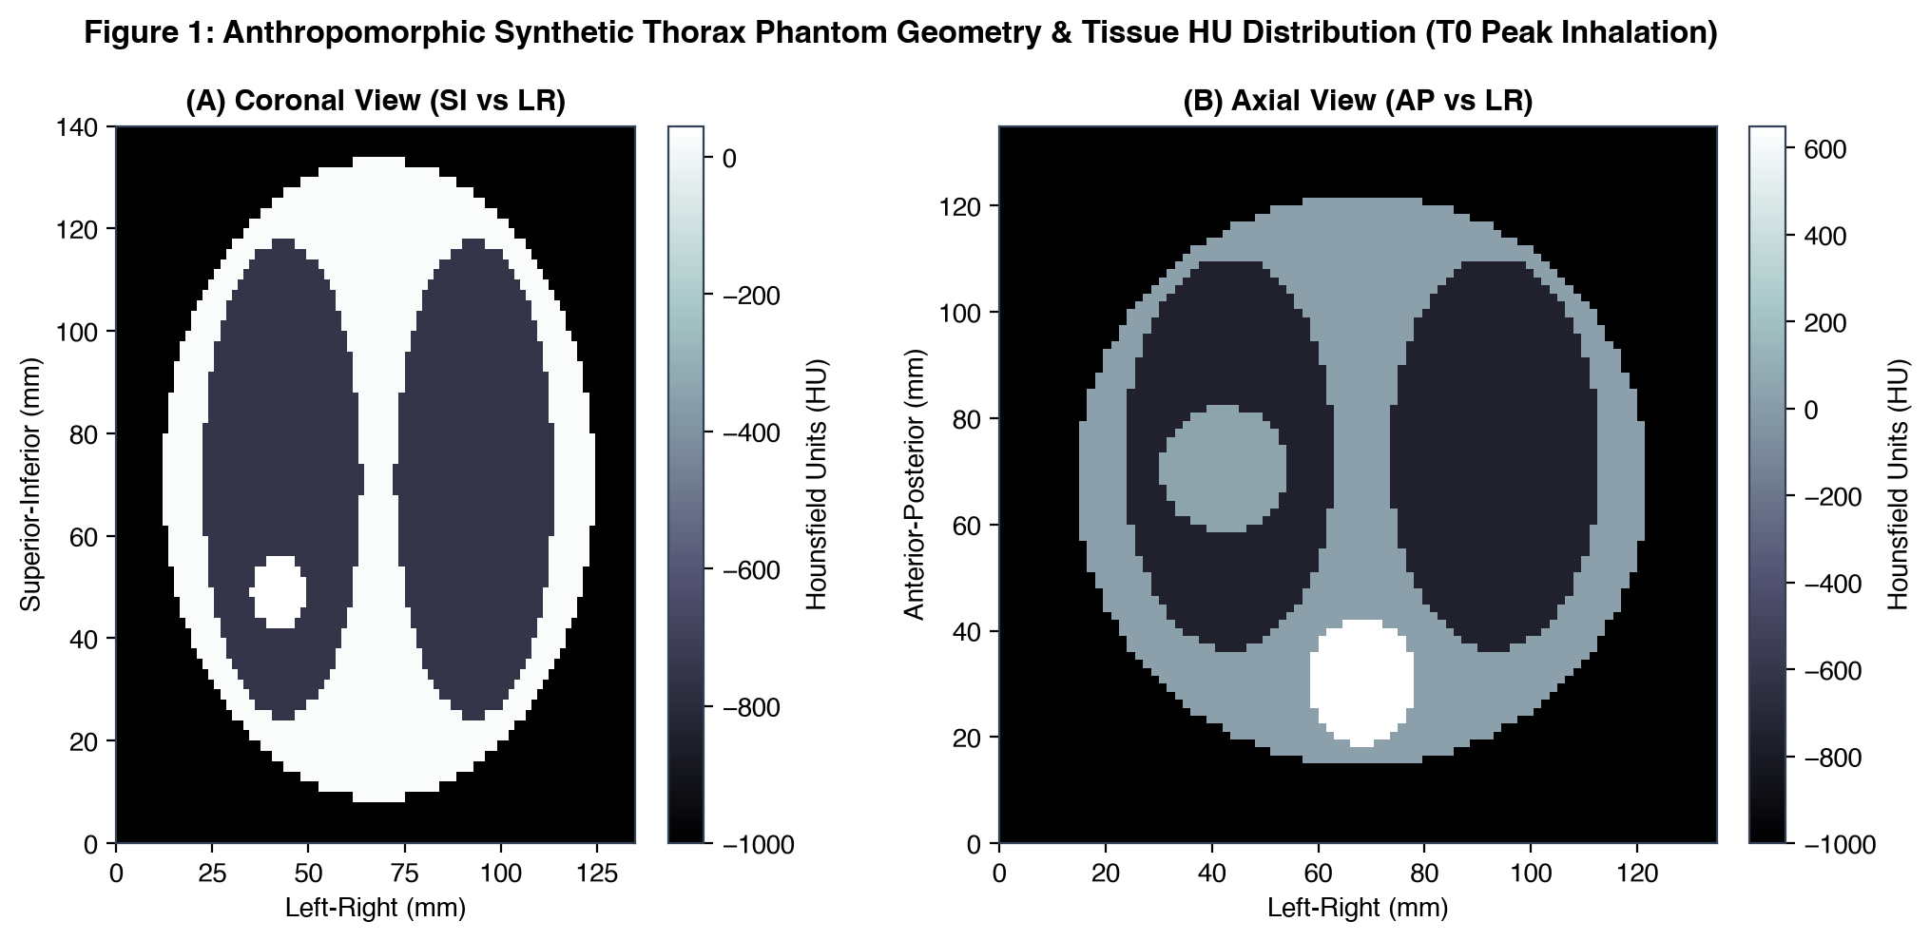
Figure 1: Anthropomorphic synthetic thorax phantom with tissue HU distribution at Peak Inhalation (T0).
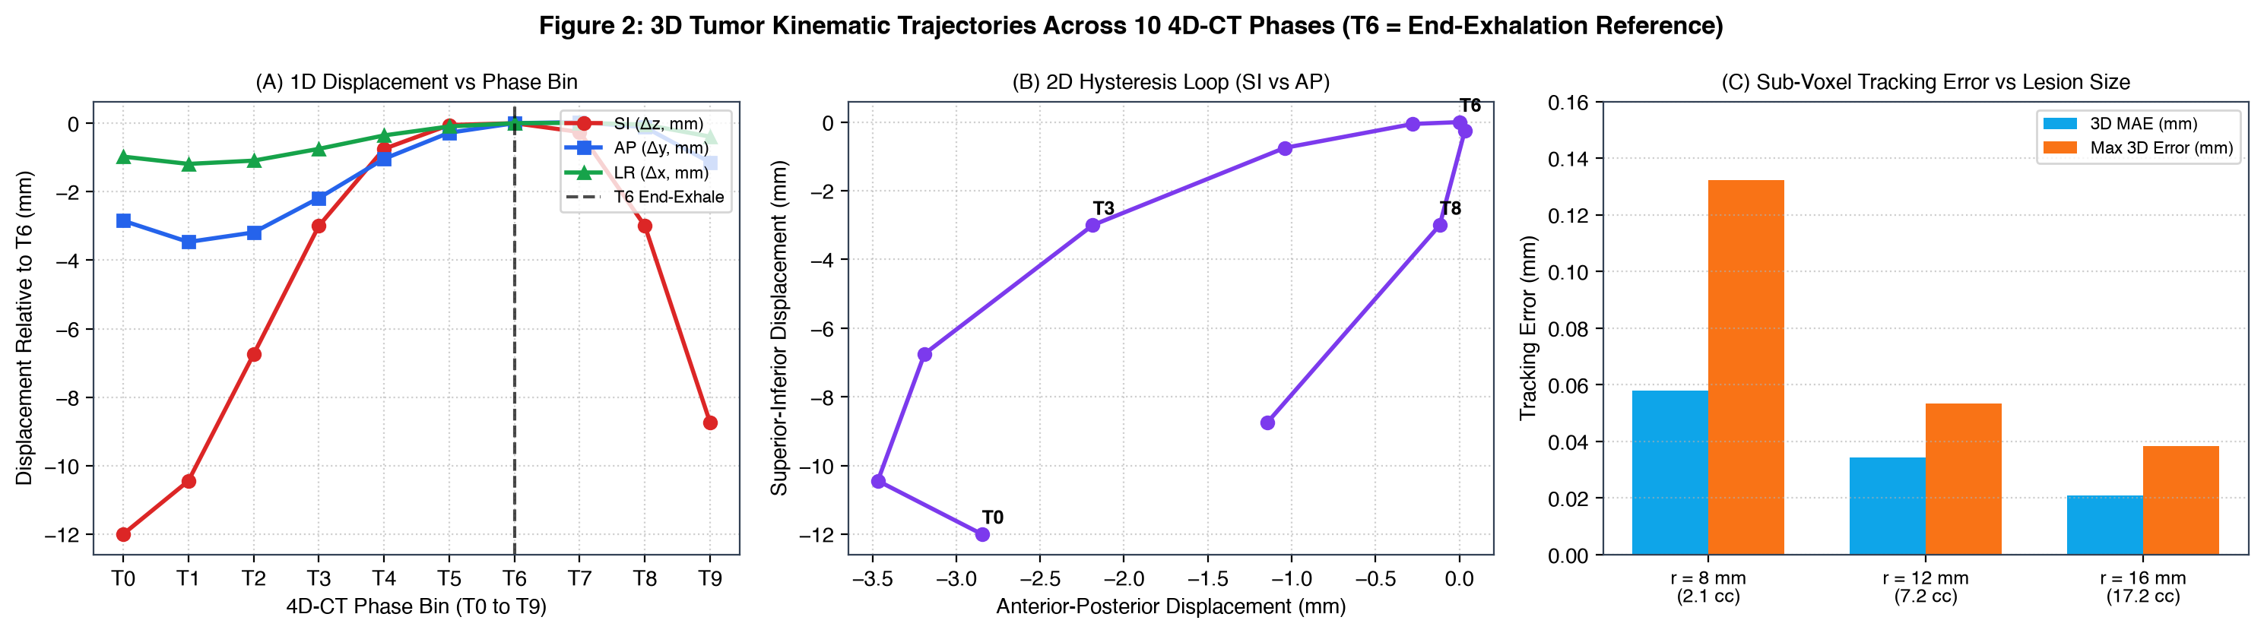
Figure 2: 3D tumor centroid trajectories across 10 4D-CT phases, highlighting the T6 End-Exhalation reference phase.

3.2 Isotropic Expansion Benchmark (Table 2)
Table 2 reports isotropic expansions from T6 GTV. Margins of 2 mm, 3 mm, and 5 mm achieved planning minimum coverage of 42.2%, 50.1%, and 64.7%, respectively. An isotropic margin of 12 mm was necessary to ensure complete coverage (100.0%) across all phases.
Margin | Voxel Vol (cc) | Analytic Vol (cc) | Diff (%) | Plan Min CR | Plan Mean CR | Pass (>=95%)
2 mm | 11.3 | 11.5 | -1.6% | 42.2% | 81.5% | Fail
3 mm | 14.2 | 14.1 | +0.5% | 50.1% | 85.8% | Fail
5 mm | 20.6 | 20.6 | +0.1% | 64.7% | 91.6% | Fail
8 mm | 33.3 | 33.5 | -0.7% | 84.4% | 97.3% | Fail
10 mm | 44.3 | 44.6 | -0.6% | 94.5% | 99.3% | Fail
12 mm | 58.0 | 57.9 | +0.2% | 100.0% | 100.0% | Pass

3.3 Target Strategy Volumes, Planning Coverage, and Multi-Regimen Robustness (Table 3)
Table 3 compares target strategies across planning coverage, Monte Carlo robustness (N=5,000), and multi-regimen setup uncertainty across N_pat = 200 virtual patients (7,600 sessions). ITV + 3 mm achieved complete 100.0% planning coverage (22.3 cc, +8.3% vs. baseline). Anisotropic PTV (Mid-pos + 2 mm) achieved 99.4% minimum coverage (19.3 cc, -6.5% vs. 5 mm baseline). In SBRT 5-fraction courses, ITV + 3 mm yielded only 6.0% all-fraction success [3.5%, 10.2%], while ITV + 5 mm maintained 53.0% [46.1%, 59.8%] (and 66.0% [59.2%, 72.2%] in 3-fraction SBRT). Fraction pass rates in CFRT 30-fx are reported with patient-level cluster bootstrap CIs.
Strategy | Vol (cc) | vs 5mm | Plan MinCR | Irreg Pass (95% Wilson CI) | SBRT 3fx AllPass (95% Wilson) | SBRT 5fx AllPass (95% Wilson) | CFRT 30fx FracPass (95% ClusterBoot)
Isotropic 5mm | 20.6 | Baseline | 64.7% | 0.0% [0.0, 0.1] | 0.0% [0.0, 1.9] | 0.0% [0.0, 1.9] | 1.5% [1.1, 1.9]
Isotropic 12mm | 58.0 | +181.6% | 100.0% | 29.9% [28.6, 31.1] | 37.5% [31.1, 44.4] | 31.5% [25.5, 38.2] | 69.8% [66.3, 73.1]
ITV + 2mm setup | 17.7 | -14.2% | 100.0% | 48.5% [47.1, 49.9] | 1.5% [0.5, 4.3] | 0.0% [0.0, 1.9] | 20.7% [19.0, 22.5]
ITV + 3mm setup | 22.3 | +8.3% | 100.0% | 68.3% [67.0, 69.5] | 16.5% [12.0, 22.3] | 6.0% [3.5, 10.2] | 46.4% [43.6, 49.1]
ITV + 4mm (TG-324) | 26.2 | +27.3% | 100.0% | 87.2% [86.3, 88.1] | 42.0% [35.4, 48.9] | 27.0% [21.3, 33.5] | 68.5% [65.7, 71.3]
ITV + 5mm (TG-324) | 31.0 | +50.3% | 100.0% | 96.2% [95.7, 96.7] | 66.0% [59.2, 72.2] | 53.0% [46.1, 59.8] | 82.7% [80.5, 84.9]
Anisotropic (Mid-pos + 2mm setup) | 19.3 | -6.5% | 99.4% | 18.3% [17.3, 19.4] | 0.5% [0.1, 2.8] | 0.0% [0.0, 1.9] | 20.4% [18.6, 22.2]
Anisotropic (Mid-pos + 3mm setup) | 23.0 | +11.6% | 100.0% | 53.1% [51.7, 54.5] | 12.0% [8.2, 17.2] | 4.0% [2.0, 7.7] | 42.5% [39.8, 45.4]
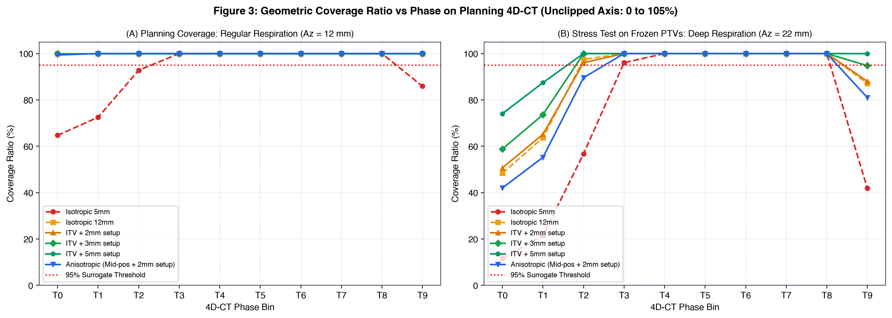
Figure 3: Geometric Coverage Ratio vs phase on planning 4D-CT (unclipped 0-105% axes).
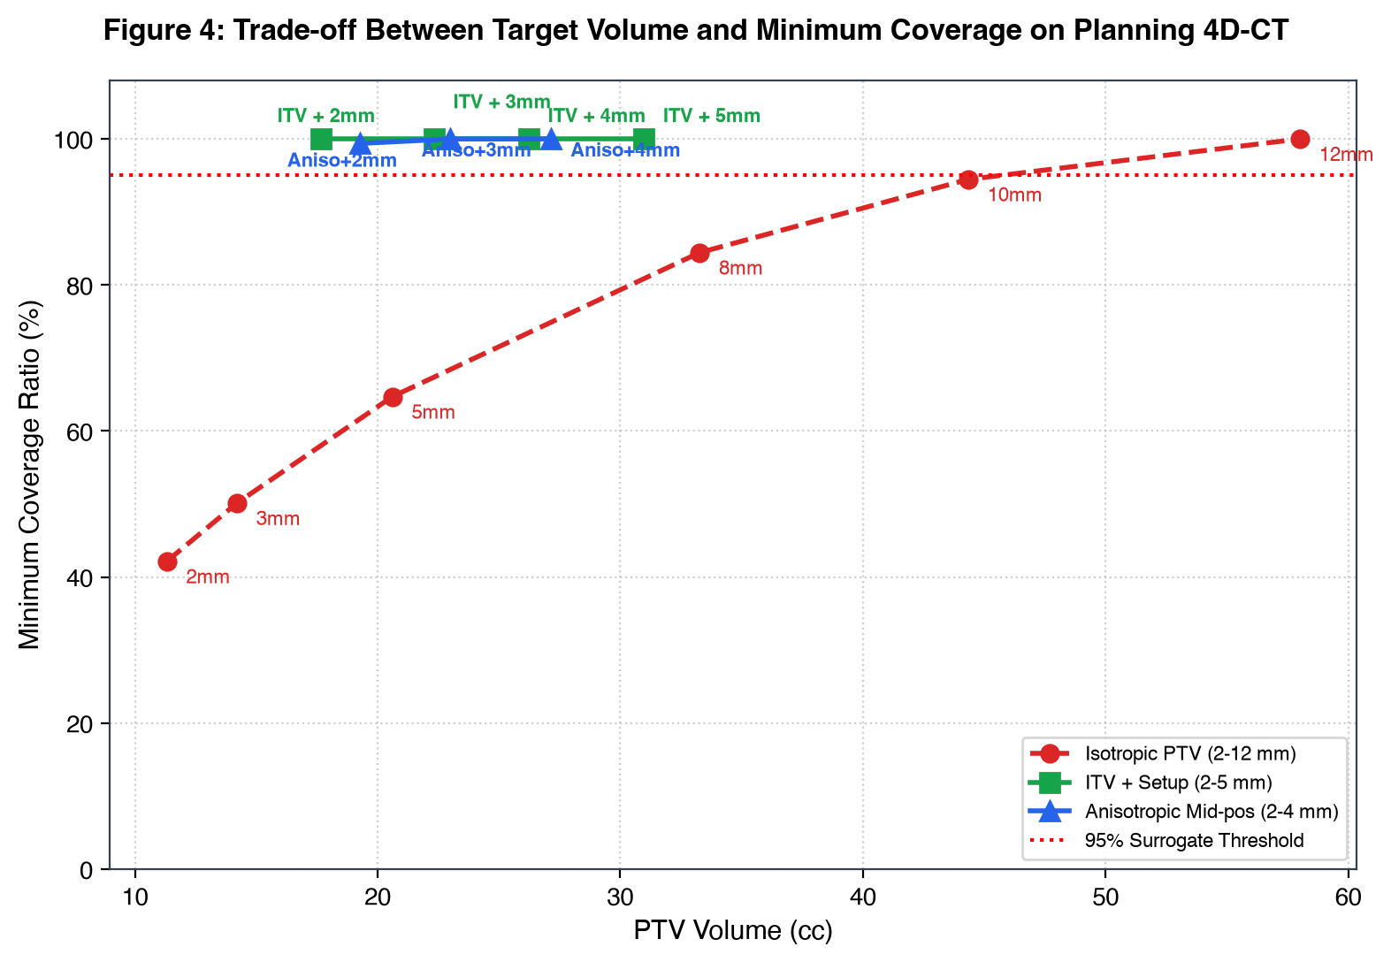
Figure 4: Trade-off between PTV volume and minimum target coverage under regular respiration with staggered method labels.

3.4 Multi-Lesion Target Coverage Robustness (Table 4)
To evaluate how anatomical tumor dimensions influence sensitivity to breathing variations and setup shifts, target coverage was simulated across small (r=8 mm, 2.1 cc), nominal (r=12 mm, 7.2 cc), and large (r=16 mm, 17.2 cc) lesions under identical motion and setup uncertainty models (N = 2,000 Monte Carlo cycles per size, N_pat = 200 virtual patients, SBRT 5-fx). Table 4 details the findings.
Lesion Radius (mm) | Target Strategy | PTV Vol (cc) | Plan Min CR | Irreg MC Pass (95% Wilson CI) | SBRT 5fx Frac Pass (95% ClusterBoot) | SBRT 5fx All-Pass (95% Wilson CI)
r = 8 mm (Small) | ITV + 3mm setup | 9.9 | 100.0% | 54.9% [52.7, 57.1] | 33.2% [29.8, 36.5] | 0.5% [0.1, 2.8]
r = 8 mm (Small) | ITV + 5mm setup | 15.1 | 100.0% | 86.3% [84.7, 87.7] | 73.8% [70.4, 77.1] | 29.5% [23.6, 36.2]
r = 12 mm (Nominal) | ITV + 3mm setup | 22.3 | 100.0% | 67.8% [65.7, 69.8] | 45.8% [41.8, 49.7] | 6.5% [3.8, 10.8]
r = 12 mm (Nominal) | ITV + 5mm setup | 31.0 | 100.0% | 96.3% [95.4, 97.0] | 84.3% [81.4, 87.1] | 51.0% [44.1, 57.8]
r = 16 mm (Large) | ITV + 3mm setup | 41.7 | 100.0% | 81.2% [79.5, 82.9] | 53.7% [49.9, 57.4] | 9.0% [5.8, 13.8]
r = 16 mm (Large) | ITV + 5mm setup | 54.5 | 100.0% | 97.9% [97.1, 98.4] | 88.0% [85.5, 90.3] | 60.0% [53.1, 66.5]

3.5 Monte Carlo Robustness and Population Setup Uncertainty
Figure 5 presents a dual-panel analysis distinguishing binomial pass probability from continuous minimum coverage ratio. Panel A presents the pass probability (P(CR_min >= 95%)) with 95% Wilson score confidence intervals across motion amplitudes (Az = 10 to 22 mm). Panel B presents the continuous minimum Coverage Ratio showing the mean alongside the empirical 95% inter-percentile range [P2.5, P97.5]. Figure 6 illustrates population setup uncertainty distributions across 200 virtual patients.
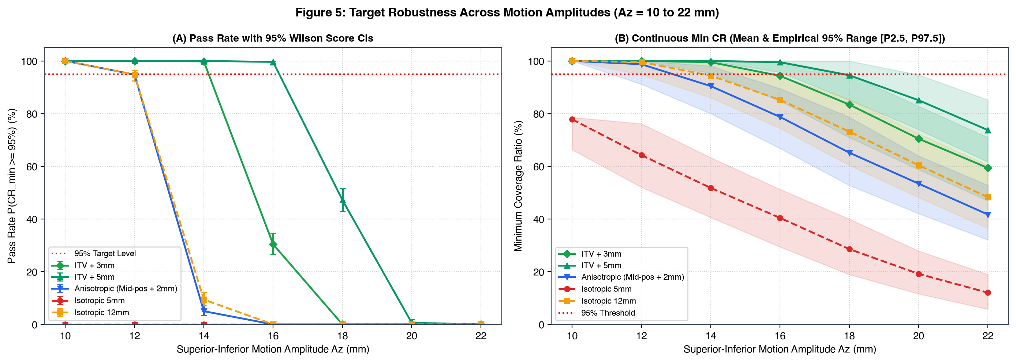
Figure 5: Dual-panel target coverage robustness across motion amplitudes (Az = 10 to 22 mm): (A) Pass Rate with 95% Wilson Score CIs; (B) Continuous Minimum Coverage Ratio with mean and empirical 95% range [P2.5, P97.5].
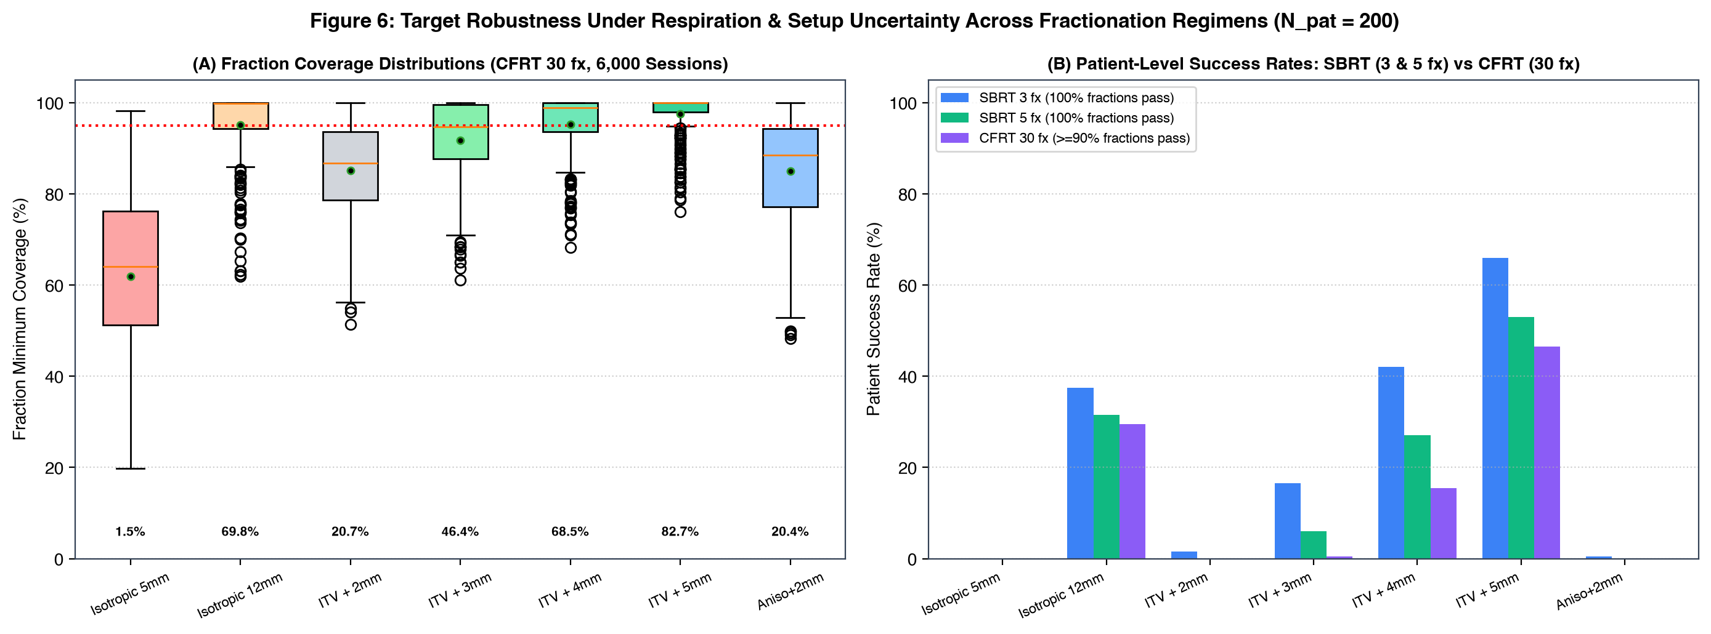
Figure 6: Multi-regimen setup uncertainty across 200 virtual patients comparing CFRT 30-fraction distribution (left) and SBRT 3-fx & 5-fx all-pass rates (right).

4. Discussion and Limitations
Our simulations reveal a pronounced disconnect between nominal planning coverage and real-world delivery robustness. Under idealized regular breathing on simulation 4D-CT, conservative margins like ITV + 3 mm (22.3 cc) or Anisotropic Mid-pos + 2 mm (19.3 cc) appear highly effective, achieving 100.0% and 99.4% minimum target enclosure while sparing normal lung parenchyma. However, this geometric protection deteriorates under realistic delivery conditions: when challenged with unseen irregular breathing cycles, the ITV + 3 mm pass rate falls to 68.3%. When inter-fraction setup displacements are introduced, its complete-course success rate in 5-fraction SBRT collapses to 6.0%.
The physical basis for this vulnerability lies in the mechanics of hypofractionation. In conventional fractionated radiotherapy (30 daily fractions), daily random execution offsets (sigma) blur the penumbra and partially average out over time, allowing ITV + 3 mm to maintain an overall fraction pass rate of 46.4%. In a 5-fraction SBRT course, by contrast, each patient is subject to an unvarying systematic preparation offset (Sigma) across their entire treatment. If this systematic error translates the lesion toward the PTV margin boundary, every single fraction fails the 95% coverage threshold. Consequently, a fraction pass rate of 46.8% translates into a complete-course patient success rate of only 6.0%.
Expanding the margin buffer to ITV + 5 mm (31.0 cc) significantly reinforces geometric robustness, yielding a 96.2% pass rate under irregular breathing, 53.0% complete-course pass in 5-fraction SBRT, and 82.7% fraction pass in conventional delivery. These findings provide empirical computational confirmation for the 4-to-5 mm ITV-to-PTV baseline recommended in AAPM Task Group 324 Report 91.b [2]. Nonetheless, even with a 5 mm margin, geometric misses occur in 17.3% of conventional fractions and 47.0% of 5-fraction SBRT courses, demonstrating that margin enlargement alone cannot overcome setup uncertainties without daily volumetric image guidance (CBCT) and active motion monitoring.
Our multi-lesion sensitivity analysis highlights a pronounced volume-dependent vulnerability. Small nodules (r = 8 mm, volume 2.1 cc) exhibited dramatically higher sensitivity to setup errors than large tumors (r = 16 mm, volume 17.2 cc), achieving only a 29.5% complete-course pass rate with ITV + 5 mm under 5-fraction SBRT, compared to 60.0% for large lesions. This disparity is governed by surface-to-volume ratio: a 2 mm positional displacement forces a substantially larger percentage of an 8 mm sphere's volume across the PTV boundary than it does for a 16 mm sphere. When administering SBRT to small peripheral pulmonary nodules, clinicians must maintain rigorous image-guided alignment.
Study Limitations: Several methodological considerations should be noted. (1) The simulation modeled the tumor as a rigid sphere, whereas clinical lung lesions can undergo non-rigid deformation and cardiac pulsation [6, 13]. (2) Geometric coverage ratio (CR >= 95%) was utilized as a spatial surrogate; physical absorbed dose involves tissue heterogeneities, secondary electron disequilibrium, and beam penumbra, which necessitate 4D Monte Carlo dose calculation [5, 7]. (3) External breathing surrogates used in clinical 4D-CT acquisition can exhibit phase discrepancies relative to internal anatomy [1, 12]. (4) In hypofractionated SBRT, biological effective dose (BED) escalation means that partial underdosing across several fractions can adversely impact tumor control probability [18, 19]. (5) Couch correction workflows were evaluated contextually from published clinical data rather than through explicit in silico couch shift modeling.

5. Conclusion
Expanding target margins to ITV + 5 mm substantially improves geometric robustness over tight 3 mm margins, elevating 5-fraction SBRT complete-course pass rates from 6.0% to 53.0% and conventional fraction pass rates from 46.4% to 82.7%. These findings support the 4-to-5 mm ITV-to-PTV baseline recommended by AAPM Task Group 324 Report 91.b. However, because geometric misses still affect 17.3% of conventional fractions and 47.0% of 5-fraction SBRT courses under typical setup uncertainties, margin expansion alone cannot guarantee target coverage. Daily volumetric image guidance (CBCT) and active motion management remain essential.

Data and Code Availability
The full simulation pipeline, phantom routines, Monte Carlo algorithms, and analysis tools are open-source under the MIT license at https://github.com/anhvu7123/4d-ct-lung-motion. The random seed configurations (seed=42 for 3-fraction SBRT, seed=43 for 5-fraction SBRT, seed=44 for 30-fraction conventional radiotherapy) are declared across all modules for bitwise reproducibility.

References
1. Keall PJ, Mageras GS, Balter JM, et al. The management of respiratory motion in radiation oncology report of AAPM Task Group 76. Med Phys. 2006;33(10):3874-3900.
2. AAPM Task Group 324 Report 91.b. The Management of Respiratory Motion in Radiation Oncology. Med Phys. 2026. DOI: 10.1002/mp.70677.
3. van Herk M. Errors and margins in radiotherapy. Semin Radiat Oncol. 2004;14(1):52-64.
4. van Herk M, Remeijer P, Rasch C, Lebesque JV. The probability of correct target dosage: dose-population histograms for deriving margins. Int J Radiat Oncol Biol Phys. 2000;47(4):1121-1135.
5. Lujan AE, Larsen EW, Balter JM, Ten Haken RK. A method for incorporating organ motion due to breathing into 3D dose calculations. Med Phys. 1999;26(5):715-720.
6. Seppenwoolde Y, Shirato H, Kitamura K, et al. Precise and real-time measurement of 3D tumor motion in lung due to breathing and heartbeat, measured during radiotherapy. Int J Radiat Oncol Biol Phys. 2002;53(4):822-834.
7. International Commission on Radiation Units and Measurements. Prescribing, Recording, and Reporting Photon-Beam Intensity-Modulated Radiation Therapy (ICRU Report 83). J ICRU. 2010;10(1).
8. Underberg RWM, Lagerwaard FJ, Slotman BJ, Cuijpers JP, Senan S. Use of maximum intensity projections (MIP) for target volume generation in 4DCT scans for lung cancer. Int J Radiat Oncol Biol Phys. 2005;63(1):253-260.
9. Wolthaus JW, Sonke JJ, van Herk M, Belderbos JS, Rossi MM, Lebesque JV, Damen EM. Reconstruction of a time-averaged midposition CT scan for radiotherapy planning of lung cancer patients using deformable registration. Med Phys. 2008;35(9):3998-4011.
10. Sonke JJ, Lebesque J, de Bois J, et al. Frameless stereotactic body radiotherapy for lung cancer using four-dimensional cone beam CT guidance. Int J Radiat Oncol Biol Phys. 2008;70(2):590-598.
11. Shirato H, Shimizu S, Kitamura K, et al. Four-dimensional treatment planning and fluoroscopic real-time tumor-tracking radiotherapy for moving tumor. Int J Radiat Oncol Biol Phys. 2000;48(2):435-442.
12. Vedam SS, Keall PJ, Kini VR, Mostafavi H, Shukla HP, Mohan R. Acquiring a four-dimensional computed tomography dataset using an external respiratory signal. Phys Med Biol. 2003;48(1):45-62.
13. Rietzel E, Chen GT, Choi NC, Willett CG. Four-dimensional image-based treatment planning: Target volume segmentation and dose calculation in the presence of respiratory motion. Int J Radiat Oncol Biol Phys. 2005;61(5):1535-1550.
14. Engelsman M, Sharp GC, Bortfeld T, Onimaru R, Shirato H. How much margin reduction is possible with respiratory gating? Int J Radiat Oncol Biol Phys. 2001;50(5):1357-1365.
15. Guckenberger M, Meyer J, Wilbert J, et al. Precision of image-guided radiotherapy (IGRT) in patient positioning and target volume definition for stereotactic body radiotherapy of lung cancer. Int J Radiat Oncol Biol Phys. 2009;74(2):581-588.
16. Bissonnette JP, Balter PA, Dong L, et al. Quality assurance for image-guided radiation therapy: report of AAPM Task Group 179. Med Phys. 2012;39(4):1946-1963.
17. Wilson EB. Probable inference, the law of large numbers, and test of bias. J Am Stat Assoc. 1927;22(158):209-212.
18. Timmerman R, McGarry M, Yiannoutsos C, et al. Extracranial stereotactic radioablation: results of a phase I study in medically inoperable stage I non-small cell lung cancer. J Clin Oncol. 2006;24(30):4833-4839.
19. Benedict SH, Yenice KM, Followill D, et al. Stereotactic body radiation therapy: the report of AAPM Task Group 101. Med Phys. 2010;37(8):4078-4101.
20. Stroom JC, de Boer HC, Huizenga H, Visser AG. Inclusion of geometrical uncertainties in radiotherapy treatment planning by means of coverage probability. Int J Radiat Oncol Biol Phys. 1999;43(4):905-919.

