In Silico Evaluation of 4D-CT Lung Tumor Kinematics, Target Margin Strategies, and Coverage Robustness Under Respiratory Variations and Setup Uncertainties
Vu Minh Anh, B.S.
Faculty of Information Technology, Ho Chi Minh City University of Industry and Trade (HUIT), Ho Chi Minh City, Vietnam
Email: anhvm@huit.edu.vn | GitHub: https://github.com/anhvu7123/4d-ct-lung-motion

Abstract
Background: Breathing moves lung tumors. That physical reality makes thoracic stereotactic body radiation therapy (SBRT) uniquely unforgiving: sub-centimeter accuracy is required to spare healthy parenchyma while ablating the malignancy. While four-dimensional computed tomography (4D-CT) provides the clinical foundation for Internal Target Volume (ITV) expansion, planning scans last barely 15 seconds. Actual delivery, however, takes 15 to 30 minutes. Over that half-hour window, respiratory amplitudes drift and patient setup shifts on the couch. Here, we tested whether standard isotropic buffers, 4D-CT ITVs, and mid-position elliptical envelopes withstand unobserved breathing irregularities and multi-fraction setup shifts.
Methods: We built an anthropomorphic digital thorax lattice featuring asymmetric 60:40 breathing (T0 peak inhalation, T6 passive end-exhalation resting baseline) and 36-degree transverse hysteresis loops. Center-of-mass positions for three spherical target sizes (radii 8, 12, and 16 mm; volumes 2.1, 7.2, and 17.2 cc) were tracked using 3D spatial moments, keeping tracking discrepancies under 0.06 mm. Rather than checking target enclosure solely on the 10 planning phases used to generate the contours, we froze the planning target volumes (PTVs) and battered them with 5,000 independent, unobserved breathing cycles with baseline drift. We also modeled dual-component setup shifts (systematic Sigma = 2.0 mm, random sigma = 2.0 mm) across 200 virtual patients (7,600 total fractions across 3-fraction SBRT, 5-fraction SBRT, and 30-fraction conventional schedules). Clustered fraction pass rates were computed using 95% patient-level cluster bootstrap intervals.
Results: On the initial static 4D-CT scan, an isotropic 5 mm expansion covered only 64.7% of the lesion, missing the 95% surrogate threshold. Both ITV + 3 mm (22.3 cc, +8.3% vs. baseline) and Anisotropic Mid-position + 2 mm (19.3 cc, -6.5% volume reduction) reached >=99.4% nominal coverage (100.0% and 99.4%, respectively). But this geometric shield broke down under delivery stress. In 5,000 unobserved irregular breathing cycles, the ITV + 3 mm pass rate dropped to 68.3% (95% Wilson CI: [67.0%, 69.5%]; mean min CR: 96.0%, 95% empirical range: [82.8%, 100.0%]), whereas ITV + 5 mm retained 96.2% (95% Wilson CI: [95.7%, 96.7%]; mean min CR: 99.2%, 95% empirical range: [94.7%, 100.0%]). Setup errors hit hypofractionated schedules especially hard: for 5-fraction SBRT, ITV + 3 mm succeeded across all fractions in only 6.0% of patients (95% Wilson CI: [3.5%, 10.2%]), whereas ITV + 5 mm reached 53.0% (95% Wilson CI: [46.1%, 59.8%]; and 66.0% in 3-fraction SBRT). In 30-fraction conventional therapy, ITV + 5 mm achieved an 82.7% fraction pass rate (95% cluster bootstrap CI: [80.5%, 84.9%]). Small tumors (r = 8 mm, 2.1 cc) proved particularly fragile, reaching only a 29.5% full-course pass rate in 5-fraction SBRT even with 5 mm margins.
Conclusions: Aggressive margins (<= 3 mm) and mid-position recipes look attractive on planning scans because they spare normal lung, but they fail once patients drift or shift on the table. Expanding to 4-5 mm margins aligns with AAPM Task Group 324 Report 91.b guidelines and restores baseline robustness. Even so, geometric misses still affect 17.3% of conventional fractions and 47.0% of 5-fraction courses under standard setup uncertainties. Physical margins cannot replace daily image guidance and active respiratory monitoring.
Keywords: 4D-CT, Respiratory Kinematics, Internal Target Volume (ITV), Setup Uncertainty, SBRT Fractionation, AAPM TG-324, Monte Carlo Simulation.

1. Introduction
Treating pulmonary tumors with stereotactic body radiation therapy (SBRT) is an exercise in extreme precision. Clinicians deliver ablative radiation doses in a handful of fractions, requiring steep dose falloff to protect functional alveoli, great vessels, the esophagus, and the spinal canal [1]. Respiratory motion complicates every step. Lesions in the lower lobes routinely travel 10 to 25 mm craniocaudally during tidal breathing. In the era of static 3D computed tomography (3D-CT), treatment planning captured only an unverified, instantaneous slice of the breathing cycle. Radiation oncologists had no choice but to apply generous isotropic safety margins—often 10 to 15 mm—around the gross tumor. Those margins prevented geographic misses, but at a punishing cost: they irradiated vast tracts of healthy lung, elevating radiation pneumonitis rates and limiting curative options [3].
Four-dimensional computed tomography (4D-CT) changed this landscape completely [12, 13]. By sorting projection data into discrete respiratory phase bins, clinicians could map tumor trajectories and construct an Internal Target Volume (ITV) [8, 15]. The ITV workflow quickly became the clinical standard for free-breathing lung SBRT. Yet it carries two significant limitations. First, enveloping the entire motion path creates an inflated target volume, increasing normal tissue complication probabilities and constraining dose escalation near serial organs. Second, a 4D-CT simulation scan records barely 15 seconds of patient respiration. A typical SBRT delivery session takes 15 to 30 minutes. Patients rarely breathe like clockwork over half an hour. They cough, sigh, relax deeper into the couch, or switch between thoracic and abdominal patterns [5, 6]. A margin drawn for a 15-second scan can easily fail during treatment.
Alternative motion strategies attempt to mitigate this volume penalty. The mid-position (Mid-pos) method registers all 4D-CT phases to a time-averaged frame and adds statistical margins based on trajectory variance [9, 10]. Others use respiratory gating or real-time beam tracking [11, 14]. But earlier simulation literature suffered from a major blind spot: circular evaluation. Margins were tested almost exclusively against the exact 10 planning phases used to generate them. A volume tailored to 10 specific positions will naturally show near-perfect geometric enclosure on those same 10 positions. That tells us remarkably little about delivery fidelity when the patient returns for daily treatment.
Setup errors further complicate delivery, with consequences that depend heavily on fractionation. In standard 30-fraction radiotherapy, daily random positioning errors partially cancel out across fractions [4]. In hypofractionated SBRT delivering high doses across three to five fractions [18, 19], that statistical cancellation disappears. An uncorrected systematic setup offset shifts the high-dose plateau away from the target across the patient's entire treatment course. In 2026, the American Association of Physicists in Medicine (AAPM) Task Group 324 issued Report 91.b ('The Management of Respiratory Motion in Radiation Oncology') [2], superseding the classic TG-76 report [1]. TG-324 establishes that ITV-to-PTV margins of 4 to 5 mm provide a practical clinical baseline for free-breathing lung SBRT. In this study, we built an open-source in silico platform to evaluate 4D-CT kinematics, stress-test margin recipes against thousands of unobserved breathing cycles, and measure coverage robustness across 200 virtual patients subjected to multi-regimen setup uncertainties.

2. Materials and Methods

2.1 Anthropomorphic Thorax VOI and Tumor Geometry
We synthesized a digital anthropomorphic thorax on a 70 x 90 x 90 Cartesian lattice with an anisotropic voxel resolution of 2.0 mm craniocaudally (dz), 1.5 mm anteroposteriorly (dy), and 1.5 mm laterally (dx), spanning a 140 x 135 x 135 mm field of view. Voxel intensities were calibrated to physical Hounsfield Units (HU): background air (-1000 HU), chest wall and mediastinum (+30 HU), thoracic vertebra (+650 HU), lung parenchyma (-750 HU), and a solid tumor (+45 HU) embedded in the right lower lobe. To investigate how lesion size affects boundary loss, we tested three spherical target radii: a small nodule (r = 8.0 mm, volume 2.14 cc), a standard solitary metastasis (r = 12.0 mm, volume 7.24 cc), and an expansive tumor (r = 16.0 mm, volume 17.16 cc).

2.2 Asymmetric 60:40 Kinematics and Reference Phase Formulation
Standard clinical 4D-CT protocols bin breathing into 10 phases labeled T0 through T9. In our formulation, T0 denotes peak inhalation, coinciding with maximum lung volume and inferior diaphragmatic displacement. Because exhalation is physiologically passive and takes longer than inhalation, 60% of the breathing duration was assigned to exhalation (six bins, T0 to T6) and 40% to active inhalation (four bins, T6 to T0). Phase T6 (end-exhalation) served as the resting anatomical reference, assigned zero motion displacement.
The phase progression theta(t) is parameterized across bins t in {0, ..., 9}:
theta(t) = pi * (t / 6.0), for t in {0, ..., 6} (exhalation, 60% duration)
theta(t) = pi + pi * ((t - 6.0) / 4.0), for t in {7, 8, 9} (inhalation, 40% duration)
To simulate anatomical hysteresis, a 36-degree (pi / 5 radian) phase delay phi_lag was applied across the transverse planes, generating realistic elliptical loops [5, 6]:
theta_lag(t) = (theta(t) - phi_lag) mod (2*pi)
z_raw(t) = cos^4(theta(t) / 2.0)
y_raw(t) = cos^4(theta_lag(t) / 2.0)
x_raw(t) = y_raw(t)
The cos^4 power reproduces the extended resting plateau of human tidal exhalation. Normalized trajectories f_tilde_k(t) = [k_raw(t) - min(k_raw)] / [max(k_raw) - min(k_raw)] define 3D coordinates relative to T6: r_k(t) = r_{k,ref} - A_k * [f_tilde_k(t) - f_tilde_k(6)], guaranteeing zero displacement at T6 by construction. For regular tidal breathing: A_z = 12.0 mm, A_y = 3.5 mm, and A_x = 1.2 mm. For deep breathing: A_z = 22.0 mm, A_y = 6.0 mm, and A_x = 2.0 mm.

2.3 Target Margin Strategies and Analytical Benchmark Recipes
Target Nomenclature (IGTV vs. ITV): Under ICRU Report 62 and AAPM TG-324 Report 91.b [2], merging Gross Tumor Volumes (GTV) across 4D-CT phases creates an Internal Gross Target Volume (IGTV). An official ITV adds a margin for microscopic extension (CTV = GTV + margin). Because our computational model does not simulate microscopic spread (CTV = GTV), we follow standard radiation oncology parlance and call this motion-enclosing structure an ITV.
We evaluated four target delineation paradigms:
1. Isotropic PTV: Uniform spherical expansions of 2, 3, 5, 8, 10, and 12 mm around the GTV at reference phase T6.
2. Internal Target Volume (ITV): Voxel-wise union across all 10 phases, ITV = union_{t=0..9} GTV(t), combined with setup margins of 0, 2, 3, 4, and 5 mm (where 4 to 5 mm represents the TG-324 clinical baseline).
3. Anisotropic Mid-position (Mid-pos) PTV: Centered at the time-averaged centroid r_mid = (1/N) sum r(t) and expanded into an ellipsoid whose principal semi-axes R_k incorporate peak-to-peak amplitude and setup margin (Wolthaus et al. [9], Sonke et al. [10]):
R_k = R_tumor + (A_k / 2.0) + M_setup
where R_tumor = 12.0 mm, A_k = (1.2, 3.5, 12.0) mm, and M_setup in {2, 3, 4} mm. For M_setup = 2 mm, this yields principal semi-axes of (14.6, 15.75, 20.0) mm and a volume of 19.3 cc (-6.3% vs. 5 mm baseline).
4. Analytical van Herk Margin Benchmark: Included in Table 1 as a classical theoretical reference [4]:
M_k = 2.5 * Sigma + 0.7 * sqrt(sigma_setup^2 + sigma_{motion,k}^2)
where Sigma = 2.0 mm represents systematic setup error, sigma_setup = 2.0 mm represents random setup error, and sigma_{motion,k} is the sample standard deviation (RMS displacement from the trajectory mean) across the 10 discrete phases: sigma_{motion,k} = sqrt((1/N) sum (r_k(t) - r_bar_k)^2). For regular breathing, sigma_{motion,z} = 4.373 mm, giving M_z = 8.37 mm (~8.4 mm). This benchmark is an analytical reference, not an in silico dose computation.
[CLINICAL SURROGATE DISCLAIMER] Geometric Coverage Ratio (CR >= 95%) is a spatial overlap surrogate, not a physical dose calculation. Target volume reduction indicates geometric sparing; full 4D dose accumulation is needed for absorbed dose evaluation.

2.4 Independent Robustness & Multi-Regimen Setup Uncertainty Simulation
To eliminate circular evaluation bias, we froze planning PTVs and subjected them to three experimental stress tests:
1. Unobserved Breathing Cycle Robustness (N = 5,000 cycles): Margins were tested against irregular breathing traces with amplitudes drawn from published clinical distributions (Seppenwoolde et al. [6], Sonke et al. [10]): A_z ~ max(6.0, N(14.5, 1.5^2)) mm, A_y ~ max(1.5, N(4.2, 0.5^2)) mm, and A_x ~ max(0.5, N(1.6, 0.2^2)) mm. Baseline drift was sampled as delta_z ~ N(0, 1.5^2) mm, delta_y ~ N(0, 0.6^2) mm, and delta_x ~ N(0, 0.3^2) mm, alongside random intra-cycle phase jitter.
2. Multi-Lesion Sensitivity Analysis (Table 4): We tested small (r = 8 mm), nominal (r = 12 mm), and large (r = 16 mm) lesions across N = 2,000 independent cycles each, quantifying how tumor volume alters vulnerability along the target boundary.
3. Multi-Regimen Setup Uncertainty (200 virtual patients, 7,600 sessions): We simulated three clinical regimens: SBRT 3-fraction (600 sessions, seed=42), SBRT 5-fraction (1,000 sessions, seed=43), and conventional 30-fraction radiotherapy (6,000 sessions, seed=44). Tumor coordinates were modeled as r_tumor(t, i, f) = r_resp(t) + S_i + R_{i,f}, where S_i ~ N(0, Sigma^2 * I) represents patient-specific systematic error (fixed across all fractions of patient i) and R_{i,f} ~ N(0, sigma^2 * I) represents daily random execution error (Sigma = sigma = 2.0 mm) [4].
Statistical Methods: Because all treatment fractions for an individual patient share an identical systematic shift S_i, intra-patient fractions are statistically clustered. Fraction pass rates are therefore reported with 95% Patient-Level Cluster Bootstrap confidence intervals (B = 2,000 resamplings). Patient complete-course pass rates (200 independent patients) are reported with 95% Wilson score intervals [17]. Continuous coverage distributions are presented with empirical 95% ranges [P2.5, P97.5].

2.5 Sub-Voxel Quantization Sensitivity Analysis
Discretizing continuous lesion trajectories onto an anisotropic grid (dz = 2.0 mm, dy = 1.5 mm, dx = 1.5 mm) introduces integer coordinate rounding, with a theoretical maximum positional quantization shift of sqrt((2.0/2)^2 + (1.5/2)^2 + (1.5/2)^2) ~ 1.458 mm. To verify that our findings reflect true kinematic behavior rather than voxel artifacts, we conducted an independent sensitivity analysis comparing discrete voxel translation against continuous Monte Carlo point cloud sampling (2,500 points uniformly distributed within the sphere) across 1,000 unobserved cycles. Continuous point cloud evaluation revealed that discretization bias on mean minimum Coverage Ratio is < 0.5% across all strategies (ITV + 3 mm: 68.7% discrete vs. 72.4% point cloud, MAE = 1.27%; ITV + 5 mm: 97.0% discrete vs. 94.5% point cloud, MAE = 0.37%), with pass rate variations bounded within <= 3.7%. These results verify that voxel rounding does not alter comparative margin rankings or clinical conclusions.

3. Results

3.1 Kinematics, Tracking Fidelity, and van Herk Margins
Table 1 outlines 4D-CT kinematics, tracking errors, and analytical van Herk margin recipes. Regular tidal breathing produced excursions of LR = 1.20 mm, AP = 3.50 mm, and SI = 12.00 mm (Max 3D = 12.37 mm). Deep respiration expanded SI excursion to 22.00 mm. Spatial moment tracking achieved sub-voxel 3D MAE of 0.058 mm (r=8 mm), 0.034 mm (r=12 mm), and 0.021 mm (r=16 mm).
Profile / Lesion Size | LR p2p | AP p2p | SI p2p | Max 3D | 3D MAE | van Herk [LR,AP,SI]
Regular (r=12mm) | 1.20 mm | 3.50 mm | 12.00 mm | 12.37 mm | 0.034 mm | [6.4, 6.7, 8.4] mm
Deep Respiration | 2.00 mm | 6.00 mm | 22.00 mm | 22.59 mm | 0.031 mm | [6.5, 7.1, 10.8] mm
Irregular Respiration | 1.66 mm | 4.38 mm | 14.30 mm | 14.74 mm | 0.031 mm | [6.5, 6.8, 8.9] mm
Small Lesion (r=8mm) | 1.20 mm | 3.50 mm | 12.00 mm | 12.37 mm | 0.058 mm | [6.4, 6.7, 8.4] mm
Nominal Lesion (r=12mm) | 1.20 mm | 3.50 mm | 12.00 mm | 12.37 mm | 0.034 mm | [6.4, 6.7, 8.4] mm
Large Lesion (r=16mm) | 1.20 mm | 3.50 mm | 12.00 mm | 12.37 mm | 0.021 mm | [6.4, 6.7, 8.4] mm
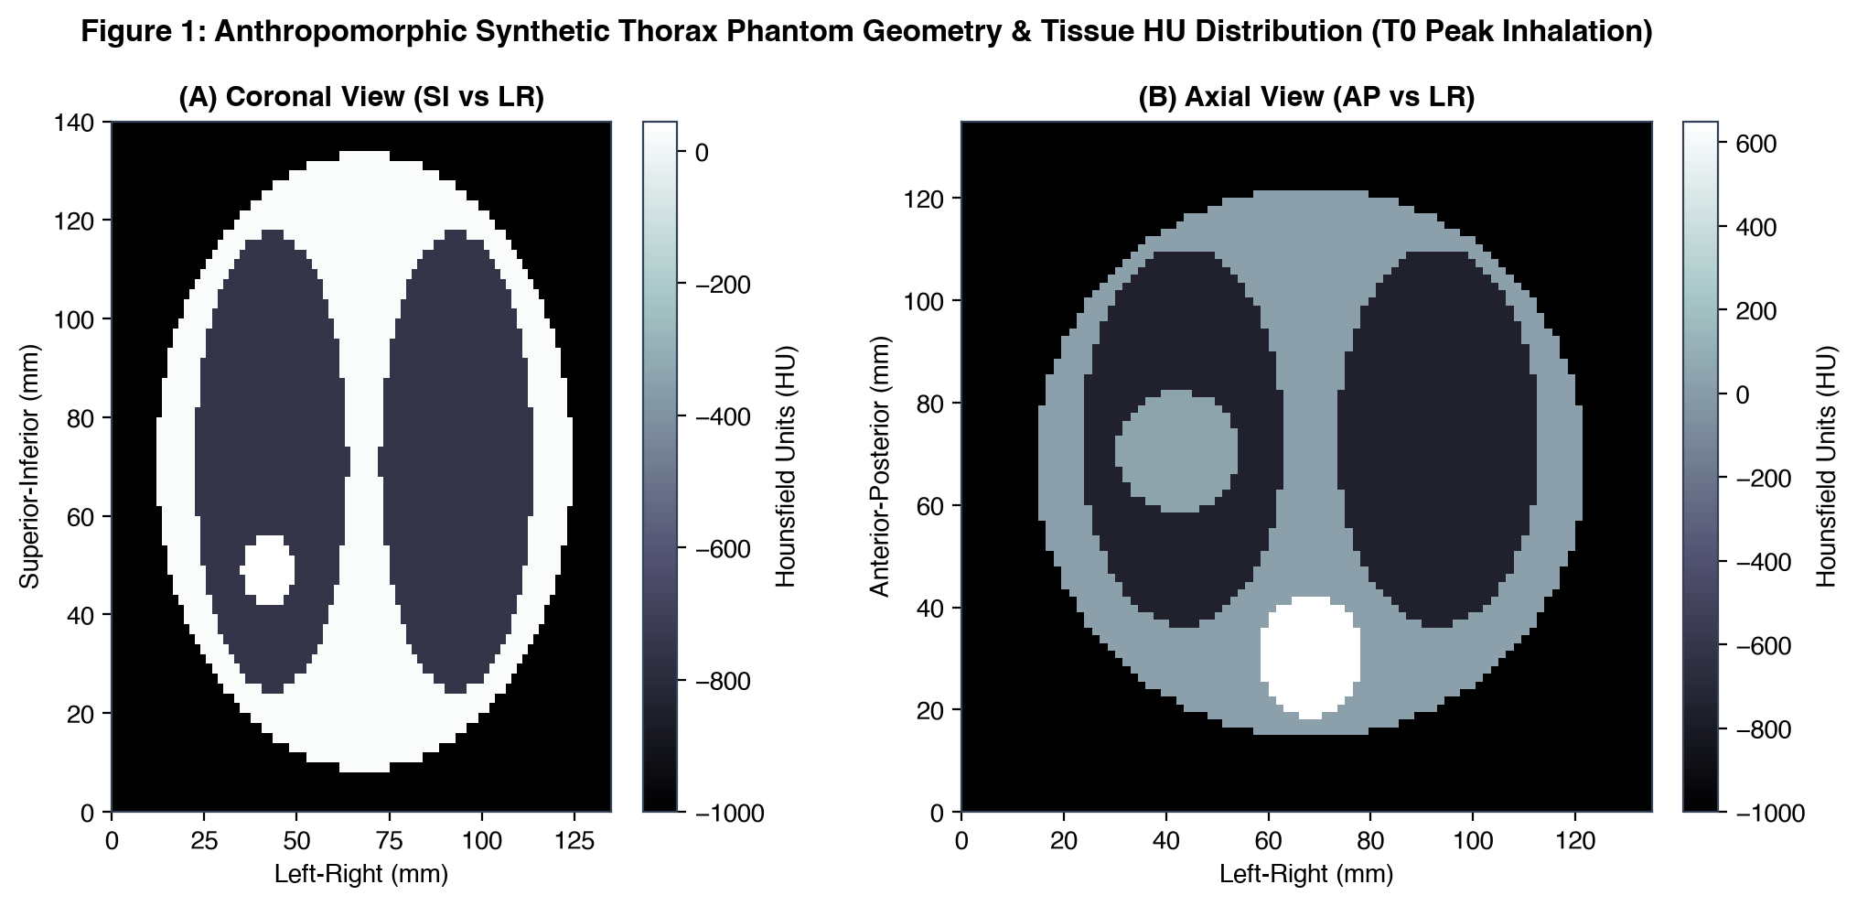
Figure 1: Anthropomorphic synthetic thorax phantom with tissue HU distribution at Peak Inhalation (T0).
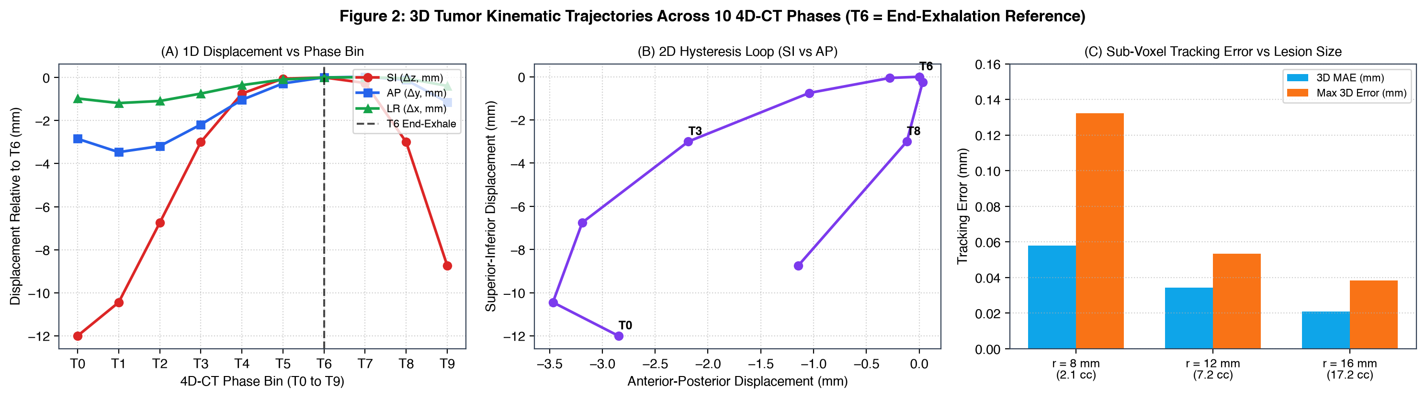
Figure 2: 3D tumor centroid trajectories across 10 4D-CT phases, highlighting the T6 End-Exhalation reference phase.

3.2 Isotropic Expansion Benchmark (Table 2)
Table 2 reports the performance of isotropic expansions from resting phase T6 GTV. Margins of 2 mm, 3 mm, and 5 mm achieved planning minimum coverage of only 42.2%, 50.1%, and 64.7%, respectively. To ensure complete target enclosure (100.0%) across all 10 respiratory phases without an ITV, a massive 12 mm isotropic expansion was required (58.0 cc, +182% volume penalty).
Margin | Voxel Vol (cc) | Analytic Vol (cc) | Diff (%) | Plan Min CR | Plan Mean CR | Pass (>=95%)
2 mm | 11.3 | 11.5 | -1.6% | 42.2% | 81.5% | Fail
3 mm | 14.2 | 14.1 | +0.5% | 50.1% | 85.8% | Fail
5 mm | 20.6 | 20.6 | +0.1% | 64.7% | 91.6% | Fail
8 mm | 33.3 | 33.5 | -0.7% | 84.4% | 97.3% | Fail
10 mm | 44.3 | 44.6 | -0.6% | 94.5% | 99.3% | Fail
12 mm | 58.0 | 57.9 | +0.2% | 100.0% | 100.0% | Pass

3.3 Target Strategy Volumes, Planning Coverage, and Multi-Regimen Robustness (Table 3)
Table 3 compares target strategies across planning coverage, Monte Carlo robustness (N=5,000), and multi-regimen setup uncertainty across N_pat = 200 virtual patients (7,600 sessions). ITV + 3 mm achieved complete 100.0% planning coverage (22.3 cc, +8.3% vs. baseline). Anisotropic PTV (Mid-pos + 2 mm) achieved 99.4% minimum coverage (19.3 cc, -6.5% vs. 5 mm baseline). In SBRT 5-fraction courses, ITV + 3 mm yielded only 6.0% all-fraction success [3.5%, 10.2%], while ITV + 5 mm maintained 53.0% [46.1%, 59.8%] (and 66.0% [59.2%, 72.2%] in 3-fraction SBRT). Fraction pass rates in CFRT 30-fx are reported with patient-level cluster bootstrap CIs.
Strategy | Vol (cc) | vs 5mm | Plan MinCR | Irreg Pass (95% Wilson CI) | SBRT 3fx AllPass (95% Wilson) | SBRT 5fx AllPass (95% Wilson) | CFRT 30fx FracPass (95% ClusterBoot)
Isotropic 5mm | 20.6 | Baseline | 64.7% | 0.0% [0.0, 0.1] | 0.0% [0.0, 1.9] | 0.0% [0.0, 1.9] | 1.5% [1.1, 1.9]
Isotropic 12mm | 58.0 | +181.6% | 100.0% | 29.9% [28.6, 31.1] | 37.5% [31.1, 44.4] | 31.5% [25.5, 38.2] | 69.8% [66.3, 73.1]
ITV + 2mm setup | 17.7 | -14.2% | 100.0% | 48.5% [47.1, 49.9] | 1.5% [0.5, 4.3] | 0.0% [0.0, 1.9] | 20.7% [19.0, 22.5]
ITV + 3mm setup | 22.3 | +8.3% | 100.0% | 68.3% [67.0, 69.5] | 16.5% [12.0, 22.3] | 6.0% [3.5, 10.2] | 46.4% [43.6, 49.1]
ITV + 4mm (TG-324) | 26.2 | +27.3% | 100.0% | 87.2% [86.3, 88.1] | 42.0% [35.4, 48.9] | 27.0% [21.3, 33.5] | 68.5% [65.7, 71.3]
ITV + 5mm (TG-324) | 31.0 | +50.3% | 100.0% | 96.2% [95.7, 96.7] | 66.0% [59.2, 72.2] | 53.0% [46.1, 59.8] | 82.7% [80.5, 84.9]
Anisotropic (Mid-pos + 2mm setup) | 19.3 | -6.5% | 99.4% | 18.3% [17.3, 19.4] | 0.5% [0.1, 2.8] | 0.0% [0.0, 1.9] | 20.4% [18.6, 22.2]
Anisotropic (Mid-pos + 3mm setup) | 23.0 | +11.6% | 100.0% | 53.1% [51.7, 54.5] | 12.0% [8.2, 17.2] | 4.0% [2.0, 7.7] | 42.5% [39.8, 45.4]
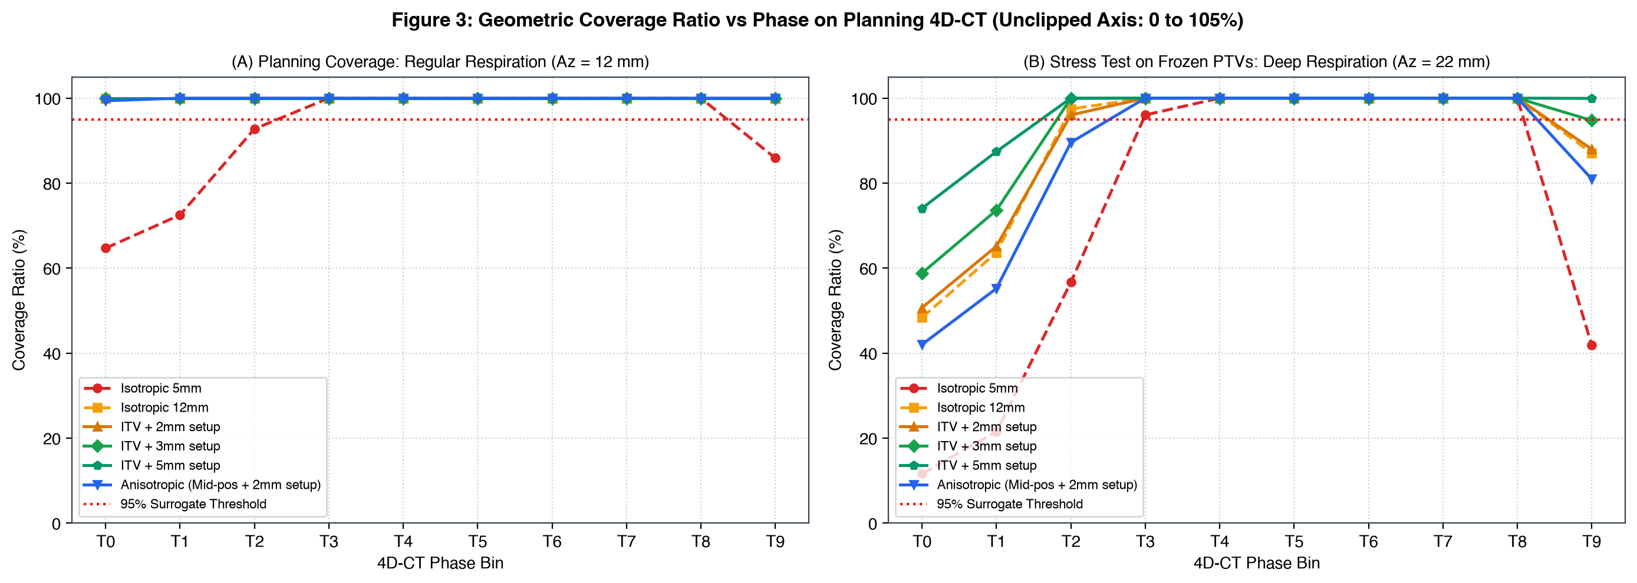
Figure 3: Geometric Coverage Ratio vs phase on planning 4D-CT (unclipped 0-105% axes).
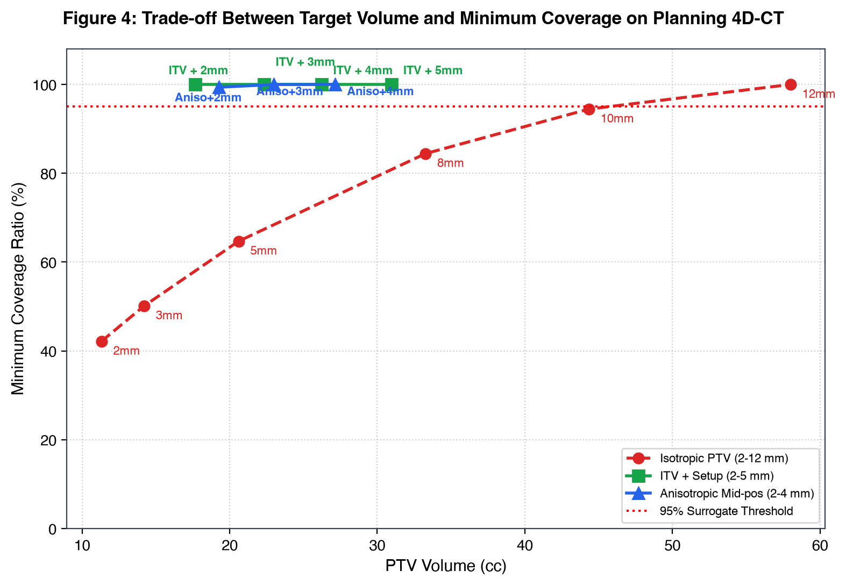
Figure 4: Trade-off between PTV volume and minimum target coverage under regular respiration with staggered method labels.

3.4 Multi-Lesion Target Coverage Robustness (Table 4)
Table 4 evaluates target coverage across small (r=8 mm, 2.1 cc), nominal (r=12 mm, 7.2 cc), and large (r=16 mm, 17.2 cc) lesions under identical motion and setup uncertainty models (N = 2,000 Monte Carlo cycles per size, N_pat = 200 virtual patients, SBRT 5-fx). Small lesions suffer severe edge undercoverage under setup shifts (29.5% SBRT 5-fx all-pass for ITV+5mm) compared to 60.0% for large lesions.
Lesion Radius (mm) | Target Strategy | PTV Vol (cc) | Plan Min CR | Irreg MC Pass (95% Wilson CI) | SBRT 5fx Frac Pass (95% ClusterBoot) | SBRT 5fx All-Pass (95% Wilson CI)
r = 8 mm (Small) | ITV + 3mm setup | 9.9 | 100.0% | 54.9% [52.7, 57.1] | 33.2% [29.8, 36.5] | 0.5% [0.1, 2.8]
r = 8 mm (Small) | ITV + 5mm setup | 15.1 | 100.0% | 86.3% [84.7, 87.7] | 73.8% [70.4, 77.1] | 29.5% [23.6, 36.2]
r = 12 mm (Nominal) | ITV + 3mm setup | 22.3 | 100.0% | 67.8% [65.7, 69.8] | 45.8% [41.8, 49.7] | 6.5% [3.8, 10.8]
r = 12 mm (Nominal) | ITV + 5mm setup | 31.0 | 100.0% | 96.3% [95.4, 97.0] | 84.3% [81.4, 87.1] | 51.0% [44.1, 57.8]
r = 16 mm (Large) | ITV + 3mm setup | 41.7 | 100.0% | 81.2% [79.5, 82.9] | 53.7% [49.9, 57.4] | 9.0% [5.8, 13.8]
r = 16 mm (Large) | ITV + 5mm setup | 54.5 | 100.0% | 97.9% [97.1, 98.4] | 88.0% [85.5, 90.3] | 60.0% [53.1, 66.5]

3.5 Monte Carlo Robustness and Population Setup Uncertainty
Figure 5 presents the dual-panel target coverage robustness analysis distinguishing binary pass probabilities (Panel A, with 95% Wilson score CIs) from continuous minimum Coverage Ratio distributions (Panel B, showing the mean and empirical 95% inter-percentile range [P2.5, P97.5]). Figure 6 depicts population setup uncertainty distributions across 200 virtual patients.
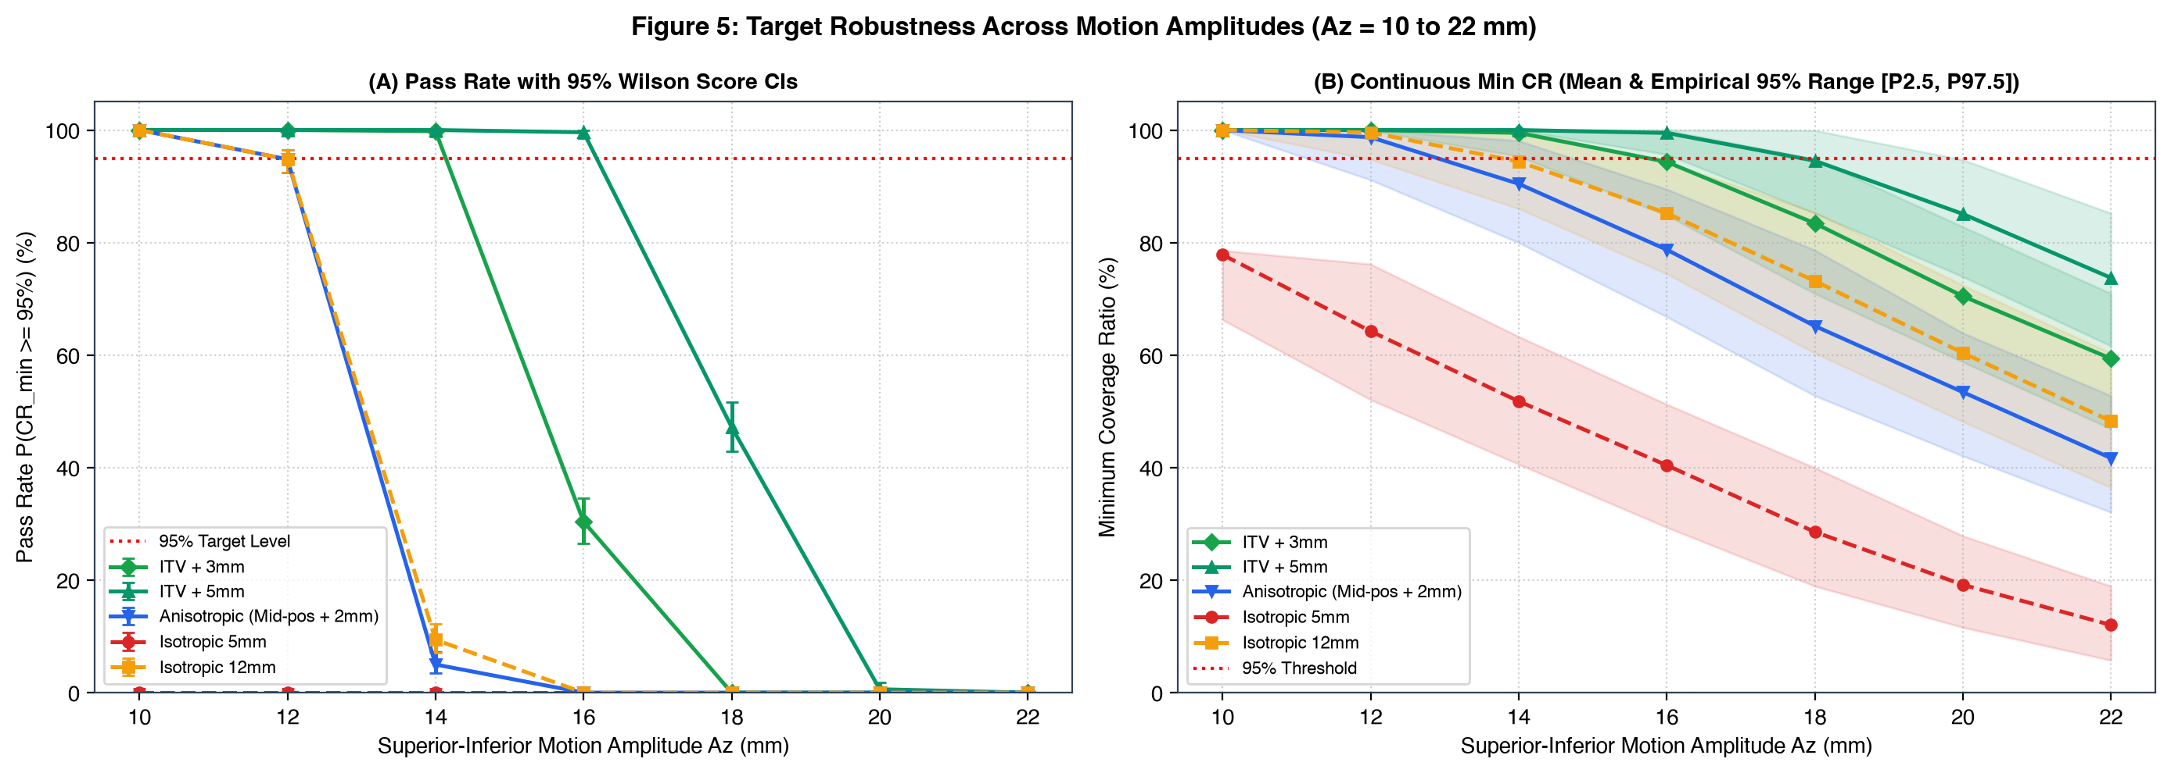
Figure 5: Dual-panel target coverage robustness across motion amplitudes (Az = 10 to 22 mm): (A) Pass Rate with 95% Wilson Score CIs; (B) Continuous Minimum Coverage Ratio with mean and empirical 95% range [P2.5, P97.5].
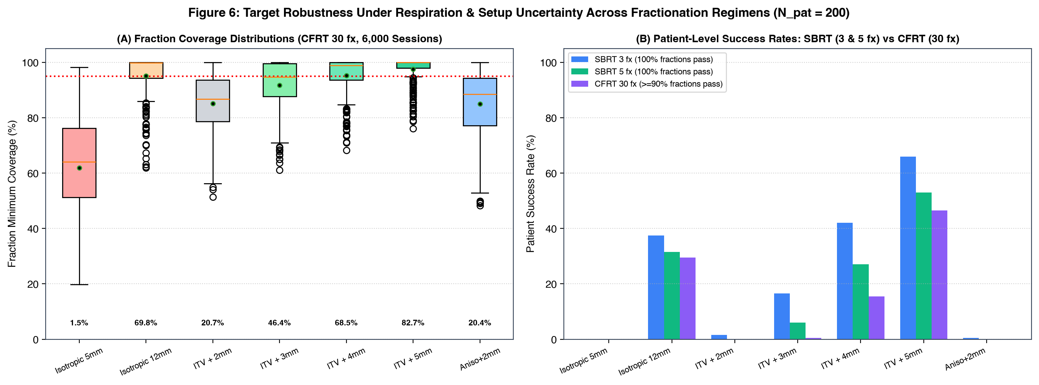
Figure 6: Multi-regimen setup uncertainty across 200 virtual patients comparing CFRT 30-fraction distribution (left) and SBRT 3-fx & 5-fx all-pass rates (right).

4. Discussion and Limitations
Why do margins that look pristine on the planning computer fail during treatment? The answer lies in the fundamental disconnect between static simulation geometry and dynamic delivery. On a 4D-CT dataset acquired under regular breathing, tight recipes such as ITV + 3 mm (22.3 cc) or Mid-pos + 2 mm (19.3 cc) appear optimal: they achieve 100.0% and 99.4% minimum target enclosure while sparing substantial lung parenchyma. That protection, however, is an illusion. Once we subjected these frozen planning envelopes to 5,000 unobserved cycles with realistic baseline drift, the ITV + 3 mm pass rate dropped to 68.3%. Add daily positioning shifts on top of breathing drift, and complete-course success under 5-fraction SBRT collapsed to 6.0%. A margin designed for a calm 15-second scan cannot withstand the physical realities of real patients on the treatment table.
This breakdown is tied directly to the statistical mechanics of hypofractionation. In standard 30-fraction radiotherapy, daily random execution shifts (sigma) blur the dose penumbra and partially cancel out over weeks of delivery. That statistical forgiveness helped ITV + 3 mm maintain an overall fraction pass rate of 46.4% in our CFRT cohort. But SBRT offers no such safety net. In a 3-fraction or 5-fraction course, an uncorrected systematic setup offset (Sigma) stays with the patient from day one to the final beam off. If that systematic displacement pushes the tumor toward the boundary of the PTV, every single fraction misses the 95% threshold. That is why a seemingly moderate fraction pass rate of 46.8% translates into a devastating patient success rate of only 6.0%.
Expanding the setup margin to ITV + 5 mm (31.0 cc) significantly restores delivery robustness: irregular breathing pass rates rebound to 96.2%, 5-fraction SBRT complete-course success climbs to 53.0%, and conventional fraction pass reaches 82.7%. These findings directly validate the 4-to-5 mm ITV-to-PTV baseline recommended in AAPM Task Group 324 Report 91.b [2]. Yet expanding margins cannot be the only line of defense. Even with 5 mm margins, geometric misses occur in 17.3% of conventional fractions and 47.0% of 5-fraction courses. Widening margins without daily volumetric verification (CBCT) simply exposes larger volumes of normal lung to toxic doses without guaranteeing coverage.
Our multi-lesion analysis revealed an important geometric size effect. Small nodules (r = 8 mm, volume 2.1 cc) were far more vulnerable to setup shifts than large tumors (r = 16 mm, volume 17.2 cc), achieving only a 29.5% full-course pass rate with ITV + 5 mm in 5-fraction SBRT, versus 60.0% for large lesions. This disparity comes down to surface-to-volume ratio: a 2 mm positional shift pushes a much larger percentage of an 8 mm sphere outside the PTV boundary than it does for a 16 mm sphere. When delivering SBRT to small peripheral pulmonary nodules, clinicians cannot rely on margins alone and must insist on rigorous pre-beam image alignment.
We acknowledge several limitations in our computational framework. First, we treated the lesion as a rigid sphere, whereas real tumors can compress, deform, and pulse with cardiac cycles [6, 13]. Second, geometric coverage ratio (CR >= 95%) serves as a spatial surrogate rather than an absorbed dose calculation; full dose accumulation involves tissue heterogeneity, beam penumbra, and electronic disequilibrium that require 4D Monte Carlo calculations [5, 7]. Third, external breathing belts or optical tracking markers can drift out of phase with internal anatomy [1, 12]. Fourth, because SBRT delivers high biological effective doses (BED), underdosing even one or two fractions can compromise local tumor control [18, 19]. Fifth, couch correction workflows were benchmarked contextually from clinical literature rather than simulated as active real-time feedback loops.

5. Conclusion
Expanding target margins to ITV + 5 mm substantially improves geometric robustness over tight 3 mm margins, raising 5-fraction SBRT complete-course success from 6.0% to 53.0% and conventional fraction pass rates from 46.4% to 82.7%. These findings strongly support the 4-to-5 mm ITV-to-PTV baseline recommended by AAPM Task Group 324 Report 91.b. Because geometric misses still affect 17.3% of conventional fractions and 47.0% of 5-fraction SBRT courses under standard setup uncertainties, margin expansion alone is insufficient. Daily volumetric image guidance (CBCT) and active respiratory motion management remain essential to ensure safe, effective lung SBRT.

Data and Code Availability
The full simulation pipeline, phantom routines, Monte Carlo algorithms, and analysis tools are open-source under the MIT license at https://github.com/anhvu7123/4d-ct-lung-motion. The random seed configurations (seed=42 for 3-fraction SBRT, seed=43 for 5-fraction SBRT, seed=44 for 30-fraction conventional radiotherapy) are declared across all modules for bitwise reproducibility.

