**Lab 5**

1. *Rules Framework.* Use the rules framework introduced in the lecture (see lesson5.lecture.factorymethods2 and the diagram below) along with the startup code provided in in lesson5.labs.prob1 to extend functionality of the UI to incorporate rule validations for a piece of software that supports adding Books and CDs to an inventory.

Implement the following rules:

*Book Rules.*  
 A. All fields must be nonempty

B. Isbn must be numeric and consist of either 10 or 13 characters

C. If Isbn has length 10, the first digit must be 0 or 1

D. If Isbn has length 13, the first 3 digits must be either 978 or 979

E. Price must be a floating point number with two decimal places

F. Price must be a number greater than 0.49.

*CD Rules.*

A. All fields must be nonempty

B. Price must be a floating point number with two decimal places

C. Price must be a number greater than 0.49.

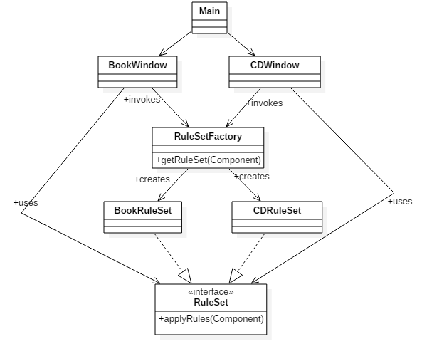

1. In class, we made progress toward a class diagram for the DuckApp, reproduced below. How will the Duck class use the FlyBehavior and QuackBehavior interfaces? Implement the diagram in Java, and make sure the answer to this question is clear in your code. To implement the methods like fly() and quack(), just print a phrase to the console, like “Flying with wings” or “Quack by squeaking.”   
     
   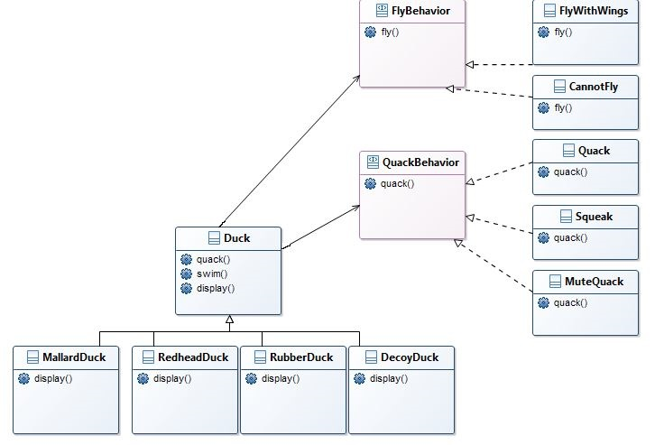To test your code, create a Main class like the following:  
     
   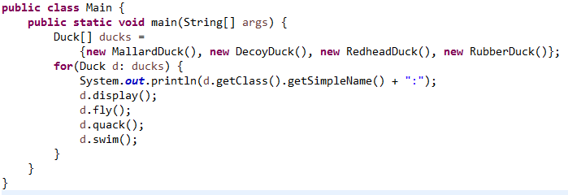

Output should look like this:

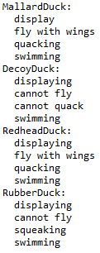

1. Create Java classes for Triangle, Rectangle, and Circle. Provide each class with a method

public double computeArea()

*Make all of these classes immutable.* (Follow the guidelines in the slides for creating this type of class – included with this lab.) Provide one constructor for each class; the constructor should accept the data necessary to specify the figure, and to compute its area. The values accepted by the constructor should be stored in (private) instance fields of the class. For example, Rectangle should have instance fields width and length, and the constructor should look like this

public Rectangle(double width, double length)

For Triangle, you may use arguments base and height. And for Circle, use radius as the constructor argument.

Whenever you create instance fields for one of these classes, provide public accessors for them (but do not provide mutators since the class is supposed to be immutable – for instance, the dimensions of a Rectangle should be read-only). For example, you will have in the Rectangle class:

private double width;   
public double getWidth() {  
 return width;  
}

Create a fourth class Main that will, in its main method, create multiple instances of these figures (you may invent your own input values), store them in a single list, and then *polymorphically* compute and write to the console the sum of the areas. In order to do this, you will need to create an appropriate interface that will be implemented by each of these geometric figures.

Typical output:

Sum of Areas = 37.38

Draw a class diagram that includes all the types mentioned in this problem.

Here are some area formulas:

Area of a rectangle = width * height

Area of a triangle = 1/2 * base * height

Area of a PI * radius * circle = radius

1. In Lesson 2, one way of maintaining a unidirectional one-many relationship was mentioned – in that approach, creation of secondary objects (in the example, these were of type Order) was controlled by limiting visibility of the constructor to *package* level. For this problem, modify the code mentioned there (which can be found in the code folder for Lab 5) so that construction of Order objects is controlled by a factory method. The guidelines given in Lesson 2 for maintaining a one-many unidirectional association are reproduced here:

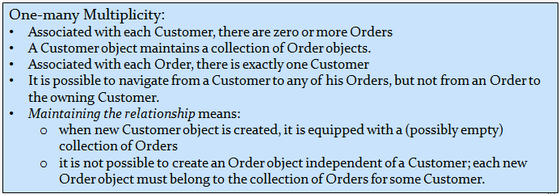

Note: An example of using a factory method to maintain an association relationship was given in the Lesson 5 slides (see lesson5.lecture.factorymethods6 for the code showing a factory method, and see lesson2.lecture.unidirectional.onemany to see another way to code a one-many unidirectional relationship).

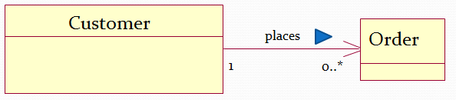

In your implementation, make sure that Customer, Order, and Item all belong to the same package and that the only way any of these classes can be instantiated is by using a factory method in a factory class (which you may wish to name as CustOrderFactory).