Combining Time Series Models to Compute Stock Prices
Anirudh Balakrishnan
Department of Applied Mathematics and Computational Science
PSG College of Technology

Abstract—Time series models find themselves in the helm of a plethora of forecasting tasks. The research involved exploring the results of combining multiple ARIMA/ARMA models into a single model which can be used to predict the closing stock prices of companies in the BSE Banking Index and BSE Auto Index. The research has been conducted on data collected from the official BSE Sensex website and consists of daily closing stock prices from January 1 2022 to November 30 2023.

Introduction
Data has been collected from the official website of the Bombay Stock Exchange. We are primarily interested in predicting the closing stock price of banks in BSE Banking Index and the companies in the BSE Auto Index. Given below is a snippet of data collected.
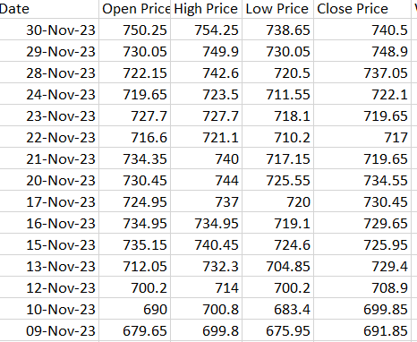
Fig. 1. Snippet of Data.

Analysis of Data using Correlation coefficient
We combine the closing stock prices into a single data-frame and compute the correlation coefficients. The correlation coefficient provides a numerical measure of the degree of association between entities and the direction of relationship. The correlation values obtained are visualized as a heatmap below.
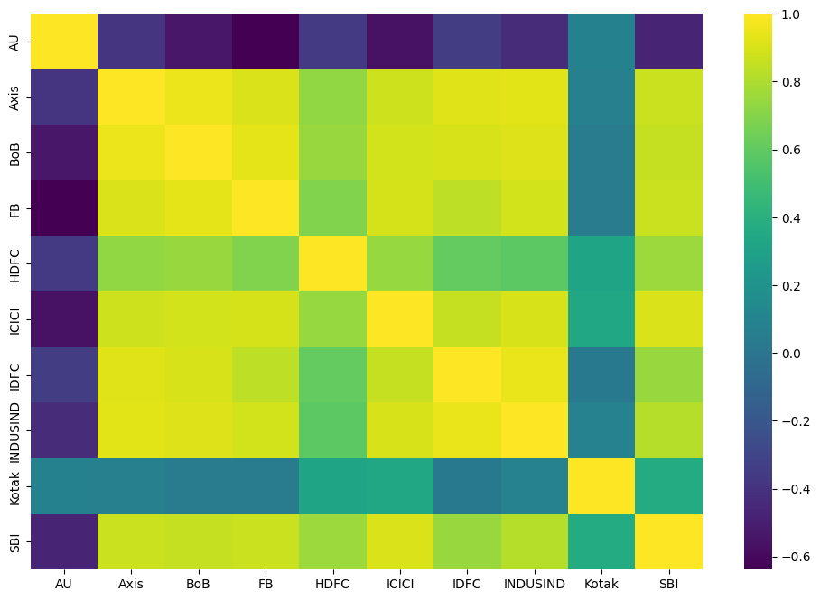
Fig 2. Correlation heatmap for BSE Banking Index

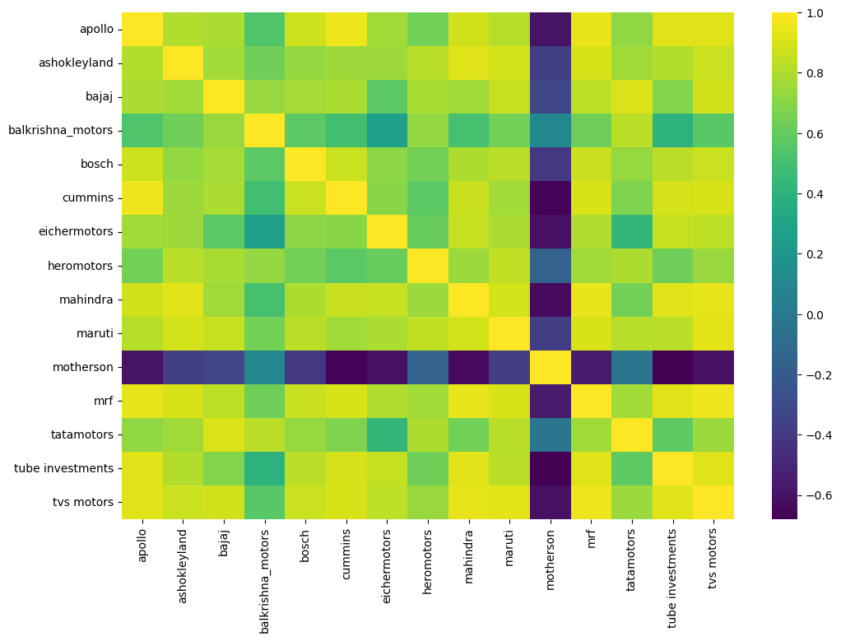
Fig 3. Correlation heatmap for BSE Banking Index

Distance metric to infer relationships between companies

d=1−ρ²

The distance metric 1−ρ² (where ρ is the correlation coefficient) is another way to quantify the relationship between the variables. It is inversely related to ρ. The distance metric is intuitive and easier to interpret. A value closer to 0 indicated that the entities are extremely similar in their behaviour and a higher value indicates stronger levels of dissimilarity. The distance metric is also robust to non-linear relationships, thus making it a better metric for comparison. The results obtained are same but the distance metric is easier to interpret. The interpretation of distance values are as given below.

Weak relationship: 0.75<=d<=1
Moderate relationship: 0.36<=d<=0.75
Strong relationship: 0<=d<=0.36

Principal Component analysis and Clustering
With a thorough analysis of the relationships, we now aimed to find as many clusters as possible from within the banks and the auto index companies. The idea is to club similar companies into a single cluster, which makes it easier to generalize the data and also ease the process of further analysis. The precursor to clustering was to perform Principal Component Analysis (PCA), to reduce the dimensions of the distance matrices. The Bankex distance matrix is 10*10 and Auto Index distance matrix is 15*15. Hence we try to reduce the dimensions.

Hierarchical Clustering
Hierarchical Clustering is a popular method used for grouping similar data points. It is a recursive approach that looks to partition the data into a hierarchy of nested clusters. There are two approaches, namely agglomerative and divisive. In agglomerative clustering, each data point is considered a cluster and points are merged iteratively based on their similarity or proximity until all data points belong to a single cluster. This is the clustering approach that we have used in this research project. We perform agglomerative clustering and results are visualized as a dendrogram.
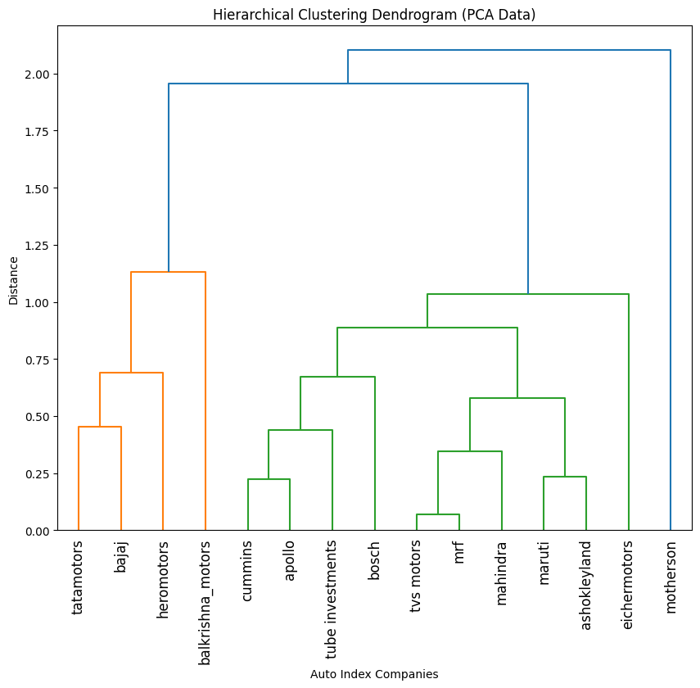
Fig.4. Dendrogram of Auto Index Data

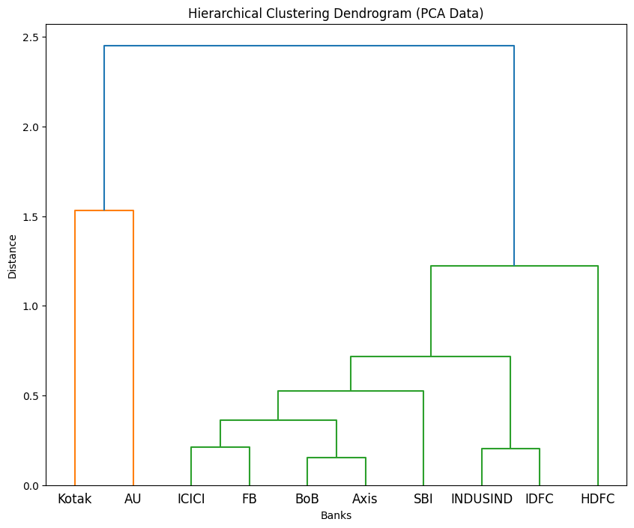
Fig.5. Dendrogram of Bankex Data

From Fig.4. we infer that TVS motors and MRF have the smallest distance between them and hence are a part of the 1st cluster that was identified. The cluster containing Tata Motors, Bajaj, Hero Motors and Balkrishna Motors seem to have a significant level of dissimilarity from the cluster containing all the other companies.
From Fig 5, we infer that Bank of Baroda and Axis Bank have the smallest distance between them and hence are a part of the 1st cluster that was identified. The cluster containing Kotak and AU Bank seem to have a significant level of dissimilarity from the cluster containing all the other banks.

Clustering Using Minimum Spanning Tree
Before delving into time series analysis, an alternate approach to cluster data points was explored, using a minimum spanning tree from the reduced data. The minimum spanning tree is constructed and we place a threshold value to obtain clusters.

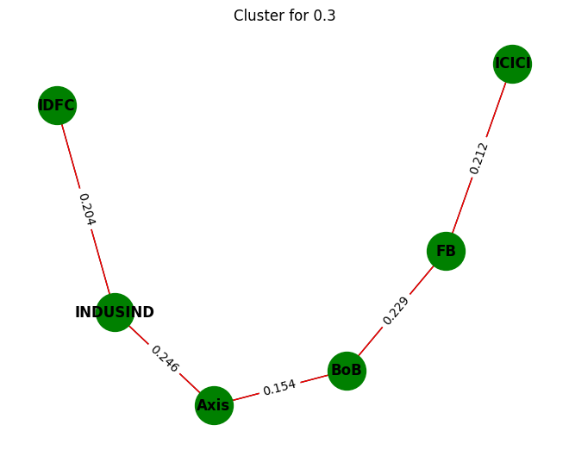
.Fig. 8. Clustering using MST for Bankex Data

From the above figure (Fig 8) we find that for a threshold of 0.3, Axis Bank, Bank of Baroda, Federal Bank, ICICI, INDUSIND and IDFC banks are identified as one cluster, with the edge weights denoting the level of similarity.

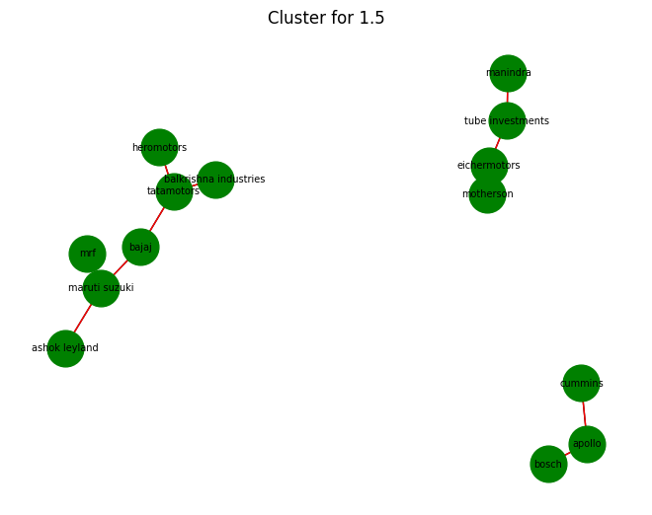
Fig 7. MST for Auto Index Data

From Fig.7 we are able to identify three different clusters for a threshold of 1.5.

The drawback of the minimum spanning tree is that it only computes the distances once and returns clusters based on the threshold whereas dendrogram uses a linkage matrix that is updated iteratively and thus is able to infer a larger number of clusters. Thus for the data we had, hierarchical clustering proved to be the better method as it provided richer insights.

Time Series ananlysis of banking index and auto index

This section describes the most vital part of the project, which is the development of time series models for the individual clusters. For the Banking Index data, we decided to have Axis bank and Bank of Baroda in one cluster, ICICI bank and Federal Bank in another and similarly IDFC bank and INDUSIND bank. All the other banks are considered to be individual clusters. Thus from 10 individual banks, we now reduce it to 7 and perform time series analysis for the 7 clusters. For the Auto Index data, we have decided to have TVS and MRF in one cluster, Maruti and Ashok Leyland in another and similarly Cummins and Apollo. All the other companies are considered individual clusters. From 15 individual companies we now reduce it to 12 and perform time series analysis for the 12 clusters.

ARMA/ARIMA models for Clusters

Before developing time series models for each cluster we need to analyse the time series components (trend, seasonality) for each cluster.

This analysis showed that the data followed a non-stationary distribution. This means that the statistical properties (mean,variance) do not remain constant with time. So we had to make the data stationary before developing ARMA(p,q) model. The data is made stationary by differencing successive points. In this case, differencing was done once, and the data was found to be stationary. It is easier to analyse stationary data since the statistical properties remain constant.

Finding the best ARMA(p,q) is an iterative procedure where we aim to find p (order of AR) and q (order of MA) within a range of (0,3). We use the AIC measire (Akaike Information Criterion) as a metric for choosing the best model. The model with the lowest AIC value is chosen to be the best fit for each cluster.

Once the time series models were obtained, the values for December 2023 were predicted and mean square error was used to evaluate the models.

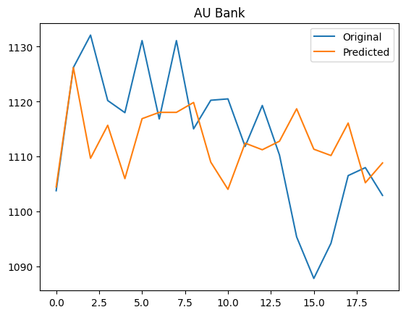
Fig. 8. Actual vs Predicted values for AU Bank

Combining the Time Series Models
The individual models for banks are combined into a single model. Similarly, all the individual auto-index models are combined into one single model. The idea is to combine each model by using different weights with the constraint that all weights should add up to 1. Essentially, we are trying to find convex combinations of all the companies. Random numbers for weights are generated and normalized. The weights are multiplied by the corresponding values predicted by each model and find the sum (for December 2023). The mean square error is computed by comparing it with the actual values for December 2023. The combination of model weights for which the mean square error is least, is considered to be the optimal weights for each model.

Results

Results for BSE Banking Index.
Cluster | Optimal Weights
Axis bank-Bank of Baroda | [0.2900908185568677, 0.1524629561451581, 0.16409131743929273, 0.12183493565498126, 0.20030569843004845, 0.0712142737736518]
Federal Bank-ICICI Bank | [0.0071210689715655836, 0.978916653618481, 0.0015543086689191403, 0.00835130339030742, 0.0004312569048826612, 0.003625408445844083]
Kotak | [0.020316246228239077, 0.00018691873677370853, 0.9732368889893044, 0.0001104447084499066, 0.0003186409448512167, 0.005830860392381636]
AU | [0.21754372427531643, 0.0013686949201799892, 0.020309733491459935, 0.3318849826022745, 0.2215067034353732, 0.20738616127539602]
HDFC | [0.02527495253781422, 0.012124815524673552, 0.1700736760180994, 0.09174695993993652, 0.6474999853155002, 0.05327961066397612]

Results for BSE Auto Index

Cluster | Optimal Weighs
TVS-MRF | [0.7696281026624708, 0.04501026450062281, 0.03428668599916671, 0.00227786772573437, 0.047679297434965504, 0.004872057381412266, 0.003986463789565384, 0.03108291048693746, 0.02199872114641309, 0.03199886500667489, 0.007178763866036623]
Maruti-Ashok Leyland | [4.277537231760183e-06, 0.9999534875623918, 1.0036425412286165e-05, 2.9748579803354468e-06, 2.97788195262637e-06, 3.776862751943092e-07, 5.588135722573045e-06, 8.274650968530693e-06, 2.494198172387867e-06, 5.507568310043062e-06, 4.00349558259615e-06]
Cummins-Apollo | [0.0019625253536085124, 0.0015903496699354108, 0.9750297840829868, 8.60333946447482e-05, 0.003833837031966539, 0.0015886253266311483, 0.000816780917533225, 0.0034376364993810634, 0.003050949209916545, 0.0046317862485598885, 0.003971692264836059]
Bajaj | [0.015796095474175053, 0.006142189162550027, 0.004511965541722955, 0.7774972451267883, 0.023826714562142706, 0.04379958664819511, 0.026389149812022863, 0.04411258617386931, 0.015390404640585127, 0.03877824971843759, 0.0037558131395110227]
Balkrishna Motors | [0.009958228750747483, 0.041439083937512305, 0.028643090569681843, 0.02867301694778767, 0.7432134707519004, 0.0024420686241396583, 0.036335781087989745, 0.00044537675675865844, 0.030787860980253084, 0.020103760193174888, 0.05795826140005418]

Acknowledgment
I would like to sincerely express my gratitude to Dr Sai Sundara Krishnan G for his valuable guidance throughout the course of the project. His insights have truly helped me understand the nuances of time series analysis that has helped me in this research.

References
- Richard I. Levin, David S. Rubin, Sanjay Rastogi, Masood Hussain Siddiqui, “Statistics for Management Seventh Edition.”
- Trevor Hastie, Robert Tibshirani and Jerome Friedman, “The elements of Statistical Learning”, Springer, 2013.
.
.

