**Table of contents**

[How to create a simple Report, testing your reports. 2](#_Toc339323949)

[How to configure the Engine 4](#_Toc339323950)

[A Slightly Harder Report, With Repeating Rows 9](#_Toc339323951)

[Repeating Cells, for variable Column number 12](#_Toc339323952)

[Adding Images to your report 14](#_Toc339323953)

[Adding Expressions 15](#_Toc339323954)

[Control break reports 19](#_Toc339323955)

# How to create a simple Report, testing your reports

1st of all, you need to know the structure of the data XML your report will consume. Take a look at the example in the image. The values that the report will try to consume are denoted by a hash character (#) commented with the node name, in the example [SubNode, day, month, year]

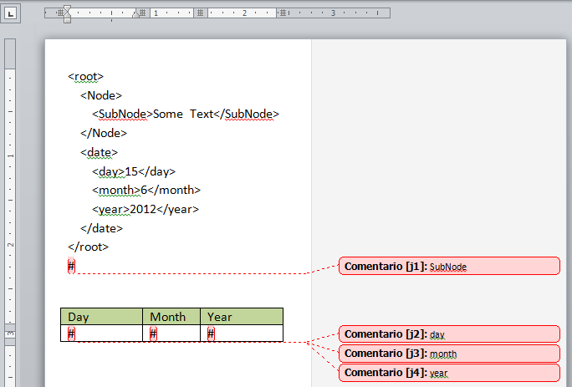

The previous template should render something like:

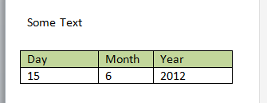

To achieve that, we need to save the word document in Word 2003 XML format (WordML) (ReportStylesheet.xml). Once you saved the report template in WordML you can proceed to save it again but this time applying the transformation to generate the actual XSLT report template (ReportStylesheet.xsl) *follow the steps in the image*.

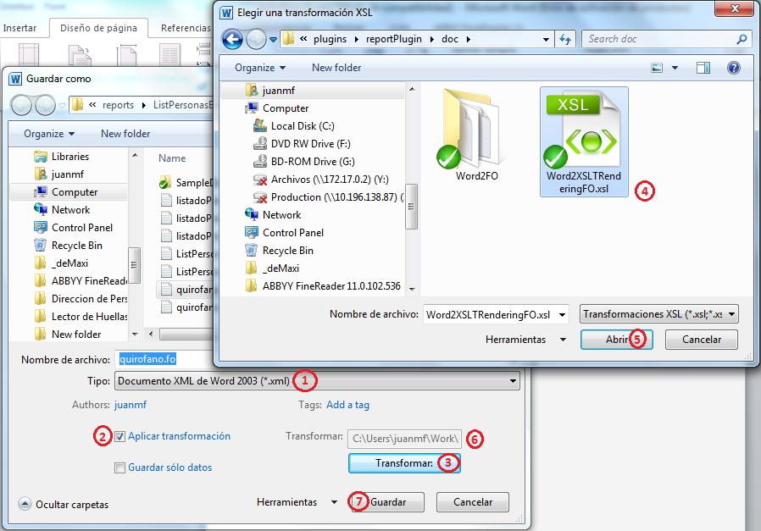

|  |
| --- |
| *Note that Word2FO directory* ***is not*** *packaged with this tool, you need to download it from RenderX in the Free tools Section* *at*<http://www.renderx.com/download/shop.html> *and decompress it next to Wor2XSLTRenderingFO.xsl otherwise it will complain about unsatisfied dependencies.* |

# How to configure the Engine

Once you have ReportStylesheet.xsl saved, you need to add it to the new report configuration in conjunction with a provider method that must generate the XML data that will be handed over to the Report stylesheet.

|  |
| --- |
| *C:\Program Files (x86)\Microsoft Office\MEDIA\OFFICE14\AutoShap\BD18217_.wmfThe provider method is optional, if you use the engine as a library instead of as a controller with its own route, you can generate the XML data as you wish. More on that later…* |

Provider method example follows:

|  |
| --- |
| // projects\src\plugins\reportPlugin\lib\RenderStep1\LogicalScreenCallbacks.php  /\*\*  \* This class helps in the Step1 of a three steps Process.  \*  \* The process consists of the following steps:  \*  \* Step 1 consists in generating the XML based raw data for the report. **RawXMLData**  \* Step 2 consists in merging this raw data with a XSL-FO template to give it  \* the presentation information. XSL-FO acts as an intermediate language used  \* to render the final report in any format with a last transformation.**XSL-FO**  \* Step 3 consists on rendering the XSL-FO representation (the intermediate  \* language) of the report to the desired output format. **FinalReport**  \*  \* This class should be used to add the methods that creates or access the  \* RawXMLData and returns it to be processed in Step2.  \*  \* To help extract data from database in XML format we have a Doctrine XML Hydrator  \* you can see a usage example in LogicalScreenCallbacks::helloworld().  \*  \* @author Juan Manuel Fernandez <juanmf@gmail.com>  \* @see %sf\_plugins\_dir%/reportPlugin/config/sfExportConfig.yml  \*/  class **LogicalScreenCallbacks**  {  /\*\*  \* This method generates the xml data for the 'How to create a simple Report'  \* topic of the Report Engine tutorial  \*  \*/  public static function **howToSimple**()  {  $xml = <<<XML  <root>  <Node>  <SubNode>Some Text</SubNode>  </Node>  <date>  <day>15</day>  <month>6</month>  <year>2012</year>  </date>  </root>  XML;  $q = new DOMDocument();  $q->loadXML($xml);  return $q;  }  } |

Now that we have both, **data** and **report Stylesheet** we need to tell the report engine that they go together. For that we use a YAML configuration file that associates the Stylesheet with the data provider method, *note that the callback is a* [ClassName, methodName] *notation*:

|  |
| --- |
| # project\src\apps\admin\config\sfExportConfig.yml  reports:  SimpleReport:  name: Simple Report  step1: # Cooking Data, optional Step.  logical\_screen\_callback: [**LogicalScreenCallbacks**, **howToSimple**]  # e.g. [p1, p2, ..] using this key, the action can pass parameters too.  callback\_params: ~  step2: # Merging data and Report XSLT Stylesheet  structure:  default:  layout:  # No need to know this for now.  class: ~  # An XPath expression selecting data nodes for this view.  nodes: **'/root'**  xslt\_structure:  # A XML to FO transformation adding structure. Path from %sf\_app\_dir%  sheet: '**/templates/reports/SimpleReport/SimpleReport.xsl.xml**'  # Associative array with relevant parameters for this xslt.  params: {}  xslt\_style:  # A FO to FO transformation adding style. Path from %sf\_app\_dir%  sheet: ~  # Associative array with relevant parameters for this xslt.  params: {} |

The files should be placed accordingly, as described in the configuration. Note that the paths in config are relative to the *apps* directory, in the following image you can see the relevant files.

File hierarchy:

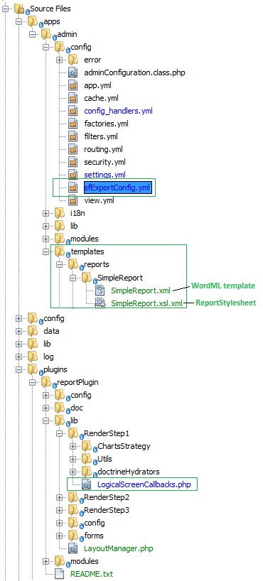

Then you go to the “http://**virtualHost.local/index.php/export**” route to see the report selection form, which now contains the new report descriptor, remember that *Simple Report* is the **name** configuration value:

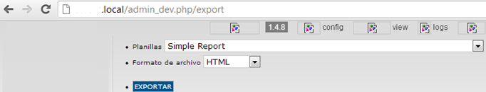

If you click “EXPORTAR” you get this:

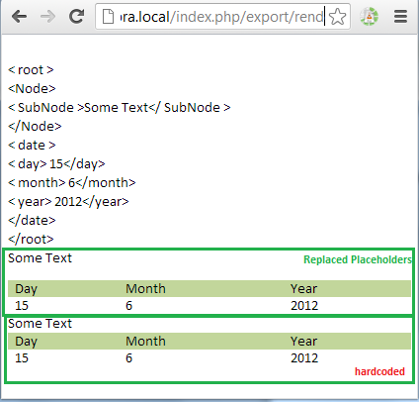

|  |
| --- |
| ***!*** *Note: Chrome doesn’t show borders if they are thinner than “1pt;”, but Firefox’d show them and they are in the HTML markup.* |

If you select PDF and you have ApacheFOP webservice running (or the local executable, which still needs a calling rederer, @see Step3);

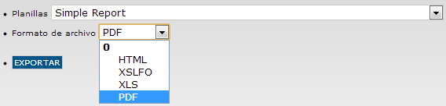

You’d get this (*note that the 2nd table is hardcoded in the report template, the 1st hast the placeHolders*):

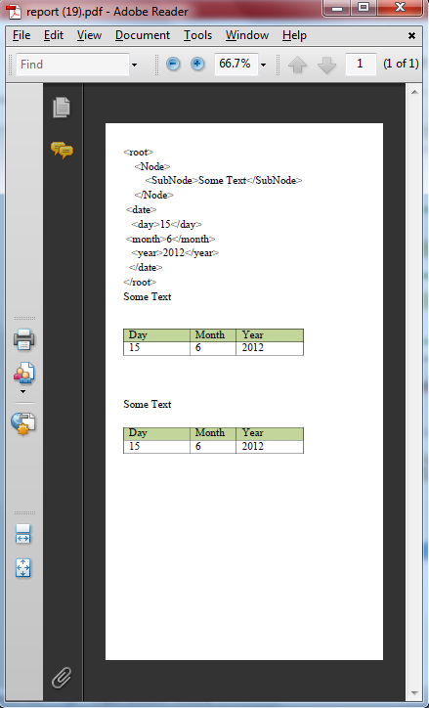

# A Slightly Harder Report, With Repeating Rows

The only difference (*besides the irrelevant fact that I removed the hardcoded “expected” table*) with the *Simple Report* exampleis that this time I added a new Comment surrounding a **leading** **white space in the 1st cell** with a command that gets interpreted by the modified Word2FO.xsl stylesheet and generates a new XSLT template that will repeat for each **date** and will be called from inside the table body. It’s important to know that whenever you use a repeat command, either **repeatTable** , **repeatRow** or **repeatCell**, the context for the repeating block (table, Row or Cell) is the current repeating node being iterated. In the following example that’d be **1st date** first, **2nd date** after and finally **3rd date** node. Therefor the **day**, **month** and **year** node selectors in the following Word Comments are relative to their **date ancestor** (that also happens to be parent, but that doesn’t matter).

**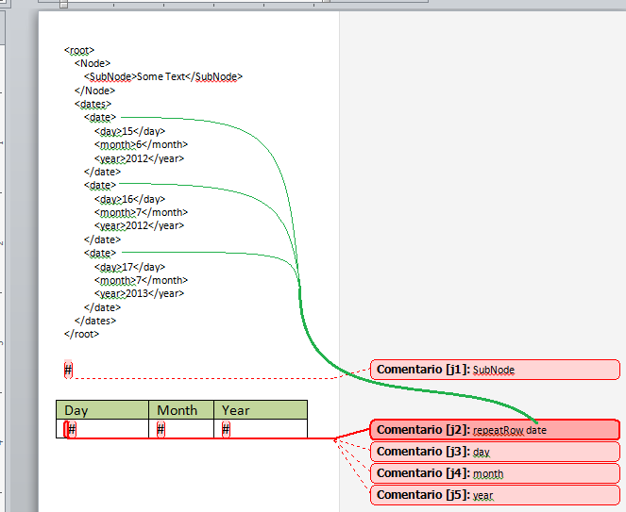**

When you select the HTML output you get this:

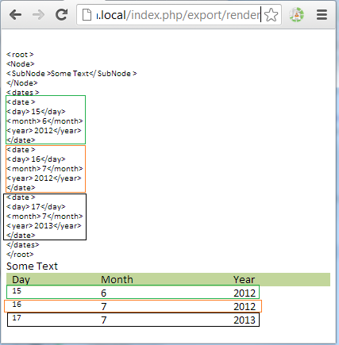

For the PDF output of the same report you get:

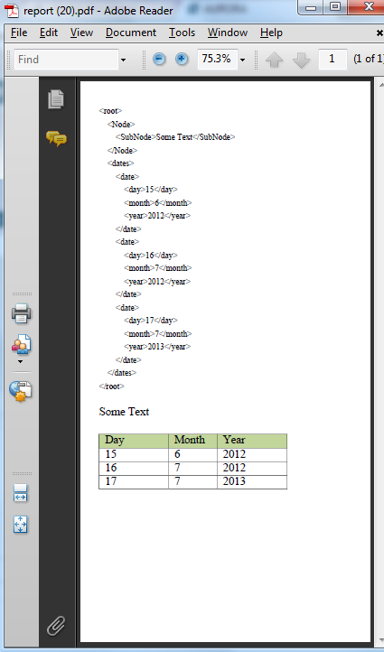

As you can see, page metrics are preserved in the PDF output, margins, page size and orientation, etc.

# Repeating Cells, for variable Column number

Now we’ll make cells repetitive, inside repetitive columns, for that I changed the data so we have a matrix of days, with an XPath view like this “//row/Column/day“

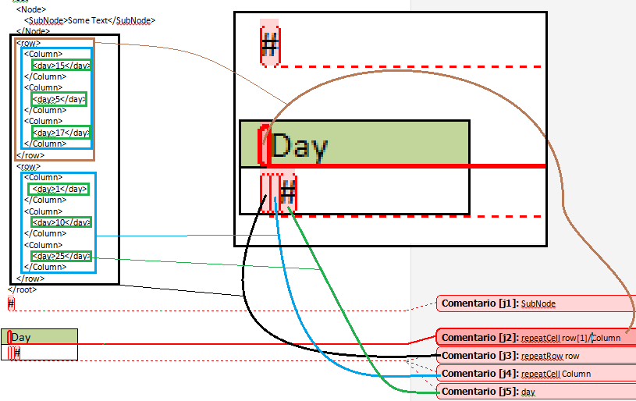

The PDF output of this Report StyleSheet looks like this.

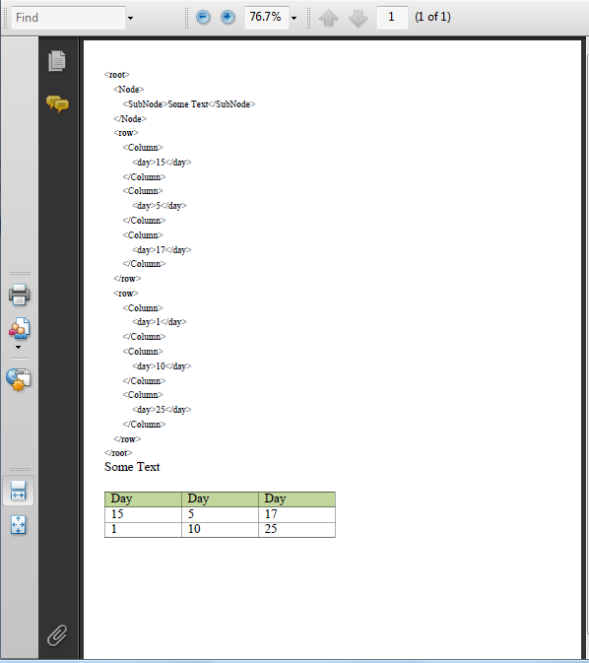

As you can see, Header cells repeated three times, once for each **Column** node inside 1st **row** (that’s “repeatCell row[1]/Column”). The two body rows obey to the two **row** nodes inside **root** (that’s “repeatRow row”). On each row in turn, we get three cells (that’s “repeatCell Column”), this works because in a current **row** context, XPath finds only 3 **Column** nodes.

Obviously, these repetitive cells would also work without repetitive rows. This example shows both toghether.

# Adding Images to your report

As with commented “**#”** placeholder you can add commented images to your report template and they will be converted into an **<fo:external-graphic >** with the contents taken from a XML node containinf a base64 encoded image, denoted by the comment, see the illustrative pic. The size and location of the image will be preserved, but the content will be replaced by your data as selected by the XPath expression “.**//imageNode**” with **<root>** as context.

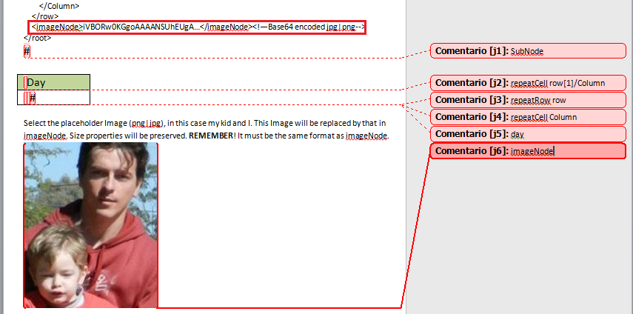

Then you must provide some relevant image in **<imageNode>** you can use pChart for instance, as follows:

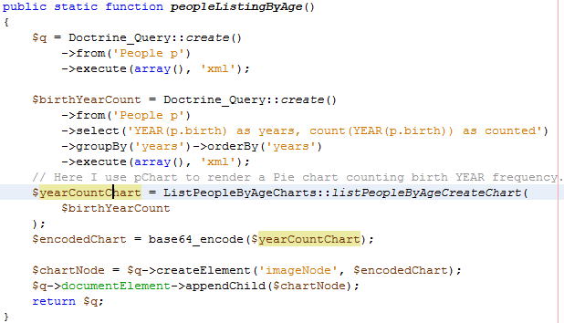

# Adding Expressions

Sometimes you might need to summarize or count some data nodes, for this trivial operations, it might be easier to process those nodes in the report template (with XSLT and XPaht) rather than adding calculated data to your raw XML data structure. By default, commented “#” are considered simple Xpath expressions, like node names or relative routes, relative to **<root>** or any repetitive table row or cell context.

So if you put someNode in the comment it will match any someNode element from the current context down. Originally current context is <root> but when you use **repeatTable, repeatRow** or **repeatCell** the node name you use as the repeat parameter will be the context for the expressions inside the repetitive structure e.g. when we used “**repeatRow date”** the context for each **day**, **month** and **year** inside a row is the respective date node.

Let’s consider the following template:

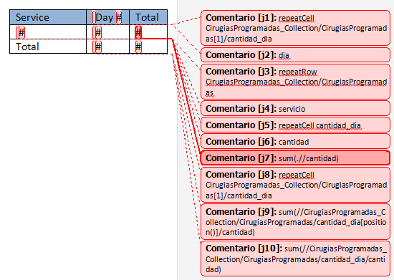

As you can see, it has a lot of directives for such a little table. This is because this little table will expand in rows (for each **service**) and columns (for each **day** in each **service** context) and also will summarize each row totals and a global total value, without getting them from the raw XML data, but calculating it with XPath expressions, directly input in the word comments.

These expressions are designed to query the following raw data XML:

|  |
| --- |
| <root>  <CirugiasProgramadas\_Collection>  <CirugiasProgramadas> <!--Scheduled surgery [1]-->  <servicio>**Cardiología**</servicio> <!--1st Service name-->  <cantidad\_dia>  <cantidad>**0**</cantidad> <!--surgery count-->  <dia>**01**</dia> <!--day-->  </cantidad\_dia>  <cantidad\_dia>  <cantidad>**0**</cantidad> <!--surgery count-->  <dia>**02**</dia> <!--day-->  </cantidad\_dia>  :::  <cantidad\_dia>  <cantidad>**1**</cantidad> <!--surgery count-->  <dia>**30**</dia> <!--30th day of the month-->  </cantidad\_dia>  </CirugiasProgramadas>  :::  <CirugiasProgramadas> <!--Scheduled surgery [1]-->  <servicio>**Urología**</servicio> <!--5th Service name-->  <cantidad\_dia>  <cantidad>**0**</cantidad> <!--surgery count-->  <dia>**01**</dia> <!--day-->  </cantidad\_dia>  <cantidad\_dia>  <cantidad>**0**</cantidad> <!--surgery count-->  <dia>**02**</dia> <!--day-->  </cantidad\_dia>  :::  <cantidad\_dia>  <cantidad>**1**</cantidad> <!--surgery count-->  <dia>**30**</dia> <!--30th day of the month-->  </cantidad\_dia>  </CirugiasProgramadas>  </CirugiasProgramadas\_Collection>  </root> |

I’ll explain each word comment so you get the idea:

**J1: repeatCell CirugiasProgramadas\_Collection/CirugiasProgramadas[1]/cantidad\_dia**

Will match the 31 **cantidad\_dia** nodes inside the 1st **CirugiasProgramadas,** thus repeating the header cell “Day #” 31 times, each time with a different **cantidad\_dia** as context

**J2: dia**

With **cantidad\_dia** as context, matches the only **dia** node it has, for each “Day #” repetition.

**J3: repeatRow CirugiasProgramadas\_Collection/CirugiasProgramadas**

Will match all **CirugiasProgramadas** (we have 5) inside **CirugiasProgramadas\_Collection,** thus repeating body rows 5 times, with a different **CirugiasProgramadas** node as context each time.

**J4: servicio**

With **CirugiasProgramadas** as context it will match the only **servicio** node inside it and fill the service cell for each row.

**J5: repeatCell cantidad\_dia**

With **CirugiasProgramadas** (since we are in the repeating row) as context it will match the 31 **cantidad\_dia** nodes inside it and repeat the cell 31 times, adding 31 columns.

**J6: cantidad**

With **cantidad\_dia** (since we are in the repeating cell) as context it will match the only **cantidad** node inside it and fill the cell, replacing “#” with **cantidad** value.

**J7: sum(.//cantidad)**

In the final row cell, with **CirugiasProgramadas** as context it will sum all **cantidad** nodes it finds inside **CirugiasProgramadas** calculating the total amount of surgeries for the current context service. **(\*1 generated template hand editing needed)**

**J8: repeatCell CirugiasProgramadas\_Collection/CirugiasProgramadas[1]/cantidad\_dia**

Will match the 31 **cantidad\_dia** nodes inside the 1st **CirugiasProgramadas,** thus repeating the last row cell 31 times. Note that this time, we just use it for repeating, not for filling with any data.

**J9: sum(//CirugiasProgramadas\_Collection/CirugiasProgramadas/cantidad\_dia[position()]/cantidad)**

Inside each repeating cell in the last row (Totals row) we don’t use the context node, as we need to summarize by column (i.e. one **cantidad** node on each row, and our context is only one row). We use an absolute XPath expression to summarize, for the current column, all **cantidad**, that’s all the Nth **cantidad** in all rows, N being the current column. **(\*2 generated template hand editing needed)**

**J10: sum(//CirugiasProgramadas\_Collection/CirugiasProgramadas/cantidad\_dia/cantidad)**

This is a global absolute expression, summarizing all **cantidad** nodes in the data XML, the Total Total. **(\*1 generated template hand editing needed)**

|  |
| --- |
| **(\*1)** For XPath Expressions that are not compatible (or produce unexpected behavior) with a “.//” prefix (so far hardcoded in the template generation) like sum(), count(), “//”, etc. you need to tweak the generated XSLT template by hand as follows:  Locate the broken expression, for **J7** it will look as follows:  **<xsl:value-of select=”.//sum(.//cantidad)”>**  Edit it (remove “.//” prefix) so it looks like:  **<xsl:value-of select=”sum(.//cantidad)”>**  **(\*2)** For XPath Expressions that need to account for the position of the node currently being processed, like in **J9** where we need to get all **cantidad** nodes that are the Nth child of their parent row (see the useless **cantidad\_dia[position()]** part). It doesn’t produce the expected result, as the **[position()]** sub expression is not relative to the cell context, but to the **cantidad\_dia** being traversed by the XPath expression itself, i.e. every **cantidad\_dia** in turn.  The resulting expression looks like follows:  **<xsl:value-of select= ”.//sum(//CirugiasProgramadas\_Collection/CirugiasProgramadas/cantidad\_dia[position()]/cantidad)”>**  Edit it so it looks like:  **<xsl:variable name="pos" select="position()" />**  **<xsl:value-of select=**  **"sum(//CirugiasProgramadas\_Collection/CirugiasProgramadas/cantidad\_dia[$pos = position()]/cantidad)"/>**  (note the **cantidad\_dia[position()]** sub expression turned into **cantidad\_dia[$pos = position()]** and we added a new variable **$pos** that holds the current context cell’s position before entering into the XPath expression)  *Of course, you might as well add this value as rad data inside the input XML at runtime, but you have more options, consider also that, obviously, these hand editing changes are overridden if you re-generate the template.* |

And the resulting report looks as follows (this is not the exact same template but it has identical logic and same data XML input):

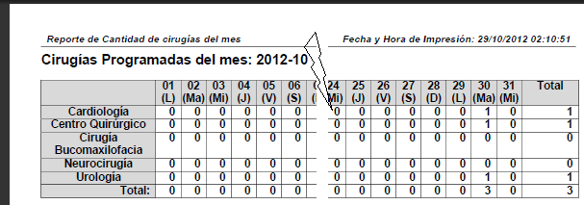

# Control break reports

By nesting any number of tables and abusing of the repeatTable command, on borderless tables, in the word Comments you can get Control Break reports of any depth.

**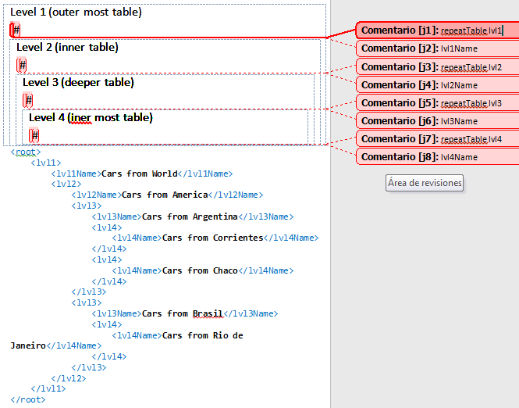**

Two minutes later, after:

* Saving the new template, optional, and re-saving as XSLT using the Word2FO transformation, in the templates directory.
* Creating dummy method in LogicalscreenCalback:: howToControlBreak() that returns the shown XML.
* Editing reports Engine configuration to call howToControlBreak() and then render the new XSLT template.
* Clearing symfony cache and loading the export module.

I could select the new Control Break report from the menu and render it as HTML or PDF.

