AnkitaSadatpure_2FEB2026

What is Cloud Computing?

Cloud computing means using servers, storage, and software over the internet instead of your own computer or physical servers.

IaaS vs PaaS vs SaaS
IaaS (Infrastructure as a Service)
You get virtual machines, storage, and networks.
You manage OS, apps, and data.
Example: AWS EC2
PaaS (Platform as a Service)
You get a ready platform to build and run apps.
No need to manage servers.
Example: AWS Elastic Beanstalk
SaaS (Software as a Service)
You use ready-made software online.
No installation or maintenance.
Example: Gmail

Why AWS?
AWS is popular because it is secure, scalable, reliable, and pay-as-you-go, with many services and global availability.

AWS Global Infrastructure

AWS has data centers all over the world (Regions & Availability Zones) to provide fast, secure, and reliable services.

AWS Regions
A Region is a geographical area where AWS has data centers.
Each Region is independent (separate country or area).
Example:
ap-south-1 → Mumbai
us-east-1 → North Virginia
You choose a Region based on latency, cost, and compliance.

AWS Availability Zones (AZs)
An Availability Zone (AZ) is a data center inside a Region.
Each Region has multiple AZs (usually 2–6).
Example:
ap-south-1a
ap-south-1b
ap-south-1c
AZs are physically separate to protect against failures.

Simple Difference
Region = City
AZ = Buildings in that city

Why Regions & AZs are Important?
High availability
Fault tolerance
Disaster recovery
If one AZ fails, your app still runs in another AZ
Aws Console
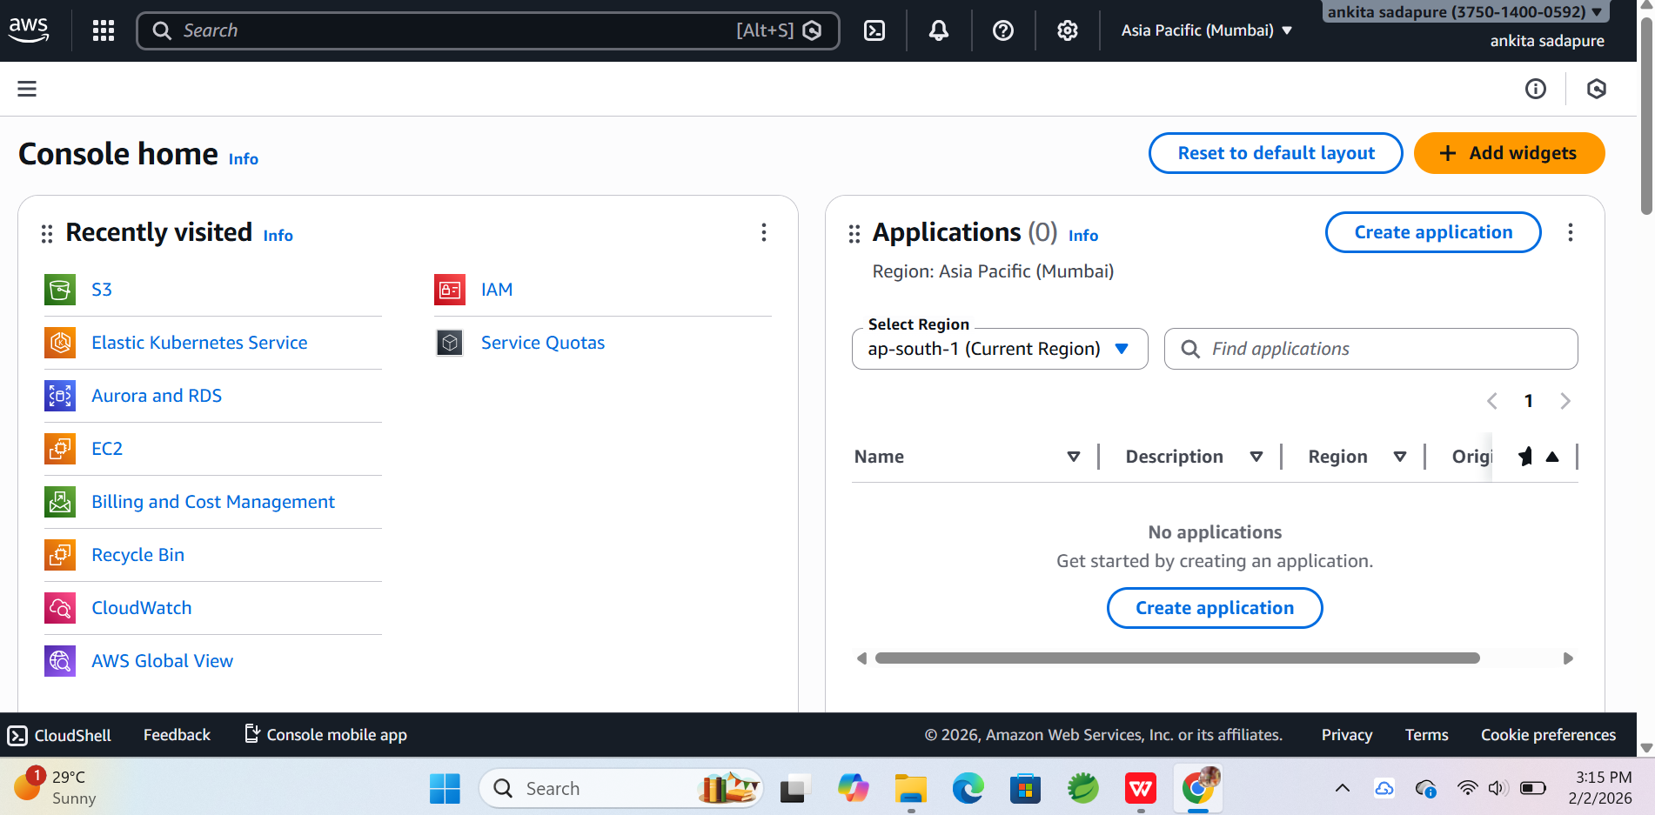
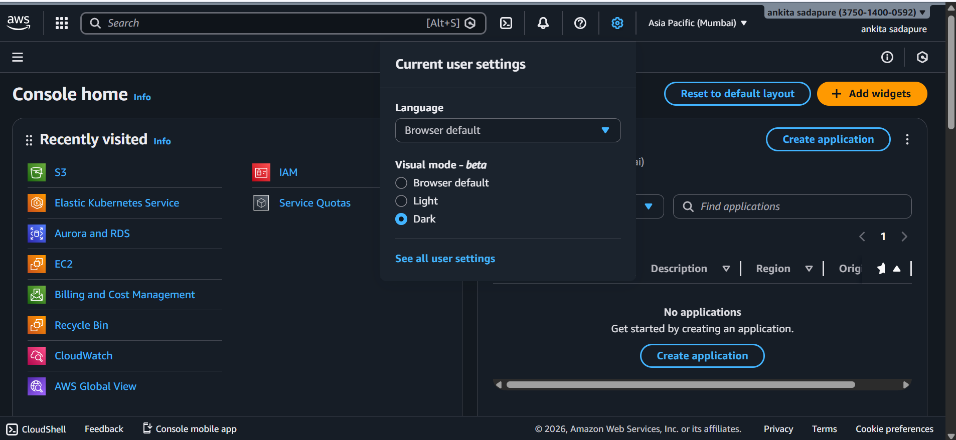
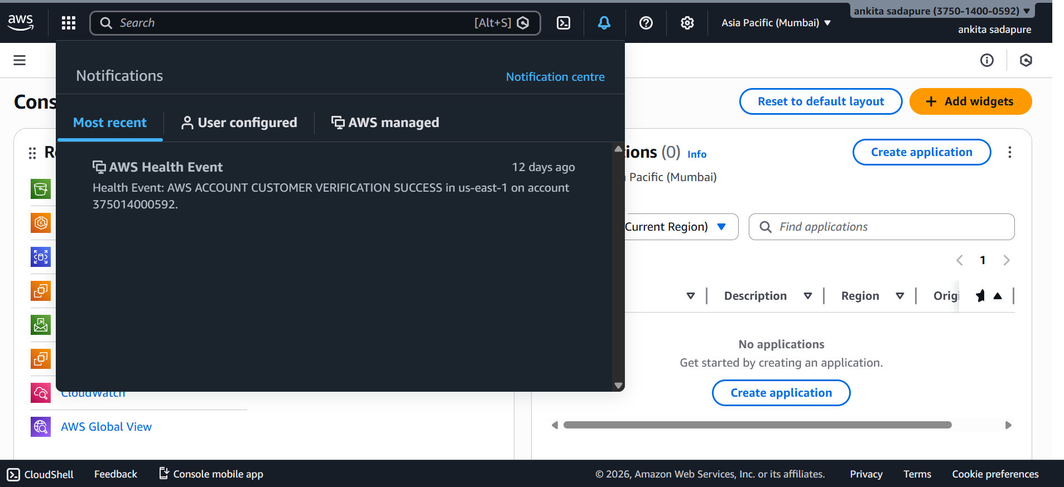
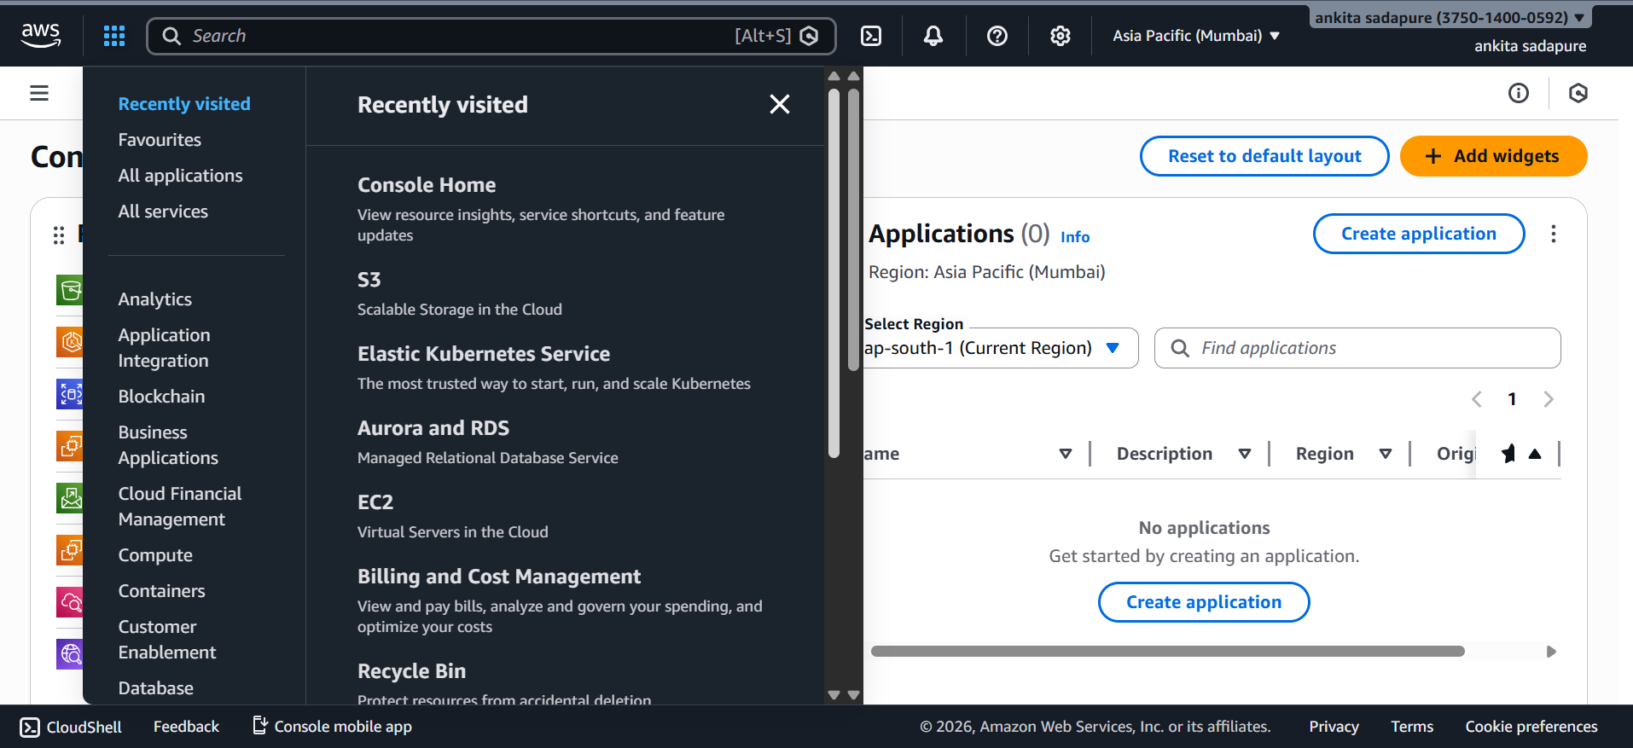
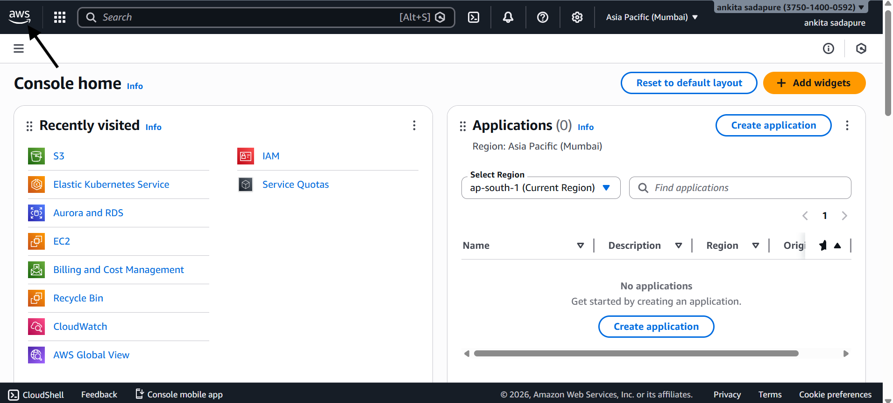
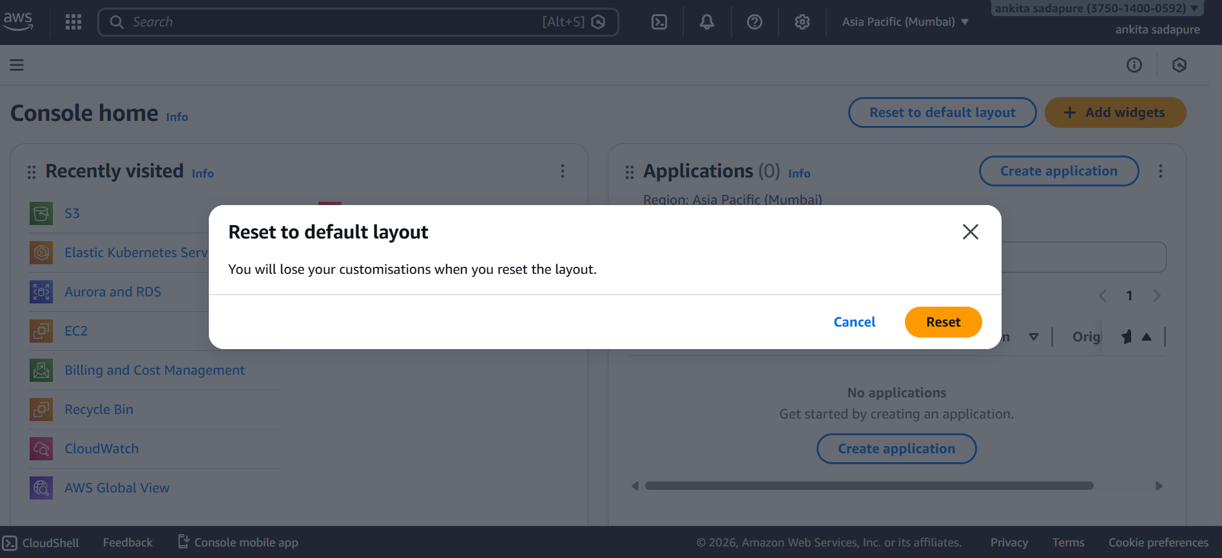
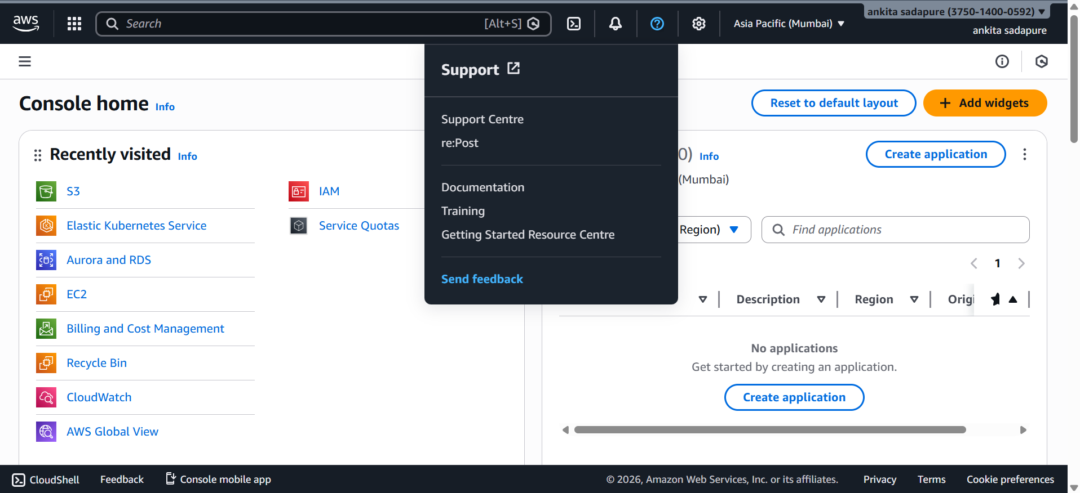
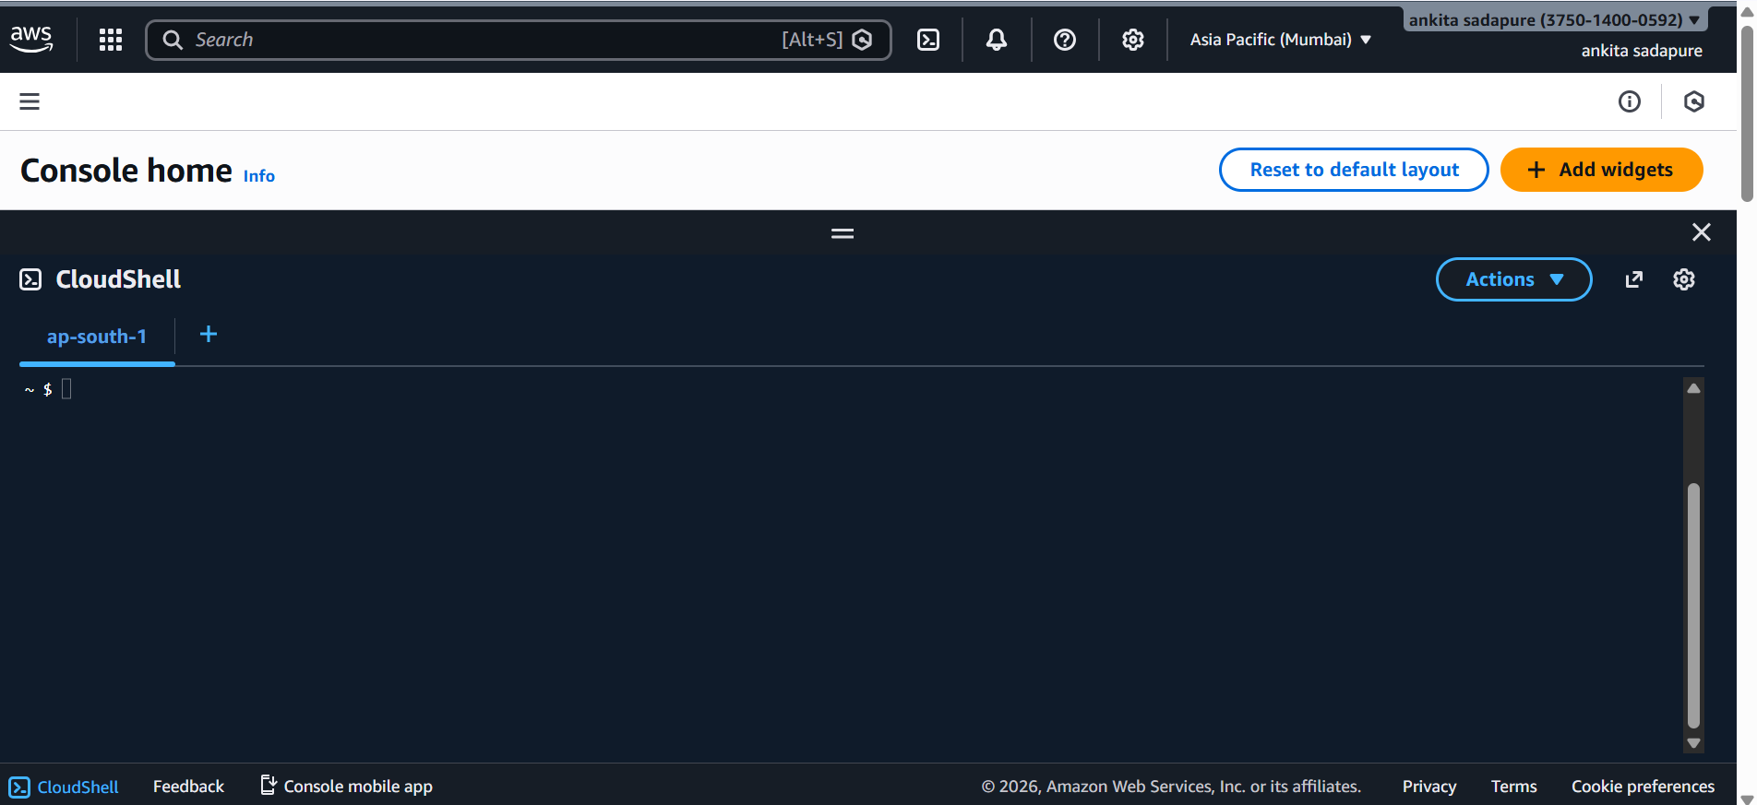
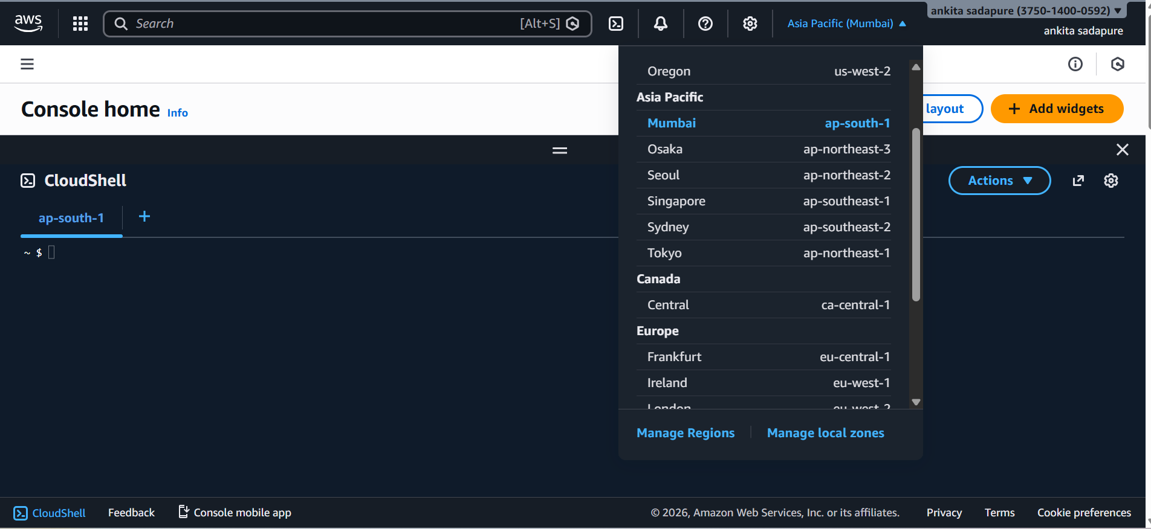
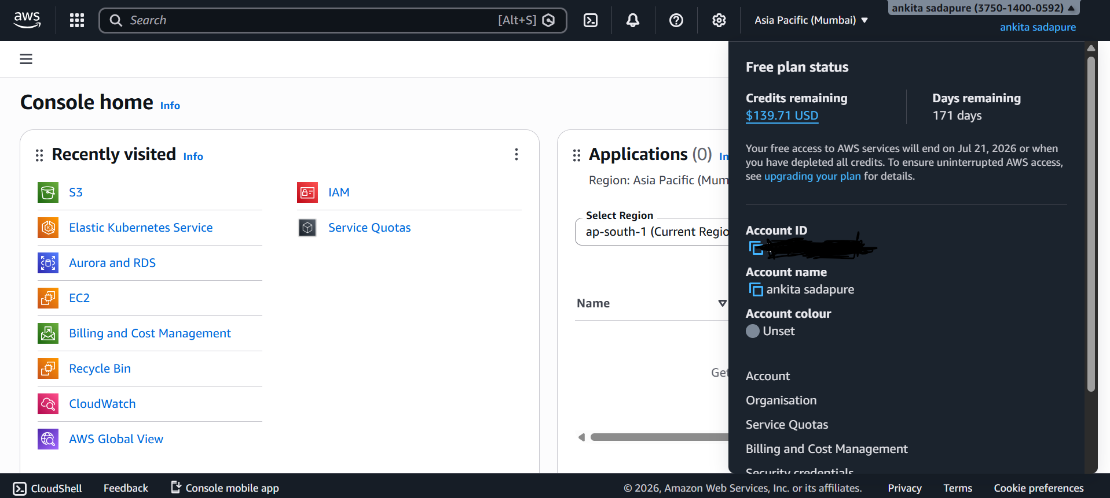
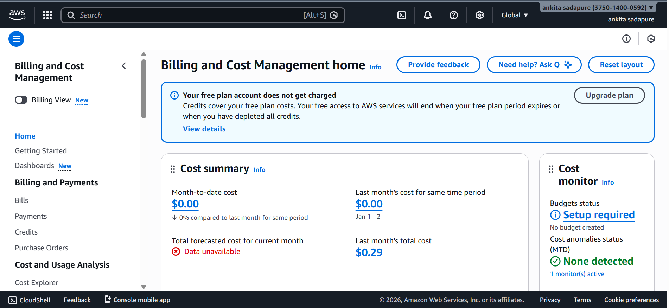
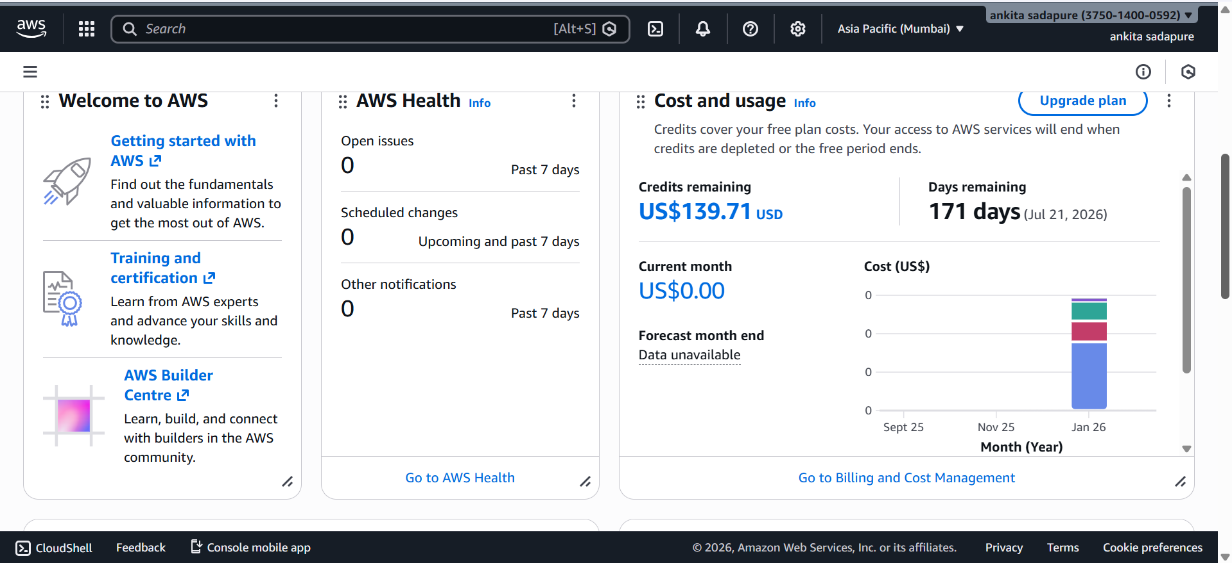
User_Setting
