25feb2026@AnkitaSadatpure

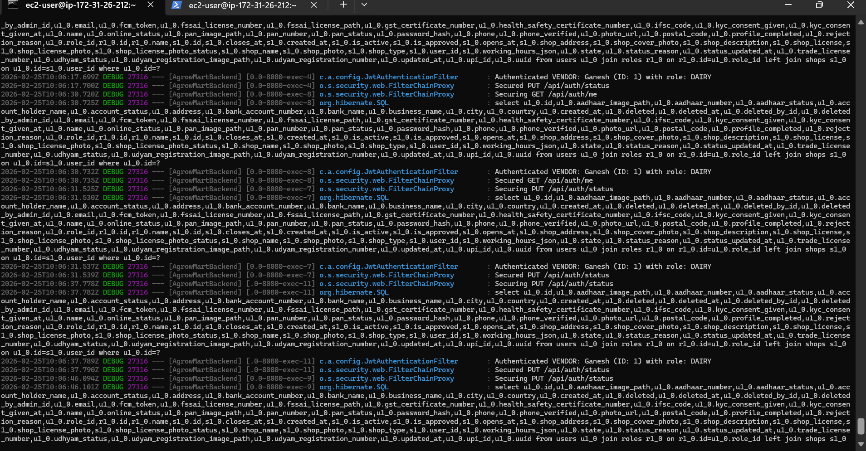

we are running Spring Boot JAR on EC2, here is the proper way to undestand.

Simulate Error

Method 1: Change DB Name
Open your application.properties:
nano application.properties
Change database name to wrong one:
spring.datasource.url=jdbc:mysql://your-rds-endpoint:3306/agrowmart
Save and run:
It will throw Hibernate connection error.

Method 2: Stop RDS
Go to: Amazon RDS
Stop your DB instance
Then start your app → it will fail.

Find Logs
Depends how you run app.
Just run:
Error will show directly in terminal.
nohup java -jar AgrowMart-0.0.1-SNAPSHOT.jar > app.log 2>&1 &
Then check logs:
tail -f app.log

Fix Issue
Example: Database name wrong
Open: nano application.properties
Correct:
spring.datasource.url=jdbc:mysql://correct-endpoint:3306/agrow
spring.datasource.username=yourusername
spring.datasource.password=yourpassword
Save and restart:

