4_Feb2026@AnkitaSadatpure

EC2 Instance Types
EC2 instance types define the CPU, memory, storage, and networking capacity of an EC2 instance.
They are chosen based on the type of workload (e.g., general purpose, compute optimized).
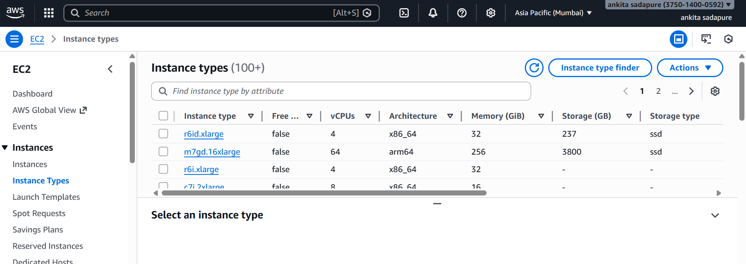

Key Pair
A key pair is used to securely log in to an EC2 instance.
It consists of a 1. public key (stored in AWS) 2. private key (kept by the user).

Security Groups
Security groups act as a virtual firewall for EC2 instances.
They control inbound and outbound traffic using rules.

Elastic IP
An Elastic IP is a static public IPv4 address provided by AWS.
It allows you to keep the same IP even if the EC2 instance is stopped or restarted.

Launch an instance
