#24FEb@AnkitaSadatpure

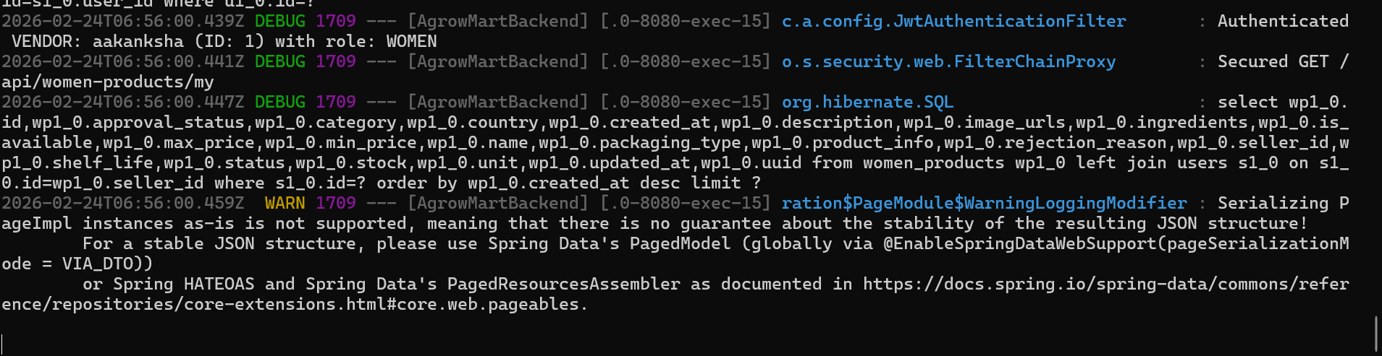

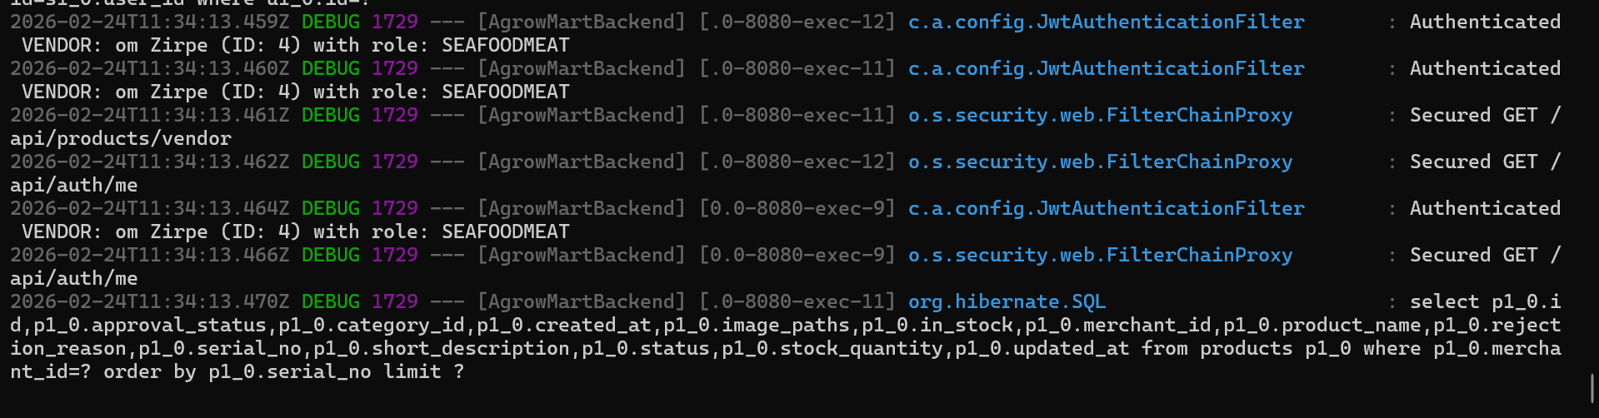

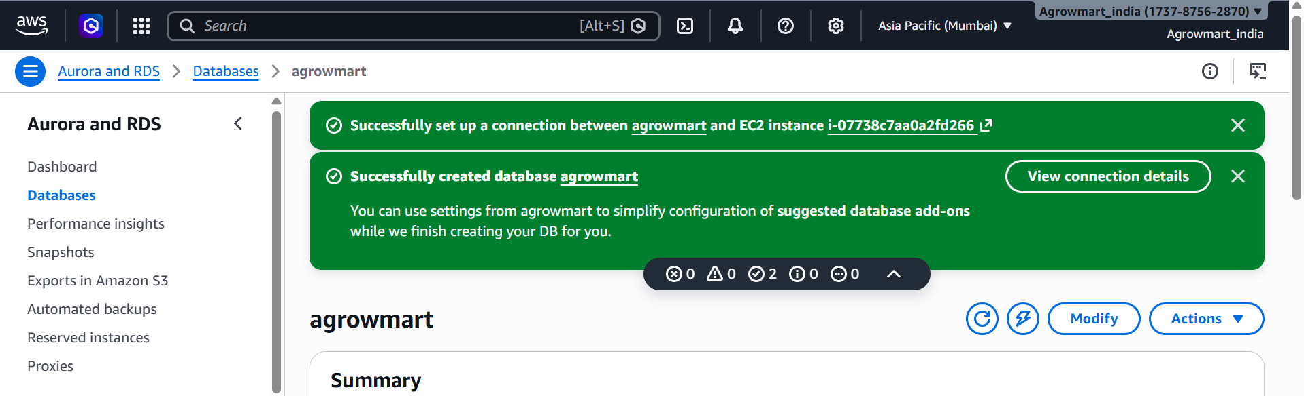

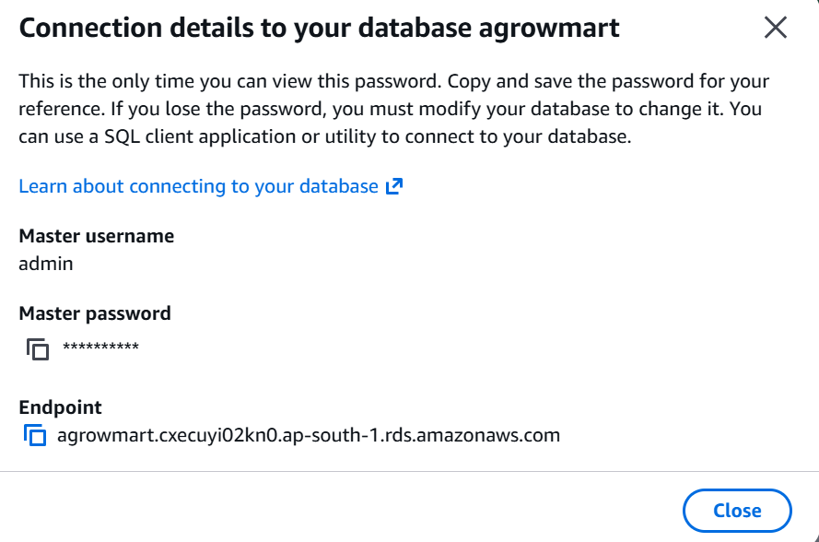

RDS Security Group:
Allow inbound:
Type: MySQL/Aurora
Port: 3306

