#20Feb2026@AnkitaSadatpure

Create rds and ec2 instace

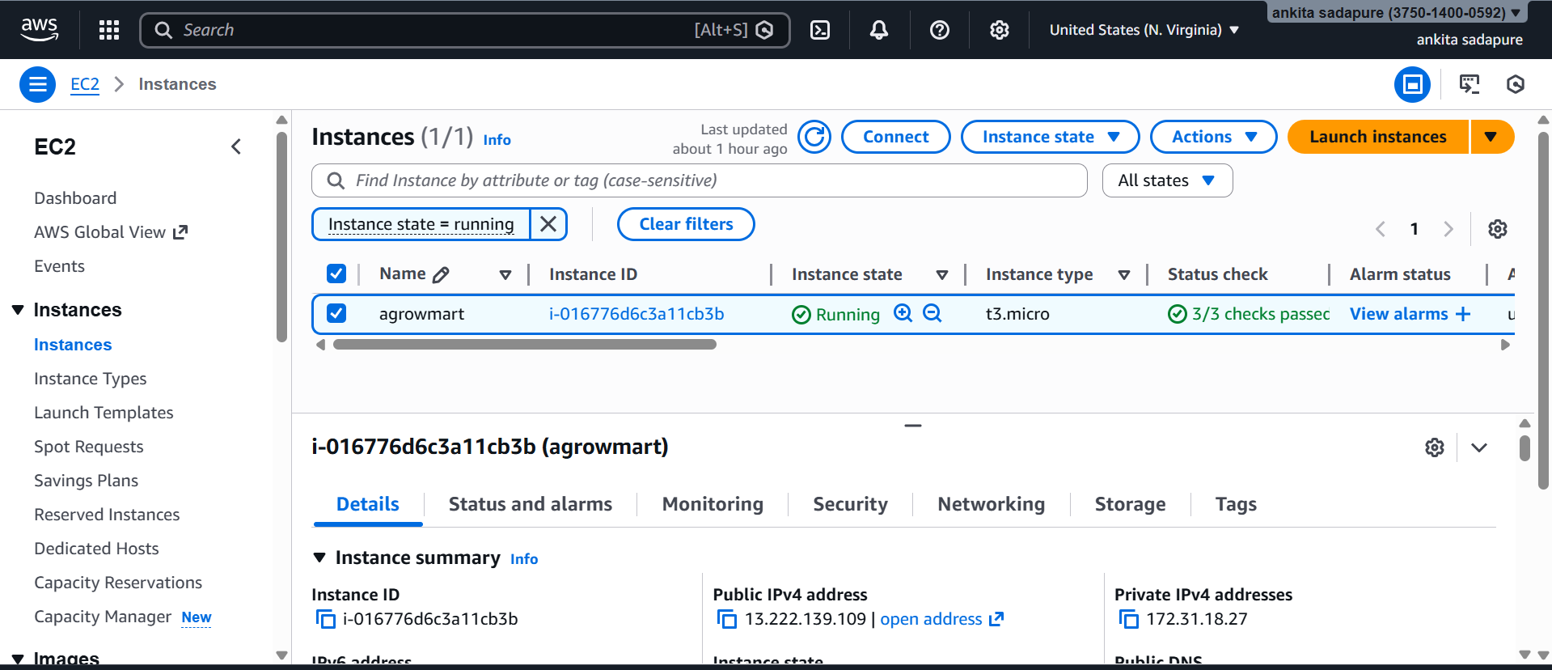

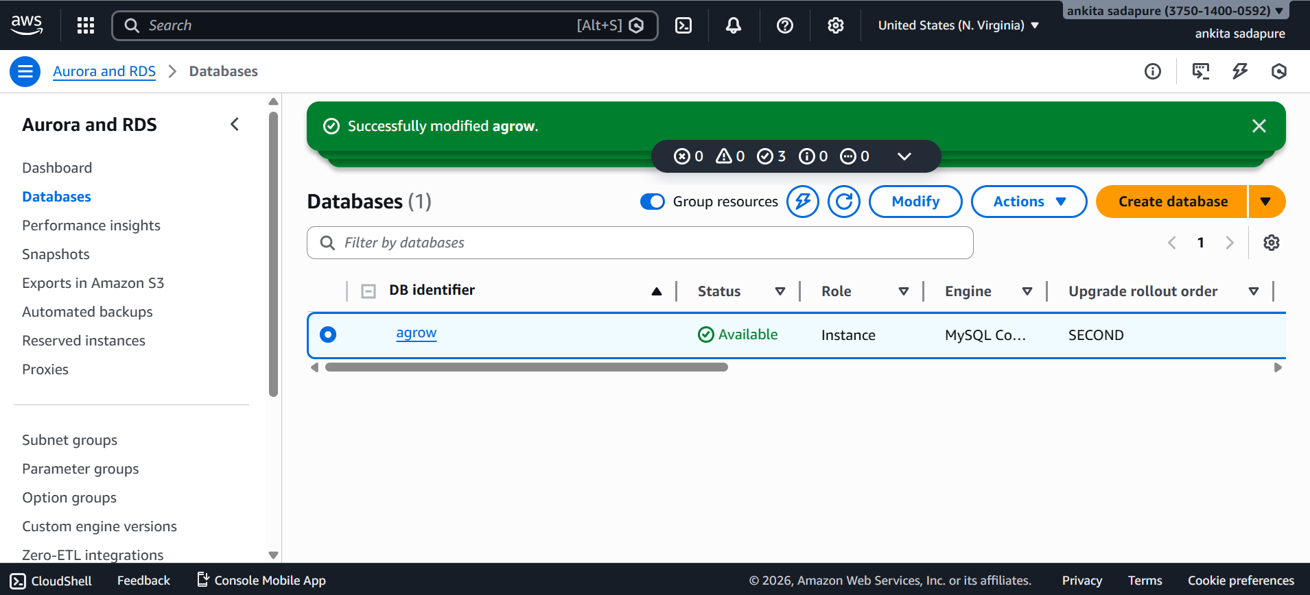

Set application property.

Connect ec2 to server

Install Java on EC2
sudo yum update -y
sudo yum install java-17-amazon-corretto -y
java -version

Run Your Spring Boot App Again
java -jar AgrowMart-0.0.1-SNAPSHOT.jar

Create maven jar file in local command propmat

mvn clean package

Jar into ec2

scp -i "C:\Users\Skynet\Downloads\agrowkey.pem" "C:\finall\AgrowBuddyFinal\target\AgrowMart-0.0.1-SNAPSHOT.jar" ec2-user@ec2-13-222-139-109.compute-1.amazonaws.com:/home/ec2-user/

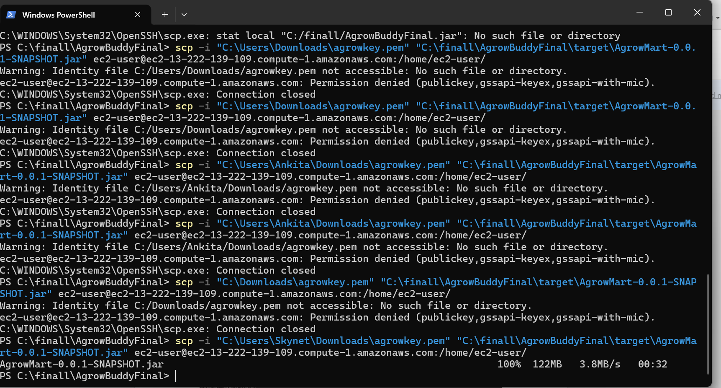

ls

java -jar AgrowMart-0.0.1-SNAPSHOT.jar

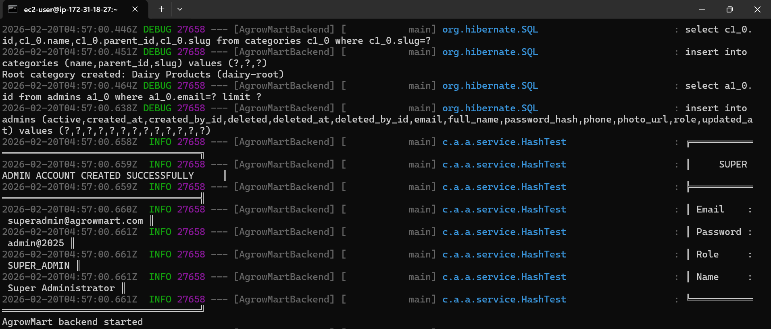

Upload jar to ec2

If check error (last 20 lines)

grep -A 20 -B 20 "ERROR" app.log

