Exploring Blood Pressure Patterns in the US Adult Population

Using NHANES 2017-2018 Data

Ani Hovhannisyan

Introduction
High blood pressure, or hypertension, is one of the leading causes of heart disease and stroke worldwide. It is often called a “silent killer’, as it shows no symptoms until serious damage has already occurred. Understanding which demographic, socioeconomic, and lifestyle factors are associated with that rising blood pressure is vital for developing efficient public health strategies.
This project uses data from the National Health and Nutrition Examination Survey (NHANES) 2017-2018, which is a large nationally representative study conducted by the CDC.
Three research questions are studied:
- Does mean arterial pressure (MAP) differ between physical activity levels?
- Is there a relationship between age and systolic blood pressure, and does it differ by gender?
- Does the prevalence of hypertension vary by income group?

- Methods
  - Data Source
Four NHANES 2017-2018 data files were utilized: demographic variables (DEMO_J.xpt), measured blood pressure (BPX_J.xpt), blood pressure questionnaire (BPQ_J.xpt), and physical activity questionnaire (PAQ_J.xpt). All files are in SAS transport format and were read into Python using pandas.read_sas(). Participants were linked across files using the unique identifier SEQN. An inner join was executed to retain only individuals present in all four files, resulting in a merged dataset of 4,450 participants.

  - Data Cleaning
The analysis was restricted to adults aged 20-80 years. Blood pressure readings were filtered to keep only physiologically plausible values: systolic between 50-250 mmHg and diastolic between 30-150 mmHg across all three readings. Pulse values of 0 bpm or above 200 bpm were excluded. NHANES special missing codes (e.g., 7, 9, 77, 99, 7777, 9999) denoting “refused” or “don’t know” responses in the questionnaire variables were replaced with NaN.

  - Feature Engineering
The following derived variables were created:
- bp_sys_avg/ bp_dias_avg: average of the three systolic and diastolic readings respectively.
- map:
$$Mean Arterial Pressure=bp_dias_avg+\frac{bp_sys_avg - bp_dias_avg}{3}$$
- hypertension: binary variable (1 = yes, 0 = no). Defined as systolic average ≥ 130 mmHg or diastolic average ≥ 80 mmHg (AHA/ACC 2017 guideline), or the participant reported being told by a doctor they have high blood pressure (BPQ020 = 1).
- activity_level: based on total weekly recreational activity minutes (PAD660 + PAD675). Participants who reported “No” had their corresponding minutes set to 0; remaining missing values were also treated as 0. Classified as “active” (≥ 150 min), “insufficient” (1-149 min), or “inactive” (0 min).
- income_group: income-to-poverty ratio (INDFMPIR) intervals: “below poverty” (< 1), “near poverty” (1 ≤ to 2), “middle income” (2 ≤ to 4), “high income” (≥ 4).

- Results
  - Research Question 1: MAP by Activity Level
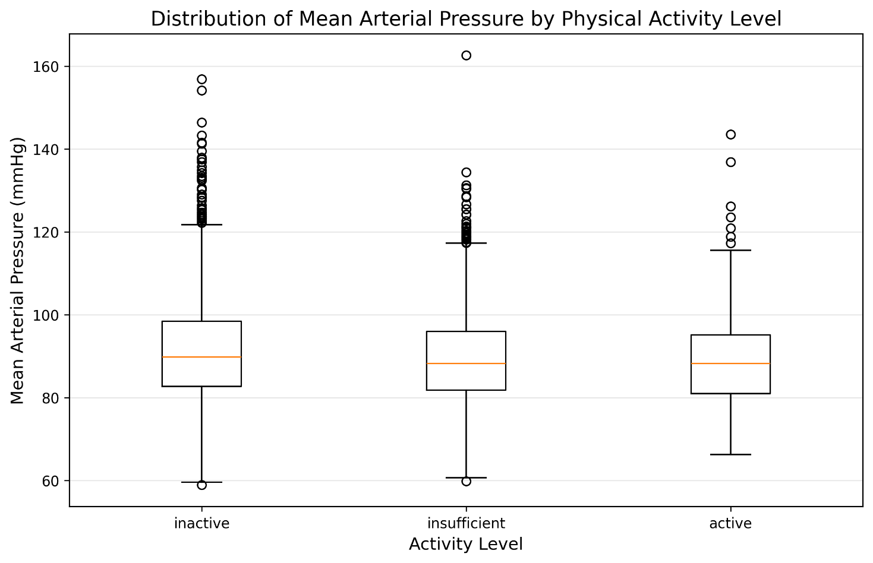
Does mean arterial pressure (MAP) differ between activity levels?
Figure 1. Distribution of Mean Arterial Pressure (mmHg) by physical activity level.

The inactive group has the highest average MAP (≈ 91.20 mmHg), followed by the insufficient group (≈ 89.53 mmHg), while the active participants had the lowest average MAP (≈ 88.89 mmHg). The difference is not visually convincing, as all three boxes sit in roughly the same range and overlap, suggesting that activity level alone does not strongly separate MAP distributions in this sample, even though the a trend exists (higher activity associated with lower MAP).

  - Research Question 2: Systolic BP vs Age by Gender
Is there a relationship between age and systolic blood pressure, and does it differ by gender?

Figure 2. Average systolic blood pressure vs. age for males (blue) and females (red), with linear trend lines.

Systolic BP increases steadily with age for both males and females. Males start higher (≈ 117 mmHg at age 20) but have a shallower slope, while females start lower (≈ 105 mmHg) but rise more steeply, crossing over and slightly exceeding males by around age 55-60.
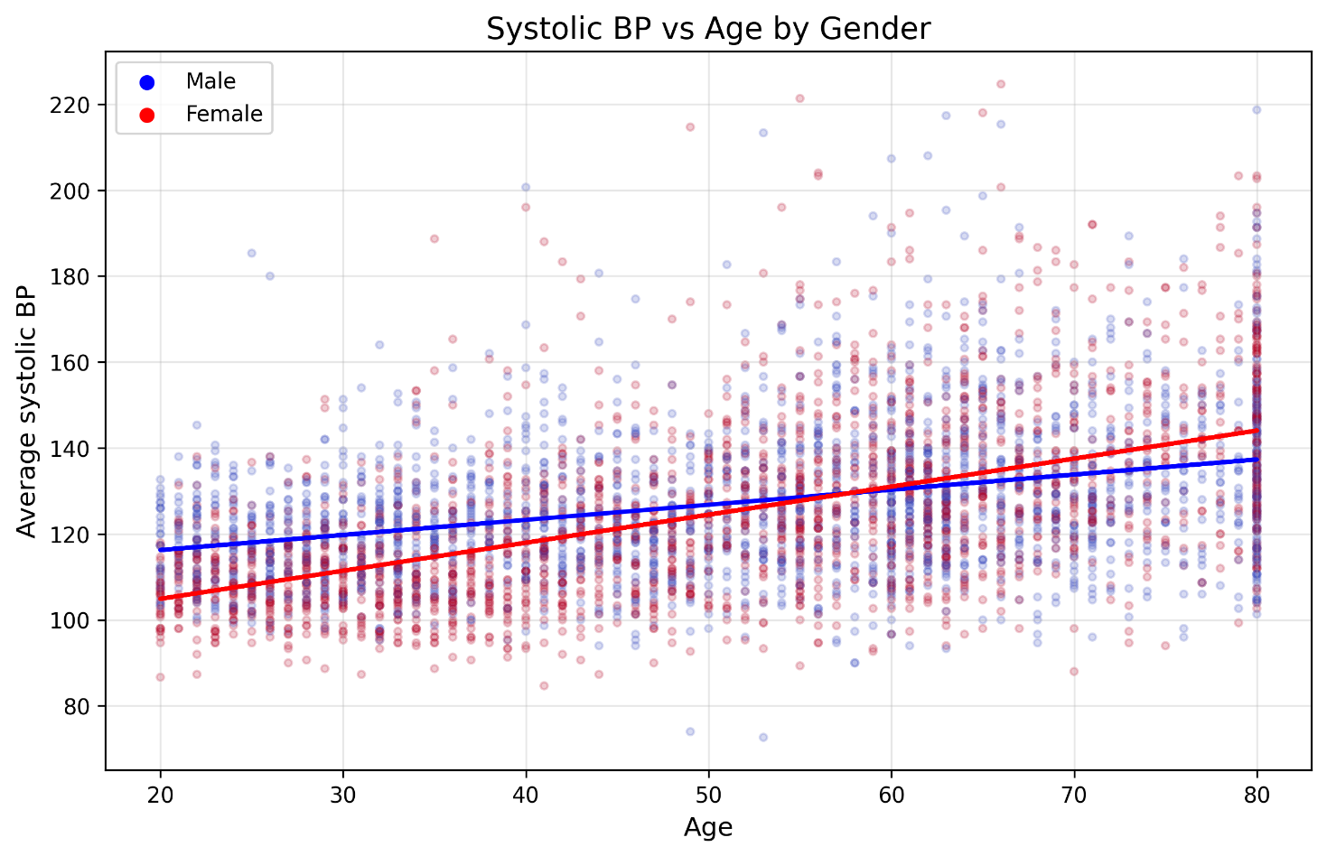
  - Research Question 3: Hypertension by Income Group
Does the prevalence of hypertension vary by income group?
Middle income (≈ 59.96%) and near poverty (≈ 57.85%) groups have the highest hypertension rates, while below poverty (≈ 54.66%) and high income (≈ 56.0%) are slightly lower. So hypertension does not consistently increase as income decreases, the pattern is mixed. One real-world reason the below poverty group may appear lower is lack of healthcare access, which means people who cannot afford regular check-ups are less likely to have ever been formally diagnosed, meaning true hypertension in that group is likely undercounted.

Figure 3. Hypertension prevalence (%) by income group, ordered from lowest to highest income.
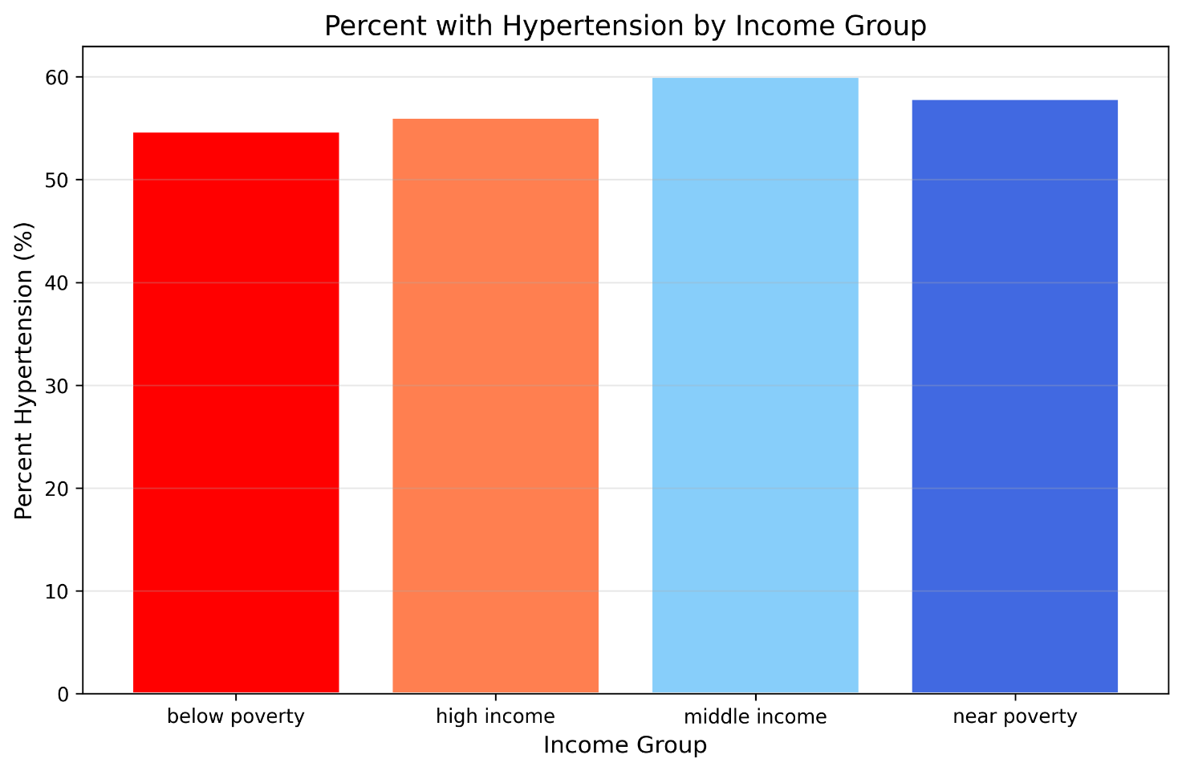
- Discussion
This analysis has several important limitations:
- Cross-sectional data: NHANES is a cross-sectional study, meaning it takes a snapshot of people at a single point in time. Hence, the plots can show associations or correlations, but they cannot prove causation (e.g., you cannot definitely prove that low income causes high blood pressure, only that they happen to occur together).
- Handling of missing minutes in activity: When a participant had missing minutes, they were treated as 0. This may misclassify people, who were actually active, as inactive, distorting the activity-level distribution.
- Self-reported activity: The physical activity data comes from a questionnaire (PAQ_J.xpt). Self-reported data is a vulnerable to memory mistakes, because participants may easily overestimate how much they exercise.
- Missing medication use: Many participants with hypertension may be taking daily medication to lower it. Because of this, a person on medication might show a perfectly normal blood pressure reading in the data, hiding their underlying hypertension.

- Conclusion
Using NHANES 2017-2018 data from 4,450 US adults, this project found three key insights. First, inactive adults tend to have slightly higher mean arterial pressure than more active groups, though the difference is modest. Second, systolic blood pressure rises with age in both genders, but the increase is steeper in women, with the two genders intersecting around the age of 55-60. Third, hypertension does not decrease monotonically with income. In fact, middle income and near poverty groups show the highest rates, suggesting the lower percentage in below poverty tier is driven by a high number of undiagnosed cases due to poor healthcare access. These findings highlight the importance of promoting physical activity across all income levels and improving healthcare access in lower-income communities, where hypertension may both be prevalent and less diagnosed.

