CON001
Hands-On Lab
Lab Manual
First Steps with the Windows Communication Foundation

This lab is designed for use with the .NET Framework 3

Information in this document is subject to change without notice. The example companies, organizations, products, people, and events depicted herein are fictitious. No association with any real company, organization, product, person or event is intended or should be inferred. Complying with all applicable copyright laws is the responsibility of the user. Without limiting the rights under copyright, no part of this document may be reproduced, stored in or introduced into a retrieval system, or transmitted in any form or by any means (electronic, mechanical, photocopying, recording, or otherwise), or for any purpose, without the express written permission of Microsoft Corporation.

Microsoft may have patents, patent applications, trademarked, copyrights, or other intellectual property rights covering subject matter in this document. Except as expressly provided in any written license agreement from Microsoft, the furnishing of this document does not give you any license to these patents, trademarks, copyrights, or other intellectual property.

© 2005 Microsoft Corporation. All rights reserved.

Microsoft, MS-DOS, MS, Windows, Windows NT, MSDN, Active Directory, BizTalk, SQL Server, SharePoint, Outlook, PowerPoint, FrontPage, Visual Basic, Visual C++, Visual J++, Visual InterDev, Visual SourceSafe, Visual C#, Visual J#, and Visual Studio are either registered trademarks or trademarks of Microsoft Corporation in the U.S.A. and/or other countries.

Other product and company names herein may be the trademarks of their respective owners.

Contents
First Steps with the Windows Communication Foundation 1
Lab Objective 1
Introduction to the Windows Communication Foundation 1
Exercise 1 – Define and implement the contract for a derivatives calculator service 2
Task 1 – Create the Derivatives Calculator Service Project 3
Task 2 – Add a Reference to the Windows Communication Foundation to the DerivativesCalculatorService Project 4
Task 3 – Define the Contract that the Derivatives Calculator Service will Expose 5
Task 4 – Implement the Contract that the Derivatives Calculator Service will Expose 6
Task 5 – Build the project 6
Exercise 2 – Host the Service in a .NET Executable 6
Task 1 – Add a Console Application Project to the Solution 6
Task 2 – Add a Reference to the Windows Communication Foundation to the Host Project 7
Task 3 – Add a Reference to System.Configuration to the Host Project 7
Task 4 – Add a Reference to the Derivatives Calculator Service to the Host Project 7
Task 5 – Write the Windows Communication Foundation code needed to provide a host for the Derivatives Calculator service 7
Task 6 – Configure the Service 9
Task 7 – Test the Service 10
Exercise 3 – Consume the Derivatives Calculator Service 11
Task 1 – Add a Second Console Application Project to the Solution 11
Task 2 – Generate a Typed Proxy and Configuration File for the Client Application 11
Task 3 – Add the Typed Proxy and Configuration File to the Client Application 11
Task 4 – Add a Reference to the Windows Communication Foundation to the Client Project 11
Task 5 – Code and Configure the Client to Consume the DerivativesCalculator Service 11
Task 5 – Have the Client Consume the DerivativesCalculator Service 13
Exercise 4 – Host the Service in IIS 14
Task 1 – Configure the DerivativesCalculatorService project to compile into the \bin directory 14
Task 2 – Add a .SVC file to the DerivativesCalculatorService Project 15
Task 3 – Create a Virtual Directory Pointing to the Project Directory in IIS 16
Task 4 – Configure the Service 16
Task 5 – Confirm the Availability of the Service 16
Task 6 – Reconfigure the Client to Consume the Service Hosted in IIS 17
Exercise 5 – Secure the service 18
Task 1 – Prove that Communications with the Derivatives Calculator Service are not Confidential 18
Task 2 – Alter the Binding of the Derivatives Calculator Service so that Communications with the Service are Kept Confidential 19

First Steps with the Windows Communication Foundation

Lab Objective
Estimated time to complete this lab: 60 minutes
The objective of this lab is to provide some practice in delivering and consuming services using the Windows Communication Foundation.

- Exercise 1 – Define and implement the contract for a derivatives calculator service
- Exercise 2 – Host the service in a .NET executable
- Exercise 3 – Consume the derivatives calculator service
- Exercise 4 – Host the service in IIS
- Exercise 5 – Secure the service

Introduction to the Windows Communication Foundation
In their book, Software Factories, Jack Greenfield and Keith Short argue that progress in model-driven development depends on eschewing general-purpose modeling languages in favor of domain-specific languages, or DSLs. A DSL models the concepts found in a specific domain. DSLs should be used in conjunction with a corresponding class framework, a set of classes specifically designed to cover the same domain. Then, if the DSL is used to model particular ways in which those classes can be used, it should be possible to generate the software described in the model from the class framework.

The combination of a DSL and a corresponding class framework constitute the core of a software factory template. Software factory templates serve as the software production assets of a software factory from which many varieties of the same software product can be readily fabricated.

A fine example of a software factory template is the Windows Forms Designer in Microsoft Visual Studio .NET and subsequent versions of Microsoft Visual Studio. In that particular case, the Windows Forms Designer is the DSL, the Toolbox and Property Editor being among the terms of the language, and the classes in the System.Windows.Forms namespace of the .NET Framework Class Library constitute the class framework. Users of the Windows Forms Designer use it to model software that gets generated from those classes.

Programmers have been using the Windows Forms Designer and tools like it in other integrated development environments for many years to develop software user interfaces. So Greenfield and Short, in introducing the concept of software factory templates, are not proposing a new approach. Rather, they are formalizing one that has already proven to be very successful, and suggesting that it be used to develop other varieties of software besides user interfaces.

The Windows Communication Foundation is a software factory template for software communication. It consists of a DSL, called the Service Model, and a class framework, called the Channel Layer. The Service Model consists of the classes of the System.ServiceModel namespace, and an XML configuration language. The Channel Layer consists of the classes in the System.ServiceModel.Channel namespace. Developers model how a piece of software is to communicate using the Service Model, and the communication components they need to have included in their software are generated from the Channel Layer, in accordance with their model. Later, if they need to change or supplement how their software communicates, they make alterations to their model, and the modifications or additions to their software are generated. If they want to model a form of communication that is not already supported by the Channel Layer, they can build or buy a suitable channel to add to the Channel Layer, and proceed to generate their software as usual, just as a user of the Windows Forms Designer can build or buy controls to add to the Windows Forms Designer’s Toolbox.

The key terms in the language of the Windows Communication Foundation Service Model are address, binding, and contract. The address defines where the software is, the binding specifies the protocols for communicating with it, and the contract defines what it will do. Consequently, the handy acronym a, b, c can serve as a reminder of the key terms of the Windows Communication Foundation Service Model and, thereby, as a reminder to the steps to follow in using it to enable a piece of software to communicate. An address, a binding and contract constitute an endpoint in the parlance of the Windows Communication Foundation.

Exercise 1 – Define and implement the contract for a derivatives calculator service
In providing a Windows Communication Foundation Service, a programmer always begins by defining the contract. In this exercise, you will define and implement the contract for a Windows Communication Foundation service. That service will calculate the value of derivatives.

A derivative is a financial entity whose value is derived from that of another. Here is an example. The value of a single share of Microsoft Corporation Stock was $24.41 on October 11, 2005. Given that value, one might offer for sale an option to buy 1,000 of those shares for $25 each on November 11, 2005. Such an option, which is known as a call, might be purchased by someone who anticipates that the price of the shares will rise above $25 by November 11, 2005, and sold by someone who anticipates that the price of the shares will drop. The call is a derivative, its value being derived from the value of Microsoft Corporation stock.

Pricing a derivative is a complex task. Indeed, estimating the value of derivatives is perhaps the most high-profile problem in modern microeconomics.

In the case of our example, clearly the quantity of the stock, and the current and past prices of the Microsoft Corporation stock are factors to consider, but other factors might be based on analyses of the values of quantities that are thought to affect the prices of the stock, such as the values of various stock market indices, or the interest rate of the U.S. Federal Reserve Bank. In fact, one can say that, in general, the price of derivative is some function of one or more quantities, one or more market values, and the outcome of one or more quantitative analytical functions.

Task 1 – Create the Derivatives Calculator Service Project
- Log onto the virtual PC with the username Administrator, and the password, pass@word1. A folder with an electronic copy of this manual is located on the desktop, which will be useful for copying and pasting code into Visual Studio .NET.
- Open Visual Studio 2005, and create a new blank solution called, DerivativesCalculator, in c:\Windows Communication Foundation\Labs\, as shown in figure 1.1, below.
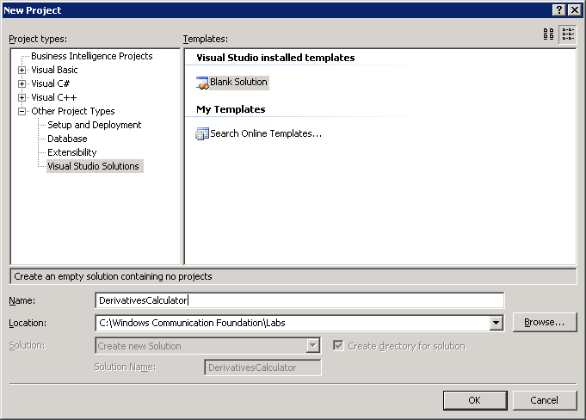
Figure 1.1 Creating a blank Visual Studio solution
- Add a C# Class Library project called, DerivativesCalculatorService, to the solution, as shown in figure 1.2, below.
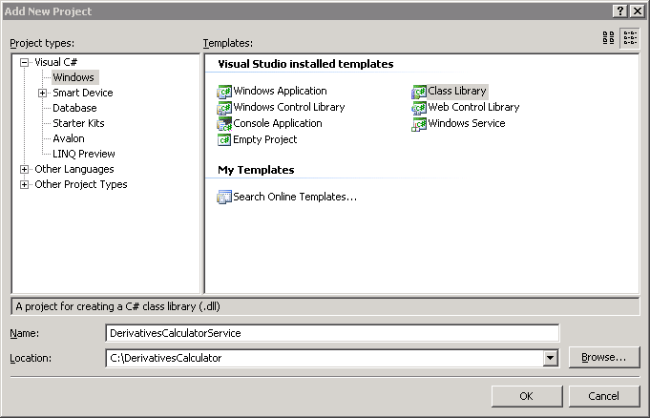
Figure 1.1 Adding a Class Library project to the solution

Task 2 – Add a Reference to the Windows Communication Foundation to the DerivativesCalculatorService Project
- Add a reference to the System.ServiceModel .NET assembly, to the DerivativesCalculatorService project, as shown in figure 1.3, below.
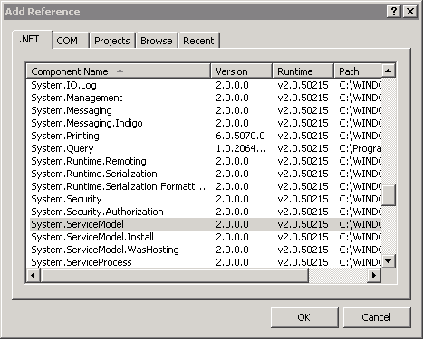
Figure 1.1 Adding a reference to the System.ServiceModel .NET assembly

Task 3 – Define the Contract that the Derivatives Calculator Service will Expose
- Windows Communication Foundation contracts are defined by
- writing an interface in a .NET programming language,
- adding the ServiceContract attribute to the interface to designate it as a Windows Communication Foundation service contract,
- adding the OperationContract attribute to any of the methods of the interface that are to be included in the contract.

So rename the class file, Class1.cs, in the DerivativesCalculatorService project to IDerivativesCalculator.cs, and modify the content thereof to read as follows:

using System;
using System.Collections.Generic;
using System.ServiceModel;
using System.Text;

namespace DerivativesCalculatorService
{
[ServiceContract]
public interface IDerivativesCalculator
{
[OperationContract]
Decimal CalculateDerivative(int days, string[] symbols, string[] functions);
}
}

Task 4 – Implement the Contract that the Derivatives Calculator Service will Expose
- Once a Windows Communication Foundation contract has been defined, the next step is to implement it. That is done simply by writing a class that implements the interface by which the contract is defined. In the parlance of the Windows Communication Foundation, a class that implements a Windows Communication Foundation contract is a service type.

Create a service type for the IDerivatesCalculator contract now by adding a class named, Calculator.cs, to the project, and modifying its contents to look like this:

using System;
using System.Collections.Generic;
using System.ServiceModel;
using System.Text;

namespace DerivativesCalculatorService
{
public class Calculator: IDerivativesCalculator
{
#region IDerivativesCalculator Members

decimal IDerivativesCalculator.CalculateDerivative(int days, string[] symbols, string[] functions)
{
return (decimal)(System.DateTime.Now.Millisecond);
}

#endregion
}
}

Task 5 – Build the project
- Build the DerivativesCalculatorService project. If the project builds without error, then the implementation of the contract for the Derivatives Calculator service is complete.

Exercise 2 – Host the Service in a .NET Executable

In this exercise, you will host the Derivatives Calculator Service that you defined and implemented in the first exercise. Specifically, you will host the service within a .NET console application.

Task 1 – Add a Console Application Project to the Solution
- Add a C# Console Application project called, Host, to the DerivativesCalculator solution.

Task 2 – Add a Reference to the Windows Communication Foundation to the Host Project
- Add a reference to the System.ServiceModel .NET assembly, to the Host project.

Task 3 – Add a Reference to System.Configuration to the Host Project
- Add a reference to the System.Configuration .NET assembly, to the Host project.

Task 4 – Add a Reference to the Derivatives Calculator Service to the Host Project
- Add a reference to the DerivatesCalculatorService project to the Host project, as show in figure 2-1, below.

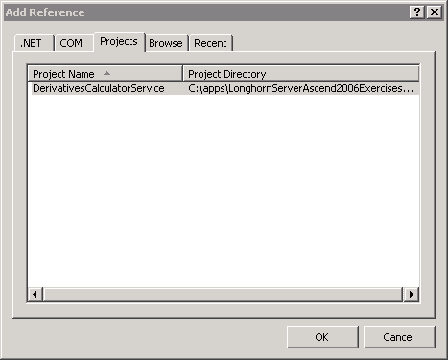

Figure 2.1 Adding a reference to the DerivativesCalculatorService project

Task 5 – Write the Windows Communication Foundation code needed to provide a host for the Derivatives Calculator service
- Modify the Program.cs class in the Host project to read as follows:

using System;
using System.Collections.Generic;
using System.ServiceModel;
using System.Text;
using System.Configuration;
using DerivativesCalculatorService;

namespace Host
{
public class Program
{
public static void Main(string[] args)
{
Type serviceType = typeof(Calculator);

string httpBaseAddress =
ConfigurationManager.AppSettings["HTTPBaseAddress"];
string tcpBaseAddress =
ConfigurationManager.AppSettings["TCPBaseAddress"];
Uri httpBaseAddressUri = new Uri(httpBaseAddress);
Uri tcpBaseAddressUri = new Uri(tcpBaseAddress);
Uri[] baseAdresses = new Uri[] {
httpBaseAddressUri,
tcpBaseAddressUri};

using(ServiceHost host = new ServiceHost(
serviceType,
baseAdresses))
{
host.Open();

Console.WriteLine(
"The derivatives calculator service is available."
);
Console.ReadKey();

host.Close();
}

}
}
}

The code you have added retrieves base addresses for the HTTP and TCP protocols from the application configuration file. Those base addresses are simply valid HTTP and TCP addresses. The addresses of Windows Communication Foundation endpoints are relative to their host’s base addresses. The remaining code creates an instance of the Windows Communication Foundation’s ServiceHost class, and specifies that it is to be used to host instances of the Calculator service type defined earlier, at addresses relative to the base addresses retrieved from the configuration file. The call to the host’s Open() method starts the host listening for messages directed at the Calculator service type. Exactly how the host listens for those messages is defined by information in the application configuration file that you will provide now.

Task 6 – Configure the Service
- Add an application configuration file named, app.config, to the Host project in the DerivativesCalculator solution.
- Modify the contents of that file thusly:

<?xml version="1.0" encoding="utf-8" ?>
<configuration>
<appSettings>
<add key="HTTPBaseAddress" value="http://localhost:8000/Derivatives/"/>
<add key="TCPBaseAddress" value="net.tcp://localhost:8010/Derivatives/"/>
</appSettings>
<system.serviceModel>
<services>
<service name="DerivativesCalculatorService.Calculator">
<endpoint
address="CalculatorService"
binding="basicHttpBinding" contract="DerivativesCalculatorService.IDerivativesCalculator"/>
</service>
</services>
</system.serviceModel>
</configuration>

Your additions to the appSettings section simply serve to provide the base addresses for the HTTP and TCP protocols. The system.serviceModel section that you added is more important. That section is specifically designed for configuring Windows Communication Foundation endpoints, and, as you can see, what you added to that section defines the address, binding, and contract that constitute such an endpoint.

Specifically, you have added a service element for the derivates calculator service type that you programmed. The name attribute of the service element refers to that service type.

The endpoint element defines one endpoint for the service. The address attribute of the endpoint element defines an address that will be relative to one of the base addresses. The value assigned to the binding attribute of the endpoint element, basicHttpBinding, refers to a pre-defined set of protocols for communication, a set of protocols that corresponds to those defined by the WS-I Basic Profile 1.1. The Windows Communication Foundation defines a number of such pre-defined sets of protocols, and you can define your own sets, which may include protocols that you have extended the Windows Communication Foundation to implement. Because the BasicHttpBinding that you selected uses the HTTP protocol for transporting messages, the address that you provided for the endpoint will be relative to the HTTP base address, so the absolute address for your endpoint will be http://localhost:8000/Derivates/CalculatorService. The value of the contract attribute refers to the Windows Communication Foundation contract that your service type implements.

Task 7 – Test the Service
- Build the DerivativesCalculator solution.
- Start a new instance of the Host project.
- Choose Run from the Windows Start menu, and enter,

http://localhost:8000/Derivatives/
Internet Explorer should open, and display a page like the one in figure 2-2 below:
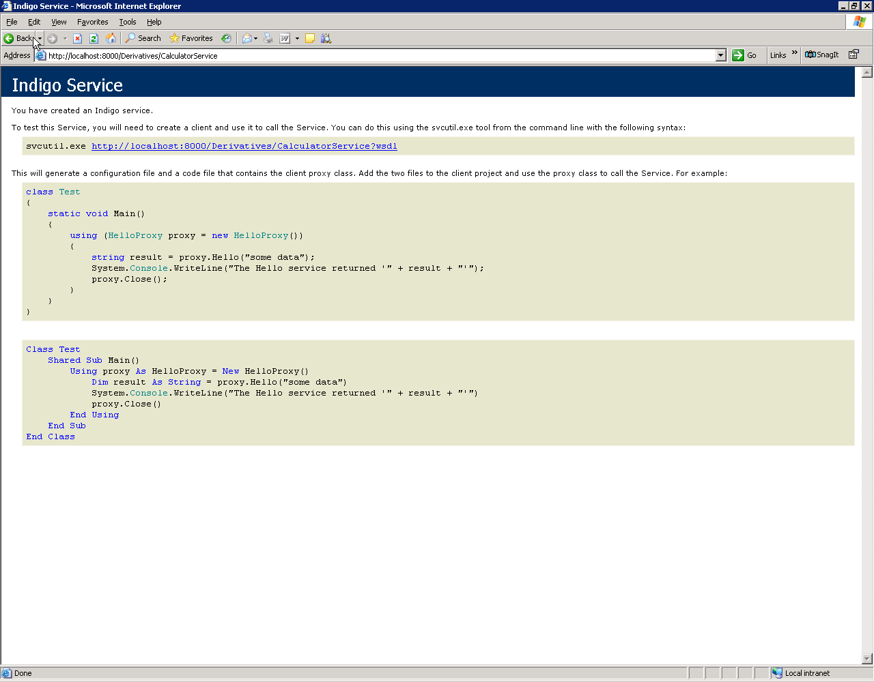
Figure 2.2 A Windows Communication Foundation Service Information Page

Click on the link to http://localhost:8000/Derivatives/?wsdl near the top of the page and examine the page of WSDL that appears.
- Close Internet Explorer.
- Enter a keystroke into the console application window of the Host executable to terminate the Derivatives Calculator Service.

Exercise 3 – Consume the Derivatives Calculator Service

In this exercise, you will build a client that will use the Derivatives Calculator Service that you constructed in the previous two exercises. To do so, you will rely on a tool, SvcUtil.exe, that is provided with the Windows Communication Foundation for generating client proxies and configuration files from the metadata of a service.

Task 1 – Add a Second Console Application Project to the Solution
- Add a C# Console Application project called, Client, to the DerivativesCalculator solution.

Task 2 – Generate a Typed Proxy and Configuration File for the Client Application
- Start a new instance of the Host project.
- Open the Start->Programs->Microsoft Windows SDK->Cmd Shell command prompt.
- Enter,

cd c:\Windows Communication Foundation\Labs\DerivativesCalculator
at the command prompt.
- Next, enter,

svcutil http://localhost:8000/Derivatives/ /out:Client.cs /config:app.config

- Choose Debug and Stop Debugging from the Visual Studio menus.

Task 3 – Add the Typed Proxy and Configuration File to the Client Application
- Add the files, Client.cs and app.config, in the folder, c:\Windows Communication Foundation\Labs\DerivativesCalculator, to the Client project of the DerivativesCalculator solution. (Choose Add Existing Item from the context menu on the Client project)

Task 4 – Add a Reference to the Windows Communication Foundation to the Client Project
- Add a reference to the System.ServiceModel .NET assembly, to the Client project.

Task 5 – Code and Configure the Client to Consume the DerivativesCalculator Service
- Modify the app.config file in the Client project of the DerivativesCalculator solution thus:

<?xml version="1.0" encoding="utf-8"?>
<configuration>
<system.serviceModel>
<bindings>
<basicHttpBinding>
<binding name="BasicHttpBinding_IDerivativesCalculator" bypassProxyOnLocal="false"
hostNameComparisonMode="StrongWildcard" maxBufferSize="65536"
maxBufferPoolSize="524288" maxReceivedMessageSize="65536"
messageEncoding="Text" textEncoding="utf-8" transferMode="Buffered"
useDefaultWebProxy="true">
<readerQuotas maxDepth="2147483647" maxStringContentLength="2147483647"
maxArrayLength="2147483647" maxBytesPerRead="2147483647" maxNameTableCharCount="2147483647" />
<security mode="None">
<transport clientCredentialType="None" proxyCredentialType="None"
realm="" />
<message clientCredentialType="UserName" algorithmSuite="Default" />
</security>
</binding>
</basicHttpBinding>
</bindings>
<client>
<endpoint address="http://localhost:8000/Derivatives/CalculatorService"
binding="basicHttpBinding" bindingConfiguration="BasicHttpBinding_IDerivativesCalculator"
contract="IDerivativesCalculator"
name="DerivativesCalculatorConfiguration" />
</client>
</system.serviceModel>
</configuration>

This modification of yours simply provides a name, a label, DerivativesCalculatorConfiguration, for the client configuration that was automatically generated by the tool. You will use that name to refer to the configuration from the code that you write next.

- Alter the code in the Program.cs file of the Client project of the DerivativesCalculator solution in this way:

using System;
using System.Collections.Generic;
using System.Text;

namespace Client
{
class Program
{
static void Main(string[] args)
{
Console.WriteLine("Press any key when the service is ready.");
Console.ReadKey();

using(DerivativesCalculatorClient proxy = new DerivativesCalculatorClient("DerivativesCalculatorConfiguration"))
{
decimal result = proxy.CalculateDerivative(3,new string[]{"MSFT"},new string[]{});
Console.WriteLine("Result: {0}",result);

Console.WriteLine("Press any key to exit.");
Console.ReadKey();
}
}
}
}

This code creates an instance of a proxy class that was generated by the SvcUtil.exe tool, and tells the proxy about the service endpoint by referring to the configuration information that you named in the previous step. Then you use the proxy to invoke the operations of the service.

Task 5 – Have the Client Consume the DerivativesCalculator Service
- Modify the Startup Project properties of the DerivativesCalculator solution as shown in figure 3-1, below to have both the client and server start when the solution is started. Right click on the solution in the solution explorer and choose “Set startup projects”:
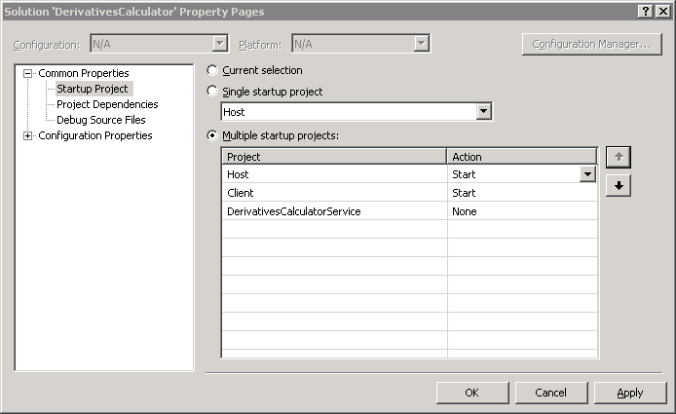

Figure 3.1 The Startup Project Properties of the DerivativesCalculator Solution

- Choose Debug|Start Debugging from the Visual Studio menu.
- When you see activity in the console for the Host application, enter a keystroke into the console for the Client application. You should see the client obtain an estimate of the value of a derivative from the Derivatives Calculator service, as shown in figure 3.2, below. Note that the value shown in the Client application console may vary from the value shown in figure 3.2, due to variations in prevailing market conditions over time.

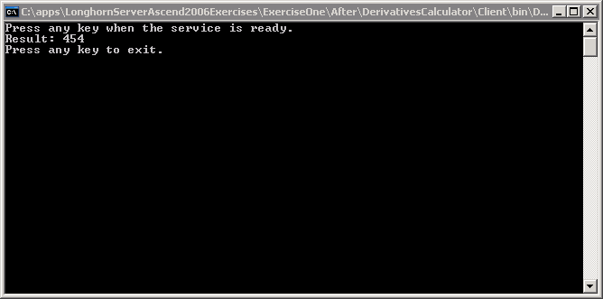

Figure 3.2 Using the Derivatives Calculator Service

- In Visual Studio, choose Debug|Stop Debugging from the menu.

Exercise 4 – Host the Service in IIS
In this exercise, you will host the Derivatives Calculator Service that you previously hosted within a .NET executable within IIS instead. Hosting within IIS is wiser, because IIS provides a robust, efficient and secure host for your Windows Communication Foundation Services.

Task 1 – Configure the DerivativesCalculatorService project to compile into the \bin directory
- Alter the build properties of the DerivativesCalculatorService project so that the output path is the bin subdirectory of the project directory. As in the case of ASP.NET applications, IIS looks for executable code in the bin subdirectory of application directories by default.

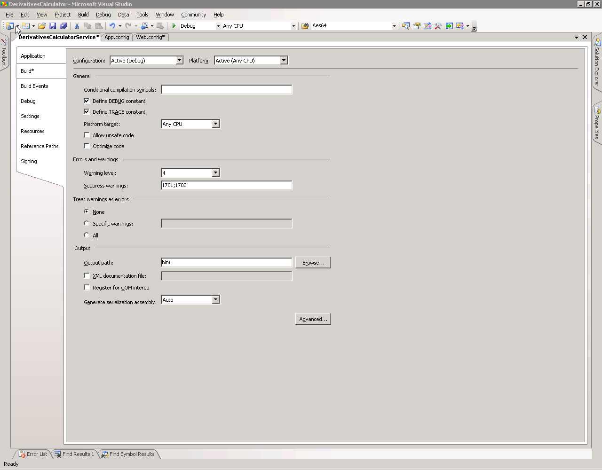
Figure 4.1 Altering the Build Properties of the DerivativesCalculatorService Project

Task 2 – Add a .SVC file to the DerivativesCalculatorService Project
- Add a text file named, Service.svc, to the DerivativesCalculatorService project.
- Add content to that file so that it refers to your service type, like so:

<%@ServiceHost Service="DerivativesCalculatorService.Calculator" %>

As you will see in a few moments, the client application will be modified to use the URL of this Service.svc file as the address for the application. When a message arrives that is directed at that address, IIS identifies the service type for which the message is intended based on the information in the .svc file.

Task 3 – Create a Virtual Directory Pointing to the Project Directory in IIS
- Choose Administrative Tools | Internet Information Services (IIS) Manager from the Windows Start menu.
- Expand the nodes of the tree control in the left-hand pane until the node named, Default Web Site becomes visible.
- Right-click on that node, and choose New|Virtual Directory from the context menu that appears.
- In the Virtual Directory Creation Wizard, enter, DerivativesCalculator in the Virtual Directory alias screen.
- Enter, c:\Windows Communication Foundation\Labs\DerivativesCalculator\DerivativesCalculatorService as the path on the Web Site Content Directory screen of the wizard.
- Select the Read, and Run Scripts permissions on the wizard’s Virtual Directory Access Permissions screen, then click on the button labeled, Next, and follow the instructions to exit from the wizard.

Task 4 – Configure the Service
The configuration of the service hosted within IIS can be identical to the configuration used for hosting the service within a custom .NET executable. However, the address for the service endpoint can be left blank to signify that the address of the endpoint is simply the address of the .svc file.

- Add a new web configuration file named, Web.config, to the DerivativesCalculatorService project in the DerivativesCalculator solution.
- Modify the contents of that file thusly (or copy the app.config from the host project, rename to web.config and null out the address attribute) :

<?xml version="1.0" encoding="utf-8" ?>
<configuration>
<system.serviceModel>
<services>
<service name="DerivativesCalculatorService.Calculator">
<endpoint
address=""
binding="basicHttpBinding" contract="DerivativesCalculatorService.IDerivativesCalculator"/>
</service>
</services>
</system.serviceModel>
</configuration>

Task 5 – Confirm the Availability of the Service
- Build the DerivativesCalculator solution.
- Choose Run from the Windows Start menu, and enter,

http://localhost/DerivativesCalculator/Service.svc
Internet Explorer should open and display a page similar to the one in figure 2.2, above.

Task 6 – Reconfigure the Client to Consume the Service Hosted in IIS
- Modify the app.config file in the Client project of the DerivativesCalculator to change the address on the endpoint to refer to the .svc file, as shown below:

<?xml version="1.0" encoding="utf-8"?>
<configuration>
<system.serviceModel>
<bindings>
<basicHttpBinding>
<binding name="BasicHttpBinding_IDerivativesCalculator" bypassProxyOnLocal="false"
hostNameComparisonMode="StrongWildcard" maxBufferSize="65536"
maxBufferPoolSize="524288" maxReceivedMessageSize="65536"
messageEncoding="Text" textEncoding="utf-8" transferMode="Buffered"
useDefaultWebProxy="true">
<readerQuotas maxDepth="2147483647" maxStringContentLength="2147483647"
maxArrayLength="2147483647" maxBytesPerRead="2147483647" maxNameTableCharCount="2147483647" />
<security mode="None">
<transport clientCredentialType="None" proxyCredentialType="None"
realm="" />
<message clientCredentialType="UserName" algorithmSuite="Default" />
</security>
</binding>
</basicHttpBinding>
</bindings>
<client>
<endpoint address="http://localhost/DerivativesCalculator/Service.svc"
binding="basicHttpBinding" bindingConfiguration="BasicHttpBinding_IDerivativesCalculator"
contract="IDerivativesCalculator" name="DerivativesCalculatorConfiguration" />
</client>
</system.serviceModel>
</configuration>

- Build the DerivativesCalculator solution.
- Start an instance of the Client executable, and enter a keystroke into the console for the Client application. You should see the client obtain an estimate of the value of a derivative from the Derivatives Calculator service hosted in IIS, as shown in figure 3.2, above. Note, once again, that the value shown in the Client application console may vary from the value shown in figure 3.2, due to variations in prevailing market conditions over time.
- Close the Client executable.

Exercise 5 – Secure the service
In this exercise, you will prove to yourself that communications with the Derivatives Calculator Service are not being kept confidential, and you will modify the binding for the service so that communications with the service are kept confidential.

Task 1 – Prove that Communications with the Derivatives Calculator Service are not Confidential
- Create the folder, c:\logs, if it does not already exist. If it does already exist, delete its contents. Modify the Web.config file of the DerivativesCalculatorService project thusly (note that you might get schema validation errors on the “source” element and this is expected) :

<?xml version="1.0" encoding="utf-8" ?>
<configuration>
<system.diagnostics>
<sources>
<source name="System.ServiceModel.MessageLogging" switchValue="Verbose">
<listeners>
<add name="xml" type="System.Diagnostics.XmlWriterTraceListener" initializeData="c:\logs\message.log" />
</listeners>
</source>
</sources>
<trace autoflush="true" />
</system.diagnostics>
<system.serviceModel>
<diagnostics>
<messageLogging logEntireMessage="true"
maxMessagesToLog="300"
logMessagesAtServiceLevel="false"
logMalformedMessages="true"
logMessagesAtTransportLevel="true" />
</diagnostics>
<services>
<service name="DerivativesCalculatorService.Calculator">
<endpoint address=""
binding="basicHttpBinding"
contract="DerivativesCalculatorService.IDerivativesCalculator"/>
</service>
</services>
</system.serviceModel>
</configuration>

- Build the DerivativesCalculator solution.
- Start an instance of the Client executable, and enter a keystroke into the console for the Client application. You should see the client obtain an estimate of the value of a derivative from the Derivatives Calculator service hosted in IIS, as shown in figure 3.2, above.
- Close the Client executable.
- Open the file, c:\logs\Message.log, in Notepad. Search for the string, MSFT. You will find it, because that is the stock symbol included in the client’s message to the service, and communications with the Derivatives Calculator service are not being kept confidential.

Task 2 – Alter the Binding of the Derivatives Calculator Service so that Communications with the Service are Kept Confidential

- Make the highlighted modification to the Web.config file of the DerivativesCalculatorService project:

<?xml version="1.0" encoding="utf-8" ?>
<configuration>
<system.diagnostics>
<sources>
<source name="System.ServiceModel.MessageLogging" switchValue="Verbose">
<listeners>
<add name="xml" type="System.Diagnostics.XmlWriterTraceListener" initializeData="c:\logs\message.log" />
</listeners>
</source>
</sources>
<trace autoflush="true" />
</system.diagnostics>
<system.serviceModel>
<diagnostics>
<messageLogging logEntireMessage="true"
maxMessagesToLog="300"
logMessagesAtServiceLevel="false"
logMalformedMessages="true"
logMessagesAtTransportLevel="true" />
</diagnostics>
<services>
<service type="DerivativesCalculatorService.Calculator,DerivativesCalculatorService">
<endpoint address=""
binding="wsHttpBinding"
contract="DerivativesCalculatorService.IDerivativesCalculator,DerivativesCalculatorService"/>
</service>
</services>
</system.serviceModel>
</configuration>

- Modify the app.config file of the Client project so that it looks like this:

<?xml version="1.0" encoding="utf-8"?>
<configuration>
<system.serviceModel>
<bindings>
<basicHttpBinding>
<binding name="BasicHttpBinding_IDerivativesCalculator" bypassProxyOnLocal="false"
hostNameComparisonMode="StrongWildcard" maxBufferSize="65536"
maxBufferPoolSize="524288" maxReceivedMessageSize="65536"
messageEncoding="Text" textEncoding="utf-8" transferMode="Buffered"
useDefaultWebProxy="true">
<readerQuotas maxDepth="2147483647" maxStringContentLength="2147483647"
maxArrayLength="2147483647" maxBytesPerRead="2147483647" maxNameTableCharCount="2147483647" />
<security mode="None">
<transport clientCredentialType="None" proxyCredentialType="None"
realm="" />
<message clientCredentialType="UserName" algorithmSuite="Default" />
</security>
</binding>
</basicHttpBinding>
</bindings>
<client>
<!—remove bindingConfiguration attribute -->
<endpoint address="http://localhost/DerivativesCalculator/Service.svc"
binding="wsHttpBinding"
contract="IDerivativesCalculator" name="DerivativesCalculatorConfiguration" />
</client>
</system.serviceModel>
</configuration>

- Build the DerivativesCalculator solution.
- Create the folder, c:\logs, if it does not already exist. If it does already exist, delete its contents.
- Start an instance of the Client executable, and enter a keystroke into the console for the Client application. You should see the client obtain an estimate of the value of a derivative from the Derivatives Calculator service hosted in IIS, as shown in figure 3.2, above.
- Close the Client executable.
- Open the svcTraceViewer.exe program from C:\Program Files\Microsoft SDKs\Windows\v1.0\Bin
- Open the file, c:\logs\Message.log, in the Service Trace Viewer. Search the message for the string, MSFT. You will not find it, because the service is now configured to encrypt incoming and outgoing messages, to keep their contents confidential.
Lab Summary
In this lab you performed the following exercises.

- Defined and implemented the contract for a derivatives calculator service
- Hosted the service in a .NET executable
- Consumed the derivatives calculator service
- Hosted the service in IIS
- Secured the service

You used the Windows Communication Foundation to provide and use a simple service. You saw the flexibility of the options for hosting services, by which services can be hosted in any .NET executable as well as in IIS. You also saw how the address and bindings of a service can be altered independently of the code in the service or in its clients, to change the location of a service, and also how it communicates.

