This will come on the home page when user clicks "Post Crisp" present in the home page. (in short very easy to post and nothing much to do). The city where the post will be mapped to will be user's location.

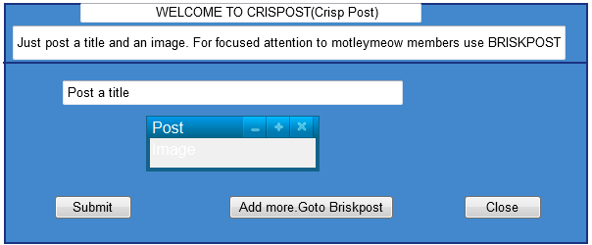

This page is the page where anyone can post anything on the site. It can be reached through briskpost option in the main page or from the pop-up at "Goto Briskpost". When you click on radio boxes separate panel gets invoked which is specific to the post.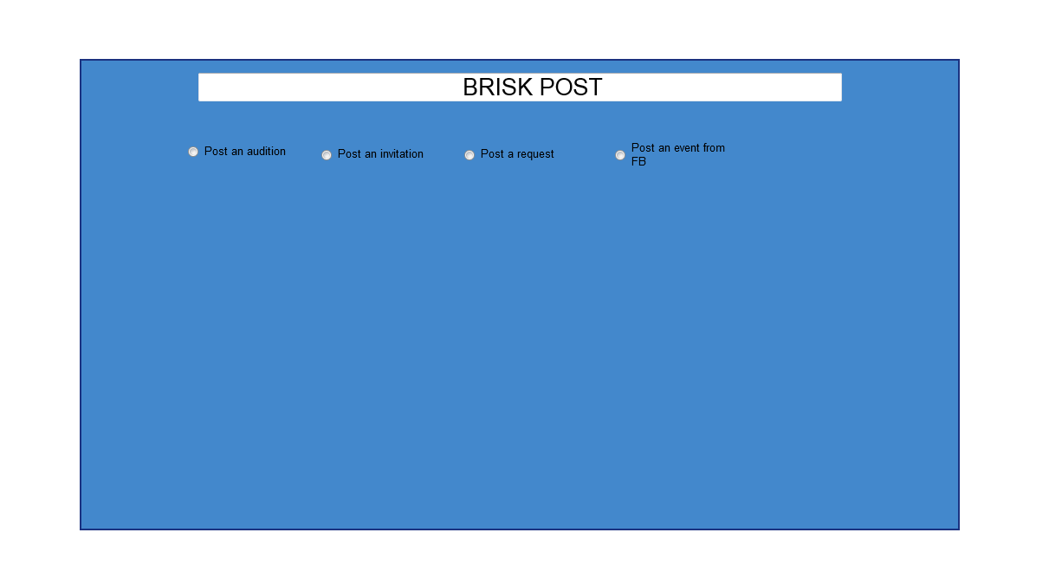

After that we have series of images showing what happens when radio buttons are pressed on specific items. It may not be complete in every sense but gives an idea what it will look like.