­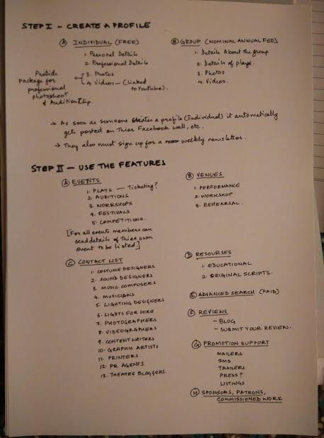

**Users of the website**:

1. Individuals who can login
2. Theatre Groups who can login
3. One who doesn’t login but just browsing the site

**One who just come for the first time in the website:**

1. View the events happening in town ( can also book tickets - TBD)
2. Login through facebook.
3. Download our app - TBD
4. Why should you join the website ( Contribute to theatre) ( Video message )

**Individual logged in(only through Facebook):**

1. ­­Profile will show the details captured from FB.
2. Link to Update profile, set your availability
3. Link to a page of ongoing auditions
4. Link to a page of theatre education(videos, materials, recommended books)
5. Link to a page of events going on in the town or anywhere(plays or workshops)
6. Other requirements/check inbox
7. Upcoming plays
8. Search(anything)

**Theatre groups:**

1. Profile will show the details captured from FB
2. Events tab ( sync through FB)
3. Search

**Events link:**

1. Sync through FB – dates, time + where it is being performed
2. Promote your event on the website main page - FREE
3. Promote your event (sms/emailers/posters/trailers) – **PAID**
4. Request for services – mailers to all categories – for eg.:

Request for service of a light designer who is having experience in designing lights of atleast 1-2 years..

This mail will go to all the individuals registered as light designers having 1-2 years exp.

**PAID**

1. Tickets booking- TBD
2. Request feedback from audience
3. Browse all database of contacts – **PAID**
4. Book a performance space/rehearsal spaces in Bangalore – to be maintained manually (TBD)
5. Search

**Search engine:**

1. Search all sort of contacts in the database
2. Advanced search - **PAID**

NICE TO HAVE:

1. Create a new profile without sync from FB.
2. Add/update photos/videos – in DB
3. Create an event from the website
4. Tickets booking
5. Space provider ( someone who can provide space for performance or for rehearsals)