Department of CSE, IIT (BHU)

Undergraduate Project Plan

Title: Segmentation of Capsule Endoscopic Images Gastro Intestinal Tract.

Team: Name 1: Pradumn Jalan Roll No 15074011
Name 2: Animesh Anand Roll No 15075005
Name 3: Anand Vir Singh Chauhan Roll No 15074003

Supervisor(s): Prof. Rajeev Srivastava

Objective:

Capsule endoscopy is a procedure used to record internal images of the gastrointestinal tract for use in medical diagnosis. The capsule is similar in shape to a standard pharmaceutical capsule, although a little larger, and contains a tiny camera and an array of LEDs powered by a battery. After a patient swallows the capsule, it passes along the gastrointestinal tract taking a number of images per second which are transmitted wirelessly to an array of receivers connected to a portable recording device carried by the patient. The primary use of capsule endoscopy is to examine areas of the small intestine that cannot be seen by other types of endoscopy.
Our aim is to determine whether any abnormality in gastrointestinal tract (Ulcer, Cancer or other infections) is present or not. If any abnormality is present, then we have to classify which kind of infection is there in the gastrointestinal tract like Ulcer or Cancer etc.

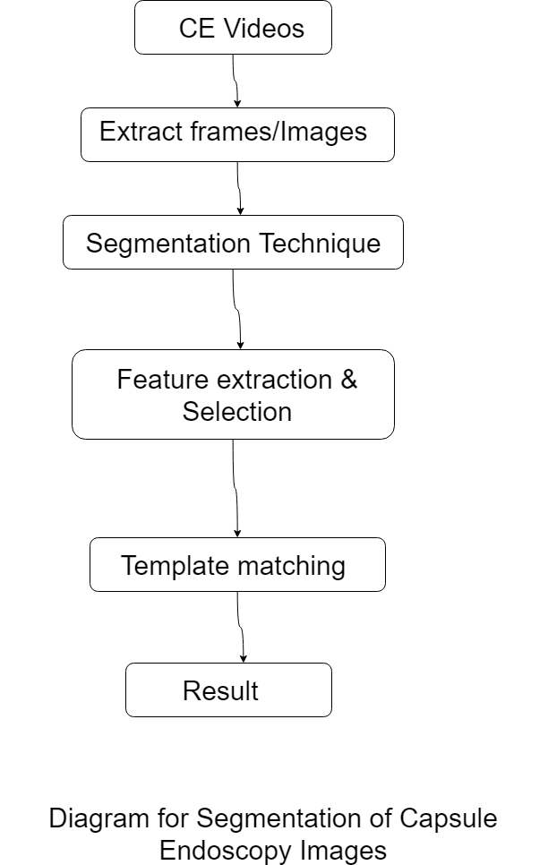

Deliverables / Achievable

On successful completion of the project we will be able to process a video of gastrointestinal tract and able to say whether there is any abnormality in in this tract or not. If there is any abnormality, then recognise which kind of infection is present in the tract.

Work Plan:
I. Week-wise/ Month-wise plan for Semester VI:
Remaining January to Mid-February:
Collect the Capsule Endoscopy Videos for the Gastro Intestinal Tract and extract images from those. The capsule emits images at a rate of 2 frames/s for over 8 h, that can result with 57600 images for a single study. Also, we aim to learn programming using Computer Vision libraries.
(Python or Matlab)
Mid-February to March:
Here we will have to study about the existing image segmentation techniques. Image segmentation is the process of partitioning a digital image into multiple segment. Image segmentation is typically used to locate objects and boundaries in images. More precisely, image segmentation is the process of assigning a label to every pixel in an image such that pixels with the same label share certain characteristics.
Our aim is to recognise abnormal (Ulcer/Cancer) areas or boundary of those areas. For this work to be done we need to study and implement different techniques which is more effective for the aforementioned work of distinguishing or segmenting the boundaries of abnormal areas.
After the segmentation is performed we need to make out more images out of the segmented images for different angles for further processing.

April:
Feature Extraction and Selection of the segmented Image Features extraction starts from an initial set of measured data and builds derived values (features) intended to be informative and non-redundant, facilitating the subsequent learning and generalization steps, and in some cases leading to better human interpretations. Feature extraction is related to dimensionality reduction. Depending on the complexity of the images we may switch to next step in the April itself.
We will proceed with our final step of Template Matching.
Template matching is a technique in digital image processing for finding small parts of an image which match a template image. It can be used in manufacturing as a part of quality control, a way to navigate a mobile robot, or as a way to detect edges in images.
In our case we have templates of Ulcer/Cancer in intestine in different orientations (rotated with different angles and partial parts).
Template based matching will be done by using cross correlation or sum of absolute differences.
A basic method of template matching uses an image patch (template), tailored to a specific feature of the search image, which we want to detect. This technique can be easily performed on grey images or edge images. The cross-correlation output will be highest at places where the image structure matches the mask structure, where large image values get multiplied by large mask values.

II. Broad overview plan for Semester VII

For this semester we will try to improve the performance of prototype and try to explore other methods and techniques to implement it.

We plan to work according to the above plan.

Signature of students with name:

1.
2.
3.
4.

The above plan is approved.

Signature of Supervisor(s) with date ___________________________________

