RawFit Project Diagrams

Activity Diagram
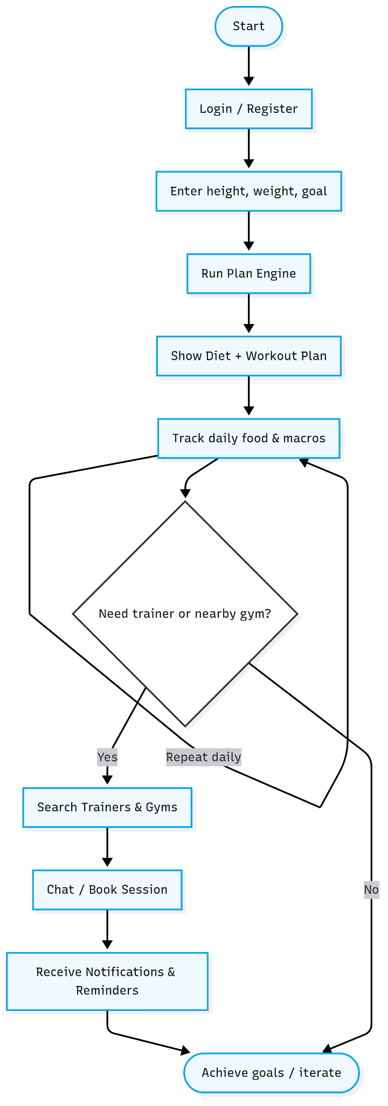
Activity Diagram

Class Diagram
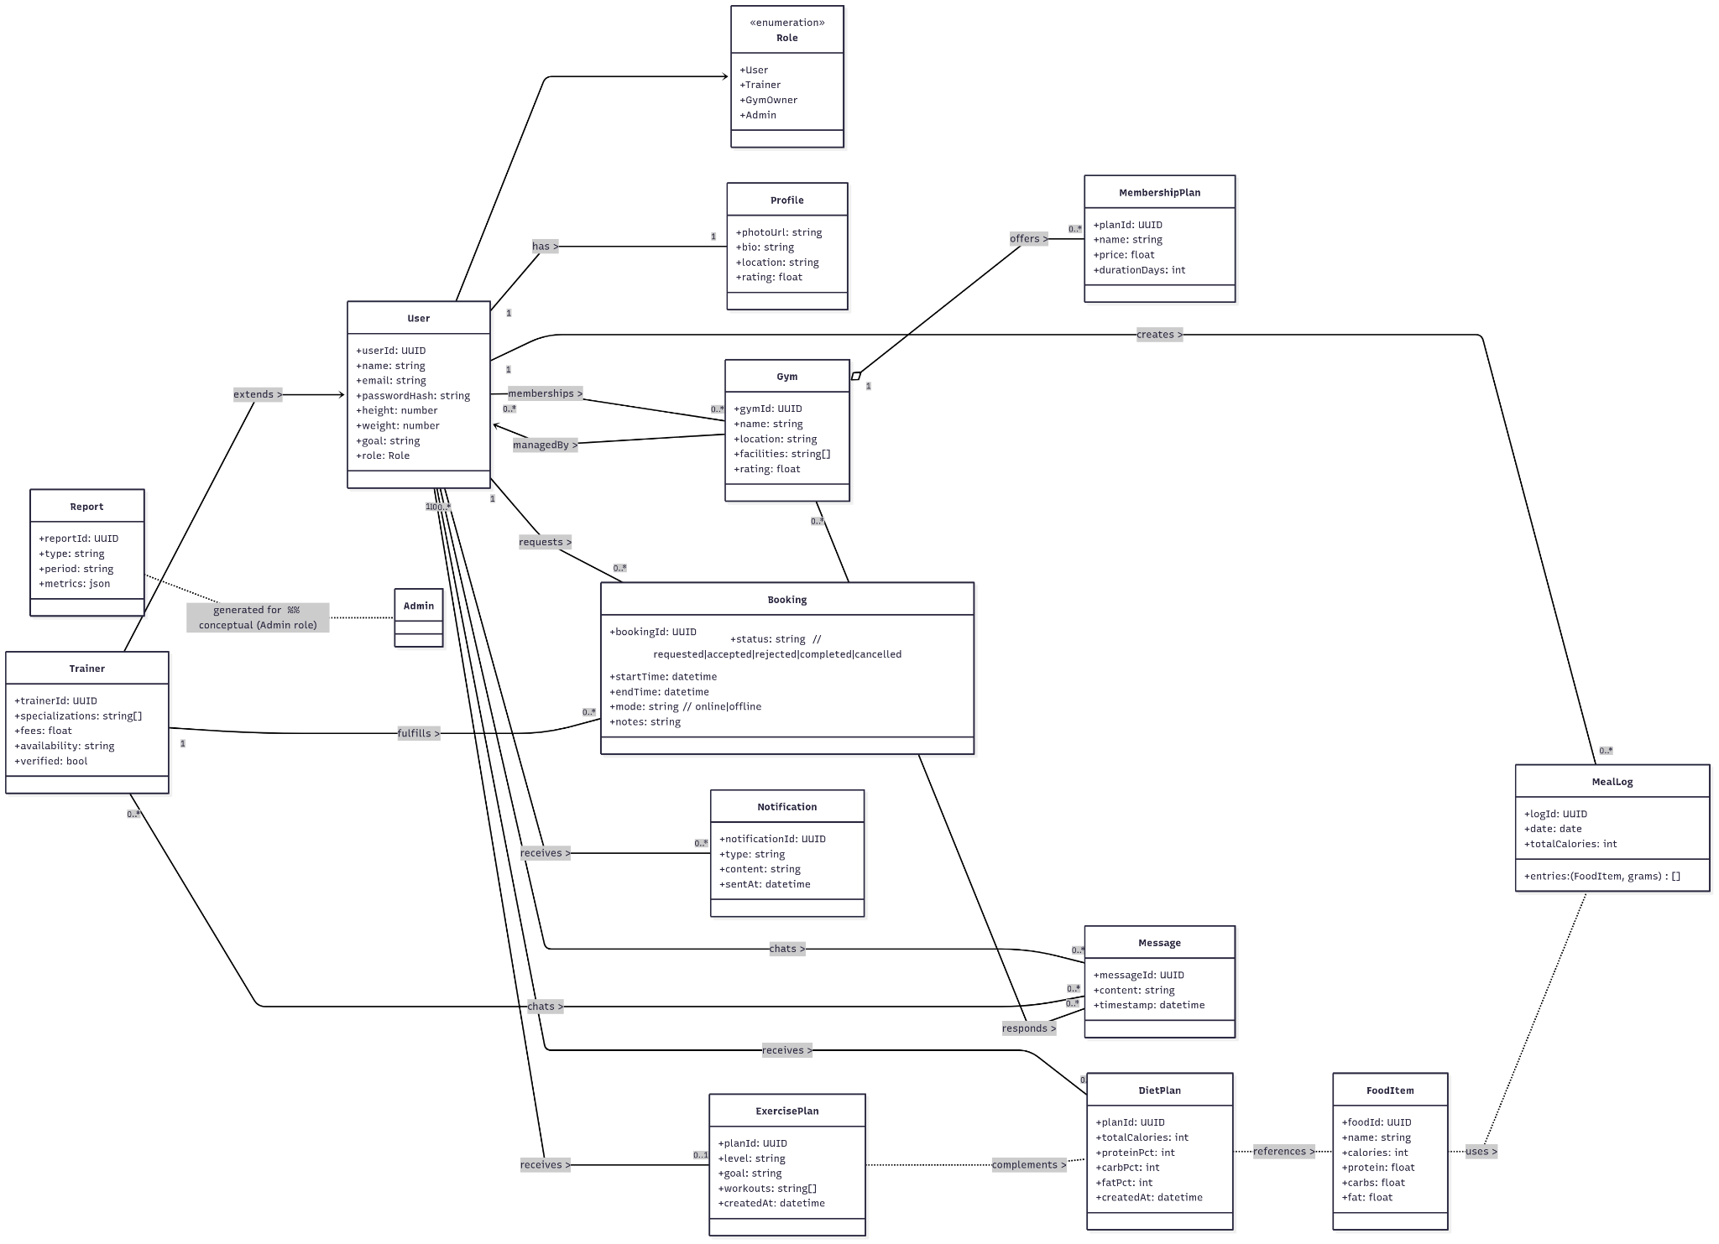
Class Diagram

DFD Level 0
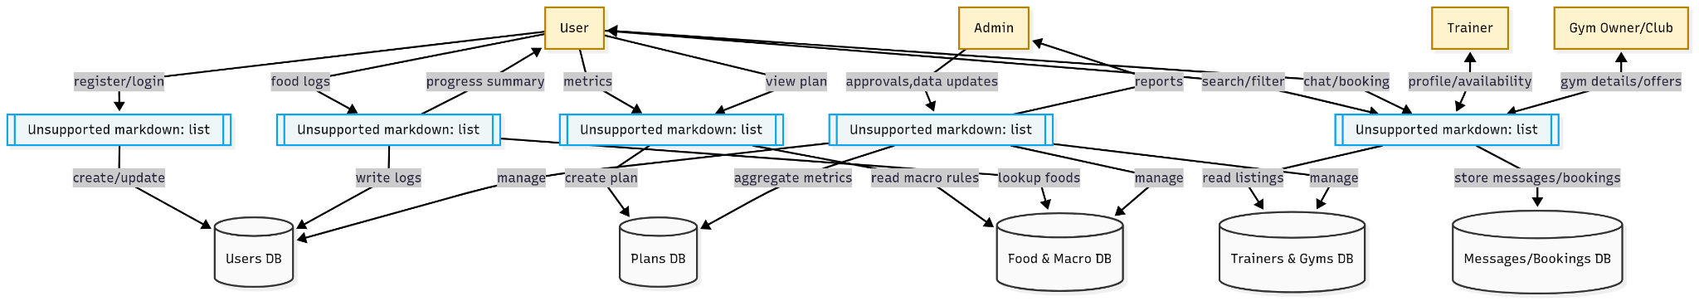
DFD Level 0

DFD Level 1
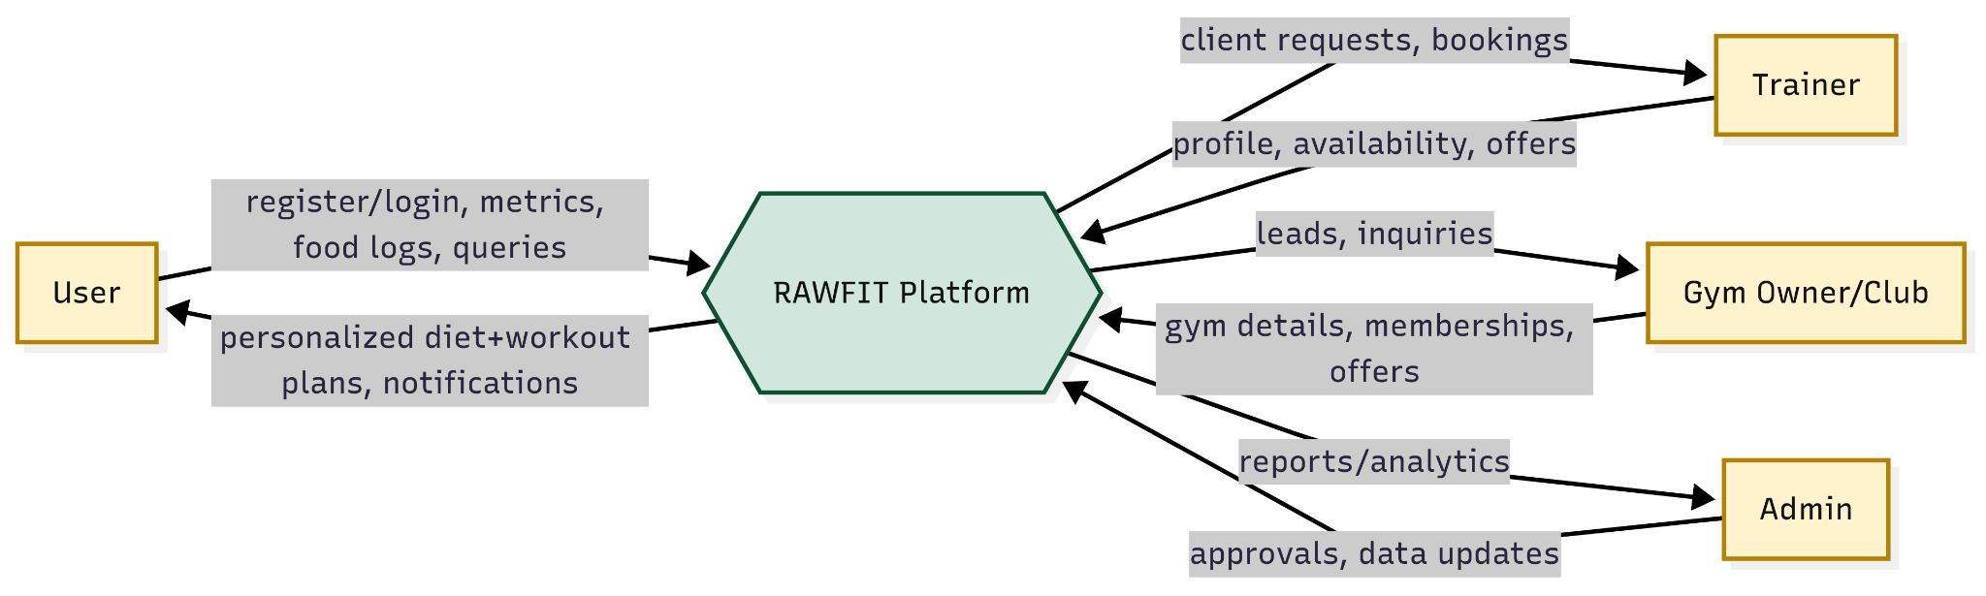
DFD Level 1

DFD Level 2
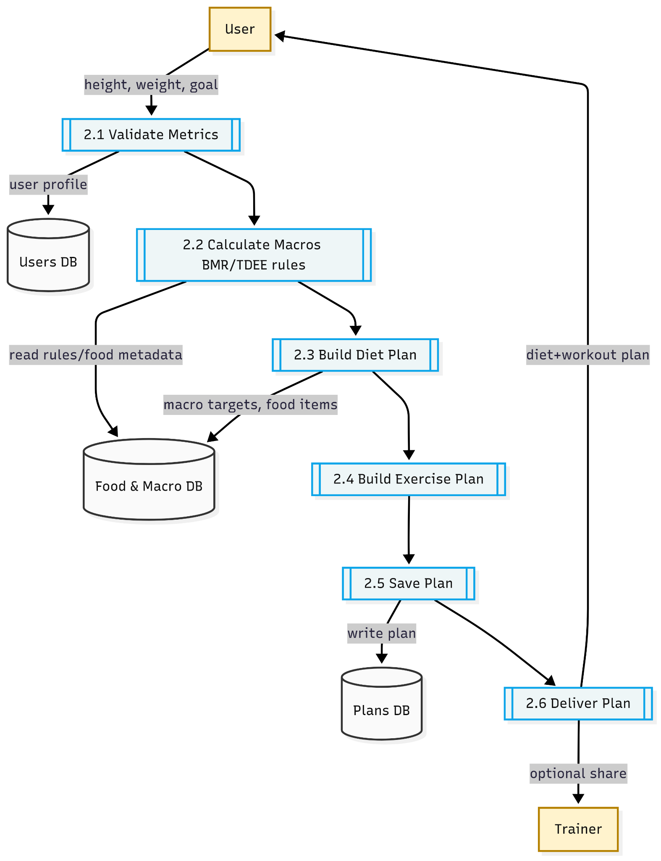
DFD Level 2

Sequence Diagram
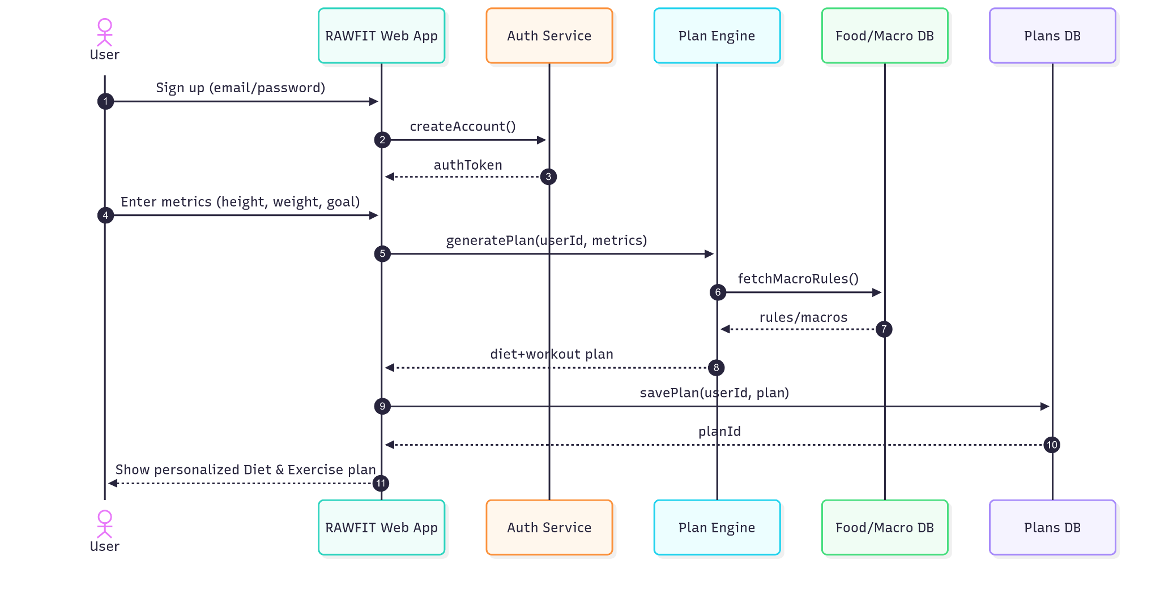
Sequence Diagram

