Abstract
Children are increasingly exposed to generative artificial intelligence (AI) systems during critical periods of cognitive development, yet the effects of such exposure on selective trust remain poorly understood. This study introduces a home-based event-boundary paradigm designed to test epistemic deference within a child–caregiver–AI triadic context. One child (aged 3 years) and a caregiver viewed a 2:04-minute clip from Bluey with four predefined pauses: two at event boundaries (high narrative uncertainty) and two at control moments (low uncertainty). At each pause, the child completed three tasks: event segmentation (“same/new”), narrative prediction, and deference choice under caregiver–AI disagreement. Informant accuracy was counterbalanced by design (AI correct at boundaries; caregiver correct at controls; both 2/4 overall), isolating contextual uncertainty from cumulative reliability learning. As a proof-of-concept pilot (N = 1), the study targeted feasibility and mechanism-level hypothesis refinement rather than population-level effect estimation. The protocol was fully executable and produced complete trial-level data. Overall robot choice was 3/4, yet robot deference was lower at boundaries (.50) than controls (1.00), yielding a negative boundary deference effect (Δ = –.50). Segmentation and prediction accuracy dropped from perfect in the first half (1.00) to null in the second half (.00), suggesting attentional or fatigue contamination. The pilot does not confirm the original directional hypothesis; instead, it supports a refined model in which epistemic deference reflects interactions among novelty bias, recency-weighted reliability tracking, and subjective boundary detection. These findings justify progression to a preregistered, adequately powered confirmatory study.
Keywords: selective trust, epistemic deference, event segmentation, artificial intelligence, cognitive offloading, early childhood, proof-of-concept pilot

1. Introduction
From at least the age of three, children are not indiscriminate consumers of testimony. They express trust by integrating informant characteristics (e.g. familiarity, past accuracy, and attributed expertise) into their learning decisions (Harris and Corriveau, 2011; Koenig and Harris, 2005). This capacity for selective trust is a cornerstone of cultural learning. It enables children to acquire knowledge efficiently while filtering unreliable sources (Tomasello et al., 2005). Crucially, the relation between an informant’s accuracy history and children’s trust is robust enough that it resists moderation by inferences about the informant’s traits or intentions (Ronfard and Lane, 2018). Yet contemporary digital ecologies introduce a radically new epistemic actor into the child’s social world: generative artificial intelligence.
AI systems such as voice assistants, smart toys, and large language model interfaces are now present in many households with young children (Xu, 2024). These systems generate predictions, offer explanations, and answer questions with surface fluency that can be mistaken for genuine competence, a phenomenon that recent work has termed the confidence heuristic (Jose and Thomas, 2025). Emerging research on epistemic trust in generative AI demonstrates that users, including students, often accept AI-generated output uncritically, engaging in what has been called automation bias (Jose, B. et al., 2025). A growing body of work warns that heavy cognitive offloading onto AI tools may produce illusions of understanding and reduce the kind of effortful engagement on which deep learning depends (Fan et al., 2025; Gerlich, 2025). Yet nearly all of this evidence comes from adults or adolescents. The developmental question, how preschool children, whose epistemic vigilance mechanisms are still maturing (Sperber et al., 2010), navigate trust decisions involving AI; remains largely unaddressed.
Event-segmentation theory provides a tractable framework for studying the cognitive conditions under which trust decisions occur. According to this theory, people spontaneously parse continuous experience into discrete events, and narrative boundaries (points at which the situational model must be updated) generate transient increases in prediction error and uncertainty (Zacks et al., 2007). We hypothesized that these moments of heightened epistemic openness could function as natural modulators of deference. Specifically, if a child’s internal model is disrupted at an event boundary, the child may be more susceptible to external guidance, including guidance from a novel artificial informant.
A central methodological challenge in testing this hypothesis is separating the effects of contextual uncertainty from simple reliability learning. If one informant is consistently more accurate across trials, any observed deference pattern may reflect cumulative reinforcement history rather than boundary-specific epistemic openness. To address this confound, the present paradigm counterbalances informant accuracy by condition: the AI is correct at event boundaries, the caregiver is correct at control moments, and both informants end with identical overall accuracy (2/4 each). This design isolates the contextual effect of boundary uncertainty from the accumulation of differential reliability.
The original directional hypothesis predicted higher AI deference at event boundaries. However, because the paradigm is novel and involves a demanding triadic interaction with a 3-year-old in a domestic setting, a proof-of-concept pilot was necessary before committing to a powered confirmatory study. Consistent with best practice in experimental design (Leon et al., 2011), the primary goals of this pilot were: (a) to evaluate operational feasibility, (b) to test whether the measurement system yields interpretable behavioral variance, and (c) to identify design-level threats and refine the theoretical model.
Before committing to a large-scale confirmatory study, a proof-of-concept pilot using a Single-Case Experimental Design (SCED) is methodologically imperative. Following the logic of Smith and Little (2018), small-N designs are not merely “preliminary” but are often superior for discovering cognitive mechanisms that are obscured by group averaging in large-N samples. This pilot adopts a “discovery-oriented” approach, prioritizing procedural fidelity and the identification of nuisance variables (e.g., novelty bias, fatigue) over population-level inference.

2. Method

The present study employed a Single-Case Experimental Design (SCED) to evaluate the operational viability of a novel domestic paradigm designed to measure epistemic deference (trust) in early childhood. This pilot phase focused on a single three-year-old participant in an ecological home setting. The primary objective was not to confirm generalizable effects but to refine the experimental protocol and identify qualitative markers of cognitive conflict that group averages might otherwise obscure.

2.1 Design
This was a single-case proof-of-concept pilot using a within-session repeated-measures structure (four trials: P1–P4). The inferential target was feasibility and mechanism discovery, not population-level confirmation. The study follows the SCRIBE 2016 (Single-Case Reporting guideline In BEhavioural interventions) statement to ensure transparency and rigor in reporting. Although this is a feasibility pilot, the use of a within-session repeated-measures structure allows for 'dense' observation of trial-level trajectories, which is critical for evaluating how narrative uncertainty modulates choice in real-time.

2.3 Participant and setting
One child (3 years, male) participated with a primary caregiver in a domestic setting. The caregiver was present throughout. The protocol was administered via a portable proyector and the child responded using physical cards depicting the caregiver and a cartoon robot. Informed consent was obtained from the caregiver. The study complied with the Declaration of Helsinki and institutional ethical guidelines. The study protocol was reviewed and approved by the Research Ethics Committee of the University of Granada (CEIH), approval number 4948/CEIH/2025

2.4 Materials and stimulus
The stimulus was a 2:04-minute clip from Bluey Season 1, Episode 1 (“Magic Xylophone”). Bluey was selected for its high narrative density, child appeal, and well-defined event structure. Four pause points were pre-specified based on prior event-segmentation coding of the episode:
P1 (Boundary, ~0:25): Scene transition—AI-correct trial.
P2 (Control, ~0:50): Within-scene continuation—caregiver-correct trial.
P3 (Boundary, ~1:15): Scene transition—AI-correct trial.
P4 (Control, ~1:35): Within-scene continuation—caregiver-correct trial.

2.5 Procedure
At each pause, the same three-step micro-protocol was administered:
Segmentation. The child was asked: “Is it the same thing happening, or is something new happening?” This provides a behavioral index of subjective boundary detection.
Prediction. The child chose between two forced-choice options for what would happen next. This assesses narrative prediction accuracy as a proxy for model-updating engagement.
Deference. The caregiver and the AI (represented by the robot card and a pre-recorded voice) offered opposing predictions. The child selected which informant to follow. This is the primary measure of epistemic deference.
After each response, playback resumed for approximately 10–15 seconds so the child could observe the true outcome and update informant accuracy representations.

2.6 Measures
The primary construct was the boundary deference effect, operationalized as Δ_{deference} = P(robot | boundary) – P(robot | control). Secondary outcomes included, for example, segmentation accuracy by condition and session half, prediction accuracy by condition and session half, deference rate by condition, and hesitation (binary: present/absent) as a conflict marker.

2. 7 Analytic strategy
Given N = 1 and four trials, analyses were descriptive and case-based: (a) trial-level trajectory analysis, (b) condition-level proportions, (c) first-half versus second-half temporal profile, and (d) exact binomial 95% confidence intervals for observed proportions. No confirmatory population inferences were attempted.

3. Results

3.1 Feasibility and data completeness
The full protocol was completed (4/4 trials). All planned variables were captured without missing values. The counterbalanced accuracy manipulation was successfully implemented as designed. Administration time was approximately five minutes, well within the attentional tolerance window for this age group.

3. 2 Trial-level pattern
The deference sequence across trials was: Robot (P1), Robot (P2), Caregiver (P3), Robot (P4). Hesitation—operationalized as a visible delay or gaze alternation between response cards—occurred only at P1. This trial-level trajectory is displayed in Figure 1.
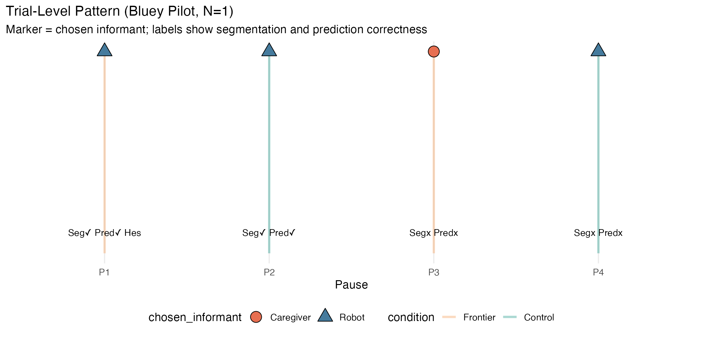
Figure 1. Trial-level response pattern across P1–P4. Markers indicate chosen informant (triangle = robot; circle = caregiver). Vertical bars are color-coded by condition (orange = boundary; teal = control). Bottom labels show segmentation and prediction correctness (✓ = correct; x = incorrect) and hesitation marker.

3. 3 Condition-level outcomes
Overall robot choice was 3/4 = .75, 95% CI [.194, .994]. Robot choice at event boundaries was 1/2 = .50, 95% CI [.013, .987]; at control moments, 2/2 = 1.00, 95% CI [.158, 1.000]. The boundary deference effect was Δ_{deference} = –.50. These condition-level outcomes are summarized in Figure 2.
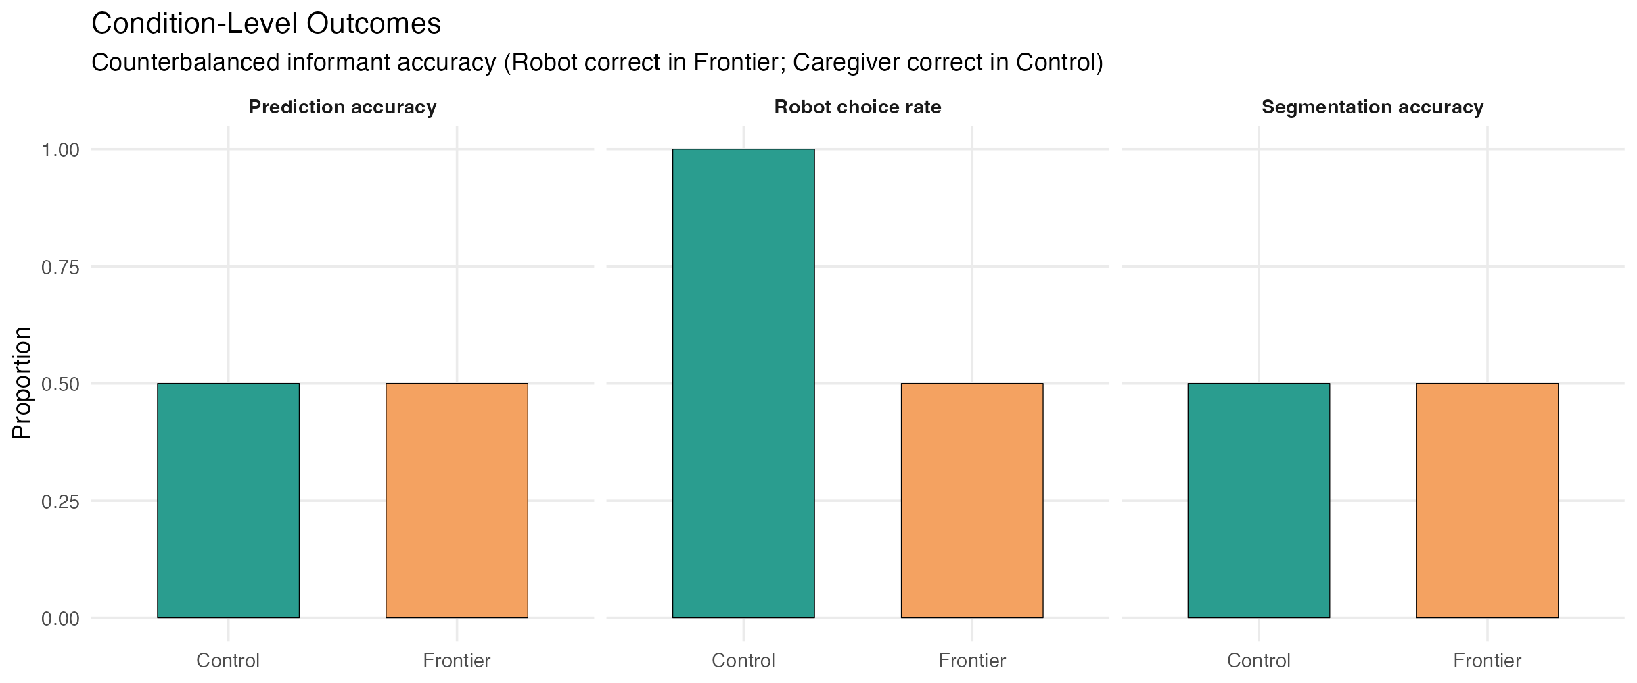
Figure 2. Condition-level outcomes for prediction accuracy, robot choice rate, and segmentation accuracy, disaggregated by condition (control vs. boundary). Informant accuracy was counterbalanced: robot correct at boundaries, caregiver correct at controls.

3.4 Temporal profile
Segmentation accuracy in the first half (P1–P2) was 2/2 = 1.00, 95% CI [.158, 1.000]; in the second half (P3–P4), 0/2 = .00, 95% CI [.000, .842]. Prediction accuracy followed an identical pattern: 1.00 in the first half, .00 in the second half. This complete first-to-second-half collapse, displayed in Figure 3, is consistent with attentional fatigue or disengagement in a four-pause sequence for this age group.
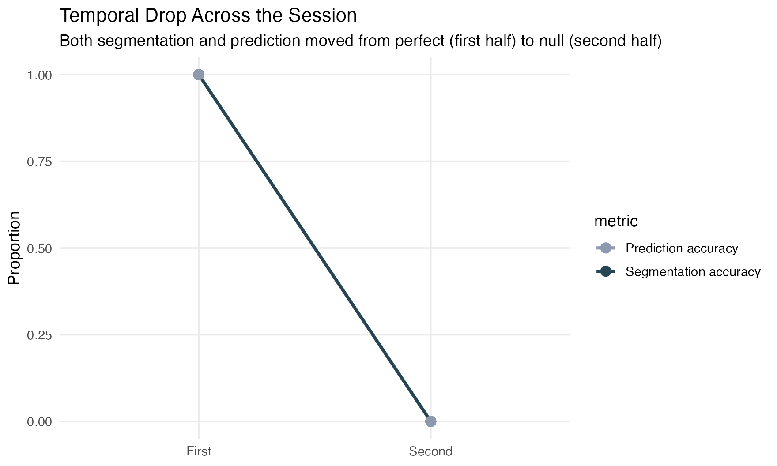
Figure 3. Temporal profile of segmentation accuracy and prediction accuracy by session half. Both metrics dropped from perfect performance in the first half (P1–P2) to null performance in the second half (P3–P4), indicating attentional or fatigue contamination.

4. Discussion

4.1. Summary of findings
This pilot did not support the original directional hypothesis that AI deference would increase at event boundaries. The observed boundary deference effect was negative (Δ = –.50), with the child choosing the robot less at boundaries than at control moments. Nevertheless, the pilot generated diagnostic evidence that is essential for theory refinement and design correction prior to a confirmatory study.

4.2. Mechanistic interpretation
Four patterns from the trial-level data warrant theoretical attention.
(1) Baseline novelty attraction. The child chose the robot in 3 of 4 trials, consistent with the well-documented novelty bias that preschoolers exhibit toward robotic and AI agents (Kahn et al., 2012). This baseline preference complicates the interpretation of any boundary-specific effect, because ceiling-level robot choice in one condition leaves little room for a directional contrast. A brief familiarization phase in the confirmatory design should attenuate this inflation.
(2) Recency-weighted reliability tracking. The single caregiver choice occurred at P3, immediately after the child had observed the robot give an incorrect prediction at P1 (visible after P1 outcome feedback). This is consistent with short-horizon reliability weighting: the child may have updated her informant model based on the most recent error rather than cumulative accuracy (Corriveau and Harris, 2009). Such recency effects are well-documented in the selective trust literature and pose a specific confound that the between-subjects confirmatory design must address.
(3) Temporal degradation of cognitive engagement. The abrupt collapse of both segmentation and prediction accuracy from perfect in the first half to null in the second half signals attentional fatigue. This is a serious validity threat: if the child is disengaged during P3–P4, deference choices in those trials cannot be meaningfully interpreted as reflecting epistemic processing. The confirmatory design should reduce to two pauses per child (one boundary, one control) to stay within the attentional envelope of 3-year-olds.
(4) Epistemic conflict at first boundary. Hesitation occurred uniquely at P1, the first boundary exposure. This singular hesitation event is consistent with heightened epistemic conflict—a moment in which the child’s internal model was genuinely disrupted, and the deference decision carried subjective weight. The absence of hesitation in subsequent trials may reflect either resolution of the conflict or disengagement. In the confirmatory study, continuous latency coding should replace binary hesitation to capture graded conflict.

4.3 Toward a Refined Model of Epistemic Deference
The original hypothesis assumed a simple main effect of event boundaries on AI deference. The pilot data suggest that a more adequate model must incorporate at least three interacting processes: (a) novelty salience—the baseline attractiveness of a novel artificial agent; (b) recency-weighted reliability memory—the tendency to update informant trust based on the most recent outcome rather than cumulative accuracy; and (c) subjective boundary detection—the degree to which the child actually perceives a boundary, which may diverge from the experimenter’s structural coding. This refined model aligns with recent accounts of AI as epistemic infrastructure rather than mere tool (Chen, 2025), and with warnings about the erosion of epistemic vigilance when children engage with confident-sounding artificial agents (Jose and Thomas, 2025; Sperber et al., 2010).

4.4 Scientific validity of a single-case proof-of-concept
The validity claim of this study is narrow and explicit: it supports procedural and diagnostic validity, not population validity. What is validly established includes: (a) operational validity—the paradigm can be implemented end-to-end in a domestic setting with a 3-year-old; (b) measurement validity—all three behavioral channels (segmentation, prediction, deference) and the hesitation marker can be captured at trial resolution; (c) manipulation validity—the counterbalanced informant-accuracy structure can be executed as designed; and (d) mechanism discovery value—trial-level trajectories reveal concrete confounds (fatigue, novelty, recency) that would remain invisible in aggregate-only reporting.
What is explicitly not claimed: no population prevalence estimate, no confirmatory test of the original hypothesis, and no stable effect-size inference. This inferential boundary is methodologically necessary. Proof-of-concept work answers a different question from confirmatory work: “Does the design function, and which nuisance processes dominate?” versus “What is the population-level effect under preregistered inference?” (See, Leon et al., 2011). The present pilot answers the former and prepares the ground for the latter.
The primary contribution of this pilot is its diagnostic validity. By capturing the “second-half collapse” in segmentation and prediction accuracy , the pilot identifies a physiological ceiling in the attentional envelope of 3-year-olds. Rather than a failure, this finding serves as a “red-team” evaluation of the paradigm, providing empirical grounds to reduce the trial density in the confirmatory stage to avoid fatigue-induced noise.

4.5 Limitations
The principal limitations of this pilot are threefold. First, the single-participant design precludes any external generalizability. Second, the fixed within-session order induces confounding by fatigue and recency that cannot be disentangled from condition effects. Third, hesitation was coded as a binary variable; continuous response latency was not measured, limiting sensitivity to graded epistemic conflict.

4.6 Confirmatory next step
A scaled confirmatory design should incorporate: (a) a between-subjects structure with two pauses per child (one boundary, one control), eliminating within-session order and fatigue confounds; (b) a brief pre-task robot familiarization phase to attenuate novelty inflation; (c) continuous latency coding alongside binary deference choice as primary and secondary outcomes; (d) preregistered hypotheses and a fully specified analytic plan deposited on OSF prior to data collection; and (e) a target sample of approximately N = 130 (approximately 65 per condition), based on power analysis for the primary binary endpoint.

5. Conclusion
As a proof-of-concept pilot, this N = 1 study is scientifically valid within explicit inferential boundaries. Its contribution is not a population claim but the rigorous validation of a novel paradigm, the identification of dominant confounds, and the specification of a refined theoretical model. In an era in which generative AI is increasingly embedded in children’s epistemic environments (Jose, B. et al., 2025; Gerlich, 2025), understanding the conditions under which young children defer to artificial informants is both a developmental and a societal imperative. The present work provides the methodological foundation for that inquiry.

Statements & Declarations
Funding
This publication is part of CONFIIA project PID2024-156166OA-I00, funded by MICIU/AEI/10.13039/501100011033 and by the ESF+; and Consejería de Universidad, Investigación e Innovación, Junta de Andalucía (Grant EMEC_2023_00442).
Competing interests
The author has no relevant financial or non-financial interests to disclose.
Data availability
Data and materials are openly available on the Open Science Framework (OSF): https://osf.io/svjf9/.
The full project package is available under osfstorage/osf_package/, including trial-level de-identified pilot data, analysis scripts, study materials, and derived outputs.

References
Chen, B. (2025). Beyond tools: Generative AI as epistemic infrastructure in education. arXiv preprint, arXiv:2504.06928. https://doi.org/10.48550/arXiv.2504.06928
Corriveau, K. H., & Harris, P. L. (2009). Choosing your informant: Weighing familiarity and recent accuracy. Developmental Science, 12(3), 426–437. https://doi.org/10.1111/j.1467-7687.2008.00792.x
Fan, Y., Tang, L., Le, H., Shen, K., Tan, S., Zhao, Y., ... & Gasevic, D. (2025). Beware of metacognitive laziness: Effects of generative artificial intelligence on learning motivation, processes, and performance. British Journal of Educational Technology, 56(2), 489–530. https://doi.org/10.1111/bjet.13544
Gerlich, M. (2025). AI tools in society: Impacts on cognitive offloading and the future of critical thinking. Societies, 15(1), 6. https://doi.org/10.3390/soc15010006
Harris, P. L., & Corriveau, K. H. (2011). Young children’s selective trust in informants. Philosophical Transactions of the Royal Society B: Biological Sciences, 366(1567), 1179–1187. https://doi.org/10.1098/rstb.2010.0321
Jose, B., & Thomas, A (2025). Digital anthropomorphism and the psychology of trust in generative AI tutors: An opinion-based thematic synthesis. Frontiers in Computer Science, 7, 1638657. https://doi.org/10.3389/fcomp.2025.1638657
Jose, B., Cleetus, A., Joseph, B., Joseph, L., Jose, B., & John, A. K. (2025). Epistemic authority and generative AI in learning spaces: Rethinking knowledge in the algorithmic age. Frontiers in Education, 10, 1647687. https://doi.org/10.3389/feduc.2025.1647687
Kahn, P. H., Jr., Kanda, T., Ishiguro, H., Gill, B. T., Ruckert, J. H., Shen, S., ... & Severson, R. L. (2012). “Robovie, you’ll have to go into the closet now”: Children’s social and moral relationships with a humanoid robot. Developmental Psychology, 48(2), 303–314. https://doi.org/10.1037/a0027033
Koenig, M. A., & Harris, P. L. (2005). Preschoolers mistrust ignorant and inaccurate speakers. Child Development, 76(6), 1261–1277. https://doi.org/10.1111/j.1467-8624.2005.00849.x
Leon, A. C., Davis, L. L., & Kraemer, H. C. (2011). The role and interpretation of pilot studies in clinical research. Journal of Psychiatric Research, 45(5), 626–629. https://doi.org/10.1016/j.jpsychires.2010.10.008
Ronfard, S., & Lane, J. D. (2018). Preschoolers continually adjust their epistemic trust based on an informant’s ongoing accuracy. Child Development, 89(2), 414–429. https://doi.org/10.1111/cdev.12720
Smith, P. L., & Little, D. R. (2018). Small is beautiful: In defense of the small-N design. Psychonomic bulletin & review, 25(6), 2083-2101.
Sperber, D., Clément, F., Heintz, C., Mascaro, O., Mercier, H., Origgi, G., & Wilson, D. (2010). Epistemic vigilance. Mind & Language, 25(4), 359–393. https://doi.org/10.1111/j.1468-0017.2010.01394.x
Tate, R. L., Perdices, M., Rosenkoetter, U., Shadish, W., Vohra, S., Barlow, D. H., ... & Wilson, B. (2016). The single-case reporting guideline in behavioural interventions (SCRIBE) 2016 statement. Physical therapy, 96(7), e1-e10.
Tomasello, M., Carpenter, M., Call, J., Behne, T., & Moll, H. (2005). Understanding and sharing intentions: The origins of cultural cognition. Behavioral and Brain Sciences, 28(5), 675–735. https://doi.org/10.1017/S0140525X05000129
Xu, Y. (2024). AI’s impact on children’s social and cognitive development [Research presentation]. Children and Screens: Institute of Digital Media and Child Development, New York, NY.
Zacks, J. M., Speer, N. K., Swallow, K. M., Braver, T. S., & Reynolds, J. R. (2007). Event perception: A mind-brain perspective. Psychological Bulletin, 133(2), 273–293. https://doi.org/10.1037/0033-2909.133.2.273

