REPORTE DE CONTROL NOCTURNO (CORTES PROGRAMADOS)
Reporte generado: 19-03-2026 23:14:30 (hora local)

RESUMEN EJECUTIVO
Periodo evaluado: 2026-03-12 a 2026-03-18
Ventana de control: según horario de corte de cada establecimiento (Excel de horarios).
Umbral de alerta: > 0.000
Cantidad de puntos analizados: 20
Puntos cumpliendo corte: 7
Puntos fuera de control: 13
Porcentaje fuera de control: 65.00%

Gráfico de cumplimiento de control:
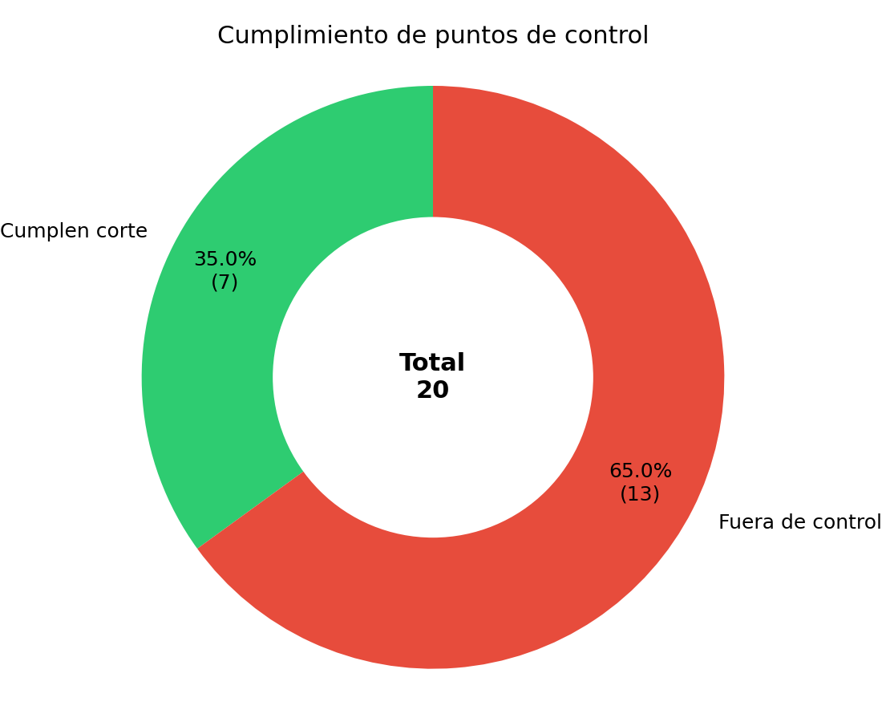

TABLA DE PUNTOS FUERA DE CONTROL
Se listan los puntos que registraron consumo durante la ventana de corte programada:
Fecha | Cliente | Establecimiento | Horas detectadas | Consumo total 00-06 | Máximo por hora | ID WES
2026-03-12 | PROVIDENCIA | LASTARRIA | 23:00(0.300); 00:00(0.050); 01:00(0.040); 02:00(0.040); 03:00(0.030); 04:00(0.040); 05:00(0.040); 06:00(0.030) | 0.570 | 0.300 | 000006-01
2026-03-12 | PROVIDENCIA | CARMELA CARVAJAL | 06:00(0.800) | 0.800 | 0.800 | 000006-02
2026-03-12 | CORMUP | ANTONIO HERMIDA FABRES | 00:00(1.200); 01:00(1.400); 02:00(1.400); 03:00(1.400); 04:00(1.300); 05:00(1.300); 06:00(1.400) | 9.400 | 1.400 | 000008-01
2026-03-12 | CORMUP | CARLOS FERNANDEZ PEÑA | 00:00(0.740); 01:00(0.750); 02:00(0.740); 03:00(0.770); 04:00(0.750); 05:00(0.750); 06:00(0.760) | 5.260 | 0.770 | 000008-03
2026-03-12 | CORMUP | TOBALABA | 00:00(2.800); 01:00(2.800); 02:00(2.900); 03:00(2.900); 04:00(2.800); 05:00(3.000); 06:00(2.900) | 20.100 | 3.000 | 000008-04
2026-03-12 | CORMUP | SANTAMARIA | 01:00(0.200) | 0.200 | 0.200 | 000008-05
2026-03-12 | CORMUP | ERASMO ESCALA | 00:00(0.700); 01:00(0.600); 02:00(0.600); 03:00(0.740); 04:00(0.550); 05:00(0.610); 06:00(0.600) | 4.400 | 0.740 | 000008-07
2026-03-12 | CORMUP | JUAN BAUTISTA PASTENES | 00:00(0.400); 01:00(0.500); 02:00(0.500); 03:00(0.400); 04:00(0.500); 05:00(0.500); 06:00(0.500) | 3.300 | 0.500 | 000008-09
2026-03-12 | LAS CONDES | COLEGIO FLEMING | 23:00(0.060); 00:00(64.000); 01:00(64.000); 02:00(64.000); 03:00(64.000); 04:00(64.000); 05:00(64.000); 06:00(64.000) | 448.060 | 64.000 | 000022-00
2026-03-12 | LA REINA | DE HOSTOS | 23:00(1.100); 00:00(1.000); 01:00(1.200); 02:00(1.100); 03:00(1.200); 04:00(1.200); 05:00(1.100); 06:00(1.100) | 9.000 | 1.200 | 000024-01
2026-03-12 | LA FLORIDA | LICEO ALTO CORDILLERA | 22:00(4.130); 23:00(4.070); 00:00(4.150); 01:00(4.200); 02:00(4.270); 03:00(4.280); 04:00(4.300); 05:00(4.290); 06:00(4.250) | 37.940 | 4.300 | 000028-01
2026-03-13 | PROVIDENCIA | LASTARRIA | 23:00(0.100) | 0.100 | 0.100 | 000006-01
2026-03-13 | PROVIDENCIA | CARMELA CARVAJAL | 06:00(0.900) | 0.900 | 0.900 | 000006-02
2026-03-13 | CORMUP | ANTONIO HERMIDA FABRES | 00:00(1.200); 01:00(1.300); 02:00(1.400); 03:00(1.300); 04:00(1.300); 05:00(1.400); 06:00(1.300) | 9.200 | 1.400 | 000008-01
2026-03-13 | CORMUP | CARLOS FERNANDEZ PEÑA | 00:00(0.730); 01:00(0.740); 02:00(0.760); 03:00(0.770); 04:00(0.750); 05:00(0.710); 06:00(0.110) | 4.570 | 0.770 | 000008-03
2026-03-13 | CORMUP | TOBALABA | 00:00(2.900); 01:00(2.700); 02:00(2.900); 03:00(2.900); 04:00(2.900); 05:00(2.900); 06:00(2.900) | 20.100 | 2.900 | 000008-04
2026-03-13 | CORMUP | SANTAMARIA | 00:00(0.020); 01:00(0.290); 03:00(0.090); 04:00(0.100); 05:00(0.020) | 0.520 | 0.290 | 000008-05
2026-03-13 | CORMUP | ERASMO ESCALA | 00:00(1.050); 01:00(1.110); 02:00(1.020); 03:00(1.060); 04:00(1.080); 05:00(1.000); 06:00(1.010) | 7.330 | 1.110 | 000008-07
2026-03-13 | CORMUP | JUAN BAUTISTA PASTENES | 00:00(0.400); 01:00(0.500); 02:00(0.500); 03:00(0.400); 04:00(0.500); 05:00(0.500); 06:00(0.500) | 3.300 | 0.500 | 000008-09
2026-03-13 | CORMUP | MATILDE HUICI NAVAS | 00:00(0.100); 01:00(0.280); 02:00(0.010); 03:00(0.160); 04:00(0.370); 05:00(0.380); 06:00(0.250) | 1.550 | 0.380 | 000008-10
2026-03-13 | LAS CONDES | COLEGIO FLEMING | 23:00(64.000); 00:00(0.050); 01:00(0.060); 02:00(0.060); 03:00(0.050); 04:00(0.060); 05:00(0.060); 06:00(0.060) | 64.400 | 64.000 | 000022-00
2026-03-13 | LA REINA | DE HOSTOS | 23:00(1.300); 00:00(1.200); 01:00(1.100); 02:00(1.100); 03:00(1.200); 04:00(1.200); 05:00(1.300); 06:00(1.100) | 9.500 | 1.300 | 000024-01
2026-03-13 | LA FLORIDA | LICEO ALTO CORDILLERA | 22:00(3.980); 23:00(4.000); 00:00(4.180); 01:00(4.190); 02:00(4.310); 03:00(4.330); 04:00(4.330); 05:00(4.320); 06:00(4.280) | 37.920 | 4.330 | 000028-01
2026-03-14 | CORMUP | ANTONIO HERMIDA FABRES | 00:00(1.300); 01:00(1.300); 02:00(1.300); 03:00(1.300); 04:00(1.400); 05:00(1.400); 06:00(1.300) | 9.300 | 1.400 | 000008-01
2026-03-14 | CORMUP | CARLOS FERNANDEZ PEÑA | 00:00(0.090); 01:00(0.100); 02:00(0.090); 03:00(0.100); 04:00(0.100); 05:00(0.100); 06:00(0.100) | 0.680 | 0.100 | 000008-03
2026-03-14 | CORMUP | TOBALABA | 00:00(2.800); 01:00(2.800); 02:00(2.900); 03:00(2.900); 04:00(2.900); 05:00(3.000); 06:00(2.900) | 20.200 | 3.000 | 000008-04
2026-03-14 | CORMUP | SANTAMARIA | 00:00(0.080); 01:00(0.240); 02:00(0.070) | 0.390 | 0.240 | 000008-05
2026-03-14 | CORMUP | ERASMO ESCALA | 00:00(0.600); 01:00(0.700); 02:00(0.690); 03:00(0.610); 04:00(0.600); 05:00(0.630); 06:00(0.670) | 4.500 | 0.700 | 000008-07
2026-03-14 | CORMUP | JUAN BAUTISTA PASTENES | 00:00(0.400); 01:00(0.500); 02:00(0.500); 03:00(0.500); 04:00(0.400); 05:00(0.500); 06:00(0.500) | 3.300 | 0.500 | 000008-09
2026-03-14 | CORMUP | MATILDE HUICI NAVAS | 00:00(0.210); 01:00(0.010); 02:00(0.370); 03:00(0.600); 04:00(0.510); 05:00(0.470); 06:00(0.470) | 2.640 | 0.600 | 000008-10
2026-03-14 | LAS CONDES | COLEGIO FLEMING | 23:00(64.000); 00:00(64.000); 01:00(64.000); 02:00(64.000); 04:00(64.000); 06:00(0.010) | 320.010 | 64.000 | 000022-00
2026-03-14 | LA REINA | DE HOSTOS | 23:00(1.300); 00:00(1.200); 01:00(2.100); 02:00(2.100); 03:00(1.400); 04:00(1.300); 05:00(1.400); 06:00(2.100) | 12.900 | 2.100 | 000024-01
2026-03-14 | LA FLORIDA | LICEO ALTO CORDILLERA | 22:00(4.040); 23:00(4.080); 00:00(4.090); 01:00(4.110); 02:00(4.180); 03:00(4.210); 04:00(4.210); 05:00(4.230); 06:00(4.200) | 37.350 | 4.230 | 000028-01
2026-03-15 | CORMUP | ANTONIO HERMIDA FABRES | 00:00(1.300); 01:00(1.200); 02:00(1.300); 03:00(1.300); 04:00(1.400); 05:00(2.200); 06:00(1.300) | 10.000 | 2.200 | 000008-01
2026-03-15 | CORMUP | CARLOS FERNANDEZ PEÑA | 00:00(0.090); 01:00(0.100); 02:00(0.080); 03:00(0.100); 04:00(0.100); 05:00(0.100); 06:00(0.110) | 0.680 | 0.110 | 000008-03
2026-03-15 | CORMUP | TOBALABA | 00:00(2.900); 01:00(2.900); 02:00(2.800); 03:00(2.900); 04:00(2.900); 05:00(3.000); 06:00(2.900) | 20.300 | 3.000 | 000008-04
2026-03-15 | CORMUP | SANTAMARIA | 03:00(0.030); 04:00(0.020) | 0.050 | 0.030 | 000008-05
2026-03-15 | CORMUP | ERASMO ESCALA | 00:00(0.590); 01:00(0.710); 02:00(0.720); 03:00(0.650); 04:00(0.620); 05:00(0.710); 06:00(0.620) | 4.620 | 0.720 | 000008-07
2026-03-15 | CORMUP | JUAN BAUTISTA PASTENES | 00:00(0.500); 01:00(0.500); 02:00(0.400); 03:00(0.500); 04:00(0.500); 05:00(0.500); 06:00(0.400) | 3.300 | 0.500 | 000008-09
2026-03-15 | CORMUP | MATILDE HUICI NAVAS | 00:00(0.070); 01:00(0.010); 02:00(0.030); 03:00(0.010) | 0.120 | 0.070 | 000008-10
2026-03-15 | LAS CONDES | COLEGIO FLEMING | 23:00(64.000); 00:00(64.000); 01:00(64.000); 02:00(64.010); 03:00(64.000); 04:00(64.000); 05:00(64.000); 06:00(64.000) | 512.010 | 64.010 | 000022-00
2026-03-15 | LA REINA | DE HOSTOS | 23:00(3.200); 00:00(1.200); 01:00(1.300); 02:00(1.300); 03:00(1.400); 04:00(1.400); 05:00(1.300); 06:00(1.300) | 12.400 | 3.200 | 000024-01
2026-03-15 | LA FLORIDA | LICEO ALTO CORDILLERA | 22:00(3.960); 23:00(4.020); 00:00(4.140); 01:00(4.130); 02:00(4.220); 03:00(4.240); 04:00(4.240); 05:00(4.240); 06:00(4.250) | 37.440 | 4.250 | 000028-01
2026-03-16 | PROVIDENCIA | LASTARRIA | 23:00(0.400) | 0.400 | 0.400 | 000006-01
2026-03-16 | PROVIDENCIA | CARMELA CARVAJAL | 06:00(0.800) | 0.800 | 0.800 | 000006-02
2026-03-16 | CORMUP | ANTONIO HERMIDA FABRES | 00:00(1.400); 01:00(1.300); 02:00(1.200); 03:00(1.300); 04:00(1.400); 05:00(2.200); 06:00(1.300) | 10.100 | 2.200 | 000008-01
2026-03-16 | CORMUP | CARLOS FERNANDEZ PEÑA | 00:00(0.100); 01:00(0.100); 02:00(0.100); 03:00(0.100); 04:00(0.100); 05:00(0.100); 06:00(0.100) | 0.700 | 0.100 | 000008-03
2026-03-16 | CORMUP | TOBALABA | 00:00(3.000); 01:00(2.800); 02:00(2.900); 03:00(3.000); 04:00(2.900); 05:00(2.900); 06:00(3.000) | 20.500 | 3.000 | 000008-04
2026-03-16 | CORMUP | ERASMO ESCALA | 00:00(0.700); 01:00(0.750); 02:00(0.710); 03:00(0.660); 04:00(0.660); 05:00(0.700); 06:00(0.640) | 4.820 | 0.750 | 000008-07
2026-03-16 | CORMUP | JUAN BAUTISTA PASTENES | 00:00(0.500); 01:00(0.500); 02:00(0.500); 03:00(0.500); 04:00(0.400); 05:00(0.500); 06:00(0.600) | 3.500 | 0.600 | 000008-09
2026-03-16 | CORMUP | MATILDE HUICI NAVAS | 05:00(0.010); 06:00(0.130) | 0.140 | 0.130 | 000008-10
2026-03-16 | LAS CONDES | COLEGIO FLEMING | 23:00(0.040); 00:00(64.000); 01:00(64.000); 02:00(64.000); 03:00(64.000); 04:00(64.000); 05:00(64.000); 06:00(64.000) | 448.040 | 64.000 | 000022-00
2026-03-16 | LA REINA | DE HOSTOS | 23:00(1.200); 00:00(2.200); 01:00(1.300); 02:00(2.000); 03:00(1.400); 04:00(1.300); 05:00(2.300); 06:00(1.300) | 13.000 | 2.300 | 000024-01
2026-03-16 | LA FLORIDA | LICEO ALTO CORDILLERA | 22:00(4.110); 23:00(4.180); 00:00(4.140); 01:00(4.170); 02:00(4.230); 03:00(4.250); 04:00(4.250); 05:00(4.240); 06:00(4.200) | 37.770 | 4.250 | 000028-01
2026-03-17 | PROVIDENCIA | LASTARRIA | 23:00(0.300) | 0.300 | 0.300 | 000006-01
2026-03-17 | PROVIDENCIA | CARMELA CARVAJAL | 06:00(1.200) | 1.200 | 1.200 | 000006-02
2026-03-17 | CORMUP | ANTONIO HERMIDA FABRES | 00:00(1.200); 01:00(1.300); 02:00(1.400); 03:00(1.300); 04:00(1.300); 05:00(1.300); 06:00(1.400) | 9.200 | 1.400 | 000008-01
2026-03-17 | CORMUP | CARLOS FERNANDEZ PEÑA | 00:00(0.110); 01:00(0.110); 02:00(0.110); 03:00(0.120); 04:00(0.120); 05:00(0.120); 06:00(0.120) | 0.810 | 0.120 | 000008-03
2026-03-17 | CORMUP | TOBALABA | 00:00(3.000); 01:00(3.100); 02:00(3.200); 03:00(3.200); 04:00(3.200); 05:00(3.200); 06:00(3.300) | 22.200 | 3.300 | 000008-04
2026-03-17 | CORMUP | SANTAMARIA | 00:00(0.040); 01:00(0.080); 02:00(0.060) | 0.180 | 0.080 | 000008-05
2026-03-17 | CORMUP | ERASMO ESCALA | 00:00(0.870); 01:00(0.850); 02:00(0.680); 03:00(0.740); 04:00(0.790); 05:00(0.650); 06:00(0.820) | 5.400 | 0.870 | 000008-07
2026-03-17 | CORMUP | JUAN BAUTISTA PASTENES | 00:00(0.400); 01:00(0.500); 02:00(0.400); 03:00(0.500); 04:00(0.500); 05:00(0.500); 06:00(0.600) | 3.400 | 0.600 | 000008-09
2026-03-17 | CORMUP | MATILDE HUICI NAVAS | 00:00(1.290); 01:00(1.130); 02:00(1.440); 03:00(1.120); 04:00(1.280); 05:00(0.950); 06:00(1.200) | 8.410 | 1.440 | 000008-10
2026-03-17 | RENCA | CUMBRE DE CONDORES PONIENTE | 06:00(0.100) | 0.100 | 0.100 | 000017-07
2026-03-17 | LAS CONDES | COLEGIO FLEMING | 23:00(0.080); 00:00(0.030); 01:00(0.040); 02:00(0.030); 03:00(0.040); 04:00(0.030); 05:00(0.040); 06:00(0.030) | 0.320 | 0.080 | 000022-00
2026-03-17 | LA REINA | DE HOSTOS | 23:00(1.100); 00:00(1.500); 01:00(1.700); 02:00(1.600); 03:00(2.600); 04:00(2.600); 05:00(3.300); 06:00(1.600) | 16.000 | 3.300 | 000024-01
2026-03-17 | LA FLORIDA | LICEO ALTO CORDILLERA | 22:00(4.040); 23:00(4.140); 00:00(4.250); 01:00(4.280); 02:00(4.340); 03:00(4.360); 04:00(4.360); 05:00(4.350); 06:00(4.310) | 38.430 | 4.360 | 000028-01
2026-03-18 | PROVIDENCIA | LASTARRIA | 23:00(0.200) | 0.200 | 0.200 | 000006-01
2026-03-18 | PROVIDENCIA | CARMELA CARVAJAL | 06:00(1.000) | 1.000 | 1.000 | 000006-02
2026-03-18 | CORMUP | ANTONIO HERMIDA FABRES | 00:00(2.100); 01:00(4.800); 02:00(5.000); 03:00(4.900); 04:00(5.000); 05:00(5.200); 06:00(5.100) | 32.100 | 5.200 | 000008-01
2026-03-18 | CORMUP | CARLOS FERNANDEZ PEÑA | 00:00(0.330); 01:00(0.330); 02:00(0.320); 03:00(0.340); 04:00(0.330); 05:00(0.340); 06:00(0.330) | 2.320 | 0.340 | 000008-03
2026-03-18 | CORMUP | TOBALABA | 00:00(3.100); 01:00(3.000); 02:00(3.000); 03:00(3.000); 04:00(3.000); 05:00(3.200); 06:00(3.100) | 21.400 | 3.200 | 000008-04
2026-03-18 | CORMUP | SANTAMARIA | 00:00(0.080); 01:00(0.110); 02:00(0.070) | 0.260 | 0.110 | 000008-05
2026-03-18 | CORMUP | ERASMO ESCALA | 00:00(1.100); 01:00(1.140); 02:00(0.960); 03:00(0.720); 04:00(0.640); 05:00(0.770); 06:00(0.730) | 6.060 | 1.140 | 000008-07
2026-03-18 | CORMUP | JUAN BAUTISTA PASTENES | 00:00(0.500); 01:00(0.400); 02:00(0.500); 03:00(0.500); 04:00(0.600); 05:00(0.500); 06:00(0.500) | 3.500 | 0.600 | 000008-09
2026-03-18 | CORMUP | MATILDE HUICI NAVAS | 00:00(0.050); 01:00(0.360); 02:00(0.040); 05:00(0.060); 06:00(0.030) | 0.540 | 0.360 | 000008-10
2026-03-18 | LAS CONDES | COLEGIO FLEMING | 23:00(0.110); 00:00(0.080); 01:00(0.070); 02:00(0.080); 03:00(0.080); 04:00(0.080); 05:00(0.090); 06:00(0.070) | 0.660 | 0.110 | 000022-00
2026-03-18 | LA REINA | DE HOSTOS | 23:00(1.000); 00:00(0.100) | 1.100 | 1.000 | 000024-01
2026-03-18 | LA FLORIDA | LICEO ALTO CORDILLERA | 22:00(4.020); 23:00(4.090); 00:00(4.250); 01:00(4.270); 02:00(4.350); 03:00(4.380); 04:00(4.360); 05:00(4.360); 06:00(4.300) | 38.380 | 4.380 | 000028-01

Nota: un punto se marca 'fuera de control' cuando presenta consumo mayor al umbral dentro de la ventana de corte asignada en el archivo de horarios por establecimiento.

