

**Internal Credit Report**

**Company: NVIDIA Corporation**

**Analyst Producer: AAA AVP**

**Analyst Reviewer: AAA Director**

**Date: March 2024**

**Copyright © 2024 Barclays Bank PLC and/or its affiliates. All rights reserved.**

**1. Executive Summary**

**Overview**: NVIDIA Corporation is a leading designer and manufacturer of graphics processing units (GPUs) for gaming, professional visualization, data centers, and automotive markets.  
**Credit Rating**: A (Stable)  
**Summary of Findings**: Strong financial performance driven by robust demand in gaming and data center markets, balanced by high competition and significant R&D expenses.

**2. Company Profile**

**History**: Founded in 1993, NVIDIA revolutionized the gaming industry with its GPU technology.  
**Business Model**: Revenue primarily from GPU sales, complemented by AI and data center solutions.  
**Market Position**: Market leader in GPUs, strong presence in AI and data centers.

**3. Financial Analysis**

Financial Statements: Based on NVIDIA's latest 10-K report for the fiscal year ended January 30, 2022:

* Revenue: $26.91 billion
* Net Income: $9.75 billion
* Total Assets: $44.18 billion
* Total Liabilities: $17.85 billion
* Shareholders' Equity: $26.33 billion  
    
  **Key Financial Ratios:**

|  |  |  |  |
| --- | --- | --- | --- |
|  | **2022** | **2021** | **2020** |
| **Profit Margin** | 36.20% | 25.80% | 25.30% |
| **Current Ratio** | 5.3 | 4.2 | 2.8 |
| **Debt-to-Equity Ratio** | 0.54 | 0.46 | 0.4 |
| **Return on Equity (ROE)** | 37.00% | 26.30% | 25.20% |
| **Return on Assets (ROA)** | 22.10% | 15.20% | 12.80% |

**Revenue and Earnings:**

|  |  |  |
| --- | --- | --- |
| **Fiscal Year** | **Revenue ($ billions)** | **Net Income ($ billions)** |
| 2022 | 26.91 | 9.75 |
| 2021 | 16.68 | 4.33 |
| 2020 | 10.92 | 2.8 |
| 2019 | 11.72 | 4.14 |
| 2018 | 9.71 | 3.05 |

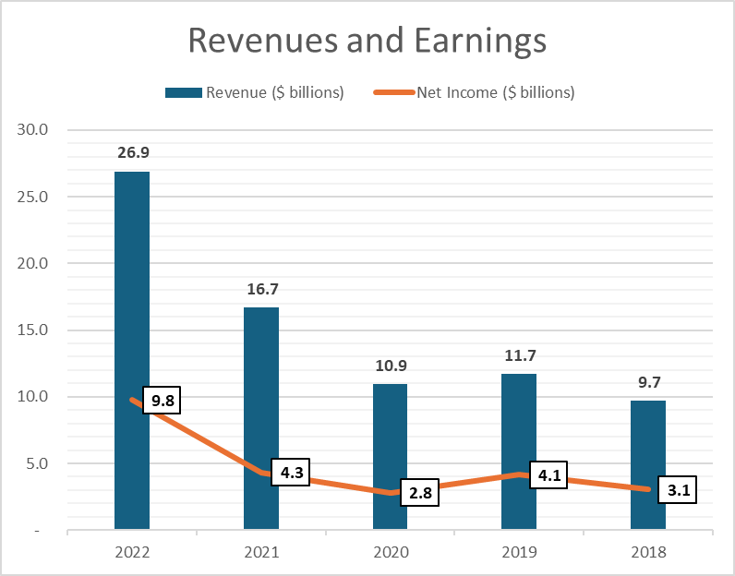

**Debt Analysis:**

* Total Debt: $11.23 billion
* Debt Maturity Profile:
  + Short-term: $0.75 billion
  + Long-term: $10.48 billion
* Interest Coverage Ratio: 22.5x

**4. Industry Analysis**

**Market Trends**: Increasing demand for GPUs in gaming, AI, and data centers.  
**Competitive Landscape**: Main competitors include AMD and Intel.  
**Regulatory Environment**: Subject to export controls and trade regulations, especially with China.

**5. Risk Assessment**

**Operational Risks**: Supply chain disruptions, reliance on key suppliers.  
**Financial Risks**: Currency fluctuations, exposure to high R&D costs.  
**Strategic Risks**: Rapid technological changes, intense competition.  
**External Risks**: Geopolitical tensions affecting supply chain and market access.

**6. Management and Governance**

**Leadership Team**: Led by CEO Jensen Huang.  
**Corporate Governance**: Strong governance practices with an independent board.  
**Management Strategies**: Focus on AI, gaming, and expanding data center capabilities.

**7. Conclusion and Recommendations**

**Overall Assessment**: NVIDIA is financially strong with a stable outlook.  
**Recommendations**: Maintain current credit limit, monitor geopolitical developments.