**Nibbles Overview**

Simple Snake variant that allows the player to move around the screen and collect numbers between 0 - 9 while avoiding collisions with itself and the screen edges. The player's snake also grows longer and moves faster as each number is gathered

**Non-Goals**

At present the game will not feature obstacles but the thought is that if the player can interact with number blocks and the edge of the screen, then an obstacle shouldn't be impossible.

**Scenario**

Random student in CS410 is bored out of their skull on a random weekday night. They decide to try out the game based on how awesome I made it sound in class.

**Flow Chart**

Game Start

Game Play

Game Over

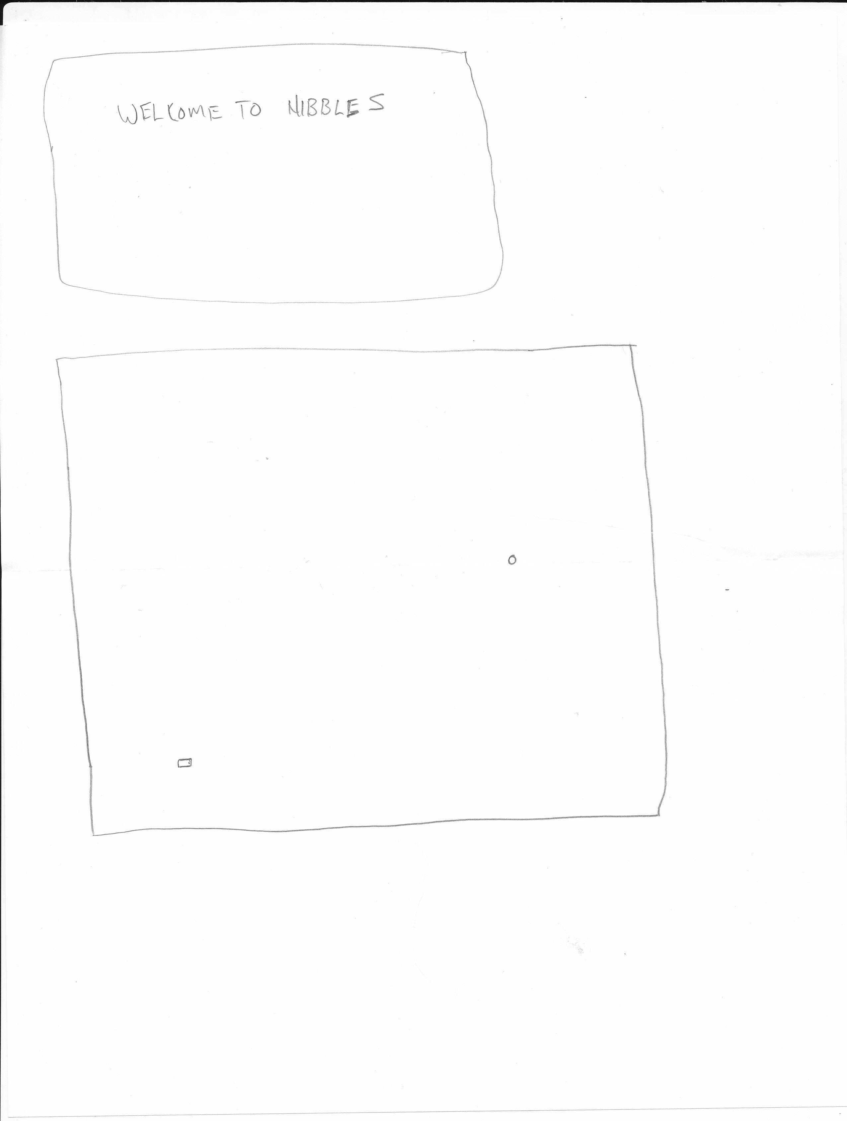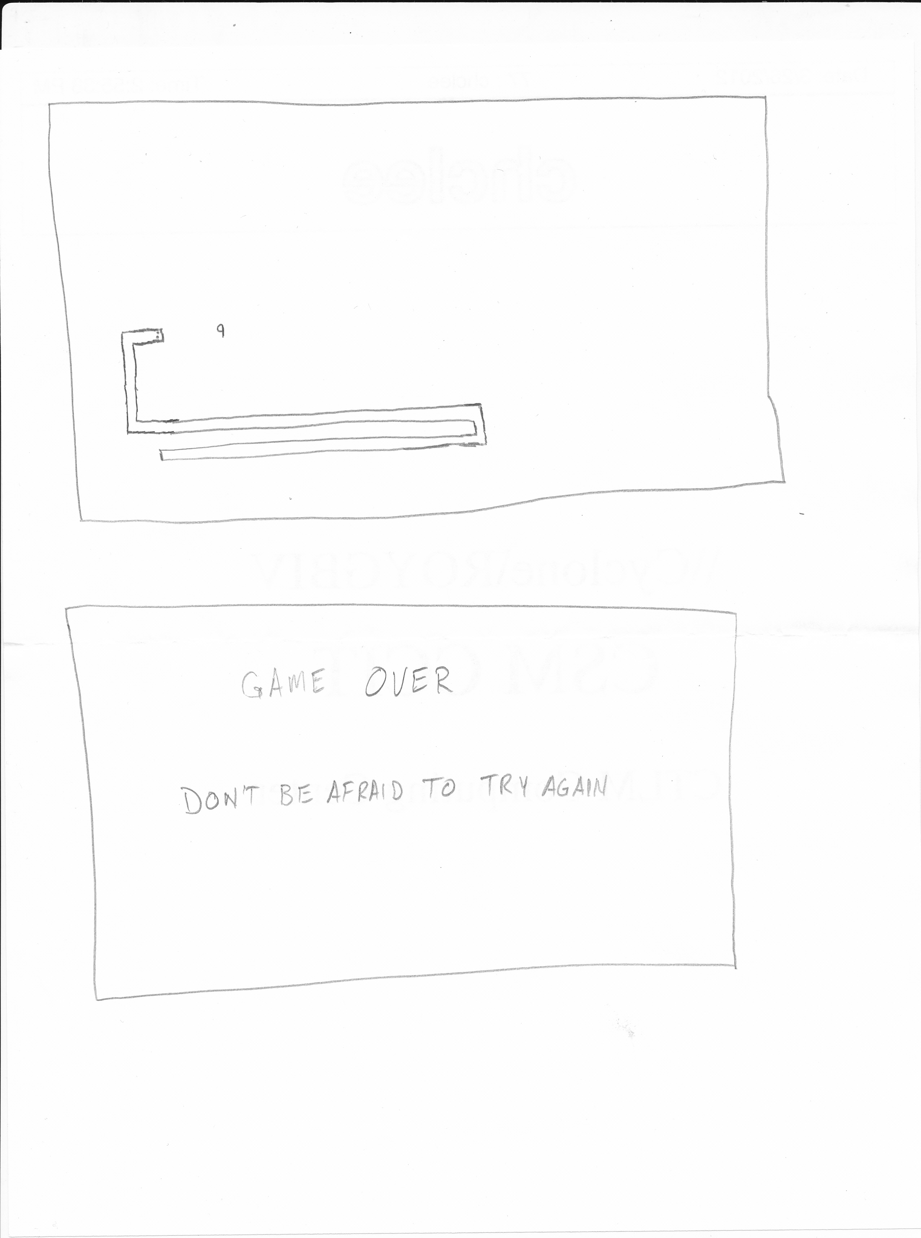

**Game Screens**

**Game Start**

The game start screen will appear when the program is run. It will prompt the player to press Enter to begin play.

**Game Play**

Game play will begin with a relatively slow moving snake at some random part of the screen. It is then up to the player to maneuver the snake around using the ASWD or arrow keys. The goal is to gather number blocks while avoiding itself and the screen edges.

**Game Over**

Screen will show up once the game is over from a collision or fantastic player has maneuvered through all levels gathering all numbers flawlessly. Those making it through flawlessly will get a congratulations message to accompany the "GAME OVER."