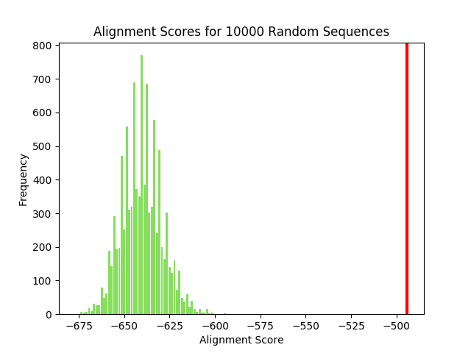

**Figure1: HOX [Alignment Score: -494]**

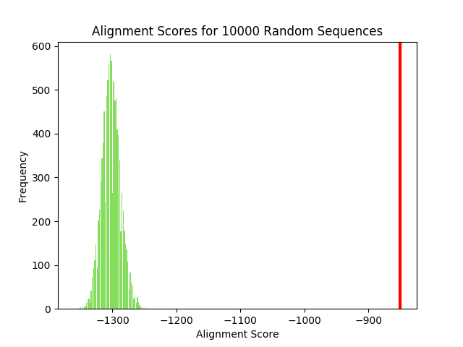

**Figure1: PAX [Alignment Score: -850]**