**Project Title:** Py-Drawer

**Product:** - Student Data Manager 2.0

**So basically Our Product is for small hold teachers and professors who have a batch of less than 50 students.**

**We analyized the thing that they were lacking behind in keeping the record of a student as they don’t have any inexpensive software, so we developed a software basically a gui which makes it easier to use and gives them a report about every student in there subject.**

**Our product will have following key features which will make it unique and classic: -**

* **A tool for Duplicity Checking**
* **A tool for selecting any kind of csv file dynamically**
* **writing and reading the csv file**

**Now main features :-**

* **Our app can analyse the data from csv file and can give you some statistical results to you.**
* **You can get graphical view of data selected by you.**
* **It predicts the marks of one subject.**

**Future Developments:-**

* **Using Django making it fit for any size of screen(To make it suitable for every screen).**
* **Using Some Ml tools some basic predication can be shown..**

**Conclusion:-**

Due to the wide set of benefits it gives to teachers, professors and indirectly to students Student Data Manager 2.0 will become quite popular and appreciated among students all over the world.

Libraries Used:

* + - tkinter module
    - csv
    - pandas
    - numpy
    - skitlearn
    - matplot.lib
    - django(In future version of our product)

This Student Data Manager 2.0 by team Py-Doodlers consists of 5 files that consists of :-

* **database.csv**
* **image.gif**
* **pydoodlers.txt**
* **sam.py** //Main program File
* **sdm.gif**
* **stu.gif**
* **syn.gif**

**Instructions To Use the Product:-**

**1. Firstly Just click on the browse button and load the file database.csv**

**2. We have given a tool for Duplicacy Checking so click on the button checkk duplicate**

**3. We have given you a button to close the software**

**4. There is a field on the home page which shows you the data in the csv file.**

**5. Now to get the data of a specific roll number click on the menubar button and enter the Roll No to get the record**

**6. Now if you want to delete the specific data of a student so you can click on the delete and enter the roll number but it is a beta function**

**7. Now click on insert data button to get the form in which enter the data and click on submit**

**8. Now click on the statistcal Representation button to get the data Analysis option window**

**9. Here you will get a lot of visualizations :-**

**10. You can get line graph by click on LINE GRAPH button at menubar.**

**11. You can get Bar graph by click on BAR GRAPH button at menubar.**

**12. You can get Pie graph by clicking on the PIE GRAPH button at menubar**

**13. You can Analysis the marks of students in python,data structures and ADBMS**

**14. You can see the predicted marks on the basis of two subject marks.**

**Technology Used**: python

**Layout:**

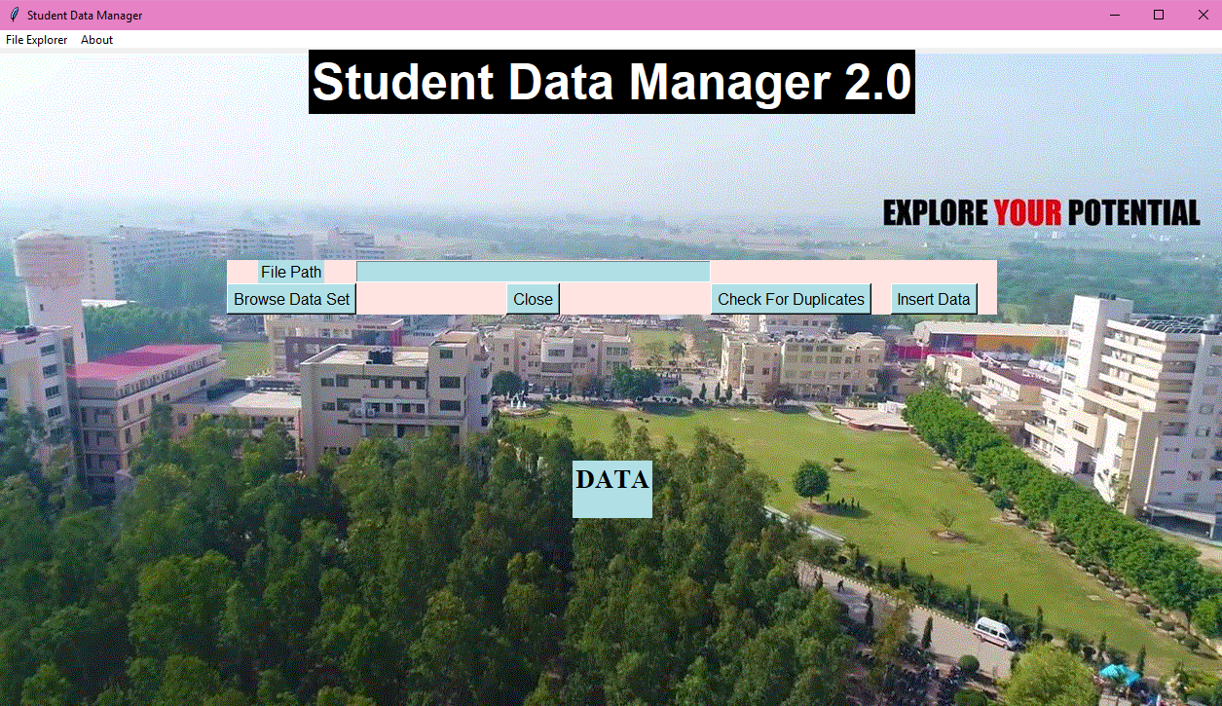

**Submitted By:**

Akanksha Singh (1610991059)

Anirudh Mishra (1610991110)

**Department Name:** Computer Science and Engineering.