# 1. Project Title

# ****Gas Leakage Detection System Using Arduino Uno, Keypad, MQ2, and Buzzer****

# 1.INTRODUCTION

This project is a gas leakage detection system designed to improve home and industrial safety.  
The system detects gas levels using an MQ2 sensor and alerts users when concentrations exceed a user-defined threshold.  
It features a keypad for manual threshold setting, a buzzer for alarm indication, and an LCD for display.

## ****2 – Project Overview****

The project uses:

* **Arduino Uno**: The microcontroller for control and logic.
* **MQ2 Sensor**: For detecting gas concentration levels.
* **4x4 Keypad (later replaced with 4x3)**: For manual threshold entry.
* **Buzzer**: For alarm notification.
* **LCD**: For displaying gas readings and system status.

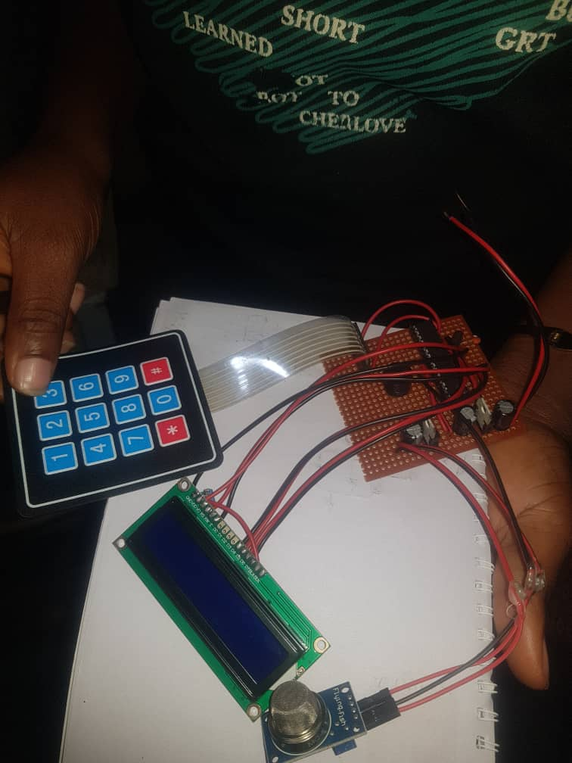

## ****Chapter 3 – Methodology****

1. The MQ2 sensor continuously measures gas concentration.
2. The LCD displays both the live gas value and the current threshold.
3. The user enters the threshold value through the keypad.
4. If the gas level rises above the set threshold, the buzzer is triggered to alert the user.
5. The system was first breadboarded for testing, and later soldered into a more permanent circuit.

## ****Chapter 4 – Circuit Designs****

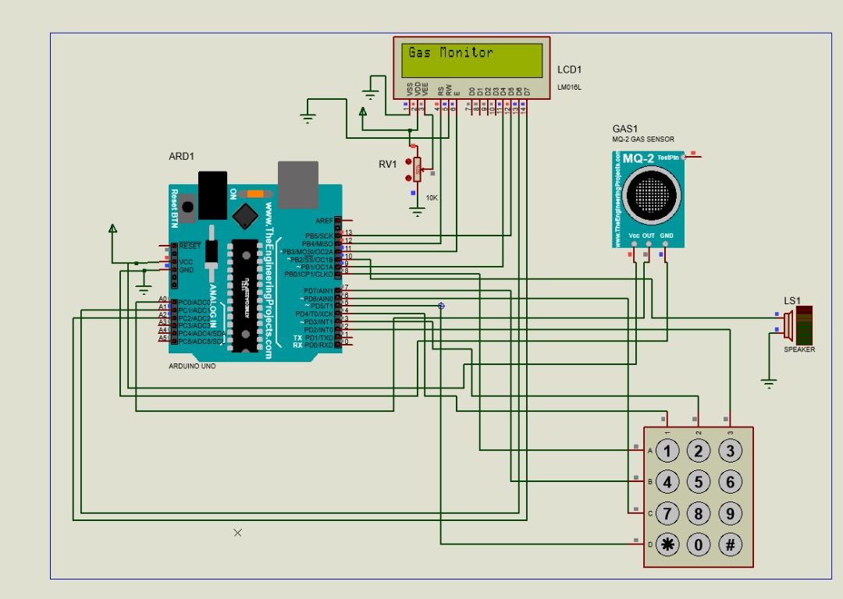

FIG.1 proteus simulation circuit



FIG.2 Soldered circuit

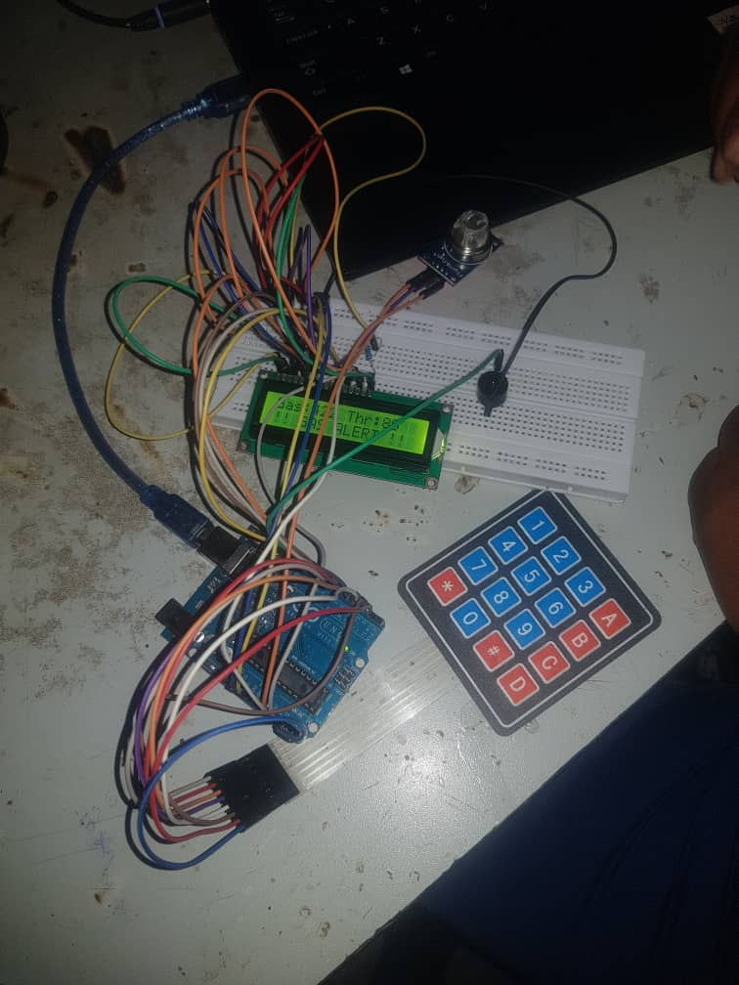

FIG.3 Breadboarded circuit

## 5. ****Working Principle****

1. Power on the system.
2. The LCD initializes and displays “Gas Monitor.”
3. The MQ2 sensor continuously monitors gas levels.
4. User sets the threshold via the keypad (Enter + # to confirm).
5. If the **gas concentration > threshold**, the **buzzer turns ON** and the LCD displays a **gas alert message**.
6. Otherwise, the system continues monitoring safely.

# 6. Source Code

# #include <LiquidCrystal.h>

# #include <Keypad.h>

# // LCD connections

# LiquidCrystal lcd(12, 11, 9, 13, A1, A2); // RS, E, D4, D5, D6, D7

# // Sensor and buzzer pins

# const int MQ2_PIN = A0;

# const int BUZZER_PIN = 10;

# // Keypad setup (4x4)

# const byte ROWS = 4, COLS = 4;

# char keys[ROWS][COLS] = {

# {'1','2','3','A'},

# {'4','5','6','B'},

# {'7','8','9','C'},

# {'*','0','#','D'}

# };

# byte rowPins[ROWS] = {8, 7, 6, 5};

# byte colPins[COLS] = {4, 3, 2, A3};

# Keypad keypad = Keypad(makeKeymap(keys), rowPins, colPins, ROWS, COLS);

# // Variables

# int threshold = 80; // default threshold

# int gasValue = 0;

# String inputBuffer = ""; // used when typing threshold

# bool enteringThreshold = false;

# bool alarmEnabled = true;

# bool alarmOn = false;

# void setup() {

# pinMode(BUZZER_PIN, OUTPUT);

# digitalWrite(BUZZER_PIN, LOW);

# lcd.begin(16, 2);

# lcd.print("Gas Detector");

# delay(1500);

# lcd.clear();

# }

# void loop() {

# // Read sensor

# gasValue = analogRead(MQ2_PIN);

# // Check alarm condition

# if (alarmEnabled && gasValue > threshold) {

# alarmOn = true;

# digitalWrite(BUZZER_PIN, HIGH);

# } else {

# alarmOn = false;

# digitalWrite(BUZZER_PIN, LOW);

# }

# // Show status if not typing threshold

# if (!enteringThreshold) {

# lcd.setCursor(0,0);

# lcd.print("Gas:");

# lcd.print(gasValue);

# lcd.print(" Thr:");

# lcd.print(threshold);

# lcd.setCursor(0,1);

# if (alarmOn) {

# lcd.print("!! GAS ALERT !! ");

# } else {

# lcd.print("Alarm:");

# lcd.print(alarmEnabled ? "ON " : "OFF");

# lcd.print(" 1:SetThr");

# }

# }

# // Keypad handling

# char key = keypad.getKey();

# if (key) {

# if (enteringThreshold) {

# if (key >= '0' && key <= '9') {

# inputBuffer += key;

# lcd.clear();

# lcd.print("New Thr: ");

# lcd.print(inputBuffer);

# }

# else if (key == '#') { // confirm

# threshold = inputBuffer.toInt();

# inputBuffer = "";

# enteringThreshold = false;

# lcd.clear();

# lcd.print("Saved Thr:");

# lcd.print(threshold);

# delay(1000);

# }

# else if (key == '*') { // cancel

# inputBuffer = "";

# enteringThreshold = false;

# lcd.clear();

# }

# }

# else {

# if (key == '1') { // set threshold

# enteringThreshold = true;

# lcd.clear();

# lcd.print("Enter threshold:");

# }

# else if (key == '2') { // toggle alarm

# alarmEnabled = !alarmEnabled;

# lcd.clear();

# lcd.print("Alarm ");

# lcd.print(alarmEnabled ? "ON" : "OFF");

# delay(1000);

# }

# }

# }

# delay(150);

# }

## 7. Applications

* Domestic kitchens for LPG leakage detection.
* Gas storage facilities.
* Laboratories and industries using flammable gases.
* Safety systems in residential and commercial buildings.

## 7. Limitations

* Only works for gases detectable by the MQ2 sensor.
* Sensor calibration is required for accurate results.
* Power supply fluctuations may affect reliability.

## ****8 Results and Discussion****

The system was tested successfully,

* The user could enter a threshold value manually via the keypad.
* The system displayed both gas concentration and threshold on the LCD.
* When gas exceeded the threshold, the buzzer activated immediately.
* The system worked on both breadboard and soldered versions.

## 9. Future Improvements

* Adding GSM/Wi-Fi module for SMS or IoT alerts.
* Mobile app integration.
* Battery backup system.
* Automatic gas shut-off valve.

## ****10 .Conclusion****

This project successfully demonstrates a low-cost, user-configurable gas leakage detection system.  
It provides safety through immediate audible alerts and flexibility through keypad input.

