|  |
| --- |
| Puppet Installation Guide |
| Installation Notes |

|  |
| --- |
|  |

# Description: edureka logol.jpg

© Brain4ce Education Solutions Pvt. Ltd.

# Connect to an EC2 instance(Ubuntu).

**Puppet Installation:**

All the commands in this installation are run as root.

Syntax: sudo su

**Setup hosts file on Machines:**

Step 1: On the master edit the host file and add the IP address of the master itself in the hosts file naming it puppet

Step 2: On the Agent machines add the master IP as puppet and the Agent’s IP address as puppet-agent



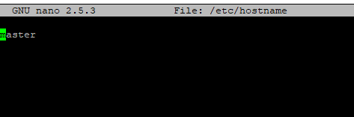

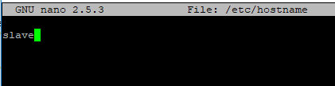

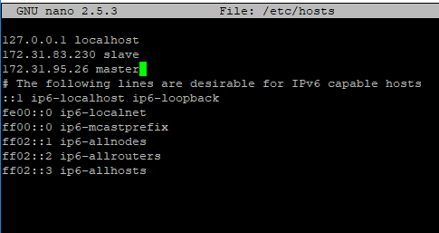

**Setup the Puppet Server:**

Step 1: Download the puppet package for ubuntu using

Syntax: wget https://apt.puppetlabs.com/puppetlabs-release-pc1-xenial.deb

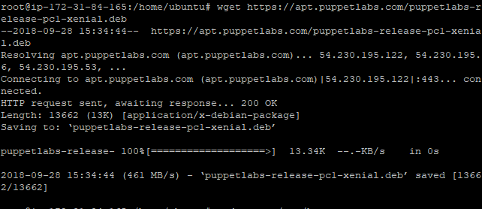

Step 2: After downloading the package install it using dpkg with -i flag

Syntax: sudo dpkg -i puppetlabs-release-pc1-xenial.deb

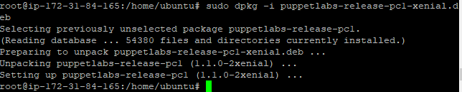

Step 3: Run the ubuntu update command to ensure all the packages are up-to-date

Syntax: apt-get update

Step 4: Now install the puppet server using the apt-get command

Syntax: apt-get install puppetserver

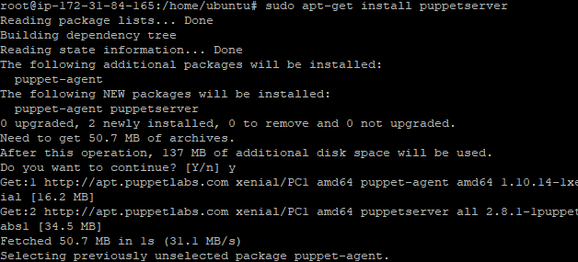

This has installed puppet server on the master machine.

Configuring Puppet Server

NOTE: If you’ve allocated the virtual machine less than 4GB of memory, you’ll have to change the default(2GB) memory size for Puppet

Step 1: Open puppetserver default file

Syntax: nano /etc/default/puppetserver



Step 2: The Xms and Xmx parameter of the JAVA_ARGS dictates the amount of memory Puppet Server is going to consume

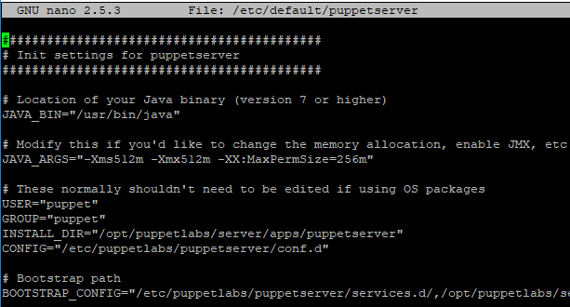

Step 3: For a system with memory less than 4GB decrease it to approx. half the system memory

Step 4: Open port number 8140 for puppet

Syntax: ufw allow 8140

**Setup Puppet-Agent**

Note: Follow step 1-3 of the Puppet Server setup.

Step 1: Install puppet agent using apt-get command

Syntax: apt-get install puppet-agent

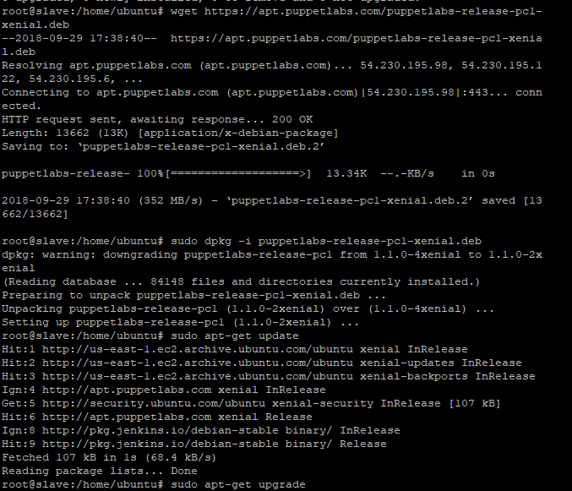

Step 2: Start and enable the puppet service

Syntax: systemctl start puppet

Syntax: systemctl enable puppet

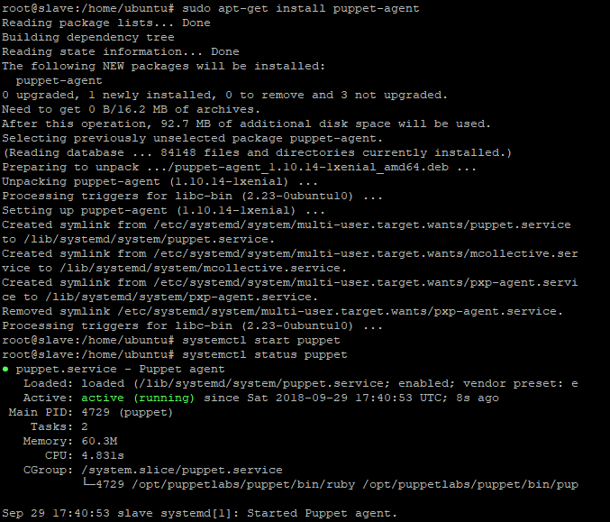



**Signing Certifactes**

Step 1: To show the all the Unsigned Certificates on Puppet Server Use cert list command

Syntax: sudo /opt/puppetlabs/bin/puppet cert list

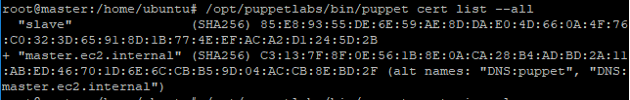

Step 2: Certificates can be signed individually using sign command with the Agent Name

Syntax: /opt/puppetlabs/bin/puppet cert sign <agent name>

OR

All the pending certificates can be signed at once by adding the --all flag

Syntax: /opt/puppetlabs/bin/puppet cert sign –all

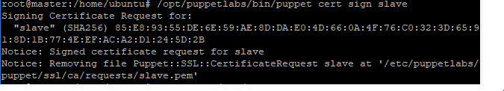

 On the agent run, run puppet agent -t

