## Appendix Z: Course-wide Instructor Notes

1. Training Lab System Setup
2. Open the AWS site from here:  <https://aws.amazon.com/>

* Login Credentials for Chef instructors:  [training-aws@chef.io](mailto:training-aws@chef.io)
* Password:  Contact Chef Training Services if you don’t know it or how to obtain it. [training@chef.io](mailto:training@chef.io)
* Partner credentials should be provided by Chef directly to partners.

1. Click the first link in column **EC2 *Virtual Servers in the Cloud***
2. From the navigation pane on the left, select **Images/AMIs**.  The "Step 1" page displays with a list of available AMIs.
3. Select **Intermediate – CentOS 6.7 – 3.0.0** from the list of options.
4. Click **Launch**.  The "Step 2" page displays.
5. Select the first **Micro Instance** from the list provided and click **Next: Configure Instance Details** at the bottom of the screen.  The "Step 3" page displays.
6. Enter the **Number of Instances**.

*Note:  You will need 1 instance for each student enrolled in the class - and 1 for yourself.*

1. Click **Next: Add Storage** at the bottom of the page.  The "Step 4" page displays.  Ensure that ‘**Delete on Termination**’ is selected.

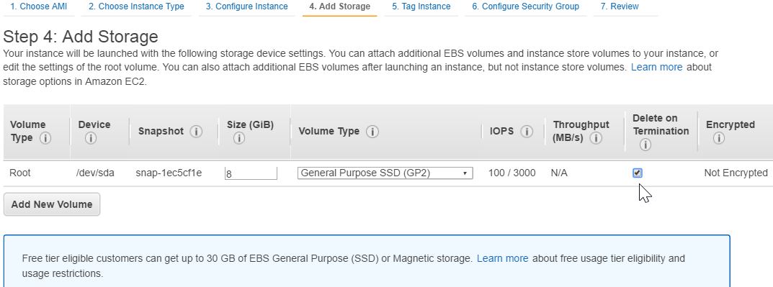

1. Click **Next: Tag Instance** at the bottom of the page.  The "Step 5" page displays.
2. Enter a **Value**.

*Note:  A recommended naming convention for the instances:  [TRAINER’S INITIALS] - [CLASS NAME] - [CLASS DATE]*

1. Click **Next: Configure Security Group**.  The "Step 6" page displays.
2. Click the **Select an existing security group** radio button.  A list of security groups displays.
3. Select **all-open**.
4. Click **Review and Launch** at the bottom of the screen.  The "Step 7" page displays.
5. After you review the instances, click **Launch**.  The "Select a key pair" window displays.
6. Confirm that this is set to **Proceed without a key pair** and click the acknowledgement check box.
7. Click **Launch Instances**.  The "Launch Status" page displays.
8. Click **View Instances**.  The instances list displays.
9. From here, copy all of the instances and create a gist file to share with the class.
10. Use [goo.gl](http://goo.gl) to shorten the URL to the gist file.

**Note**: The login credentials and password for the AMIs used in class are chef/Cod3Can!. You’ll need to tell the students that at the appropriate time.

1. How to Use Lab Slides

Regarding the "Lab" exercises (not the Group Exercises), you should encourage students to use the high-level hammer/wrench "Lab" slide steps first, and then resort to the subsequent detailed step slides if the students need the details to complete the lab. You can still use the subsequent detailed step slides as a vehicle to review each lab. For example:

This is a high-level hammer/wrench "Lab" instruction slide. Encourage students to complete the lab using this high level hammer/wrench "Lab" slide first.

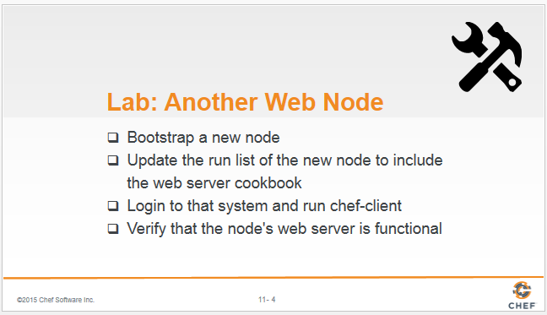

If some students can’t complete the lab based on the above slide, they are free to follow the subsequent detailed step slides, such as these:

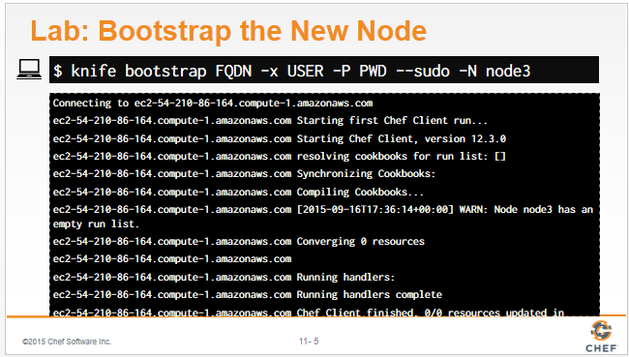

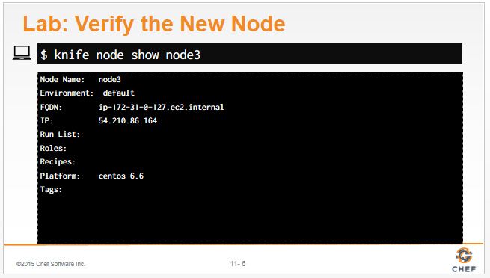

You can also use the above detailed slides as a vehicle for reviewing the labs.