Echo() vs print()
They are both used to output data to the screen. The differences are small: echo has no return value while print has a return value of 1. echo can take multiple parameters (although such usage is rare) while print can take one argument. echo is marginally faster than print .
printf ("%s (%s)\n", $row["Lastname"], $row["Age"]);

session_start() creates a session or resumes the current one based on a session identifier passed via a GET or POST request, or passed via a cookie.

The gettype() function is an inbuilt function in PHP which is used to get the type of a variable. It is used to check the type of existing variable.
Syntax: gettype ( $var )

Typecasting:
$num = "3.14";
$int = (int)$num;
$float = (float)$num;

Increament / decreament:
++$a
$a++

use include() or require() to include a file
include 'connect.php';

use header() to redirect & then use exit() / die()
header("location:index.php?err=2");
die(); //get out

$_REQUEST[] / $_POST[] / $_GET[]
$opcode= $_GET['opcode'];
$emp_name = $_POST['ename'];
$email = $_REQUEST['email'];

Session check:
session_start();

if(isset($_SESSION['login_user'])){
header("location:dashboard.php");
die(); //get out
}

Check if the form was submitted using post method
if ($_SERVER['REQUEST_METHOD'] === 'POST') {

mysqli_report(MYSQLI_REPORT_ERROR | MYSQLI_REPORT_STRICT)

Object oriented Vs Procedural style of Query
Open connection & SELECT query:

Object oriented
$conn = new mysqli($server, $username, $password, $dbname);

if($conn->connect_error){
die("connection failed: ".$conn->connect_error);
}
----------------- SELECT records ------------------------------
$sql="select * from users where uname='$usr_name' and upass='$usr_pass'";

$result=$conn->query($sql);
if ($result->num_rows == 1) {
while ($row = $result->fetch_assoc()) {
$empname = $row['ename']; //access data with colmn name
$usrid = $row['uid'];
}

$result -> free_result();
$conn->close();

Procedural
$conn = mysqli_connect("localhost","my_user","my_password","my_db");

if (mysqli_connect_errno()) {
echo "Failed to connect to MySQL: ". mysqli_connect_error();
exit();
}

------------------------- SELECT records ------------------------------
$sql="select * from users where uid=".$usrid;

$result = mysqli_query($conn, $sql);
if(mysqli_num_rows($result) == 1) {
while($row = mysqli_fetch_assoc($result)) {
echo $row['email'];
echo $row['uname'];
}

mysqli_free_result($result);
}

mysqli_close($conn);

fetch_assoc(): Fetch a result row as an associative array; so we can access column data with [‘colm_name’]
$row = $result->fetch_assoc()

fetch_object(): Fetch a result row as an object property form
if ($result->num_rows == 1) {
while ($row = $result->fetch_object()){ //fetch_assoc()) {
$ename = $row->ename; //$row['ename'];
$email = $row->email; //$row['email'];
$uname = $row->uname; //$row['uname'];
$upass = $row->upass; //$row['upass'];
$etype = $row->access_lvl; //$row['access_lvl'];
}

$result->close(); // $result->free_result(); //FREE the resultset
}

INSERT records to data base:
Object oriented
$sql="INSERT INTO users(uname, upass, ename, email, access_lvl) VALUES('$usr_name','$usr_pass','$emp_name','$email','$acc_lvl')";

$result = $conn->query($sql);
if ($result == TRUE) {
echo "User created successfully.";
}

Procedural
$sql = "INSERT INTO MyGuests (firstname, lastname, email)
VALUES ('John', 'Doe', 'john@example.com')";
if (mysqli_query($conn, $sql)) {
echo "New record created successfully";
}

Using prepared statement + MySQL:

$stmt = $conn->prepare("INSERT INTO projects (ptitle, pdesc, est_cost) VALUES (?, ?, ?)");
// bind parameters with appropriate data type
$stmt->bind_param("ssd", $title, $description, $cost);

/*
i => corresponding variable has type int
d => corresponding variable has type float
s => corresponding variable has type string
b => corresponding variable is a blob and will be sent in packets
*/

// set parameters & execute
$title = isset($_POST['txtptitle']) ? $_POST['txtptitle'] : '';
$description = isset($_POST['txtpdesc']) ? $_POST['txtpdesc'] : '';
$cost = isset($_POST['txtcost']) ? $_POST['txtcost'] : 0.0;

$stmt->execute();

UPDATE records:
Object oriented
$sql="UPDATE users set ename='$emp_name', email='$email' where uid=".$uid;

// Turn autocommit off
//$conn->autocommit(FALSE);

$result=$conn->query($sql);
$status = 0;
if ($result == TRUE) {

DELETE record:
Object oriented

$sql="DELETE from users where uid=".$uid;

$result=$conn->query($sql);

if ($result == TRUE) {

Closing a Connection:
$conn->close();

Calling a stored procedure

Connect to postgresql
Look for the dll
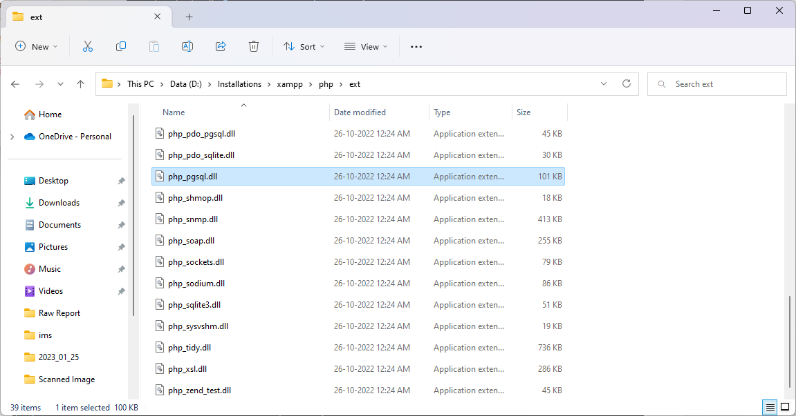

Uncomment the following line in php.ini

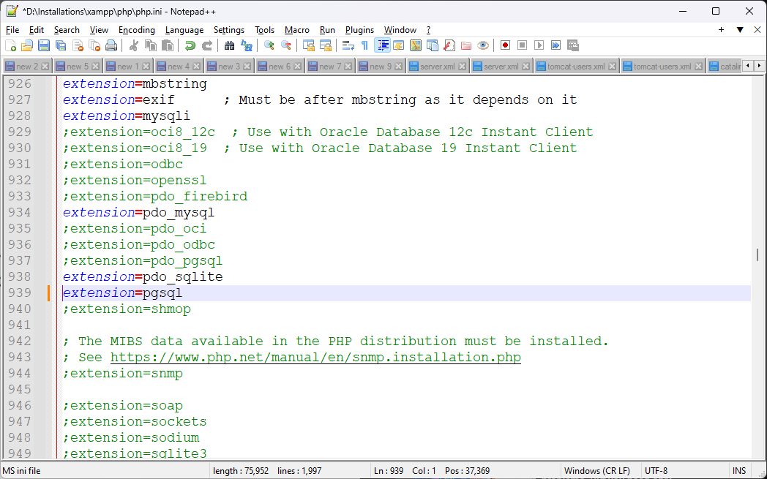

Postgres: SELECT Query (Read Data)
$sql="select, name, reg_no, total_qs, attempted_qs, correct_qs, wrong_qs";

$result= pg_query($pg_conn, $sql);
$c = 0;

while ($row = pg_fetch_object($result)){
$c++;
?>
<tr>
<td><?php echo $c; ?></td>
<td><?php echo $row->exam_code; ?> </td>
<td><?php echo $row->name; ?> </td>

Postgres: INSERT Query (Store data)
Without prepared statement

Using : prepared statement:
$sql = "INSERT INTO candidate_det(cndid, init, name, pat_name, mat_name, dob, phno) ".
" VALUES((select coalesce(max(cndid), 0) + 1 from candidate_det), $1, $2, $3, $4, to_date($5 ,'DD-MM-YYYY'), $6)";

$pstmt = pg_prepare($pg_conn, "cnd_qry", $sql);
$result = pg_execute($pg_conn, "cnd_qry", array($cnd_init, $cnd_name, $cnd_fname, $cnd_mname, $cnd_dob, $cnd_mob));

if($result){
$status = 1;
}

Handling escape symbols (‘ / “/\/\n) + using stored procedure Use pg_query_params() : Be carefull for handling exceptions raised by pg_query_params(), because upon an error it returns false (rather than raising an exception), so we need to raise exception manually under else{}
try{
$sql = "select save_item_details($1, $2, $3, $4, $5)";
$result = pg_query_params($pg_conn, $sql, array($i_name, $i_desc, $i_cat, $i_site1, $i_rate1));

if($result){ //save successful;
...
} else { // pg_query_params() --> returns false upon encountering an error / exception --> need to raise exception manually
// process errors by raising exceptions manually
trigger_error ("pg_send_query_params failed:".pg_last_error(), E_USER_ERROR);
}
} catch(Exception $e){
$s=0;
echo $e->getMessage();
}

Postgres: UPDATE Query (Store data)
Using : prepared statement:

$sql = "UPDATE candidate_det set name=$1, dob = to_date($2 ,'DD-MM-YYYY'), phno = $3, emailid = $4 where cndid = $5";

$pstmt = pg_prepare($pg_conn, "cnd_qry", $sql);
$result = pg_execute($pg_conn, "cnd_qry", array($cnd_name, $cnd_dob, $cnd_mob, $cnd_email, $cnd_id));

if($result){
$status = 1;
}

Postgres: Call stored procedure

$sql = "select save_cnd_course_reg(".$crs_id.", ".$cnd_id.") as crs_reg";
$result = NULL;

$result = pg_query($pg_conn, $sql);
$row_count = pg_num_rows($result); //number of rows in resultset

if ($row_count == 1) { // should be 1

option 2: pg_query_params see above

$sql = "select save_item_details($1, $2, $3, $4)";
$result = pg_query_params($pg_conn, $sql, array($i_name, $i_desc, $i_cat, $i_site1));

if($result){ //save successful;

Closing a connection & release resultset:
if($result != NULL){
pg_free_result($result); //FREE the resultset
}
if($pg_conn != NULL){
pg_close($pg_conn);
}

File upload in php

Edit php.ini and set file_uploads = On
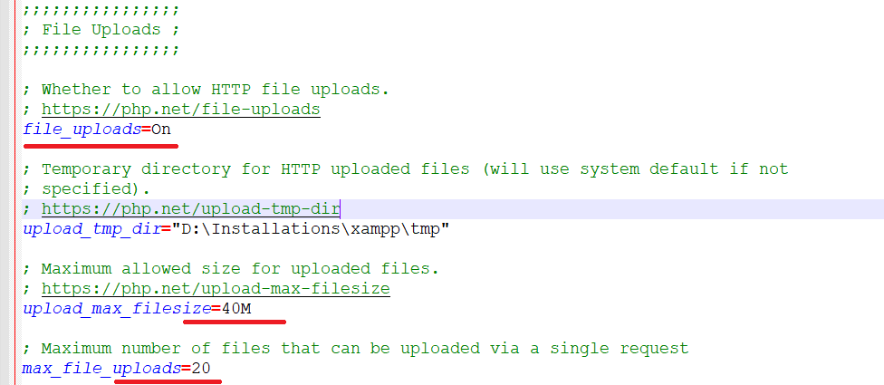

https://phppot.com/php/php-file-upload/

$_FILES[‘<file-input-name>’][‘tmp_name’] |  | PHP file upload temporary path
$_FILES[‘<file-input-name>’][‘name’] |  | File name with extension
$_FILES[‘<file-input-name>’][‘type’] |  | File MIME type. Eg: image/jpeg
$_FILES[‘<file-input-name>’][‘size’] |  | File size (in bytes)
$_FILES[‘<file-input-name>’][‘error’] |  | File upload error code if any
$_FILES[‘<file-input-name>’][‘full_path’] |  | Full path as sent by the browser

Classes in PHP:

Constructors & destructors
class Employee
{

Public $name;

Public $position;

function __construct($name,$position)

{
// This is initializing the class properties
$this->name=$name;
$this->position=$position;

}
function show_details()
{
echo $this->name." : ";
echo "Your position is ".$this->profile."\n";
}

function __destruct()
{
echo "destroying " . $this->name . "\n";
}
}

$employee_obj= new Employee("Rakesh","developer");
$employee_obj->show_details();

$employee2= new Employee("Vikas","Manager");
$employee2->show_details();

Inheritance

class ParentClass
{
function __construct()
{
print "Parent class constructor.\n";
}
}

class ChildClass extends Parentclass
{
function __construct()
{
parent::__construct();
print "Child Class constructor";
}
}
$obj = new ParentClass();
$obj = new ChildClass();

Access specifier

<?php
class GeeksForGeeks
{
protected $x = 1000 ; # protected attributes
protected $y = 100 ;
function div()
{
echo $d = $this->x / $this->y ;
echo " ";
}
}
class child extends GeeksForGeeks
{
function sub()
{
echo $s = $this->x - $this->y ;
}

}
class derived # Outside Class
{
function mul()
{
echo $m = $this->x * $this->y ;
}

}
$obj= new child;

// It will return the division result
$obj->div();

// Since it's a derived class of the main class,
$obj->sub();

// Since it's an outside class, therefore it
// will produce a fatal error .
$obj->mul();

?>

