Data Processing of sample Cyclistic data using SQL By [Aniekan Ekanem](mailto:aniekancharlesekanem@gmail.com)

**Processing Stage**

While using Big Query to process the dataset, out of the 12 data that was downloaded, I was only able to work with 6 data since Big Query can only allow data size of less than 100MB. Using appropriate file naming conventions, the following are the date files studied:

* bike_sharing_2022_nov
* bike_sharing_2022_dec
* bike_sharing_2023_jan
* bike_sharing_2023_feb
* bike_sharing_2023_mar
* bike_sharing_2023_apr

The tool I will use for processing the data is SQL because it is handy for working with larger datasets and provides more functionalities. Another tool I could use is R but I will stick with SQL for now.

After cross checking data in accordance with the credibility check, I have been able to confirm the data's integrity.

1. **Steps taken to ensure data is clean using SQL**

i. Checking for duplicates:

SELECT COUNT(*) AS duplicate_rows_count

FROM (

SELECT *, COUNT(*) AS count

FROM `motivate_int_inc.bike_sharing_2022_nov`

GROUP BY ride_id,

rideable_type,

started_at,

ended_at,

start_station_name,

start_station_id,

end_station_name,

end_station_id,

start_lat,

start_lng,

end_lat,

end_lng,

member_casual,

HAVING COUNT(*) > 1

)

AS duplicates;

The above code was carried out for the remaining 5 data

Result:

| Row | **duplicate_rows_count** |  |
| --- | --- | --- |
| 1 | 0 |  |

ii. Checking for the presence of “NA” string in the tables submitted:

SELECT *

FROM `motivate_int_inc.bike_sharing_2023_mar`

WHERE CONCAT(

ride_id,

rideable_type,

started_at,

ended_at,

start_station_name,

start_station_id,

end_station_name,

end_station_id, start_lat,

start_lng,

end_lat,

end_lng,

Member_casual

)

LIKE '%NA%'

Result:

There is no data to display.

1. **Calculating the length of each ride as ‘ride_length_hms’.**

**SELECT *,**

**FORMAT_TIMESTAMP('%H:%M:%S', TIMESTAMP_SECONDS(TIMESTAMP_DIFF(ended_at, started_at, SECOND))) AS ride_length_hms**

**FROM `motivate_int_inc.bike_sharing_2022_nov`**

1. **Calculating the days of the week to know which days each bike-sharing took place as well as the corresponding days based on the day value**

SELECT *,

EXTRACT(DAYOFWEEK FROM started_at) AS day_of_week,

CASE

WHEN EXTRACT(DAYOFWEEK FROM started_at) = 1 THEN 'sunday'

WHEN EXTRACT(DAYOFWEEK FROM started_at) = 2 THEN 'monday'

WHEN EXTRACT(DAYOFWEEK FROM started_at) = 3 THEN 'tuesday'

WHEN EXTRACT(DAYOFWEEK FROM started_at) = 4 THEN 'wednesday'

WHEN EXTRACT(DAYOFWEEK FROM started_at) = 5 THEN 'thursday'

WHEN EXTRACT(DAYOFWEEK FROM started_at) = 6 THEN 'friday'

ELSE 'saturday'

END AS starting_day

FROM `motivate_int_inc.bike_sharing_2022_nov`;

**4. Analysis**

1. **Analysis using SQL**
   1. Getting the number of Cyclistic members and casual riders by month period

## For Cyclistic members

SELECT member_casual, COUNT(*) AS count

FROM `motivate_int_inc.bike_sharing_2022_nov`

WHERE member_casual = 'member'

GROUP BY member_casual;

## For Casual riders

SELECT member_casual, COUNT(*) AS count

FROM `motivate_int_inc.bike_sharing_2022_nov`

WHERE member_casual = casual

GROUP BY member_casual;

The above code was also used to get the number of Cyclistic members and Casual riders for other month period.

Below is the table that shows the relationship between the number of Cyclistic members and casual riders according to each month period.

| **month** | **Member** | **Casual** | **Overall Total** | **Member-Casual Difference** |
| --- | --- | --- | --- | --- |
| 2022_Nov | 236963 | 100772 | 337735 | 136191 |
| 2022_Dec | 136912 | 44894 | 181806 | 92018 |
| 2023_Jan | 150293 | 40008 | 190301 | 110285 |
| 2023_Feb | 147429 | 43016 | 190445 | 104413 |
| 2023_Mar | 196477 | 62201 | 258678 | 134276 |
| 2023_Apr | 279305 | 147285 | 426590 | 132020 |

**Table 1: Number of members to casual riders relationship ratio**

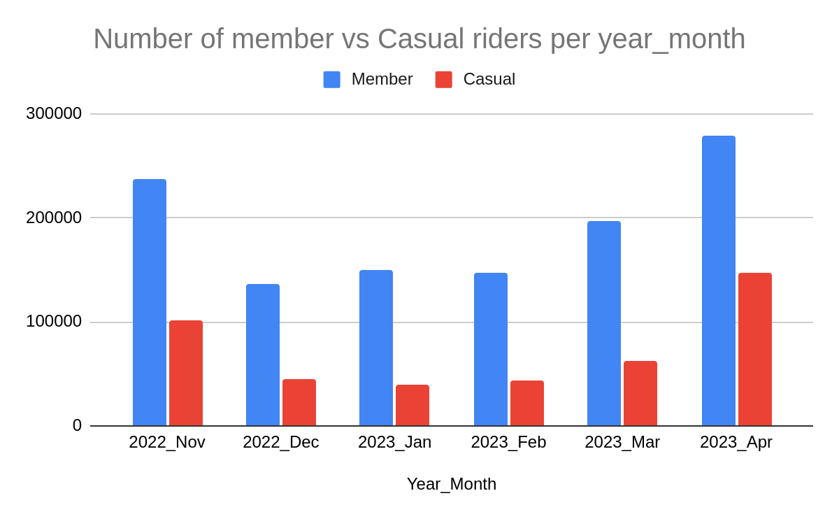

**Chart 1: Bar chart of number of member to casual riders**

* 1. Average ride_length for members and casual riders using SQL

## for Cyclistic members

SELECT

FORMAT_TIMESTAMP('%H:%M:%S', TIMESTAMP_SECONDS(CAST(AVG(TIMESTAMP_DIFF(ended_at, started_at, SECOND)) AS INT64))) AS avg_ride_length_hms

FROM `motivate_int_inc.bike_sharing_2022_nov`

WHERE member_casual = 'member';

## for casual riders

SELECT

FORMAT_TIMESTAMP('%H:%M:%S', TIMESTAMP_SECONDS(CAST(AVG(TIMESTAMP_DIFF(ended_at, started_at, SECOND)) AS INT64))) AS avg_ride_length_hms

FROM `motivate_int_inc.bike_sharing_2022_nov`

WHERE member_casual = casual;

Below is the summary result

| **month** | **Avg_ride_length_Member** | **Avg_ride_length_Casual** | **Overall_Total_Avg_ride_length** |
| --- | --- | --- | --- |
| 2022_Nov | 00:11:08 | 00:21:17 | 00:32:25 |
| 2022_Dec | 00:10:37 | 00:22:17 | 00:32:54 |
| 2023_Jan | 00:10:22 | 00:22:55 | 00:33:17 |
| 2023_Feb | 00:10:43 | 00:23:12 | 00:33:55 |
| 2023_Mar | 00:10:27 | 00:21:25 | 00:31:52 |
| 2023_Apr | 00:11:42 | 00:27:40 | 00:39:22 |
| **Average** | **00:10:50** | **00:23:08** | **00:33:58** |

**Table 2: Members to Casual riders relationship ratio on average ride length**

* 1. Calculating the maximum ride length using SQL

SELECT

FORMAT_TIMESTAMP('%H:%M:%S', TIMESTAMP_SECONDS(MAX(TIMESTAMP_DIFF(ended_at, started_at, SECOND)))) AS max_ride_length_hms

FROM `motivate_int_inc.bike_sharing_2022_nov`;

Result:

| Row | **max_ride_length_hms** |  |
| --- | --- | --- |
| 1 | 14:52:36 |  |

* 1. Getting the mode day of the week

WITH daily_counts AS (

SELECT EXTRACT(DAYOFWEEK FROM started_at) AS day_of_week,

COUNT(*) AS count

FROM `motivate_int_inc.bike_sharing_2022_nov`

GROUP BY day_of_week

),

max_count AS (

SELECT MAX(count) AS max_count

FROM daily_counts

)

SELECT day_of_week, starting_day

FROM (

SELECT EXTRACT(DAYOFWEEK FROM started_at) AS day_of_week,

CASE

WHEN EXTRACT(DAYOFWEEK FROM started_at) = 1 THEN 'sunday'

WHEN EXTRACT(DAYOFWEEK FROM started_at) = 2 THEN 'monday'

WHEN EXTRACT(DAYOFWEEK FROM started_at) = 3 THEN 'tuesday'

WHEN EXTRACT(DAYOFWEEK FROM started_at) = 4 THEN 'wednesday'

WHEN EXTRACT(DAYOFWEEK FROM started_at) = 5 THEN 'thursday'

WHEN EXTRACT(DAYOFWEEK FROM started_at) = 6 THEN 'friday'

ELSE 'saturday'

END AS starting_day,

ROW_NUMBER() OVER (ORDER BY COUNT(*) DESC) AS rn

FROM `motivate_int_inc.bike_sharing_2022_nov`

GROUP BY day_of_week, starting_day

) subquery

WHERE rn = 1

The result is displayed on the table below

| **month** | **Modal_day of the week** |
| --- | --- |
| 2022_Nov | Wednesday |
| 2022_Dec | Thursday |
| 2023_Jan | Tuesday |
| 2023_Feb | Tuesday |
| 2023_Apr | Saturday |

**Table 3: Modal day of the week per month**

* 1. Calculating the number of rides for users based on the days of the week by counting the number of ride_ids (combine the 6 tables for this)

SELECT starting_day, COUNT(ride_id) AS ride_count

FROM (

SELECT ride_id,

EXTRACT(DAYOFWEEK FROM started_at) AS day_of_week,

CASE

WHEN EXTRACT(DAYOFWEEK FROM started_at) = 1 THEN 'sunday'

WHEN EXTRACT(DAYOFWEEK FROM started_at) = 2 THEN 'monday'

WHEN EXTRACT(DAYOFWEEK FROM started_at) = 3 THEN 'tuesday'

WHEN EXTRACT(DAYOFWEEK FROM started_at) = 4 THEN 'wednesday'

WHEN EXTRACT(DAYOFWEEK FROM started_at) = 5 THEN 'thursday'

WHEN EXTRACT(DAYOFWEEK FROM started_at) = 6 THEN 'friday'

ELSE 'saturday'

END AS starting_day

FROM `motivate_int_inc.bike_sharing_2022_nov`

) subquery

GROUP BY starting_day

| **starting_day** | **ride-count** | | | | | |
| --- | --- | --- | --- | --- | --- | --- |
| 2022_nov | 2022_dec | 2023_jan | 2023_feb | 2023_mar | 2023_apr |
| Sunday | 33704 | 17460 | 22366 | 30292 | 24575 | 48314 |
| Monday | 42605 | 23825 | 28347 | 31179 | 32208 | 46043 |
| Tuesday | 61922 | 28025 | 36281 | 35484 | 41347 | 56318 |
| Wednesday | 65227 | 25840 | 30721 | 25792 | 51056 | 61446 |
| Thursday | 57106 | 35272 | 27667 | 21852 | 41347 | 71825 |
| Friday | 44862 | 26818 | 25121 | 21561 | 38517 | 69504 |
| Saturday | 32309 | 24566 | 19798 | 24285 | 24948 | 73140 |

**Table 4: Ride count based on day of week per month**

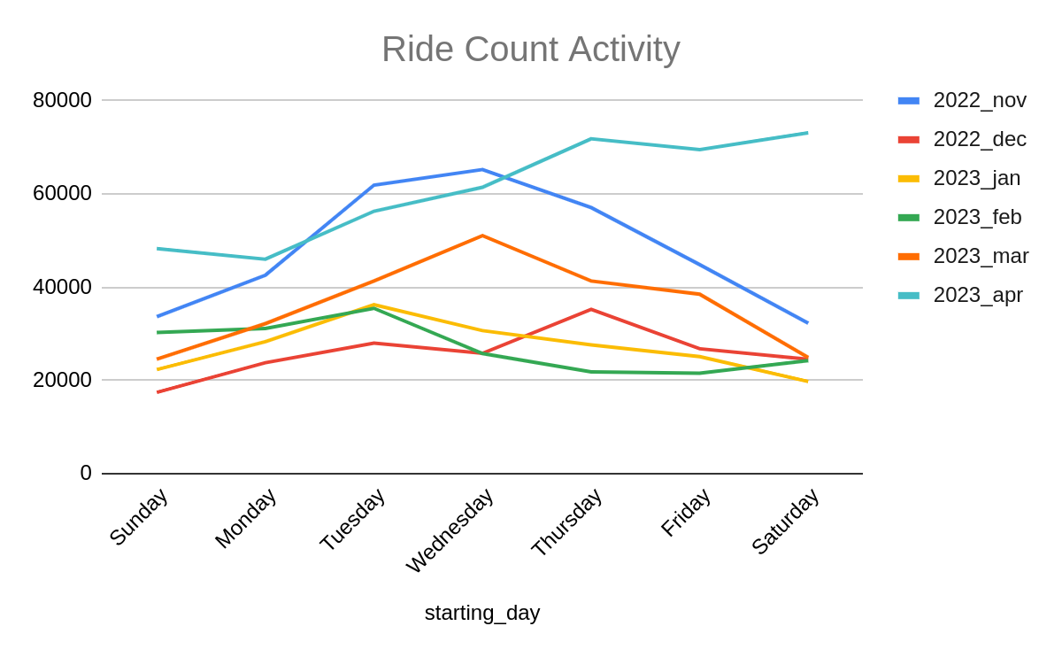

**Chart 2: Line chart of ride count activity**

1. **Analysis from the combined tables**

I combined the 6 tables together to form one table of data using SQL. Find below the code:

CREATE TABLE `motivate_int_inc.divvy_tripdata_combined2` AS

SELECT * FROM `motivate_int_inc.bike_sharing_2022_nov`

UNION ALL

SELECT * FROM `motivate_int_inc.bike_sharing_2022_dec`

UNION ALL

SELECT * FROM `motivate_int_inc.bike_sharing_2023_jan`

UNION ALL

SELECT * FROM `motivate_int_inc.bike_sharing_2023_feb`

UNION ALL

SELECT * FROM `motivate_int_inc.bike_sharing_2023_mar`

UNION ALL

SELECT * FROM `motivate_int_inc.bike_sharing_2023_apr`;

* 1. **Calculating the length of each ride as ‘ride_length_hms’.**

**SELECT *,**

**FORMAT_TIMESTAMP('%H:%M:%S', TIMESTAMP_SECONDS(TIMESTAMP_DIFF(ended_at, started_at, SECOND))) AS ride_length_hms**

**FROM `motivate_int_inc.divvy_tripdata_combined2`**

* 1. **Calculating the days of the week to know which days each bike-sharing took place as well as the corresponding days based on the day value**

SELECT *,

EXTRACT(DAYOFWEEK FROM started_at) AS day_of_week,

CASE

WHEN EXTRACT(DAYOFWEEK FROM started_at) = 1 THEN 'sunday'

WHEN EXTRACT(DAYOFWEEK FROM started_at) = 2 THEN 'monday'

WHEN EXTRACT(DAYOFWEEK FROM started_at) = 3 THEN 'tuesday'

WHEN EXTRACT(DAYOFWEEK FROM started_at) = 4 THEN 'wednesday'

WHEN EXTRACT(DAYOFWEEK FROM started_at) = 5 THEN 'thursday'

WHEN EXTRACT(DAYOFWEEK FROM started_at) = 6 THEN 'friday'

ELSE 'saturday'

END AS starting_day

FROM `motivate_int_inc.divvy_tripdata_combined2`;

* 1. **Getting the number of Cyclistic members and casual riders**

## For Cyclistic members

SELECT member_casual, COUNT(*) AS count

FROM `motivate_int_inc.divvy_tripdata_combined2`

WHERE member_casual = 'member'

GROUP BY member_casual;

## For Casual riders

SELECT member_casual, COUNT(*) AS count

FROM `motivate_int_inc.divvy_tripdata_combined2`

WHERE member_casual = 'casual'

GROUP BY member_casual;

| **Member** | **Casual** | **Overall Total** | **Member-Casual Difference** |
| --- | --- | --- | --- |
| 1147379 | 438176 | 1585555 | 709203 |

**Table 5: Number of members to casual riders relationship ratio using combined tables**

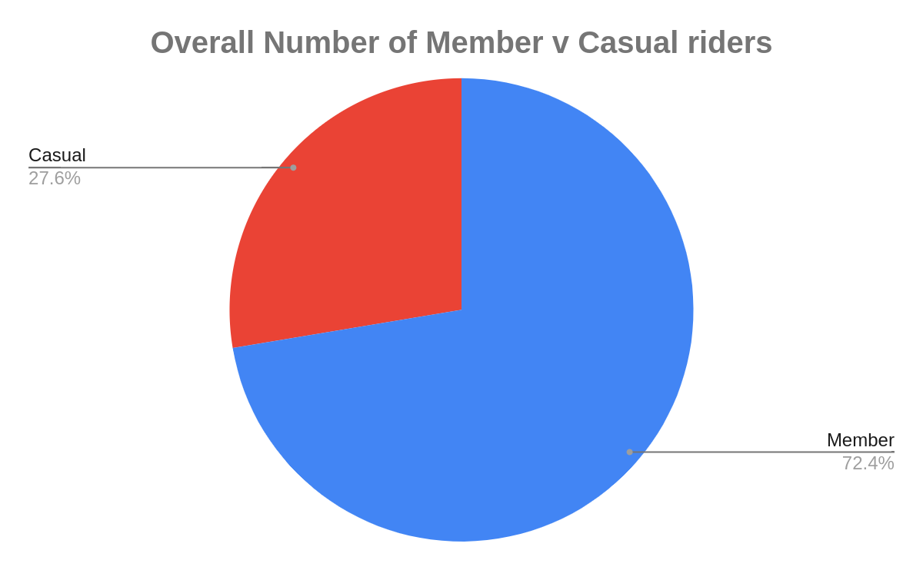

**Chart3: Pie chart showing the number of Members to casual riders**

* 1. **Calculating total rides by user type**

**## for member**

**SELECT COUNT(ride_id)**

**FROM `my-data-project-24723.motivate_int_inc.divvy_tripdata_combined2`**

**WHERE member_casual = 'member'**

**## for casual**

**SELECT COUNT(ride_id)**

**FROM `my-data-project-24723.motivate_int_inc.divvy_tripdata_combined2`**

**WHERE member_casual = casual**

The result of this finding is seen in the table below:

| **Member** | 1147379 |
| --- | --- |
| **Casual** | 438176 |

* 1. **Calculating the total rides by bike type**

**## for classic_bike**

**SELECT COUNT(rideable_type)**

**FROM `my-data-project-24723.motivate_int_inc.divvy_tripdata_combined2`**

**WHERE rideable_type = 'classic_bike'**

**## for electric_bike**

**SELECT COUNT(rideable_type)**

**FROM `my-data-project-24723.motivate_int_inc.divvy_tripdata_combined2`**

**WHERE rideable_type = 'electric_bike'**

This leads to the result as seen in the table below:

| **Classic_bike** | 674954 |
| --- | --- |
| **Electric_bike** | 886950 |

* 1. **Calculating the average ride length by user type**

**## for members**

**SELECT**

**FORMAT_TIMESTAMP('%H:%M:%S', TIMESTAMP_SECONDS(CAST(AVG(TIMESTAMP_DIFF(ended_at, started_at, SECOND)) AS INT64))) AS avg_ride_length_hms**

**FROM `motivate_int_inc.divvy_tripdata_combined2`**

**WHERE member_casual = 'member';**

**## for casual riders**

**SELECT**

**FORMAT_TIMESTAMP('%H:%M:%S', TIMESTAMP_SECONDS(CAST(AVG(TIMESTAMP_DIFF(ended_at, started_at, SECOND)) AS INT64))) AS avg_ride_length_hms**

**FROM `motivate_int_inc.divvy_tripdata_combined2`**

**WHERE member_casual = casual;**

This leads to the result as seen in the table below:

| **Members** | 00:10:56 |
| --- | --- |
| **Casual riders** | 00:23:53 |

* 1. **Getting the ride count amount by starting days**

SELECT starting_day, COUNT(ride_id) AS ride_count

FROM (

SELECT ride_id,

EXTRACT(DAYOFWEEK FROM started_at) AS day_of_week,

CASE

WHEN EXTRACT(DAYOFWEEK FROM started_at) = 1 THEN 'sunday'

WHEN EXTRACT(DAYOFWEEK FROM started_at) = 2 THEN 'monday'

WHEN EXTRACT(DAYOFWEEK FROM started_at) = 3 THEN 'tuesday'

WHEN EXTRACT(DAYOFWEEK FROM started_at) = 4 THEN 'wednesday'

WHEN EXTRACT(DAYOFWEEK FROM started_at) = 5 THEN 'thursday'

WHEN EXTRACT(DAYOFWEEK FROM started_at) = 6 THEN 'friday'

ELSE 'saturday'

END AS starting_day

FROM `motivate_int_inc.bike_sharing_2022_nov`

) subquery

GROUP BY starting_day

Below is the result

| **starting_day** | **ride_count** |
| --- | --- |
| friday | 226383 |
| tuesday | 259377 |
| saturday | 199046 |
| thursday | 259749 |
| sunday | 176711 |
| monday | 204207 |
| wednesday | 260082 |

* 1. **Calculating the total rides by months**

**SELECT COUNT(*) AS count**

**FROM `motivate_int_inc.divvy_tripdata_combined2`**

**WHERE EXTRACT(MONTH FROM started_at) = 1;**

***(1 for Jan, 2 for feb, 3 for mar and so on)***

**The result is displayed in the table below**

| **Month** | **ride_count** |
| --- | --- |
| November | 181806 |
| December | 259377 |
| January | 190301 |
| February | 190445 |
| March | 258678 |
| April | 426590 |

* 1. **Calculating the total riders:**

**SELECT COUNT(*) AS count**

**FROM `motivate_int_inc.divvy_tripdata_combined2`**

**Result = 1585555**

* 1. **Calculating average ride length:**

**SELECT**

**FORMAT_TIMESTAMP('%H:%M:%S', TIMESTAMP_SECONDS(CAST(AVG(TIMESTAMP_DIFF(ended_at, started_at, SECOND)) AS INT64))) AS avg_ride_length_hms**

**FROM `motivate_int_inc.divvy_tripdata_combined2`**

**Result: 00:14:31**

* 1. **Getting the busiest time:**

**## for morning hours**

**SELECT COUNT(*) AS count**

**FROM `motivate_int_inc.divvy_tripdata_combined2`**

**WHERE EXTRACT(HOUR FROM started_at) >= 6 AND EXTRACT(HOUR FROM started_at) < 12;**

**Result: 434286**

**## for afternoon hours**

**SELECT COUNT(*) AS count**

**FROM `motivate_int_inc.divvy_tripdata_combined2`**

**WHERE EXTRACT(HOUR FROM started_at) >= 12 AND EXTRACT(HOUR FROM started_at) < 18;**

**Result; 714686**

**## for evening hours**

**SELECT COUNT(*) AS count**

**FROM `motivate_int_inc.divvy_tripdata_combined2`**

**WHERE EXTRACT(HOUR FROM started_at) >= 18 AND EXTRACT(HOUR FROM started_at) < 6;**

**Result; 0**

* 1. **Getting the busiest weekday:**

**## for sundays**

**SELECT COUNT(*) AS count**

**FROM `motivate_int_inc.divvy_tripdata_combined2`**

**WHERE EXTRACT(DAYOFWEEK FROM ended_at) = 1**

**Result: 177405**

**—----------------------------------------------------------------------------------------------**

**## for mondays**

**SELECT COUNT(*) AS count**

**FROM `motivate_int_inc.divvy_tripdata_combined2`**

**WHERE EXTRACT(DAYOFWEEK FROM ended_at) = 2**

**Result: 204365**

**—----------------------------------------------------------------------------------------------**

**## for tuesdays**

**SELECT COUNT(*) AS count**

**FROM `motivate_int_inc.divvy_tripdata_combined2`**

**WHERE EXTRACT(DAYOFWEEK FROM ended_at) = 3**

**Result: 259289**

**—----------------------------------------------------------------------------------------------**

**## for tuesdays**

**SELECT COUNT(*) AS count**

**FROM `motivate_int_inc.divvy_tripdata_combined2`**

**WHERE EXTRACT(DAYOFWEEK FROM ended_at) = 4**

**Result: 259989**

**—----------------------------------------------------------------------------------------------**

**## for tuesdays**

**SELECT COUNT(*) AS count**

**FROM `motivate_int_inc.divvy_tripdata_combined2`**

**WHERE EXTRACT(DAYOFWEEK FROM ended_at) = 5**

**Result: 259643**

**—----------------------------------------------------------------------------------------------**

**## for tuesdays**

**SELECT COUNT(*) AS count**

**FROM `motivate_int_inc.divvy_tripdata_combined2`**

**WHERE EXTRACT(DAYOFWEEK FROM ended_at) = 6**

**Result: 226074**

**—----------------------------------------------------------------------------------------------**

**## for tuesdays**

**SELECT COUNT(*) AS count**

**FROM `motivate_int_inc.divvy_tripdata_combined2`**

**WHERE EXTRACT(DAYOFWEEK FROM ended_at) = 7**

**Result: 198790**

**—----------------------------------------------------------------------------------------------**

* 1. **Getting the busiest season:**  There are four seasons which are winter, summer, spring and fall.

Winter does occur during the months of December, January, and February in the Northern Hemisphere, and also occurs during June, July, and August in the Southern Hemisphere. In this context, Cyclistic is based in Chicago, and Chicago is located in the Northern Hemisphere, hence there will be winter in the months of December, January, and February. For other seasons, the following applies:

* Spring: March, April, May
* Summer: June, July, August
* Fall: September, October, November

Based on these, the busiest season will be gotten from the busiest months which has been deduced from the code in viii above. April being the busiest falls under Spring. This means the busiest season is Spring.