# Synopsis



Course Enrollment System



**Project id :** PS17

**Student Name :** Animesh Gupta

**University Roll number :** 2026002

**Section :** G(G2)

Page no : 1

**Problem Description**

The Course Enrollment System is designed to streamline the management of student enrollments and course records. Educational institutions often face challenges in efficiently handling course details, student registrations, and modifications to course offerings. A manual approach can lead to data inconsistency, security issues, and administrative overhead.

**Steps of implementation**

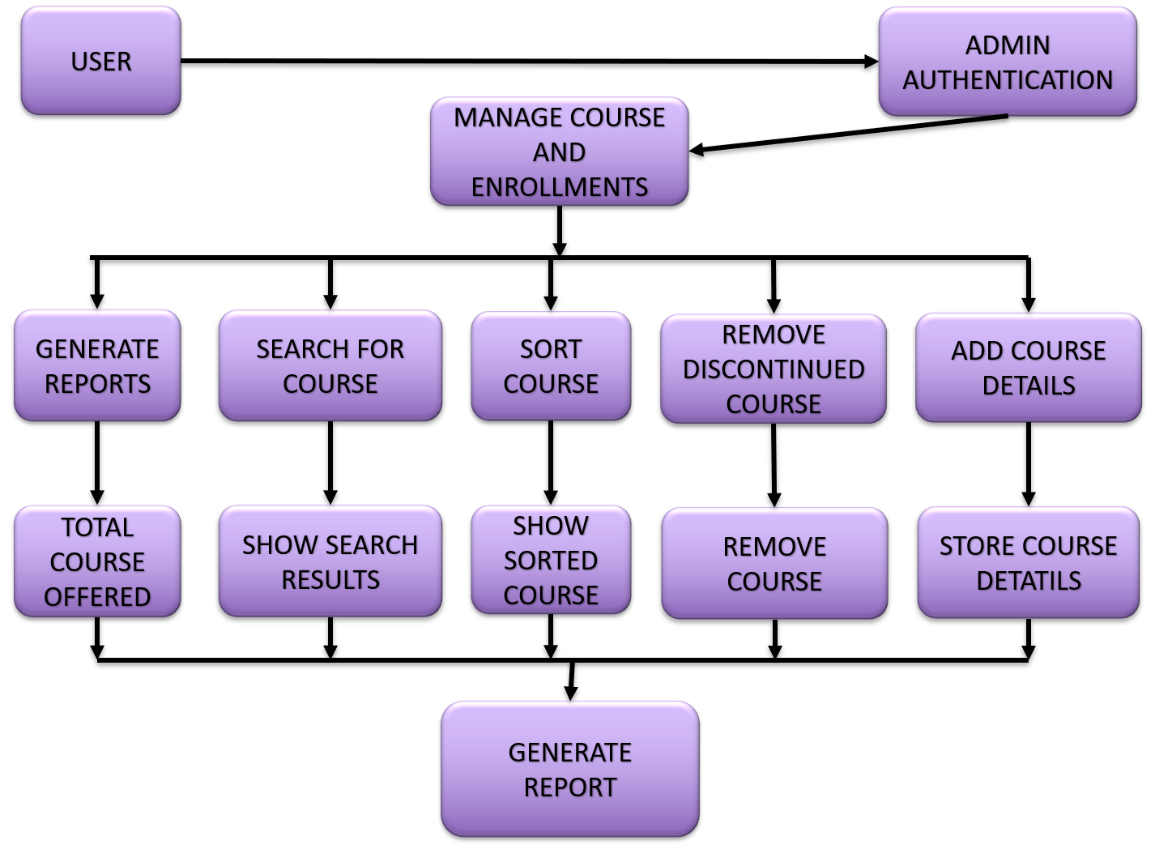

Page no : 2

1. **Design Database Structure:** Define course records (Course ID, Name, Instructor, Credits) and student enrollment details.
2. **Develop Admin Authentication:** Implement a secure login system to restrict unauthorized access.
3. **Apply File Handling:** Store and retrieve data using text/binary files for persistence.
4. **Generate Reports:** Display total courses offered and student enrollments.
5. **Testing and Debugging:** Ensure the program runs efficiently and securely.

**Proposed Modules**

1. **Authentication Module:** Secure login system for administrators.
2. **Course Management Module:**

* Adding new courses with details (Course ID, Name, Instructor, Credits).
* Searching for courses by name or instructor.
* Sorting courses by credits or alphabetical order.
* Removing discontinued courses.

1. **Search & Sorting Module:** Find courses by name/instructor and sort by name or credits.
2. **Report Generation Module:** Display statistics on courses and enrollments.
3. **File Handling Module:** Store and retrieve course details efficiently.

**Required Topics from the Subject**

1. **Programming in C:**

* Basics of C (variables, data types, loops, functions).
* Pointers and memory management.
* File handling in C (fopen, fclose, fwrite, fread).
* Structs and arrays for data organization.

1. **Strings:** Used for storing course names and instructor details.
2. **Pointers:** Essential for dynamic memory allocation in course records.
3. **File Handling:** Enables saving and retrieving data persistently.
4. **Structures:**

* Arrays and linked lists (for managing course records)
* Sorting algorithms (bubble sort, quicksort, etc., for sorting courses)
* Searching algorithms (linear search, binary search for course lookups)

Page no : 3

1. **Sorting Algorithms:** Implements sorting courses by name or credit value

**Platform Required**

* Block , visual studio or any other C compiler.

**Books and Link Sources**

* 1. **"Let Us C"** by Yashavant Kanetkar.
  2. **"The C Programming Language"** by Kernighan & Ritchie.
  3. Online tutorial from **GeeksforGeeks.**
  4. Youtube for implementation.

Page no : 4