Caesar Cipher
KEY = 3

def encrypt(text, key):
ciphertext = ""
for char in text:
if char.isalpha():
base = ord('A') if char.isupper() else ord('a')
ciphertext += chr((ord(char) - base + key) % 26 + base)
else:
ciphertext += char
return ciphertext

def decrypt(text, key):
plaintext = ""
for char in text:
if char.isalpha():
base = ord('A') if char.isupper() else ord('a')
plaintext += chr((ord(char) - base - key) % 26 + base)
else:
plaintext += char
return plaintext

# Main
plaintext = input("Enter the text to encrypt: ")
ciphertext = encrypt(plaintext, KEY)
print("\nEncrypted Text:", ciphertext)

show = input("Do you want to decrypt the text? (yes/no): ").strip().lower()
if show == "yes":
print("Decrypted Text:", decrypt(ciphertext, KEY))
else:
print("Decryption skipped.")

monoalphabetic substitution cipher

PLAIN_ALPHABET = 'ABCDEFGHIJKLMNOPQRSTUVWXYZ'
CIPHER_ALPHABET = 'QWERTYUIOPASDFGHJKLZXCVBNM'

encrypt_map = {PLAIN_ALPHABET[i]: CIPHER_ALPHABET[i] for i in range(26)}
decrypt_map = {CIPHER_ALPHABET[i]: PLAIN_ALPHABET[i] for i in range(26)}

plaintext = input("Enter the text to encrypt: ").upper()
ciphertext = "".join(encrypt_map.get(char, char) for char in plaintext)
print("\nEncrypted Text:", ciphertext)

show = input("Do you want to decrypt the text? (yes/no): ").strip().lower()
if show == "yes":
decrypted_text = "".join(decrypt_map.get(char, char) for char in ciphertext)
print("Decrypted Text:", decrypted_text)
else:
print("Decryption skipped.")

Rail Fence Cipher

def rail_fence_encrypt(text, rails):
rails_list = [""] * rails
row = 0
direction = 1 # +1 = down, -1 = up

for char in text:
rails_list[row] += char
row += direction

if row == 0 or row == rails - 1:
direction *= -1

return "".join(rails_list)

def rail_fence_decrypt(ciphertext, rails):
length = len(ciphertext)

pattern = [['' for _ in range(length)] for _ in range(rails)]

row, direction = 0, 1
for col in range(length):
pattern[row][col] = '*'
row += direction
if row == 0 or row == rails - 1:
direction *= -1

index = 0
for r in range(rails):
for c in range(length):
if pattern[r][c] == '*' and index < length:
pattern[r][c] = ciphertext[index]
index += 1

result = []
row, direction = 0, 1
for col in range(length):
result.append(pattern[row][col])
row += direction
if row == 0 or row == rails - 1:
direction *= -1

return "".join(result)

RAILS = 3
plaintext = input("Enter the text to encrypt: ")
ciphertext = rail_fence_encrypt(plaintext, RAILS)
print("\nEncrypted Text:", ciphertext)

show_decrypt = input("Do you want to decrypt the text? (yes/no): ").strip().lower()
if show_decrypt == "yes":
decrypted_text = rail_fence_decrypt(ciphertext, RAILS)
print("Decrypted Text:", decrypted_text)
else:
print("Decryption skipped.")

PLAYFAIR

KEYWORD = "PLAYFAIR"

def generate_matrix(keyword):
keyword = keyword.upper().replace("J", "I")
seen = set()
matrix_list = []

for char in keyword:
if char.isalpha() and char not in seen:
matrix_list.append(char)
seen.add(char)

for char in "ABCDEFGHIKLMNOPQRSTUVWXYZ":
if char not in seen:
matrix_list.append(char)
seen.add(char)

return [matrix_list[i*5:(i+1)*5] for i in range(5)]

def find_pos(ch, matrix):
for i in range(5):
if ch in matrix[i]:
return i, matrix[i].index(ch)
return None

def prepare_text(text):
text = text.upper().replace("J", "I")
result = ""
i = 0

while i < len(text):
if not text[i].isalpha():
i += 1
continue

a = text[i]
b = text[i+1] if i+1 < len(text) and text[i+1].isalpha() else 'X'

if a == b:
b = 'X'
i += 1
else:
i += 2

result += a + b

return result

def playfair_encrypt(plaintext, matrix):
plaintext = prepare_text(plaintext)
cipher = ""

for i in range(0, len(plaintext), 2):
a, b = plaintext[i], plaintext[i+1]
r1, c1 = find_pos(a, matrix)
r2, c2 = find_pos(b, matrix)

if r1 == r2:
cipher += matrix[r1][(c1 + 1) % 5]
cipher += matrix[r2][(c2 + 1) % 5]

elif c1 == c2:
cipher += matrix[(r1 + 1) % 5][c1]
cipher += matrix[(r2 + 1) % 5][c2]

else:
cipher += matrix[r1][c2]
cipher += matrix[r2][c1]

return cipher

def playfair_decrypt(ciphertext, matrix):
plain = ""

for i in range(0, len(ciphertext), 2):
a, b = ciphertext[i], ciphertext[i+1]
r1, c1 = find_pos(a, matrix)
r2, c2 = find_pos(b, matrix)

if r1 == r2:
plain += matrix[r1][(c1 - 1) % 5]
plain += matrix[r2][(c2 - 1) % 5]

elif c1 == c2:
plain += matrix[(r1 - 1) % 5][c1]
plain += matrix[(r2 - 1) % 5][c2]

else:
plain += matrix[r1][c2]
plain += matrix[r2][c1]

return plain

key_matrix = generate_matrix(KEYWORD)

plaintext = input("Enter the text to encrypt: ")

ciphertext = playfair_encrypt(plaintext, key_matrix)
print("\nEncrypted Text:", ciphertext)

if input("Do you want to decrypt the text? (yes/no): ").lower() == "yes":
print("Decrypted Text:", playfair_decrypt(ciphertext, key_matrix))
else:
print("Decryption skipped.")

HILL CIPHER
import numpy as np
MOD = 26
LETTER_TO_NUM = {chr(i + 65): i for i in range(26)}
NUM_TO_LETTER = {i: chr(i + 65) for i in range(26)}
KEY_MATRIX = np.array([[3, 3],
[2, 5]])
def mod_inverse(a, m):
for i in range(1, m):
if (a * i) % m == 1:
return i
raise ValueError("No modular inverse found!")
def preprocess_text(text):
text = text.replace(" ", "").upper()
if len(text) % 2 != 0:
text += "X"
return text
def create_blocks(text):
numbers = [LETTER_TO_NUM[ch] for ch in text]
return [numbers[i:i+2] for i in range(0, len(numbers), 2)]
def hill_encrypt(plaintext, key_matrix):
ciphertext = ""
for block in create_blocks(plaintext):
block_vector = np.array(block).reshape(-1, 1)
cipher_block = (key_matrix.dot(block_vector) % MOD).flatten()
ciphertext += "".join(NUM_TO_LETTER[num] for num in cipher_block)
return ciphertext
def hill_decrypt(ciphertext, key_matrix):
det = int(round(np.linalg.det(key_matrix))) % MOD
det_inv = mod_inverse(det, MOD)
adjugate = np.array([
[key_matrix[1,1], -key_matrix[0,1]],
[-key_matrix[1,0], key_matrix[0,0]]
])
inverse_matrix = (det_inv * adjugate) % MOD
plaintext = ""
for block in create_blocks(ciphertext):
block_vector = np.array(block).reshape(-1, 1)
plain_block = (inverse_matrix.dot(block_vector) % MOD).flatten()
plaintext += "".join(NUM_TO_LETTER[num] for num in plain_block)
return plaintext
text = input("Enter plaintext: ")
processed = preprocess_text(text)
ciphertext = hill_encrypt(processed, KEY_MATRIX)
print("Encrypted text:", ciphertext)
choice = input("Do you want to decrypt it? (y/n): ")
if choice.lower() == "y":
decrypted = hill_decrypt(ciphertext, KEY_MATRIX)
print("Decrypted text:", decrypted)

RSA
def is_prime(n):
for i in range(2, int(n**0.5)+1):
if n % i == 0:
return False
return n > 1

def gcd(a, b):
while b != 0:
a, b = b, a % b
return a

def modinv(a, m):
for x in range(1, m):
if (a * x) % m == 1:
return x
raise Exception("No modular inverse exists")

while True:
try:
p = int(input("Enter prime number p: "))
if is_prime(p):
break
print("Not a valid prime!")
except:
print("Enter valid integer!")

while True:
try:
q = int(input("Enter different prime q: "))
if is_prime(q) and q != p:
break
print("Not a valid prime or same as p!")
except:
print("Enter valid integer!")

print(f"\nYou entered primes: p={p}, q={q}")

# Key generation
n = p * q
phi = (p - 1) * (q - 1)

possible_e = [i for i in range(2, phi) if gcd(i, phi) == 1]
print("\nPossible values of e:")
print(possible_e)

while True:
try:
e = int(input("\nChoose e from above list: "))
if e in possible_e:
break
print("Invalid choice!")
except:
print("Enter valid integer!")

# Find d
d = modinv(e, phi)

# Display multiple solutions for d
for k in range(5):
print(f"{d + k * phi}")

# Keys
print("\nPublic Key (e, n):", (e, n))
print("Private Key (d, n):", (d, n))

while True:
try:
m = int(input("\nEnter message m (< n): "))
if m < n:
break
print("Message must be smaller than n!")
except:
print("Enter valid integer!")

C = pow(m, e, n)
print("\nEncrypted ciphertext:", C)

decrypted = pow(C, d, n)
print("Decrypted message:", decrypted)
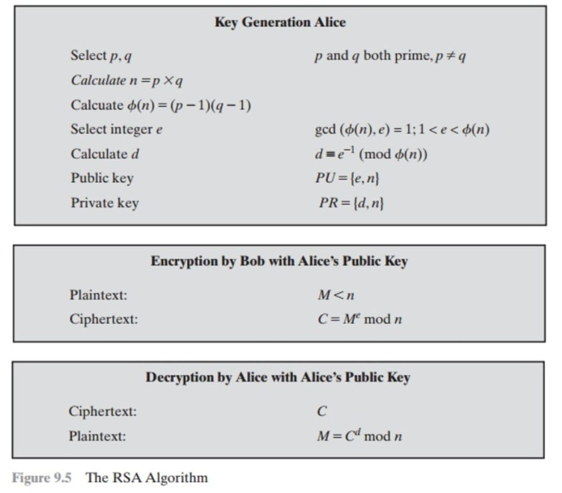
DIFFIE-HELLMAN
def is_prime(n):
if n < 2:
return False
for i in range(2, n):
if n % i == 0:
return False
return True

def is_primitive_root(a, q):
results = set()
for k in range(1, q):
value = pow(a, k, q)
results.add(value)

expected = set(range(1, q))
if results == expected:
return True
else:
return False

def all_primitive_roots(q):
roots = []
expected = set(range(1, q))

for a in range(1, q):
results = set()
for k in range(1, q):
value = pow(a, k, q)
results.add(value)
if results == expected:
roots.append(a)
return roots

while True:
q = int(input("Enter a prime number q: "))
if is_prime(q):
break
else:
print("Not a prime! Enter again.")

print("all primitve roots for given number is:", all_primitive_roots(q))

while True:
alpha = int(input("Enter alpha (primitive root of q): "))
if alpha < q and is_primitive_root(alpha, q):
break
else:
print("Not a valid primitive root! Try again.")

while True:
xa = int(input("Enter sender private key xa (< q): "))
if xa < q:
break
else:
print("Invalid, try again!")

while True:
xb = int(input("Enter receiver private key xb (< q): "))
if xb < q:
break
else:
print("Invalid, try again!")

ya = pow(alpha, xa, q)
yb = pow(alpha, xb, q)
print("\nPublic keys:")
print("Sender public key (ya) =", ya)
print("Receiver public key (yb) =", yb)

k1 = pow(yb, xa, q)
k2 = pow(ya, xb, q)

print("\nShared keys:")
print("k1 (sender side) =", k1)
print("k2 (receiver side) =", k2)
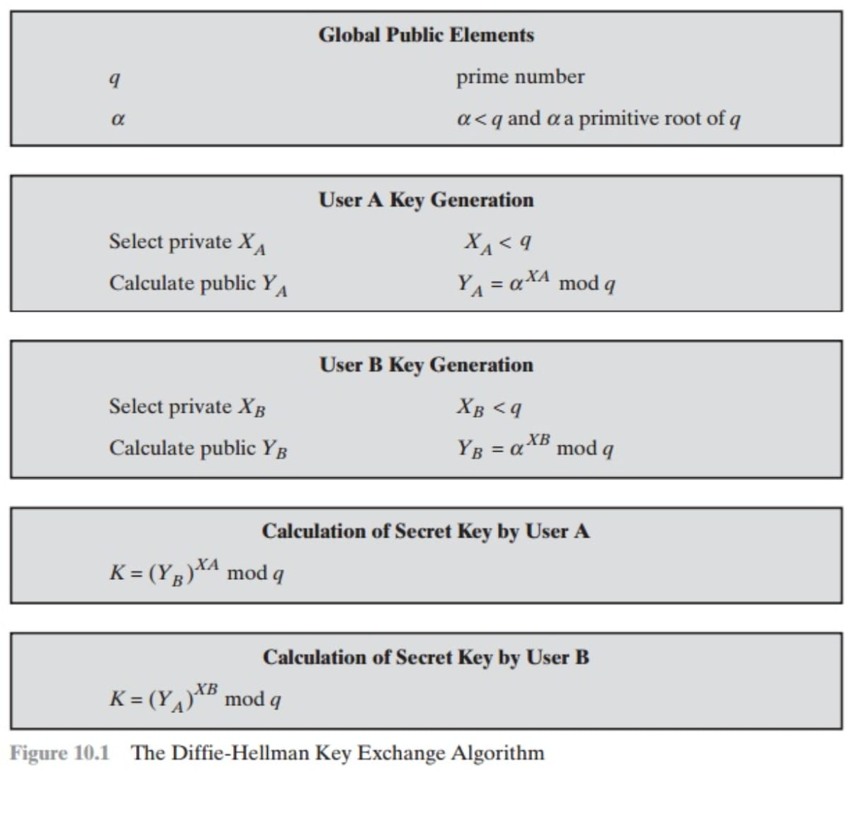
ELGAMAL
def is_prime(n):
if n < 2:
return False
for i in range(2, int(n**0.5) + 1):
if n % i == 0:
return False
return True

def is_primitive_root(g, p):
required = set()
for i in range(1, p):
required.add(pow(g, i, p))
return len(required) == p - 1

def primitive_roots(p):
roots = []
for g in range(1, p):
if is_primitive_root(g, p):
roots.append(g)
return roots

while True:
p = int(input("Enter a prime number p: "))
if is_prime(p):
break
else:
print(" Not a prime! Enter again.")

print("\n Prime number accepted:", p)

print("All Primitive Roots of p:", primitive_roots(p))

while True:
g = int(input("\nEnter a primitive root g: "))
if is_primitive_root(g, p):
print(" Valid primitive root!")
break
else:
print(" Not a primitive root! Enter again.")

x = int(input("\nEnter private key x (secret): "))

y = pow(g, x, p)
print("\nPublic Key (p, g, y):", p, g, y)

while True:
m = int(input("\nEnter message m (0 < m < p): "))
if 0 < m < p:
break
print(" Message must satisfy 0 < m < p")

while True:
k = int(input("Enter random key k (1 < k < p): "))
if 1 < k < p:
break
print("k must be between 1 and p-1")

c1 = pow(g, k, p)
c2 = (m * pow(y, k, p)) % p
print("\nCiphertext (c1, c2):", c1, c2)

s = pow(c1, x, p)
inv_s = pow(s, p-2, p)
m_dec = (c2 * inv_s) % p

print("\nDecrypted Message:", m_dec)
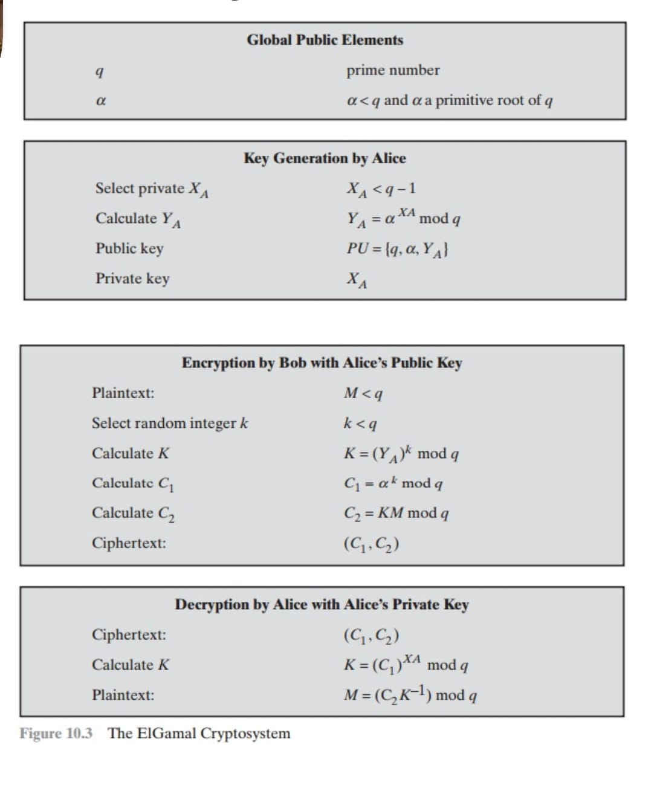

MD5 ALGORITHM
import java.security.MessageDigest;
import java.util.Scanner;

public class MD5Demo {
public static String getMD5Hash(String input) {
try {
MessageDigest md = MessageDigest.getInstance("MD5");
byte[] messageDigest = md.digest(input.getBytes());
StringBuilder hexString = new StringBuilder();
for (byte b : messageDigest) {
hexString.append(String.format("%02x", b));
}
return hexString.toString();
} catch (Exception e) {
throw new RuntimeException(e);
}
}

public static void main(String[] args) {
Scanner sc = new Scanner(System.in);
System.out.println("----- MD5 HASHING -----");
System.out.print("Enter first message: ");
String msg1 = sc.nextLine();

System.out.print("Enter slightly changed message: ");
String msg2 = sc.nextLine();

String hash1 = getMD5Hash(msg1);
String hash2 = getMD5Hash(msg2);

System.out.println("\nOriginal Message : " + msg1);
System.out.println("MD5 Hash : " + hash1);

System.out.println("\nModified Message : " + msg2);
System.out.println("MD5 Hash : " + hash2);

if (!hash1.equals(hash2)) {
System.out.println("\n Avalanche Effect: Small input change → Different hash completely!");
}

sc.close();
}
}

SHA
import java.security.MessageDigest;
import java.security.NoSuchAlgorithmException;
import java.nio.charset.StandardCharsets;
import java.util.Scanner;

public class SHA1UserInput {

public static void main(String[] args) {

Scanner sc = new Scanner(System.in);
System.out.print("Enter the message to hash using SHA-1: ");
String input = sc.nextLine();
sc.close();

if (input == null || input.trim().isEmpty()) {
System.out.println(" Error: Input cannot be null or empty!");
return;
}

try {
MessageDigest sha1 = MessageDigest.getInstance("SHA-1");

byte[] messageBytes = input.getBytes(StandardCharsets.UTF_8);

byte[] hashBytes = sha1.digest(messageBytes);

StringBuilder hexHash = new StringBuilder();
for (byte b : hashBytes) {
hexHash.append(String.format("%02x", b));
}

System.out.println("\n===== SHA-1 HASHING RESULT =====");
System.out.println("Input Message : " + input);
System.out.println("SHA-1 Hash : " + hexHash.toString());

if (hexHash.length() == 40) {
System.out.println(" Hash length verified: 40 characters (160 bits)");
} else {
System.out.println(" Invalid SHA-1 hash length!");
}

} catch (NoSuchAlgorithmException e) {
System.out.println(" Error: SHA-1 algorithm not found!");
}
}
}

DES
import javax.crypto.Cipher;
import javax.crypto.KeyGenerator;
import javax.crypto.SecretKey;
import javax.crypto.spec.SecretKeySpec;
import java.util.Base64;
import java.util.Scanner;

public class DESExample {

public static void main(String[] args) {
try {
Scanner sc = new Scanner(System.in);

System.out.print("Enter plaintext to encrypt: ");
String plaintext = sc.nextLine();

System.out.print("Enter 8-character secret key: ");
String keyInput = sc.nextLine();

sc.close();

if (keyInput.length() != 8) {
System.out.println(" Error: Key must be exactly 8 characters long (64 bits).");
return;
}

byte[] keyBytes = keyInput.getBytes();
SecretKey secretKey = new SecretKeySpec(keyBytes, "DES");

Cipher desCipher = Cipher.getInstance("DES/ECB/PKCS5Padding");

desCipher.init(Cipher.ENCRYPT_MODE, secretKey);

byte[] encryptedBytes = desCipher.doFinal(plaintext.getBytes());
String encryptedText = Base64.getEncoder().encodeToString(encryptedBytes);

desCipher.init(Cipher.DECRYPT_MODE, secretKey);
byte[] decryptedBytes = desCipher.doFinal(Base64.getDecoder().decode(encryptedText));
String decryptedText = new String(decryptedBytes);

System.out.println("\n===== DES ENCRYPTION & DECRYPTION =====");
System.out.println("Plaintext : " + plaintext);
System.out.println("Key : " + keyInput);
System.out.println("Encrypted : " + encryptedText);
System.out.println("Decrypted : " + decryptedText);

if (plaintext.equals(decryptedText)) {
System.out.println(" Verification Successful: Decrypted text matches the original plaintext.");
} else {
System.out.println("Verification Failed: Decrypted text does not match the original plaintext.");
}

} catch (Exception e) {
System.out.println(" Error occurred: " + e.getMessage());
}
}
}
AES
import javax.crypto.Cipher;
import javax.crypto.spec.SecretKeySpec;
import java.util.Scanner;
import java.util.Arrays;

public class AESExample {
public static void main(String[] args) throws Exception {
Scanner sc = new Scanner(System.in);

// Get plaintext and key from user
System.out.print("Enter text to encrypt: ");
String inputText = sc.nextLine();

System.out.print("Enter key (less than or equal to 16 chars): ");
String keyInput = sc.nextLine();

// Pad both plaintext and key if shorter than 16 bytes
byte[] keyBytes = padTo16Bytes(keyInput.getBytes());
byte[] inputBytes = padTo16Bytes(inputText.getBytes());

// Create AES key
SecretKeySpec secretKey = new SecretKeySpec(keyBytes, "AES");

// Initialize Cipher for AES encryption
Cipher cipher = Cipher.getInstance("AES/ECB/PKCS5Padding");

// Encrypt
cipher.init(Cipher.ENCRYPT_MODE, secretKey);
byte[] encrypted = cipher.doFinal(inputBytes);
System.out.println("\nEncrypted (Hex): " + bytesToHex(encrypted));

// Decrypt
cipher.init(Cipher.DECRYPT_MODE, secretKey);
byte[] decrypted = cipher.doFinal(encrypted);
System.out.println("Decrypted text: " + new String(decrypted).trim());
}

// Pads any byte array to 16 bytes with zeros
private static byte[] padTo16Bytes(byte[] input) {
return Arrays.copyOf(input, 16);
}

// Converts bytes to hex string
private static String bytesToHex(byte[] bytes) {
StringBuilder sb = new StringBuilder();
for (byte b : bytes)
sb.append(String.format("%02X", b));
return sb.toString();
}
}

