**NAME: Anisha Rathore CLASS: CI-1 [3 YEAR]**

**ENROLLMENT NUMBER: 0827CI211024**

**ABOUT UNIX**

**Q1. STUDY OF UNIX OPERATING SYSTEM & ITS FUNDAMENTALS.**

* **OS (DEFINITION)**
* **LIST OF OS WITH THEIR UTILITY**
* **ABOUT UNIX OS**
* **FEATURE**
* **DISTRIBUTION**
* **HISTORY**
* **APPLICANTS**
* **COMPARISON OF WINDOWS AND UNIX**

**ANSWER:-**

# **Operating System (OS) Definition:**

An operating system (OS) is a software system that manages computer hardware, software resources, and provides various services for computer programs. It acts as an intermediary between computer hardware and user-level applications, ensuring efficient utilization of hardware resources and providing a user-friendly interface.

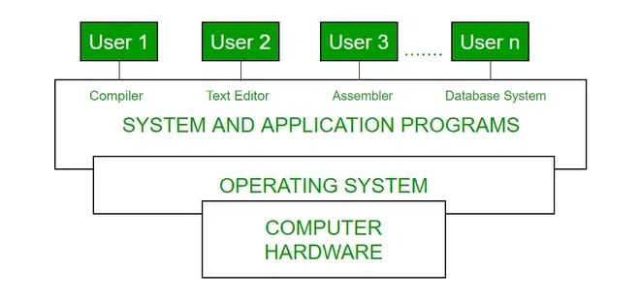

# List of Operating Systems with Their Utility:

There are numerous operating systems, each designed for specific use cases. Some examples include:

1. **Windows**: Primarily used for personal computers, workstations, and servers. Known for its user-friendly interface.
2. **macOS**: Designed by Apple for their Macintosh line of computers. Known for its aesthetics and integration with Apple's ecosystem.
3. **Linux:** A family of open-source operating systems widely used on servers and embedded systems. Offers high customization and control.
4. **Unix:** The precursor to Linux, widely used in server environments for its stability and security features.
5. **Android:** Based on the Linux kernel, used in mobile devices and tablets.
6. **iOS:** Apple's mobile operating system used exclusively on iPhones and iPads.

# About UNIX Operating System:

Unix is a family of multitasking, multi user computer operating systems that are derived from the original AT&T Unix developed in the 1970s. It emphasizes simplicity, portability, and a strong focus on command-line interfaces. The Unix philosophy promotes the idea of building small, modular tools that can be combined to perform complex tasks.

# Features of Unix:

1. **Multiuser and Multitasking:**Unix allows multiple users to access the system simultaneously and execute multiple processes concurrently.
2. **Hierarchical File System:** Files are organized in a hierarchical directory structure, allowing for easy organization and navigation.
3. **Command-Line Interface:** Unix provides a powerful command-line interface that allows users to interact with the system using textual commands.
4. **Portability:** Unix was designed to be portable across different hardware platforms, which contributed to its widespread adoption.
5. **Security:** Unix incorporates robust security mechanisms, including user authentication, permissions, and encryption.
6. **Networking:** Unix was an early adopter of networking protocols, enabling seamless communication between computers.

# Unix Distributions:

Unix doesn't have a single distribution like Linux. Instead, it has various versions developed by different organizations. Some well-known Unix-like operating systems include:

1. AIX (IBM)
2. HP-UX (Hewlett Packard)
3. Solaris (Oracle)
4. BSD (Berkeley Software Distribution)

# History of Unix:

Unix was developed in the late 1960s and early 1970s at AT&T's Bell Labs. Its development was influenced by the Multics project. Over time, various versions and flavors of Unix emerged, including the BSD variants and the System V branch. These influenced the development of Linux.

# Applications of Unix:

Unix is used in various applications, including servers, workstations, embedded systems, supercomputers, and research environments. It's commonly found in web servers, scientific research, telecommunications, and networking equipment.

# Comparison of Windows and Unix:

* + **User Interface:** Windows offers a graphical user interface (GUI) by default, while Unix primarily uses a command-line interface, though GUIs exist for Unix as well.
  + **Customization:** Unix offers greater customization and flexibility due to its open nature, while Windows provides a more standardized user experience.
  + **Stability:** Unix systems are known for their stability, making them favored for servers. Windows has historically had more frequent updates and reboots.
  + **Security:** Unix systems tend to have a better security reputation, attributed to its design principles. Windows has made significant security improvements over time.
  + **Software Availability:**\*\* Windows has a larger selection of commercial software, while Unix systems rely heavily on open-source software.
  + **Licensing:** Many Unix-like systems are open source, which can lead to cost savings. Windows typically involves licensing fees.

**Usage:**

Unix is prevalent in server environments and specialized systems. Windows is common for personal computing and enterprise use.

Remember that the operating system landscape is continually evolving, and new developments may have occurred beyond my last knowledge update in September 2021.