**Dynamic Recovering of Body Configurations by Combining Segmentation and Recognition**

**Introduction:**

The goal of this work is to take a picture, detect a person's ﬁgure, and ﬁnd the conﬁguration of parts. This is often a really difﬁcult problem, partially as a result of human bodies are versatile, presenting a wide vary of pose and aspects, several including self-occlusion, and partially as a result of variations in clothing and background clutter deny an easy look model.

Given the apparently insurmountable difﬁculties, several existing approaches to the present downside create simpliﬁcations of one kind or another, either presumptuous information of scale and appearance/color, or using motion data from video sequences for background subtraction, or limiting analysis to restricted domains like walking ﬁgures. In these cases, a canonical tree-based model is often used to model body components, wherever dynamic programming are often applied. We tend to tackle the matter in a very additional general setting. Without restrictions in pose, appearance, or background clutter, a tree-based model not sufﬁces. Extra sources of data, not provided by tree-based models, are needed to succeed. For instance, the symmetry of clothing may be a powerful cue to constrain limb look. As another example, inFigure1, what reveals the body position to US are the association between the two higher legs and also the relative geometric relationship between arms and legs, each of that don't seem to be within the traditional tree-based model.

It's an open question what models will express sufﬁcient constraints and are computationally possible. During this work, we tend to develop a technique that exploits a rich set of cues, deﬁned on arbitrary pairs of parts, to constrain body conﬁgurations. We tend to learn these constraints from empirical information. The goals of our unified framework are:

I.) to extend low-level techniques to handle multiple moving objects,

2.) to explicitly model occlusion,

3.) to estimate and predict 3D motion trajectories, and

4.) to recognize nonrigid motions.

An improved feedback mechanism is proposed that combines low-level (image segmentation) and mid- level (recursive trajectory estimation), and high-level (action recognition) modules. The recursive estimation process provides a prediction and error measure that is exploited in higher-level stages of action recognition. Conversely, higher-level mechanisms provide feedback that al- lows the system to reliably segment and maintain the tracking of multiple moving objects before, during, and after occlusion. The approach enables accurate extraction of a stabilized coordinate frame for the moving non-rigid objects that is used in action recognition.

**Methods wants to use in this experiment:**

We plan the video based human pose estimation issue into a uniﬁed tree-based improvement system, which can be understood efﬁciently by powerful programming. With a reference to the significant strides in Fig.1.

The main steps of the framework are:

1.Generate many posture theories by the N-Best technique or Deep Convolutional Neural Networks with Graphical Model (DCNNGM);

2.From 1, produce speculations for every genuine body part and prorogate them to adjoining outlines

3. Join the symmetric genuine body part speculations and acquire the unique body part theories;

4. Fabricate the speculations diagram for each unique body part and select the best one for each;

5. Fabricate the posture speculations diagram for the unique body parts and select the best posture conﬁguration.

6. use appendage arrangement and reﬁnement plans to surmise the right appendage conﬁgurations.

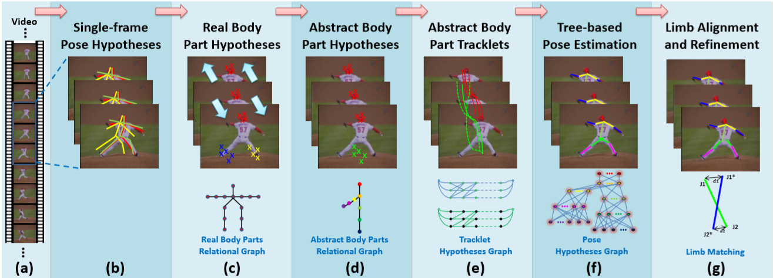

**Figure 1:** Steps of the framework

A framework of the proposed technique in fig (1). (a) demonstrates the first video outlines; in (b), present speculations in each casing are created by N-Best strategy or DCNNGM ; in (c), by utilizing the outcomes from (b), genuine body part theories are produced for each body part in each casing and proliferated to the contiguous edges; in (d), genuine body parts are consolidated into dynamic body parts and the theories are additionally joined likewise so as to evacuate the intra-outline basic cycles (for example the straightforward cycles with blue and green edges in Fig.2(b)); in (e), tracklets are produced for dynamic body parts (counting single body parts and coupled body parts) utilizing the conceptual body part speculations created in (d); in (f), the posture theories diagram is constructed, every hub is a tracklet relating to the unique body part, and the best posture estimation is gotten by choosing the best theories for the parts from the chart; and in (g), the right appendages are gathered by appendage arrangement and reﬁnement plans.

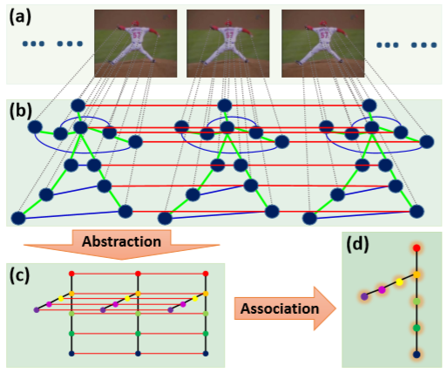

**Figure 2:** An abstract high-level illustration of proposed methodology

In figure.2 All of the above graphs are relative graphs for the issues. In (a), many sample frames of a video area unit shown. In (b), every body part in every frame is described by a node. green and blue edges represent relationships between totally different body parts within the same frame (green ones are usually used edges within the literature, and blue ones are necessary edges for symmetric parts); red edges represent the consistency constraints for a similar body part in adjacent frames. Note that this is often solely AN illustration and not all edges are shown. within the ‘Abstraction’ stage, isobilateral parts are combined along, and also the straightforward cycles among every single frame area unit removed (shown in (c)); and within the ‘Association’ stage, the easy cycles between adjacent frames area unit removed (shown in (d)).

**Experimental procedure of the project:**

We will apply our framework on three freely accessible datasets:

**Outdoor Pose Dataset:** This dataset was gathered by the creators of, which contains six video arrangements from outside scenes. There are a ton of self-impediments of the body parts in this dataset. Explanations of in excess of 1,000 edges are given by the creators.

**Human Eva-I:** This dataset contains human exercises in indoor controlled conditions. The exercises are synchronized with a ground truth of 3D movement catch information, which can be changed over into 2D joint areas. So as to have a reasonable correlation with, we will utilize as many as edges from the arrangements.

**N-Best Dataset:** This dataset was gathered by D. Park and D. Ramanan and has four successions altogether. As a reasonable correlation with V. Ramakrishna, T. Kanade, and Y. Sheikh reports, we will additionally report results on arrangements walk straight and baseball.

We will compare the projected technique with 3 progressive video primarily based human pose estimation methodologies: N-Best method , symmetric tracking method , mixing Body-part method, and a deep learning baseline method (i.e. DCNNGM ); We will not compare with some higher body pose estimation/tracking methods ,since they specialize in the modeling of hands/elbows using motion and look options however don't handle other body parts. Since is meant for upper-body pose estimation, we are going to re-implement its algorithmic program (if it's not enough) by reusing most of their implementation but extend it to a full-body detection model. Quantitative results are going to be shown in Tables, and qualitative results are going to be shown in Figures. Note that the ﬁgures for symmetric chase technique won't be re-produced from ﬁgures in since the code isn't in public on the market. We will also show detailed outcomes to break down the commitments of each progression of the proposed technique.

**Conclusion:**

We have planned a tree-based optimisation technique for human create estimation in videos. we've got incontestable that, by victimisation the temporal data inside the frames of a video, the performance of human create estimation in videos can be signiﬁcantly improved over the image based mostly create estimation ways (even for deep learning methods). Our main contribution is generally targeted on reformulating the matter to get rid of the simple cycles from the graph at identical time maintaining the helpful connections at the best doable extent, so as to rework the initial NP-hard downside into an easier tree based mostly optimisation downside, that the precise resolution exists and may be solved efﬁciently. It's may clear from the experiments that the planned approach will not solely elegantly formulates the matter, however additionally dramatically it can improve the human create estimation leads on videos. The planned formulation is general, it’s possible to be used in resolution another issues in computer vision.

**References:**

[1] J. Boyd, “Video phase-locked loops in gait recognition,” in Proc. Int. Conf. Computer Vision, vol. I, 2001, pp. 696–703.

[2] R. Tanawongsuwan and A. Bobick, “Gait recognition from time-normalized joint-angle trajectories in the walking plane,” in Proc. Int. Conf. Computer Vision and Pattern Recognition, 2001.

[3] D. M. Gavrila. The visual analysis of human movement: A survey. Computer Vision and Image Understanding: CVIU, 73(1):82–98, 1999.

[4] M. Goemans and D. Williamson. Imroved approximation algorithms for maximum cut and satisﬁability problems using semideﬁnite programming. Journal of the ACM, 42(6):1115–1145, 1995.

[5] D. Hogg, “Model-Based Vision: A Program to See a Walking Person,” Image and Vision Computing, vol. 1, no. 1, pp. 5-20, 1983.

[6] M. Yamamoto and K. Koshikawa, “Human Motion Analysis Based on a Robot Arm Model,” Proc. IEEE CS Conf. Computer Vision and Pattern Recognition, pp. 664-665, 1991.

[7] J.M. Rehg and T. Kanade, “Visual Tracking of High DOF Articulated Structures: An application to Human Hand Tracking,” Lecture Notes in Computer Science, vol. 800, pp. 35-46, 1994.