Technical Design Document
Gated Township Resident App (Problem Statement 4)
GitHub repository: https://github.com/anik-ug/township-app
Live app: Backend API on Render free tier: https://township-app-3rrg.onrender.com (sleeps when idle; first request can take 2 to 3 minutes). The full app (UI + API + database) runs with one command, see deployment.md. The UI itself is not hosted publicly.
Author: Anik Kumar. Submission: Software Engineering Intern take-home, 9 Nov 2026.

1. What I built
The brief asks for one app where residents pay maintenance, raise complaints and see their status, with a back office that matches bank payments by itself and a committee that can trust its monthly report. The core build was five things, and all five work end to end on seeded data:
- Resident login: mobile number and OTP (mocked), linked to a flat, role-based access.
- Maintenance bills and test payment: bill = area x Rs 6.50, configurable late fee, payment, receipt and a per-flat ledger.
- Bank statement matching (the hard part): a rule-based engine that posts only exact matches and sends everything unclear to an accounts queue, with a confidence score and a plain-language reason for every row.
- Complaints with AI: category and urgency, auto-assignment, status timeline, duplicate linking, and a safety-word rule that escalates to the duty manager whatever the AI says.
- Committee dashboard: collections, dues ageing and complaint response times.
Roles: RESIDENT, HELPDESK, ACCOUNTS and COMMITTEE (the last two are my assumption, see section 8). The app is mobile-first and available in English, Hindi and Marathi.
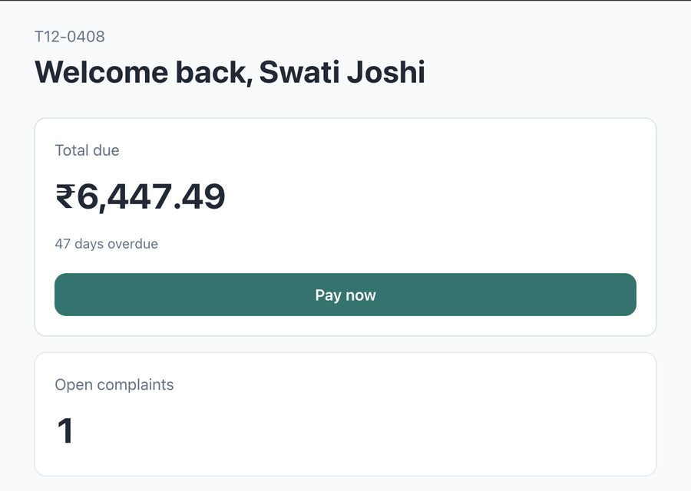
Figure 1. Resident home: the dues amount is the single hero, one primary action, open complaints below.

2. Architecture and why
Layer | Choice | Why
Backend | Spring Boot 3.3, Java 17, Spring Security (stateless JWT) | My strongest stack; the work is rules, transactions and access control, which this stack does well.
Database | PostgreSQL 16 with Flyway migrations | Exact numeric types, constraints and unique keys do real work here (for example, a unique key stops a bank row from being posted twice).
Frontend | React, Vite, TypeScript, Tailwind, react-i18next | Small bundle, installable as a web app (manifest + service worker), i18n for en, hi, mr.
Auth | Mock OTP and HS256 JWT with role and flat claims | No SMS provider is needed for the demo; the flat always comes from the token, never from a request parameter.
Packaging | Docker (backend, frontend) and docker-compose.demo.yml | A reviewer can run the whole system with one command.

A single Spring Boot service keeps the system easy to reason about: controllers per role (resident, help desk, accounts, committee), services for billing, matching and complaints, and a Flyway-managed schema. I did not use a message queue or microservices: at 2,400 flats the load does not need them, and the time limit (one week, alone) was better spent on correctness and tests.

Money and dates
- All money is stored as integer paise (BIGINT, Java long). No floating point anywhere in billing or matching. Rounding is HALF_UP and is applied once, at the end of a calculation.
- "Today" is a configurable as-of date (default 2026-11-05) so the numbers in the brief (47 and 18 days overdue) stay fixed in the demo.
- The frontend converts typed rupees to paise with a string parser (no parseFloat) and blocks letters, a second decimal point and more than two decimals.

3. Data model
Table | Purpose and key rules
flat | Tower, flat number (T21-1601), area in sq ft, optional UPI id (used for bank matching).
app_user | Phone, name, role (RESIDENT, HELPDESK, ACCOUNTS, COMMITTEE), flat, tenant flag. Seed data is fake.
bill | One per flat per month: amount in paise and due date. Unique (flat, month). Late fee and status are derived, not stored.
payment | Amount, method (TEST_ONLINE, BANK_MATCH, MANUAL), reference, late_fee_paise (the part that settled late fee), link to the bank row when it came from a statement.
late_fee_rule | Grace days, annual rate in basis points, optional cap. Read from the database, so the bye-law can change without a deploy.
bank_upload, bank_row | Every uploaded CSV row with status (MATCHED, QUEUED, DUPLICATE, RESOLVED, REJECTED, ERROR), confidence, explanation, matched flat and bill. Unique (reference, amount, date) so a re-upload cannot post twice.
bank_row_audit | Who resolved or rejected a queued row, when and why.
complaint | Text, category, urgency, category source (AI/KEYWORD/RULE/HUMAN), status, assignee, duplicate_of link, escalation flag and reason, reopen count, rating.
complaint_event | Append-only timeline of every status change and decision. Response and resolution times are computed from this table.

4. Main flows

4.1 Bills, late fee and payment
- Bill: area_sqft x 650 paise per month. The three sample flats come out exactly as in the brief: Rs 7,475, Rs 6,370 and Rs 10,660.
- Late fee: simple interest on the unpaid principal. chargeable days = max(0, days overdue - 10 grace days); fee = round_half_up(principal x 12% x chargeable days / 365). It is computed, never stored.
- Checked by hand: T12-0408, Sep bill: 637,000 paise, 47 days overdue, 37 chargeable, fee 7,749 paise, total Rs 6,447.49. T21-1601, Oct bill: 566,000 paise unpaid, 18 days overdue, fee 1,489 paise, total Rs 5,674.89.
- Payment: a payment settles the late fee first, then principal. The payment is validated (0 < amount <= total due), done in one transaction with a row lock, and returns a receipt. The ledger shows bill, late fee and payments so its final balance always equals the amount on the home screen.

4.2 Bank statement matching
The accountant uploads a bank CSV (date, amount, reference, UPI id, narration). Each row goes through these rules in order; the first hit wins and every row gets a status, a confidence and a readable reason:
# | Rule | Result | Confidence
1 | Same (reference, amount, date) already seen, in the database or earlier in the file | DUPLICATE, nothing posted | -
2 | Exactly one flat number found in reference or narration (also T211601 without a hyphen) and amount equals the total due (principal + late fee) of that flat's oldest open bill | MATCHED, payment posted | 95
3 | One flat found, amount differs (partial, wrong amount, principal only) | QUEUED | 40
4 | No flat number, UPI id linked to exactly one flat, amount equals total due | MATCHED, payment posted | 85
5 | UPI id linked to more than one flat | QUEUED, candidates listed | 20
6 | More than one flat number in the text | QUEUED, candidates listed | low
7 | Nothing recognisable; malformed amount | QUEUED / ERROR row | 0

- The rule that matters: only rules 2 and 4 can create a payment. A queued row is never posted to a flat automatically. The accountant resolves it by choosing a flat and bill (validated against the bill's total due), or rejects it with a reason. A row can be resolved once; a second attempt returns 409. Every resolve and reject is written to the audit table.
- Confidence is a fixed score per rule, a ranking of how much each rule can be trusted, not a statistical probability. The explanation text is what the accountant should read.
- Safe by design: amounts are parsed with BigDecimal and must be positive with at most two decimals; a bad row becomes an ERROR row and the rest of the file is still processed; at most 5,000 rows and 1 MB per file; uploading the same file twice posts each payment only once.
- Sample file result (docs/sample_bank.csv): 5 matched (4 by flat number, 1 by UPI), 6 queued (2 partial payments including T21-1601 paying Rs 5,000 against Rs 5,674.89, 1 wrong amount, 1 shared UPI, 2 unknown), 1 duplicate and 1 error.

4.3 Complaints and the AI part
- Safety rule first, and it cannot be overridden. Before any classifier runs, a rule engine checks the text for safety terms (fire, smoke, gas leak, smell of gas, lift stuck, shock, short circuit, sparking, plus Hindi/Hinglish such as aag, dhuan, current laga). Terms are in configuration and matched on word boundaries, so "fireplace" does not trigger. A hit sets urgency CRITICAL, marks the complaint escalated and assigns it to the duty manager. Changing the category later does not remove the escalation.
- Classifier. A deterministic keyword classifier (category, urgency, confidence) is the default and works offline. An LLM classifier is implemented behind an interface and used only when an API key is set; it sends only the complaint text (never the flat, name or phone), has a 5 second timeout, validates the answer against the allowed values, and on any error falls back to the keyword classifier. The demo runs on the keyword classifier; the LLM path is covered by tests with a fake client.
- When the AI is wrong. The help desk changes the category in one tap (the source becomes HUMAN and the change is logged). Duplicates are linked, never auto-closed: same tower and category within two hours points to the earliest open complaint, and the duplicate keeps its own status and timeline. Status changes follow OPEN, ASSIGNED, IN_PROGRESS, RESOLVED, CLOSED (and RESOLVED back to IN_PROGRESS); any other jump returns 409.
- Assignment. Round-robin to the help-desk user with the fewest open complaints.
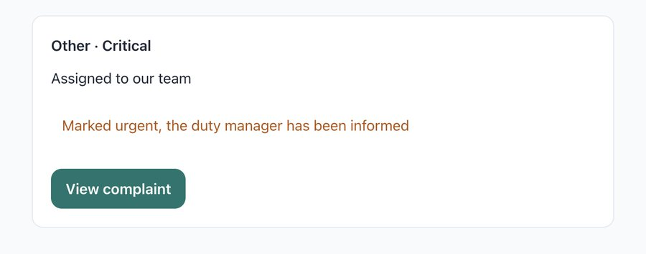
Figure 2. "gas smell in kitchen" becomes Critical and the resident is told the duty manager has been informed.
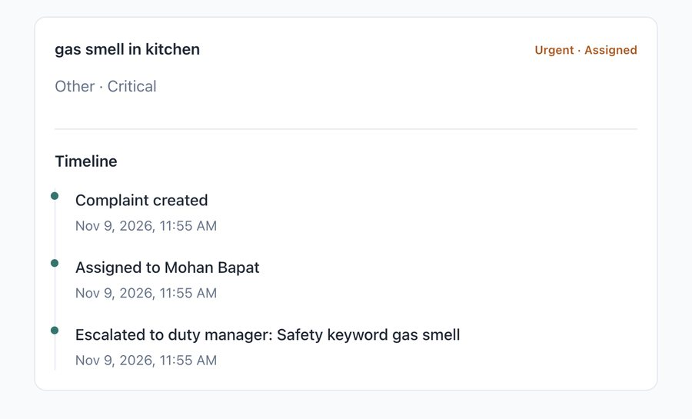
Figure 3. The timeline shows creation, assignment and the escalation with its reason.

4.4 Committee dashboard
Read-only. For the latest billing cycle it shows billed vs collected (Rs 3,15,510.00 billed, Rs 2,24,115.00 collected, 71.03%), the share paid on time and by day 10, dues ageing in 0-30, 31-60, 61-90 and 90+ day buckets (total outstanding Rs 98,308.36, T12-0408 in 31-60 and T21-1601 in 0-30), and complaint metrics: open count, SLA breaches, average first response and resolution time, reopened share and a category breakdown. Response and resolution times are computed from complaint events: the first move to IN_PROGRESS, RESOLVED or CLOSED counts as the first response (auto-assignment does not).

5. Security and data
- Role-based access on every endpoint. A resident only sees their own flat (the flat comes from the token); asking for another flat's bill or complaint returns 404. Help desk, accounts and committee endpoints return 403 for other roles and 401 without a token.
- OTP: the request-otp endpoint gives the same reply for known and unknown numbers (no user enumeration); five wrong attempts lock a number for 10 minutes.
- Input validation on every request (jakarta.validation on the server, a sanitiser on the client); CSV limits as above; the generic 500 handler logs the cause but returns a safe message.
- No secrets in the repository: everything comes from environment variables (names listed in deployment.md). All seed data is fake. No Aadhaar or other identity numbers are stored.

6. UI and design decisions
The client asked for minimal design with nothing on screen that lacks a purpose, and for residents who open the app for a few seconds. So:
- White space, one accent colour (teal), red only for overdue and critical, amber for escalated. System fonts only, so pages stay light on low-end phones; a Devanagari fallback covers Hindi and Marathi.
- Resident home shows what matters first: total due in large numerals, how overdue it is, one "Pay now" button, then open complaints. Every action is within two taps. The visitors tile from the brief is not shown because visitor management is out of scope.
- Money is always right-aligned with tabular numerals and formatted in one helper (Indian grouping). The pay screen blocks bad input, shows "Maximum Rs X" style messages and has a clear Full amount / Other amount switch.
- Every data screen has loading, empty and error states. Buttons look like buttons, links look like links, tap targets are at least 44 px, keyboard focus is visible.
- Languages: English, Hindi and Marathi through react-i18next. The language switcher shows each language in its own script. Status, urgency and category labels are translated, not printed as raw codes.
- Help desk, accounts and committee use a desktop layout with a sidebar; tables become stacked cards on phones. The accounts screen puts the reason for each match next to its confidence bar, because the accountant must be able to trust or question every row.
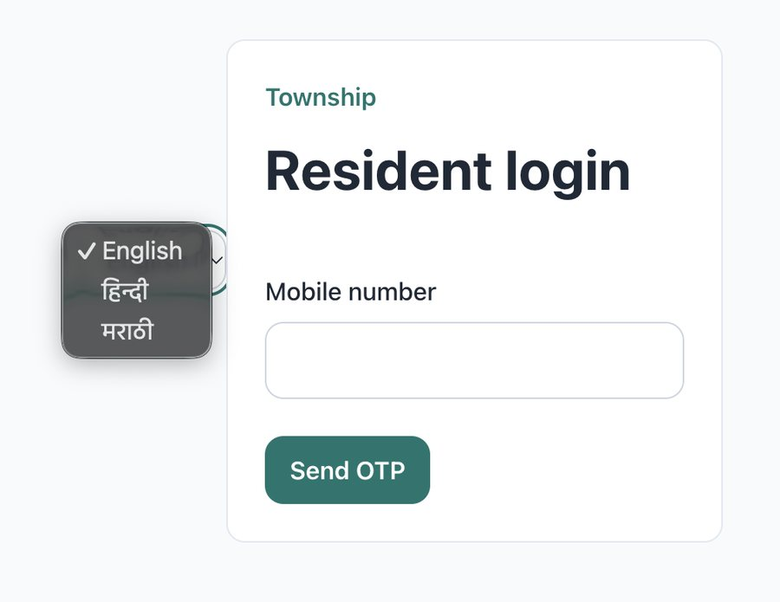
Figure 4. Login with the language switcher (English, Hindi, Marathi, each in its own script).

7. Testing
Backend: JUnit 5 and MockMvc, more than 50 tests (run ./mvnw test in backend/). Frontend: Vitest, more than 15 tests (npm test in frontend/).
- Late fee calculator: inside grace, exactly at grace, 47 and 18 day cases, rounding, cap.
- Bank matcher: exact match with late fee, principal-only, partial Rs 5,000, wrong amount, flat number without hyphen, two flats in one narration, UPI on two flats, UPI-only match, duplicates inside the file and against the database, unknown row, oldest-bill selection.
- Service and HTTP tests: uploading the sample CSV twice posts each payment once; queued rows create no payment; a second resolve returns 409; resident and help-desk tokens get 403 on accounts endpoints; tampered and expired tokens return 401.
- Complaints: each safety term, Hindi terms, "fireplace" does not trigger, escalation survives a classifier that says LOW, classifier fallback, round-robin, duplicate window, status transitions, another flat's complaint returns 404.
- Frontend: rupee-to-paise parser, input sanitiser, pay screen validation, role redirect, translation key parity (every English key exists in Hindi and Marathi), staff menu open and close.
Integration tests roll back so they leave the development database unchanged. I also checked the key numbers by hand against the running app (curl and SQL), not only through tests.

8. Assumptions (labelled)
ID | Assumption
A1 | The brief lists "Out of scope: Ai or automation" but also requires AI complaint classification and automatic matching. I read it as "any AI or automation beyond what is described".
A2 | The brief names resident and help-desk roles. I added ACCOUNTS (works the bank queue) and COMMITTEE (read-only dashboard) as separate roles.
A3 | Bill = area x Rs 6.50 per month. The brief's Rs 7,500 average is only approximate for this rate (an average flat of about 1,150 sq ft).
A4 | Late fee: simple interest of 12% a year on the unpaid principal after 10 days of grace. These are stored in late_fee_rule and can be changed to match the society bye-laws. Days overdue are counted from the due date; grace only affects the fee.
A5 | A payment settles late fee first, then principal.
A6 | Bank rows are compared with the total due (principal + late fee) of the oldest open bill. Confidence values are fixed per rule.
A7 | The as-of date is pinned to 2026-11-05. Each sample flat has one relevant open bill, with due dates set so that the overdue days match the brief (47 and 18).
A8 | OTP, the payment gateway and messages are mocked (OTP is a configured value). No real SMS or money moves.
A9 | The duty manager is the help-desk user with phone 9100000001. The response SLA is 240 minutes (configurable). Duplicate window is two hours, same tower and category.
A10 | Hindi and Marathi texts were machine-generated and have not been reviewed by native speakers.
A11 | Roll numbers, PAN, visitors and amenity booking are not part of this slice (visitors and amenities are cut, see section 9).

9. What I cut, limits, and what I would do next

Cut on purpose
- Visitor management (guard tablet, photo, approvals, 90-day photo deletion) and amenity booking: they are "optional depth" in the brief and I preferred a smaller slice that works and is tested.
- A real payment gateway, real SMS/OTP provider, photo upload for complaints, rating screen polish, the DPDP notice screens and parental-consent flows.

Known limits (honest notes)
- Live hosting is not reliable: the free backend host sleeps, takes 2 to 3 minutes to wake and was unstable during my tests. That is why the one-command docker-compose stack is the supported way to review. The UI is not hosted publicly.
- The keyword classifier is simple; it is a safe default, not a smart one. The LLM path has not been exercised against a real provider.
- Hindi and Marathi translations are unreviewed (A10).
- The help-desk table shows the assignee as a staff id, not a name (the API does not return names yet).
- Staff screens are desktop-first. On some desktop widths the sidebar can sit over part of the page content; I was fixing this layout bug at the time of submission.
- The JWT secret has a local-development default in application.yml; deployments must set JWT_SECRET (the demo compose file requires it).
- Results-day load and offline behaviour were not tested.

Next steps
- Return assignee names in the help-desk API; add pagination and search to queues.
- Real OTP/SMS and a gateway with webhook-based payment confirmation; match gateway payments the same way as bank rows.
- Visitor management with an offline-tolerant guard tablet; amenity booking with slots and fees.
- Native review of translations; a Tally export for payments; load tests; Testcontainers instead of the shared development database in integration tests.

How I used AI
I used AI tools as the brief encourages: Claude for planning, review and writing this document, and GitHub Copilot's agent for much of the code. I wrote the prompts, reviewed the diffs, ran the tests and checked the important numbers by hand (the 7,749 and 1,489 paise late fees, the matcher outcomes, the ageing buckets). I decided the rules (matching order, safe fallbacks, what to cut). The commit history shows the work in small steps.

