#Full Name : Team4(Myat Oo, Zijian Zhang, Mohammad Islam

#Course Number and Title: CSC643

#Submission Date : March 1, 2017

#Assignment Number: Assignment\_1 (queries.py)

#Purpose :

1. In this Project, we need to work with MongoDB importing Json file named 'zipcodes'

2. Write 6 queries in MongoDB

a)    Find the total number of cities in the database.

b)    Create the list of states, cities, and city populations.

c)    List the cities in the state of Massachusetts with populations between 1000 and 2000.

d)    Write a mapReducer to compute the total number of cities and total population in each state.

e)    Write a mapReducer to find the average city population for each state.

f)     Write a mapReducer to find the least densely-populated state(s).

3. Write a Pymongo driver to execute all the above queries in pythons.

A

C:\Users\zz659749\Desktop\Team4\query_a.jpg

B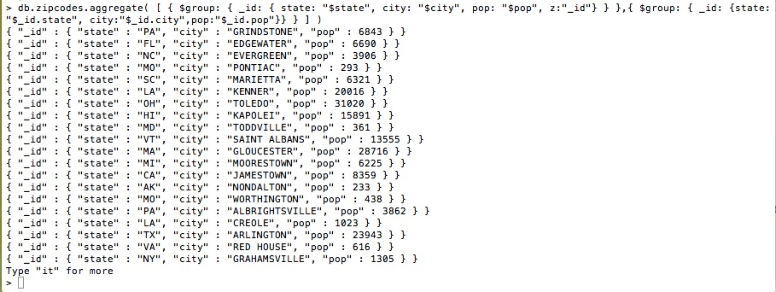

C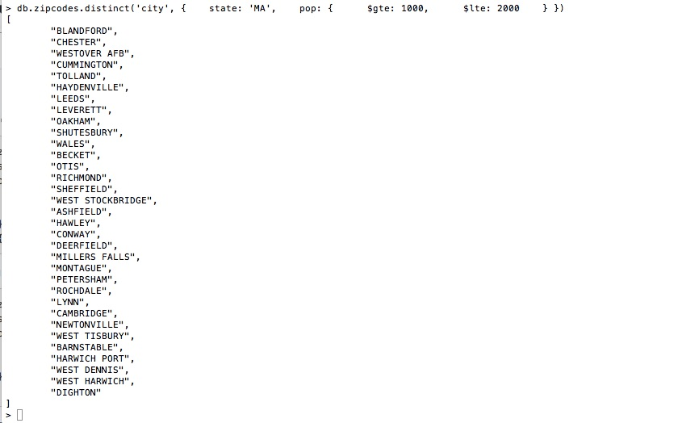

D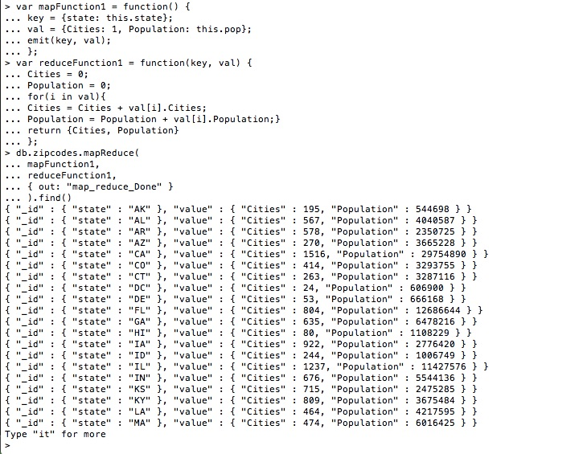

E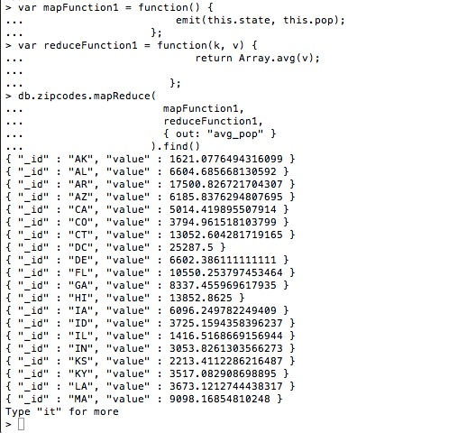

F

