- Better results in

- - EQUIPMUSE 60

% - - TEMPHOME 45

- - USEWWAC 90

- - TEMPHOMEAC 50

- - EMPLOYHH 80

% - - EDUCATION 45

- - NHSLDMEM 99

- - NUMADULT 99

- - NUMCHILD 99

- - ATHOME 60

---TRAINING FOR EQUIPMUSE ---

LR: 0.481500 (0.015923)

LDA: 0.574770 (0.013253)

KNN: 0.361070 (0.011670)

CART: 0.612293 (0.020875)

NB: 0.225811 (0.029856)

SVM: 0.379954 (0.001447)

ADB: 0.494067 (0.032300)

RFC: 0.569480 (0.022290)

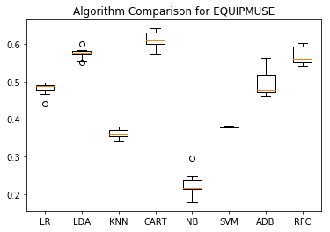

---TRAINING FOR TEMPHOME ---

LR: 0.265378 (0.020669)

LDA: 0.206764 (0.011286)

KNN: 0.177063 (0.009794)

CART: 0.418715 (0.013917)

NB: 0.061999 (0.003419)

SVM: 0.216614 (0.002411)

ADB: 0.260590 (0.003075)

RFC: 0.308236 (0.010528)

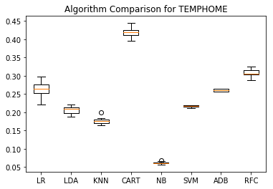

---TRAINING FOR TEMPGONE ---

LR: 0.202107 (0.016969)

LDA: 0.193186 (0.014937)

KNN: 0.139644 (0.013049)

CART: 0.357297 (0.024299)

NB: 0.055419 (0.003113)

SVM: 0.154170 (0.002290)

ADB: 0.198358 (0.003362)

RFC: 0.236461 (0.020160)

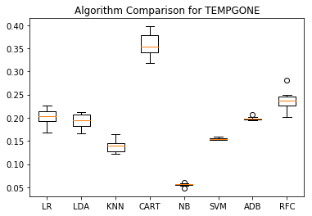

---TRAINING FOR TEMPNITE ---

LR: 0.230430 (0.011791)

LDA: 0.186554 (0.016308)

KNN: 0.135749 (0.017386)

CART: 0.362413 (0.011595)

NB: 0.055119 (0.005924)

SVM: 0.164959 (0.002897)

ADB: 0.232096 (0.017180)

RFC: 0.251224 (0.024251)

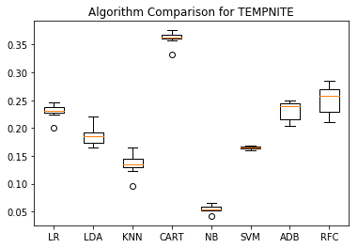

---TRAINING FOR USEWWAC ---

LR: 0.819718 (0.015518)

LDA: 0.826539 (0.013654)

KNN: 0.728686 (0.006907)

CART: 0.851612 (0.011777)

NB: 0.267807 (0.027494)

SVM: 0.748689 (0.002131)

ADB: 0.856440 (0.009242)

RFC: 0.861258 (0.010564)

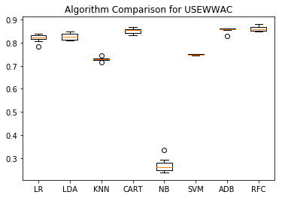

---TRAINING FOR TEMPHOMEAC ---

LR: 0.279559 (0.009815)

LDA: 0.321311 (0.020850)

KNN: 0.160135 (0.008568)

CART: 0.527962 (0.021054)

NB: 0.072986 (0.007568)

SVM: 0.140089 (0.001635)

ADB: 0.268544 (0.004457)

RFC: 0.344982 (0.027550)

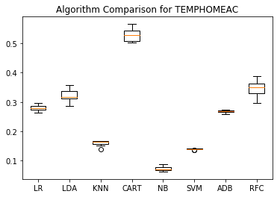

---TRAINING FOR TEMPGONEAC ---

LR: 0.261140 (0.011232)

LDA: 0.291450 (0.012736)

KNN: 0.156922 (0.012744)

CART: 0.433351 (0.025393)

NB: 0.080040 (0.007972)

SVM: 0.129771 (0.002387)

ADB: 0.159166 (0.056396)

RFC: 0.302421 (0.016638)

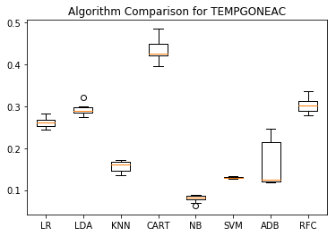

---TRAINING FOR TEMPNITEAC ---

LR: 0.275576 (0.011577)

LDA: 0.260542 (0.011080)

KNN: 0.154826 (0.015374)

CART: 0.465004 (0.021207)

NB: 0.078313 (0.008441)

SVM: 0.163411 (0.002539)

ADB: 0.288990 (0.004584)

RFC: 0.325899 (0.020347)

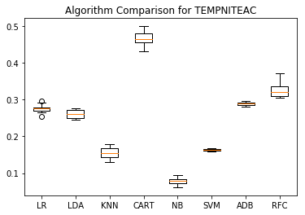

---TRAINING FOR HHAGE ---

LR: 0.034338 (0.009544)

LDA: 0.041567 (0.007664)

KNN: 0.024204 (0.007837)

CART: 0.035447 (0.006939)

NB: 0.015324 (0.003712)

SVM: 0.029043 (0.000762)

ADB: 0.056936 (0.008882)

RFC: 0.032620 (0.007303)

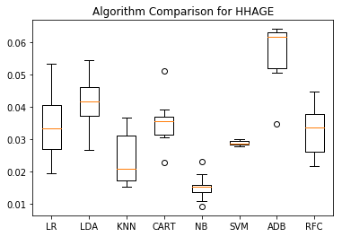

---TRAINING FOR EMPLOYHH ---

LR: 0.681637 (0.016608)

LDA: 0.697697 (0.015886)

KNN: 0.465726 (0.014575)

CART: 0.642952 (0.014339)

NB: 0.272203 (0.013998)

SVM: 0.478454 (0.000470)

ADB: 0.730010 (0.024064)

RFC: 0.675256 (0.015426)

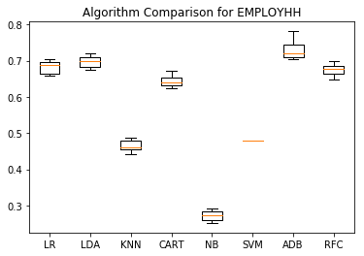

---TRAINING FOR EDUCATION ---

LR: 0.369818 (0.014993)

LDA: 0.400379 (0.018868)

KNN: 0.284937 (0.021297)

CART: 0.309580 (0.017148)

NB: 0.146860 (0.016078)

SVM: 0.334654 (0.000722)

ADB: 0.381527 (0.027307)

RFC: 0.352885 (0.026987)

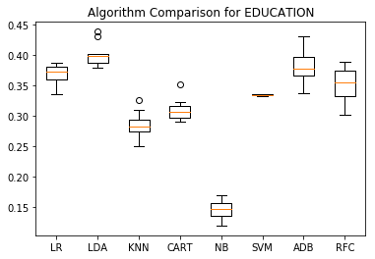

---TRAINING FOR NHSLDMEM ---

LR: 0.559421 (0.014172)

LDA: 0.957653 (0.126315)

KNN: 0.525517 (0.021683)

CART: 0.994309 (0.004376)

NB: 0.093004 (0.020078)

SVM: 0.365887 (0.001851)

ADB: 0.366543 (0.001388)

RFC: 0.704775 (0.017435)

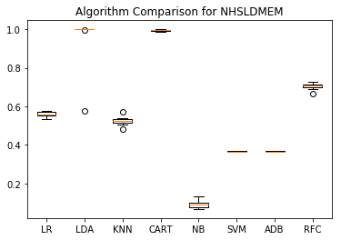

---TRAINING FOR NUMADULT ---

LR: 0.665339 (0.010615)

LDA: 0.967774 (0.095227)

KNN: 0.633221 (0.014919)

CART: 0.994076 (0.004018)

NB: 0.073366 (0.022461)

SVM: 0.546406 (0.002078)

ADB: 0.775069 (0.009119)

RFC: 0.765422 (0.016254)

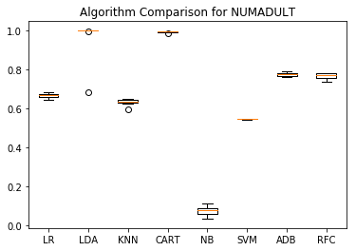

---TRAINING FOR NUMCHILD ---

LR: 0.704507 (0.009781)

LDA: 0.970577 (0.087540)

KNN: 0.671269 (0.011952)

CART: 0.992307 (0.003704)

NB: 0.047944 (0.007212)

SVM: 0.673712 (0.002185)

ADB: 0.420879 (0.266318)

RFC: 0.728695 (0.016802)

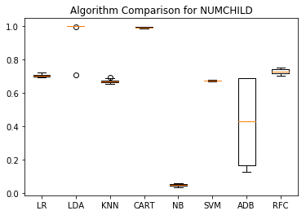

---TRAINING FOR ATHOME ---

LR: 0.558726 (0.013286)

LDA: 0.517163 (0.014911)

KNN: 0.432926 (0.017376)

CART: 0.432737 (0.020112)

NB: 0.102953 (0.018902)

SVM: 0.550581 (0.001799)

ADB: 0.569710 (0.015668)

RFC: 0.535194 (0.008956)

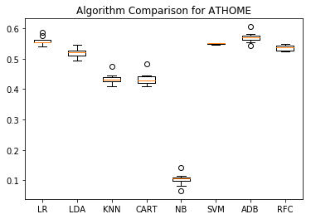

---TRAINING FOR MONEYPY ---

LR: 0.296881 (0.020438)

LDA: 0.297478 (0.015951)

KNN: 0.217927 (0.016329)

CART: 0.251722 (0.023712)

NB: 0.243390 (0.010342)

SVM: 0.221862 (0.001197)

ADB: 0.336879 (0.011870)

RFC: 0.291833 (0.017380)

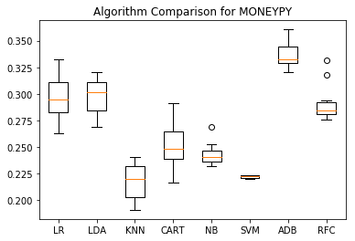

Selected Features for EQUIPMUSE

Index(['HEATHOME', 'DNTHEAT', 'EQUIPM', 'FUELHEAT', 'THERMAIN', 'PROTHERM',

'TEMPHOME', 'TEMPGONE', 'TEMPNITE', 'EQUIPAUX'],

dtype='object')

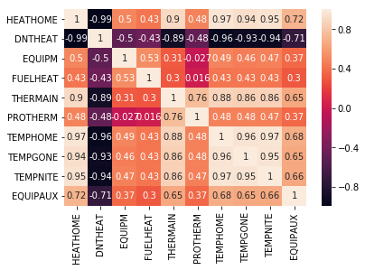

Selected Features for TEMPHOME

Index(['HEATHOME', 'DNTHEAT', 'EQUIPM', 'FUELHEAT', 'THERMAIN', 'PROTHERM',

'EQUIPMUSE', 'TEMPGONE', 'TEMPNITE', 'EQUIPAUX'],

dtype='object')

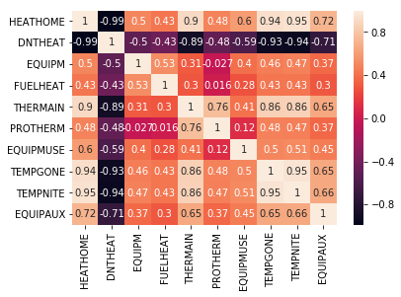

Selected Features for TEMPGONE

Index(['HEATHOME', 'DNTHEAT', 'EQUIPM', 'FUELHEAT', 'THERMAIN', 'PROTHERM',

'EQUIPMUSE', 'TEMPHOME', 'TEMPNITE', 'EQUIPAUX'],

dtype='object')

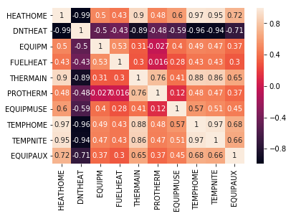

Selected Features for TEMPNITE

Index(['HEATHOME', 'DNTHEAT', 'EQUIPM', 'FUELHEAT', 'THERMAIN', 'PROTHERM',

'EQUIPMUSE', 'TEMPHOME', 'TEMPGONE', 'EQUIPAUX'],

dtype='object')

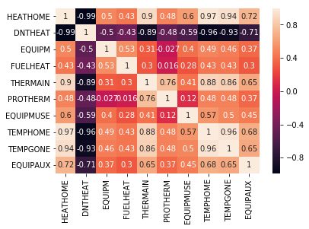

Selected Features for USEWWAC

Index(['DISHWASH', 'COOLTYPE', 'CENACHP', 'AGECENAC', 'THERMAINAC',

'PROTHERMAC', 'USECENAC', 'NUMBERAC', 'WWACAGE', 'TOTCSQFT'],

dtype='object')

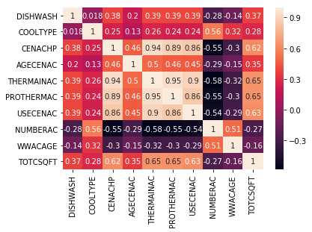

Selected Features for TEMPHOMEAC

Index(['AIRCOND', 'COOLTYPE', 'CENACHP', 'THERMAINAC', 'PROTHERMAC',

'USECENAC', 'TEMPGONEAC', 'TEMPNITEAC', 'ELCOOL', 'TOTCSQFT'],

dtype='object')

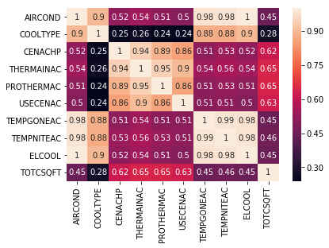

Selected Features for TEMPGONEAC

Index(['AIRCOND', 'COOLTYPE', 'CENACHP', 'THERMAINAC', 'PROTHERMAC',

'USECENAC', 'TEMPHOMEAC', 'TEMPNITEAC', 'ELCOOL', 'TOTCSQFT'],

dtype='object')

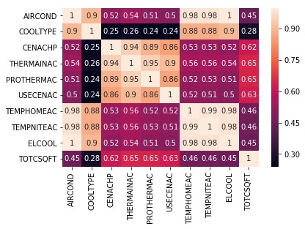

Selected Features for TEMPNITEAC

Index(['AIRCOND', 'COOLTYPE', 'CENACHP', 'THERMAINAC', 'PROTHERMAC',

'USECENAC', 'TEMPHOMEAC', 'TEMPGONEAC', 'ELCOOL', 'TOTCSQFT'],

dtype='object')

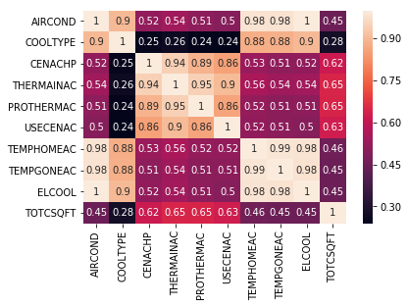

Selected Features for HHAGE

Index(['KOWNRENT', 'OCCUPYYRANGE', 'PLAYSTA', 'LGTOUTNUM', 'EMPLOYHH',

'NHSLDMEM', 'NUMCHILD', 'TOTALBTUWTH', 'ELXBTU', 'LPXBTU'],

dtype='object')

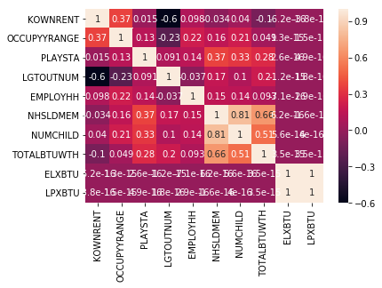

Selected Features for EMPLOYHH

Index(['OCCUPYYRANGE', 'TVONWD1', 'PLAYSTA', 'NUMLAPTOP', 'INTERNET',

'INWIRELESS', 'HHAGE', 'EDUCATION', 'ATHOME', 'MONEYPY'],

dtype='object')

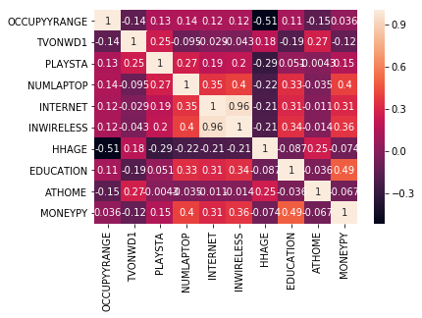

Selected Features for EDUCATION

Index(['NCOMBATH', 'DISHWASH', 'DWASHUSE', 'DWCYCLE', 'NUMLAPTOP', 'ELPERIPH',

'INTERNET', 'INWIRELESS', 'LGTINNUM', 'MONEYPY'],

dtype='object')

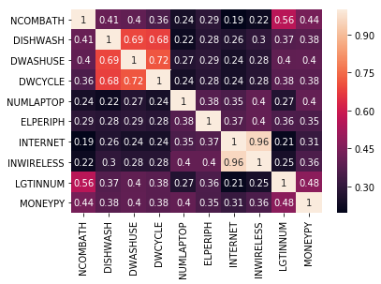

Selected Features for NHSLDMEM

Index(['BEDROOMS', 'WASHLOAD', 'DRYRUSE', 'PLAYSTA', 'NUMTABLET', 'HHAGE',

'NUMADULT', 'NUMCHILD', 'TOTALBTUWTH', 'TOTALBTUCDR'],

dtype='object')

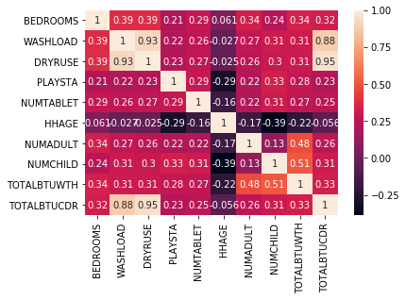

Selected Features for NUMADULT

Index(['BEDROOMS', 'OUTGRILL', 'WASHLOAD', 'DRYRUSE', 'TVCOLOR', 'NUMLAPTOP',

'NHSLDMEM', 'MONEYPY', 'TOTALBTUWTH', 'TOTALBTUCDR'],

dtype='object')

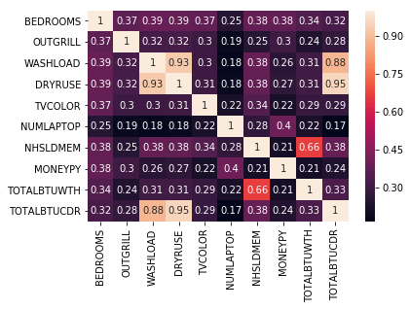

Selected Features for NUMCHILD

Index(['WASHLOAD', 'DRYRUSE', 'PLAYSTA', 'NUMTABLET', 'HHAGE', 'NHSLDMEM',

'CUFEETNGWTH', 'BTUNGWTH', 'TOTALBTUWTH', 'TOTALBTUCDR'],

dtype='object')

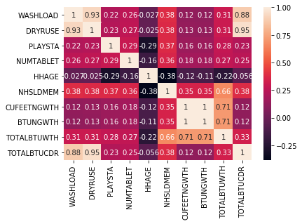

Selected Features for ATHOME

Index(['AMTMICRO', 'NUMMEAL', 'TVONWD1', 'TVONWE1', 'HHAGE', 'EMPLOYHH',

'KWHMICRO', 'KWHTV1', 'BTUELMICRO', 'BTUELTV1'],

dtype='object')

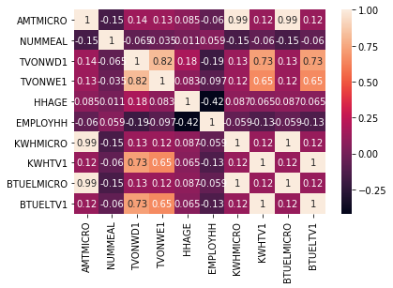

Selected Features for MONEYPY

Index(['NCOMBATH', 'TOTROOMS', 'DISHWASH', 'DWASHUSE', 'INWIRELESS',

'LGTINNUM', 'EDUCATION', 'TOTCSQFT', 'TOTHSQFT', 'TOTSQFT_EN'],

dtype='object')

