PREDICTING LOAN DEFAULT RISK
USING APACHE SPARK AND
MACHINE LEARNING
Academic Technical Project Report
Student Name: ______________________________
Roll Number: _______________________________
Course / Subject: INT315 Cluster Computing
University / College: _______________________
Academic Session: __________________________
Prepared from the verified project implementation and saved evaluation outputs

Abstract
This project develops a PySpark-based machine-learning workflow for predicting loan default risk from borrower and loan characteristics. The implementation uses a strict validation stage, exploratory analysis, categorical encoding, feature assembly, a class-stratified 64:16:20 train/validation/test split, inverse-frequency class weighting, and comparisons between Logistic Regression and Random Forest models. Thresholds from 0.10 to 0.80 are evaluated on validation data using F1-score, with recall and precision used as tie-breakers. The selected model is a weighted Logistic Regression classifier with a decision threshold of 0.65. It is refit on the 3,999 training-plus-validation records and evaluated once on 1,001 untouched test records. The final test accuracy is 0.8182, precision is 0.3072, recall is 0.4322, F1-score is 0.3592, and ROC-AUC is 0.7633. A Streamlit dashboard reads the saved metrics, predictions, comparison table, and visual outputs generated by the notebook; it does not retrain the model. The results are an academic prototype for ranking default risk and do not guarantee whether an individual borrower will default.

1. Introduction
Loan default prediction is a supervised classification problem in which historical borrower and loan attributes are used to estimate whether a loan will be associated with a future default label. Credit-risk assessment is important because lenders must balance access to credit against the possibility of financial loss. A model that detects likely defaults can support screening, portfolio monitoring, and prioritisation of manual review, although it should not be treated as an automatic lending decision without validation, governance, and fairness review.
The project also demonstrates the role of big-data technologies in a machine-learning workflow. Apache Spark provides distributed data-processing and machine-learning APIs, while this implementation runs Spark in local multi-core mode (`local[2]`) for a reproducible college demonstration. The work therefore illustrates Spark programming and leakage-safe model evaluation, but it does not claim to measure multi-node cluster performance.

2. Problem Statement
The project addresses the problem of identifying borrowers who are more likely to default using structured borrower and loan attributes. Defaults are the minority class in the supplied sample, so a model that predicts almost every borrower as a non-default can achieve high accuracy while failing to identify the cases of greatest interest. The workflow therefore evaluates precision, recall, F1-score, ROC-AUC, and the confusion matrix in addition to accuracy. The decision threshold is tuned on validation data to make the trade-off between missed defaults and false alarms explicit.

3. Objectives
- Load and validate the loan dataset with PySpark.
- Explore class distribution and relationships between default and borrower or loan attributes.
- Encode categorical variables and assemble numerical and encoded features without training-data leakage.
- Train weighted and unweighted Logistic Regression and Random Forest candidates.
- Select a model and decision threshold using validation data only.
- Evaluate the selected model once on an untouched test set.
- Save model artifacts, metrics, predictions, and visualisations for a read-only Streamlit dashboard.

4. Dataset Description
The dataset is the Loan Default Prediction Dataset published in the FGithaiga/LOAN-DEFAULT-PREDICTION repository. The project uses the first 5,000 data records with the header retained; this is a sequential subset rather than a random sample. The local file is `data/raw/Loan_default .csv`, including the space before `.csv`.
Table 1. Verified dataset profile.
Property | Verified value
Records | 5,000
Columns | 18
Missing values | 0
Duplicate rows | 0
Unique LoanID values | 5,000
Default = 0 | 4,414 (88.28%)
Default = 1 | 586 (11.72%)

The target variable is `Default`, where 0 represents no default and 1 represents default. The identifier `LoanID` is retained for output traceability but is excluded from model features. Numeric inputs are Age, Income, LoanAmount, CreditScore, MonthsEmployed, NumCreditLines, InterestRate, LoanTerm, and DTIRatio. Categorical inputs are Education, EmploymentType, MaritalStatus, HasMortgage, HasDependents, LoanPurpose, and HasCoSigner.
Table 2. Dataset fields used by the implementation.
Feature group | Columns | Role
Identifier | LoanID | Traceability only; excluded from features
Numeric (9) | Age, Income, LoanAmount, CreditScore, MonthsEmployed, NumCreditLines, InterestRate, LoanTerm, DTIRatio | Continuous/integer model inputs
Categorical (7) | Education, EmploymentType, MaritalStatus, HasMortgage, HasDependents, LoanPurpose, HasCoSigner | Encoded model inputs
Target | Default | Binary label: 0 = no default, 1 = default

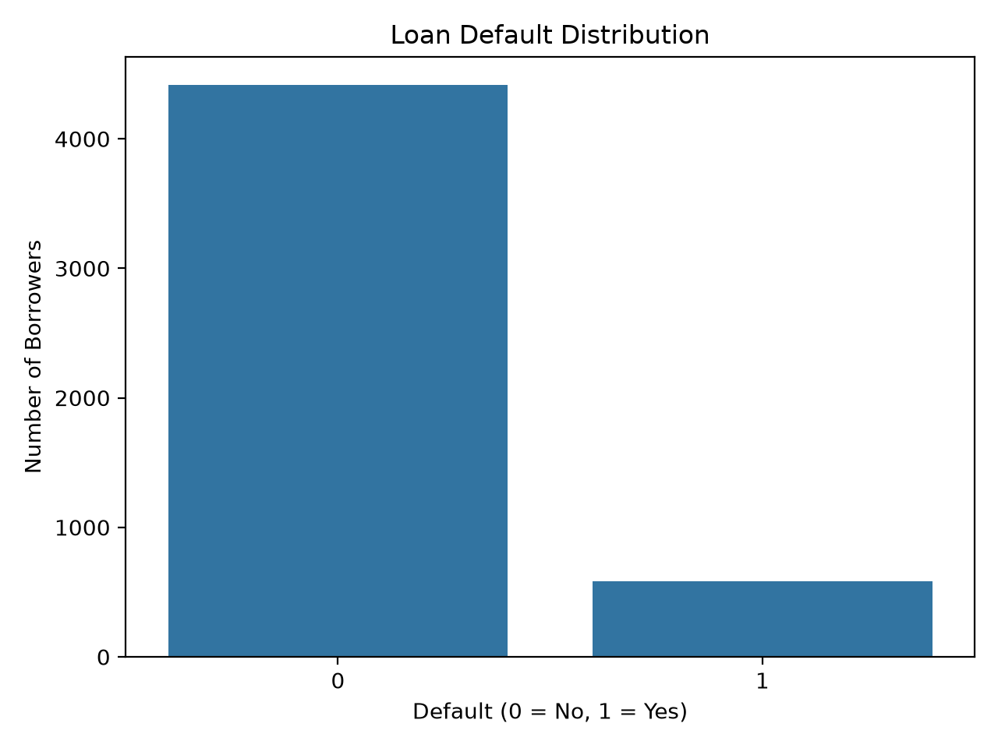
Figure 1. Default-class distribution generated by the notebook.
The dataset limitations are material: the project uses only the first 5,000 records of a much larger source dataset, the subset is sequential, and the observed relationships should not be assumed to generalise to other populations or time periods.

5. Tools and Technologies
Table 3. Technologies verified from requirements and implementation.
Technology | Verified use
Python 3.11 | Notebook and dashboard implementation environment
Apache Spark / PySpark 3.5.6 | SparkSession, DataFrame processing, ML Pipeline, classifiers, evaluators
Jupyter Notebook / VS Code | Interactive execution of the single-source-of-truth notebook
Pandas and NumPy | Tabular output handling and dashboard calculations
Matplotlib and Seaborn | EDA, model comparison, and confusion-matrix figures
Streamlit | Read-only interactive dashboard
Altair | Dashboard charts
Java 17 | Runtime requirement for local Spark

6. Methodology

6.1 Data loading and inspection
The notebook resolves the project root, reads the CSV with a header and inferred schema, prints the schema and sample records, and reports the row and column counts. The SparkSession is configured for `local[2]` with four shuffle partitions and the Spark UI disabled.
Code Listing 1. Dataset loading pattern used by the notebook.
df = (spark.read
.option("header", True)
.option("inferSchema", True)
.csv(str(DATA_PATH)))
print("Rows:", df.count(), "Columns:", len(df.columns))

6.2 Validation and cleaning
Validation occurs before splitting or fitting. The notebook checks required columns, numeric and string data types, null values, binary target labels, duplicate complete rows, and unique LoanID values. Invalid input raises an explicit error; rows are not silently discarded. Because the verified dataset contains no missing values, no imputation step is required. `handleInvalid="keep"` is used in the categorical indexers, encoder, and assembler to guard against invalid or unseen categories at transformation time.

6.3 Exploratory data analysis
The notebook creates the class-distribution chart, reports default rates by EmploymentType, Education, MaritalStatus, and LoanPurpose, compares numerical means by target class, creates boxplots for CreditScore and LoanAmount, and calculates correlations between numerical features and Default. These are descriptive associations, not causal explanations.
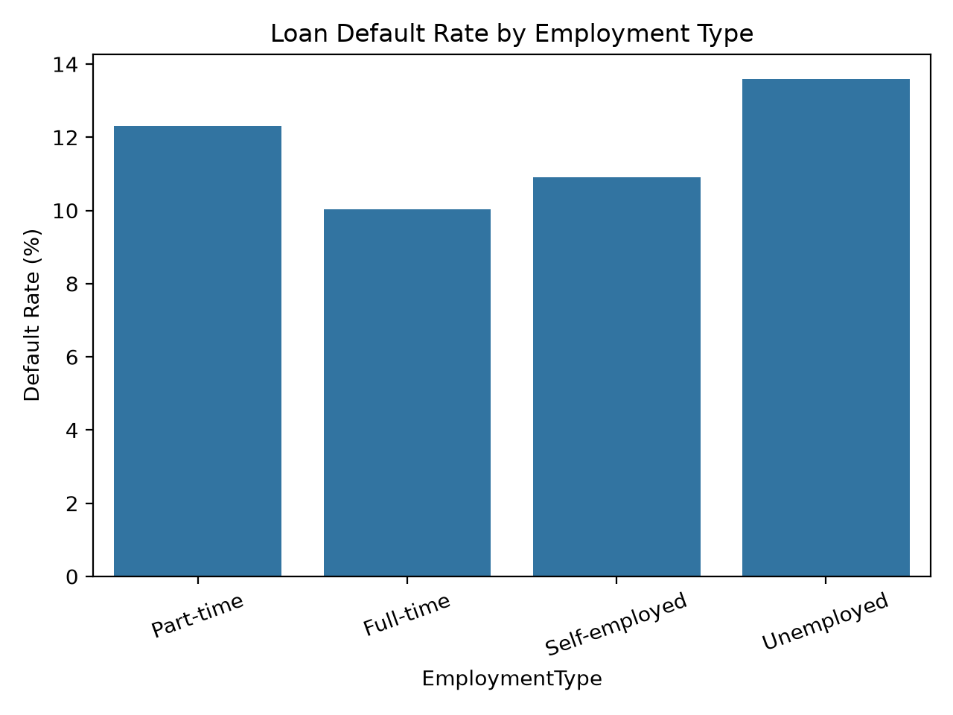
Figure 2. Default rate by employment type.
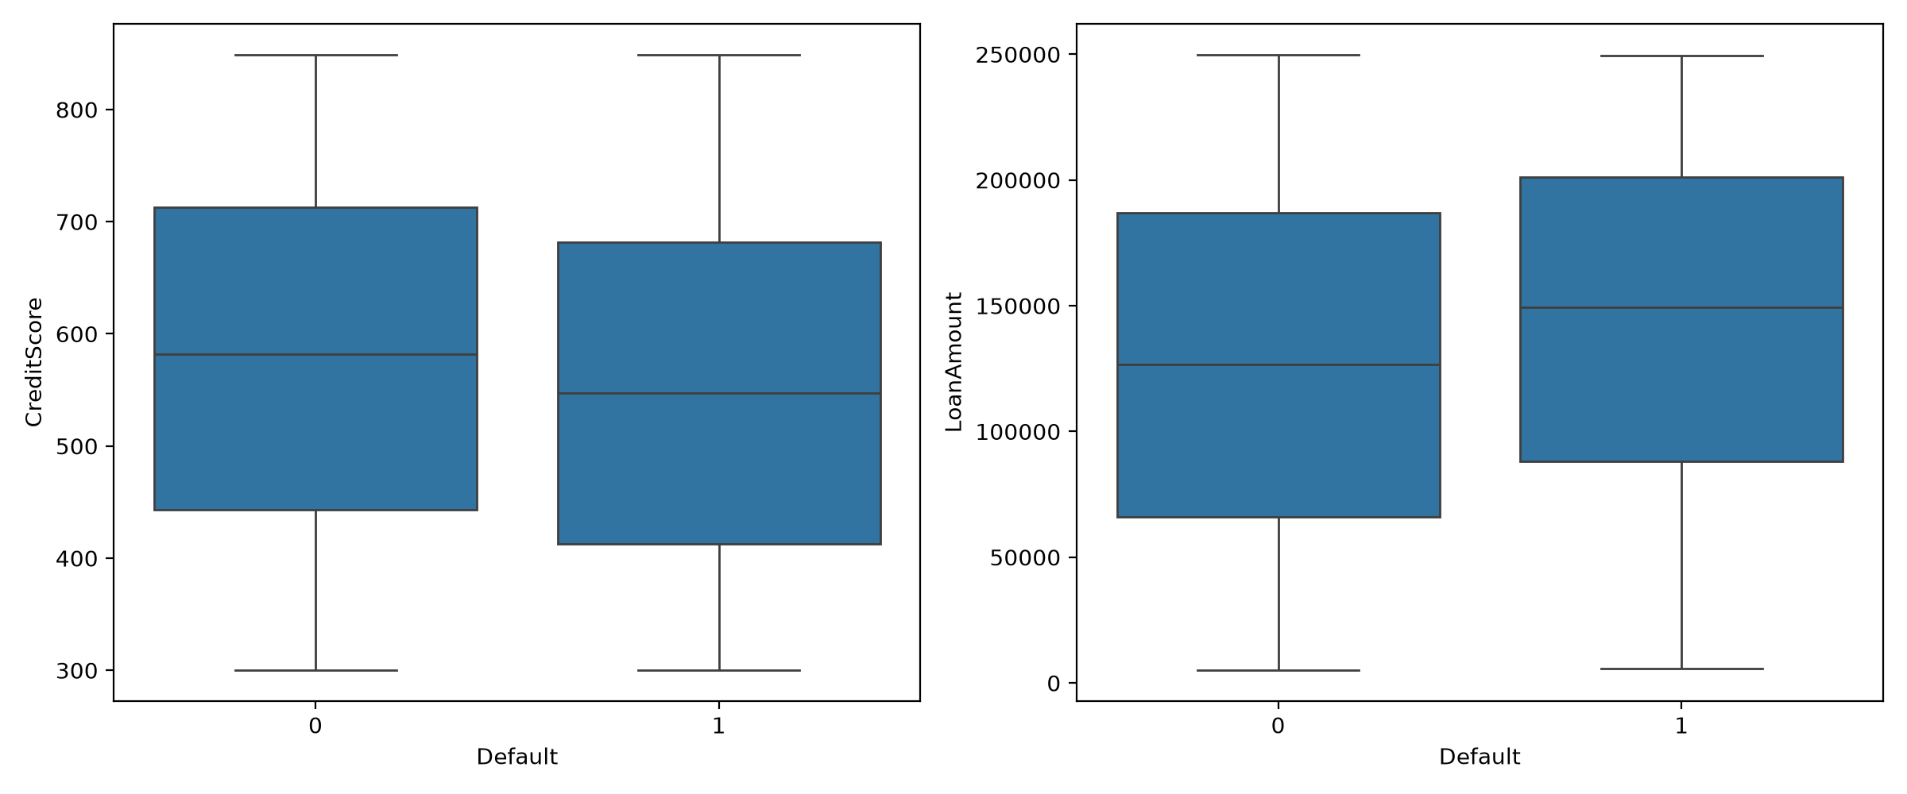
Figure 3. Numerical feature distributions by default label.
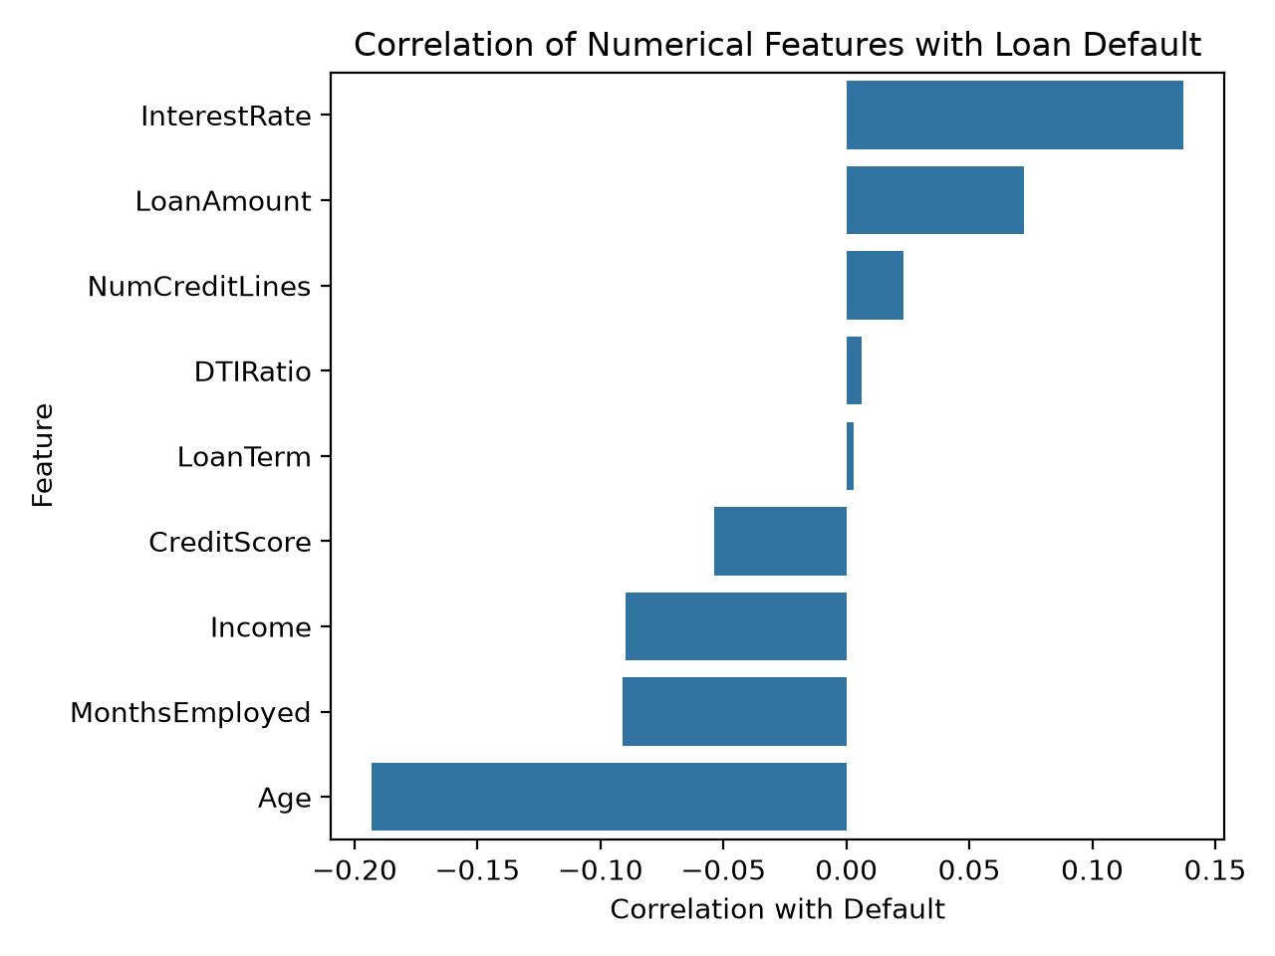
Figure 4. Correlation of numerical features with Default.

6.4 Feature engineering and preprocessing
Each categorical feature is transformed with a StringIndexer and OneHotEncoder. The nine numeric columns and seven encoded categorical columns are combined using VectorAssembler. Crucially, the preprocessing pipeline is fitted on the training partition only and then applied to validation and test partitions. This prevents category-learning and transformation decisions from using held-out data.
Code Listing 2. Leakage-safe preprocessing components.
indexers = [StringIndexer(inputCol=name,
outputCol=f"{name}_Index", handleInvalid="keep")
for name in CATEGORICAL_FEATURES]
encoder = OneHotEncoder(inputCols=[...], outputCols=[...],
handleInvalid="keep")
assembler = VectorAssembler(inputCols=NUMERIC_FEATURES + [...],
outputCol="features", handleInvalid="keep")

6.5 Stratified split
The split is generated independently within each Default class using a seeded random row number. The resulting partitions contain 3,199 training rows (64%), 800 validation rows (16%), and 1,001 test rows (20%). The notebook asserts that the partitions are complete and disjoint by LoanID. Candidate models are fitted using training data; validation data is used for model and threshold selection; the test set is not used until final evaluation.
Table 4. Stratified data partition.
Partition | Rows | Purpose
Training | 3,199 | Fit candidate models and preprocessing
Validation | 800 | Compare candidates and tune threshold
Test | 1,001 | One-time final evaluation

6.6 Class imbalance handling
The default class is approximately 11.72% of the full sample. For weighted candidates, inverse-frequency class weights are calculated from the training partition and passed to the classifier through `classWeight`. Both weighted and unweighted candidates are retained for comparison; weighting is not applied using validation or test labels.
Code Listing 3. Training-only inverse-frequency class weighting.
weights = {label: total / (len(counts) * count)
for label, count in counts.items()}
return frame.withColumn("classWeight",
when(col("Default") == 1, lit(weights[1]))
.otherwise(lit(weights[0])))

6.7 Model training and threshold tuning
The notebook trains four candidates: weighted Logistic Regression, unweighted Logistic Regression, weighted Random Forest, and unweighted Random Forest. Logistic Regression uses maxIter=100 and regParam=0.0. Random Forest uses 150 trees, maxDepth=8, and seed=42. For each candidate, thresholds from 0.10 to 0.80 in increments of 0.05 are scored on validation predictions. The maximum validation F1 is selected, with recall and precision used as tie-breakers.
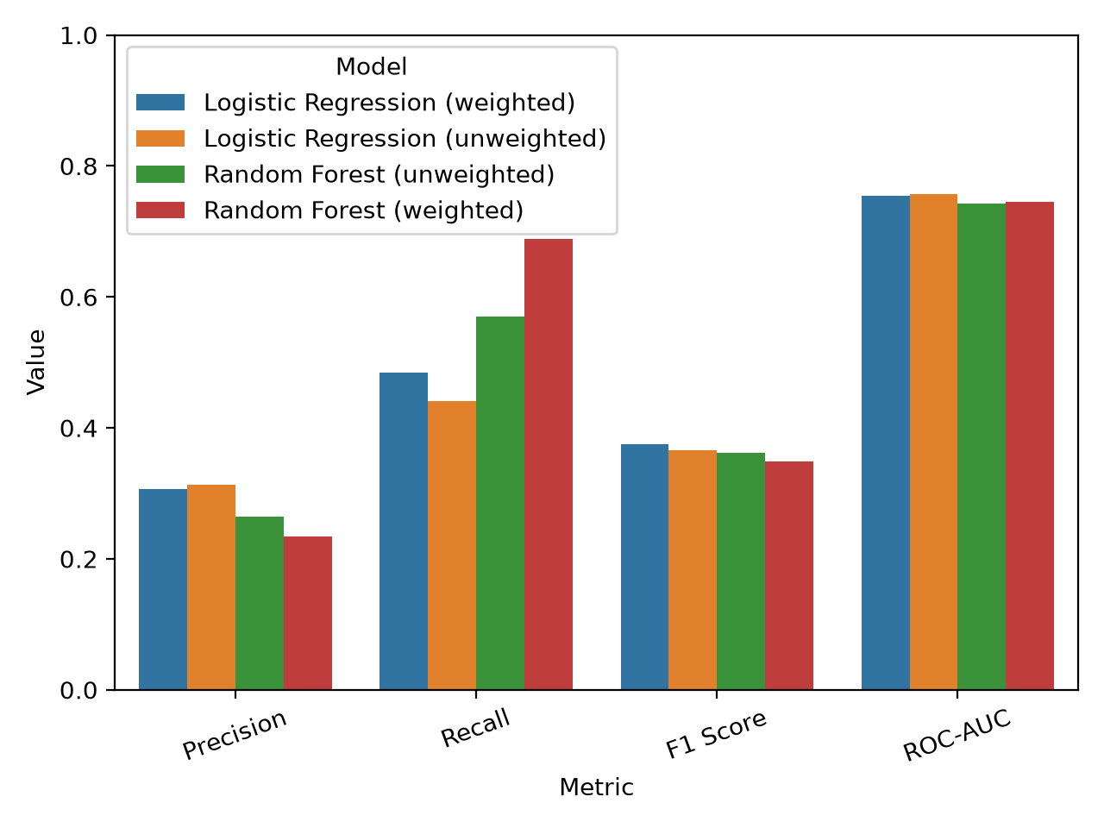
Figure 5. Validation model comparison generated by the notebook.

7. System Architecture
The project has a deliberately simplified architecture. The notebook is the only component that reads the raw dataset, trains models, evaluates them, and generates output files. The Streamlit application does not retrain models; it loads and validates the saved JSON, CSV, and comparison files through dashboard_data.py.
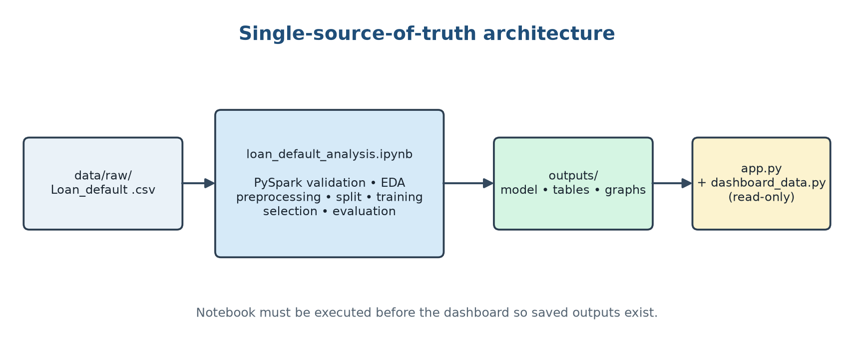
Figure 6. Verified project architecture and data flow.
- Input: data/raw/Loan_default .csv.
- Processing: Notebooks/loan_default_analysis.ipynb executes PySpark validation, EDA, preprocessing, training, selection, evaluation, and saving.
- Persisted outputs: outputs/model/loan_default_pipeline, outputs/tables, and outputs/graphs.
- Presentation: app.py and dashboard_data.py read persisted outputs and display test-set results, risk summaries, charts, filters, and CSV downloads.

8. Implementation
The notebook is organised into sequential sections so that it can be demonstrated during a viva: imports and Spark initialisation; data inspection; validation; EDA; preprocessing; stratified splitting; class weighting; candidate training; validation comparison; final refitting; test evaluation; visualisation; prediction generation; and output verification. The final output-validation cell checks that all dashboard tables, graphs, and the saved Spark pipeline exist.
Code Listing 4. Final model selection and refitting on training plus validation rows.
selected = validation_results.iloc[0].to_dict()
model_name = selected["Model"].split(" (")[0]
weighted = "weighted" in selected["Model"]
full_train = train.unionByName(validation)
final_pipeline = Pipeline(stages=
make_preprocessing_pipeline().getStages() +
[build_classifier(model_name, weighted)])
final_model = final_pipeline.fit(full_source)

Code Listing 5. Final evaluation on the untouched test partition.
final_predictions = with_threshold(
final_model.transform(test), float(selected["Threshold"]))
test_result = evaluate(final_predictions,
selected_label, float(selected["Threshold"]))

The saved borrower_predictions.csv contains LoanID, Default, prediction, default_probability, and risk_category. The risk bands are Low below 0.30, Medium from 0.30 to below 0.60, and High at or above 0.60. The dashboard and README explicitly describe these as illustrative ranking bands rather than calibrated probabilities or lending policy.

9. Results and Evaluation
The final selected model is Logistic Regression (weighted), with a classification threshold of 0.65. The selection was made using validation data; the values below are from the separate held-out test set.
Table 5. Final held-out test metrics.
Metric | Final test value
Accuracy | 0.8182
Precision | 0.3072
Recall | 0.4322
F1 Score | 0.3592
ROC-AUC | 0.7633

Table 6. Final confusion matrix counts.
 | Predicted no default | Predicted default | Total
Actual no default | 768 | 115 | 883
Actual default | 67 | 51 | 118
Total | 835 | 166 | 1001

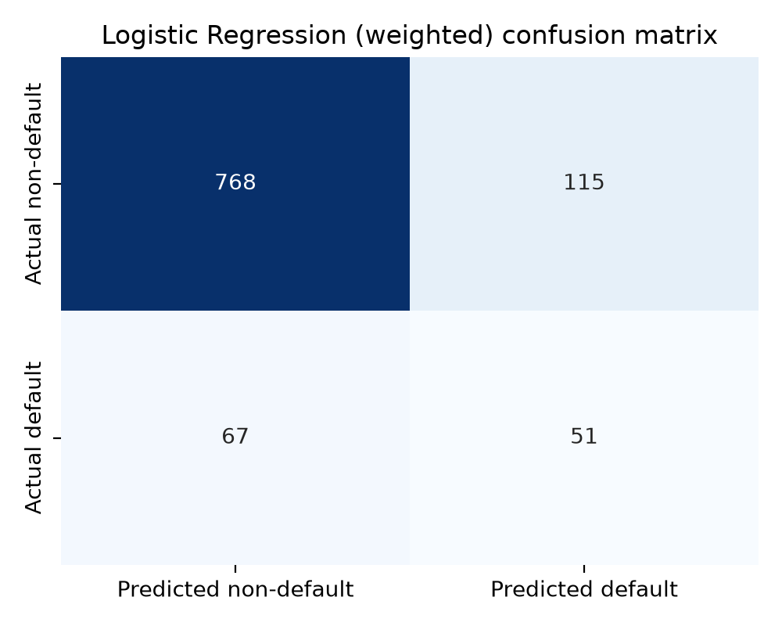
Figure 7. Final confusion matrix for the held-out test set.
The model correctly identified 51 of 118 actual defaults and missed 67. It also flagged 115 non-default borrowers as defaults. Thus, recall is materially higher than a model that ignores the minority class, but precision is limited: many flagged borrowers did not default. Accuracy should therefore not be interpreted alone.
Table 7. Validation comparison used for model selection.
Model | Threshold | Precision | Recall | F1 | ROC-AUC
Logistic Regression (weighted) | 0.65 | 0.306 | 0.484 | 0.375 | 0.755
Logistic Regression (unweighted) | 0.20 | 0.313 | 0.441 | 0.366 | 0.758
Random Forest (unweighted) | 0.15 | 0.265 | 0.570 | 0.362 | 0.742
Random Forest (weighted) | 0.35 | 0.234 | 0.688 | 0.349 | 0.745

The weighted Logistic Regression candidate achieved the highest validation F1-score (0.375), followed by unweighted Logistic Regression (0.366), unweighted Random Forest (0.362), and weighted Random Forest (0.349). Validation accuracy is not the selection criterion; threshold-tuned F1 and the stated tie-breakers are used to reflect the minority-class objective.
Table 8. Test-set risk-category summary.
Risk category | Borrowers | Actual defaults | Actual default rate | Predicted defaults
Low | 373 | 11 | 2.9% | 0
Medium | 408 | 46 | 11.3% | 0
High | 220 | 61 | 27.7% | 166

Across the test set, there are 118 actual defaults and 166 predicted defaults. All threshold-based positive predictions fall in the High risk band because the decision threshold (0.65) is above the High-band boundary (0.60). The dashboard reports actual default rates within bands rather than treating the score as a calibrated probability.

10. Dashboard
The Streamlit dashboard is intentionally independent of model training. It loads final_test_metrics.json, borrower_predictions.csv, and validation_model_comparison.csv through dashboard_data.py. It validates required columns, numeric ranges, unique LoanIDs, risk-band consistency, and agreement between saved metrics and predictions.
- Header showing the selected model and threshold.
- Six held-out-test KPIs: borrowers evaluated, actual default rate, predicted default rate, precision, recall, and ROC-AUC.
- Actual versus predicted default counts.
- Borrower distribution and actual default rate by Low, Medium, and High risk category.
- Confusion matrix and final test metrics.
- Validation comparison clearly labelled as validation rather than test performance.
- Borrower search by Loan ID, risk-category filter, actual/predicted status filters, and filtered CSV download.
All dashboard predictions represent the held-out test set. The dashboard does not guarantee whether a borrower will default; it presents model scores and classifications generated by the notebook.
[PLACEHOLDER: Insert Dashboard overview screenshot placeholder here]
Use screenshots captured from the running Streamlit dashboard; no screenshot was fabricated for this report.
Figure 8. Dashboard overview screenshot placeholder.
[PLACEHOLDER: Insert Borrower explorer screenshot placeholder here]
Use screenshots captured from the running Streamlit dashboard; no screenshot was fabricated for this report.
Figure 8. Borrower explorer screenshot placeholder.

11. Limitations
- The project uses the first 5,000 records as a sequential subset, so its class relationships and metrics may not represent the full source population.
- Spark runs in local multi-core mode (`local[2]`) on one machine. The implementation demonstrates PySpark APIs but does not benchmark a distributed multi-node cluster.
- Only one stratified train/validation/test split is used; confidence intervals and repeated cross-validation are not included.
- The final precision of 0.3072 indicates a substantial false-positive burden, while recall of 0.4322 means many actual defaults remain undetected.
- Class weighting changes the score distribution. The saved default_probability is therefore treated as a ranking score, not a calibrated probability.
- The risk bands are illustrative and are not tuned to a financial cost function or validated as a lending policy.
- The feature set includes demographic-related attributes such as age, marital status, and education. Fairness, regulatory compliance, and disparate-impact analysis are outside the current implementation.
- The model describes associations in the supplied data; it does not establish causal explanations and does not guarantee an individual outcome.

12. Future Scope
- Evaluate a larger, more representative and time-aware dataset, with documented sampling and data governance.
- Deploy the notebook workflow on a multi-node Spark cluster and compare execution time and resource usage.
- Add domain-informed feature engineering, missing-data strategies, and temporal repayment-history variables where available.
- Tune hyperparameters with nested or repeated validation and evaluate cost-sensitive objectives.
- Calibrate probabilities and validate risk bands against observed outcomes and business costs.
- Add explainability using feature importance, coefficient analysis, and local explanations.
- Conduct fairness analysis across relevant demographic groups and introduce governance controls.
- Package the workflow for monitored production deployment with data-drift, performance, and audit logging.

13. Conclusion
This project provides a complete, reproducible academic workflow for loan-default risk prediction using PySpark and a Streamlit presentation layer. The notebook validates the data, performs EDA, fits preprocessing only on training data, compares weighted and unweighted Logistic Regression and Random Forest candidates, tunes the decision threshold on validation data, and evaluates the selected model on an untouched test set. Weighted Logistic Regression at threshold 0.65 is the final selected configuration. On 1,001 held-out borrowers it achieved 0.8182 accuracy, 0.3072 precision, 0.4322 recall, 0.3592 F1-score, and 0.7633 ROC-AUC. These results demonstrate the workflow and the trade-offs involved in minority-class prediction, but they should be interpreted as a classroom prototype rather than a guaranteed or production-ready credit decision system.

References
- [1] FGithaiga, “LOAN-DEFAULT-PREDICTION,” GitHub repository, dataset source: https://github.com/FGithaiga/LOAN-DEFAULT-PREDICTION
- [2] Apache Software Foundation, “Apache Spark Documentation,” https://spark.apache.org/docs/latest/
- [3] Apache Software Foundation, “PySpark 3.5.6 API Reference,” https://spark.apache.org/docs/3.5.6/api/python/
- [4] Streamlit, “Streamlit Documentation,” https://docs.streamlit.io/
- [5] T. Fawcett, “An introduction to ROC analysis,” Pattern Recognition Letters, vol. 27, no. 8, pp. 861–874, 2006.
- [6] T. Hastie, R. Tibshirani, and J. Friedman, The Elements of Statistical Learning, 2nd ed., Springer, 2009.
- [7] Project implementation sources: Notebooks/loan_default_analysis.ipynb, app.py, dashboard_data.py, requirements.txt, and outputs/tables/final_test_metrics.json.

