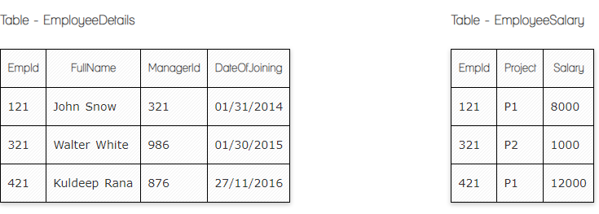

**Ques.1. Write a SQL query to fetch employee names having salary greater than or equal to 5000 and less than or equal 10000.**

**SELECT EmployeeDetails.FullName, EmployeeSalary.Salary**

**FROM EmployeeDetails**

**INNER JOIN EmployeeSalary**

**ON EmployeeDetails.EmpId=EmployeeSalary.EmpId**

**WHERE EmployeeSalary.Salary BETWEEN 5000 AND 10000**

**Ques.2. Write a SQL query to insert new record to the EmployeeDetails table with any data.**

**INSERT INTO EmployeeDetails ('FullName', 'DateOfJoining')**

**VALUES ( 'Mr Adam', '01/01/2017')**

**Ques.3. Write a SQL query to update EmployeeSalery table with setting Salary to 2000 for Project P2.**

**UPDATE EmployeeSalary**

**SET Salary='2000'**

**WHERE Project='P2'**

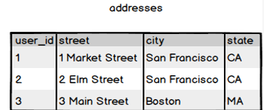

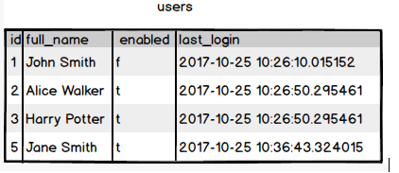

**Ques.1. Write a SQL query to fetch all users full_name who are from Main street or San Francisco**

**SELECT users.full_name, addresses.city, addresses.street**

**FROM users**

**INNER JOIN addresses**

**ON addresses.user_id=users.id**

**WHERE addresses.street=’Main street’ OR addresses.city=’San Francisco’**

**Ques.2. Write a SQL query to fetch user full_name who is equal to user_id from Boston (find user_id value in sub_query)**

**SELECT fullname**

**FROM users**

**WHERE id =**

**(SELECT user_id**

**FROM addresses**

**WHERE city=Boston)**