

American International University-Bangladesh (AIUB)  
**Department of Computer Science  
Faculty of Science &Technology (FST)  
Spring 23 24**

**<Pawsitive Stays>**

Software Requirement Engineering

Sec: **A**

Project submitted

By

Rahman,Khandkar Nafisur (19-41216-2)  
SHOUROV BHOWMICK (20-43130-1)  
Mst Anika Anjum (20-42198-1  
MAHMUDUL HASAN SHISHIR(20-43881-2)

Table of Contents

* PROBLEM DOMAIN ………………………………………………………………..
* Background to the Problem .....................................................................................
* Solution to the Problem ...........................................................................................
* SOLUTION DESCRIPTION ........................................................................................
* System Features .......................................................................................................
* Features for all users: ............................................................................................
* Features for Administrator/Admin: .......................................................................
* Features for User/ Customer: ..................................................................................................
* UML Diagrams (Any 3 types) ..................................................................................
* ER Diagram ............................................................................................................
* Activity Diagram of User .......................................................................................
* Activity Diagram of Staff .................................................................................................
* Activity Diagram of Admin..................................................................................................
* Use Case Diagram..................................................................................................
* Social Impact....................................................................................................................
* Development Plan with Project Schedule ........................................................................
* Development Plan.......................................................................................................
* Project Schedule .........................................................................................................
* Marketing Plan .................................................................................................................
* Cost and Profit Analysis ...................................................................................................
* Effort Estimation .........................................................................................................
* Budget & Profit Estimation: ........................................................................................
* Reference ...........................................................................................................................

**1.PROBLEM DOMAIN**

* **Background to the Problem**

In recent years, pets have become integral members of countless households worldwide, enriching our lives with companionship, joy, and love. As the number of pet owners continues to rise, so does the need for efficient and comprehensive pet care solutions. The concept of a "Pet Care System" emerges from this growing demand, aiming to address various challenges faced by pet owners and caregivers in ensuring the well-being and happiness of their animal companions.

The Pet Care System encompasses a broad spectrum of services, technologies, and practices designed to support every aspect of pet ownership, from basic care routines to advanced healthcare management. At its core, the system seeks to streamline and enhance the overall pet care experience, promoting responsible ownership while catering to the unique needs of diverse animal species.

The concept of a "pet care system" encompasses the multifaceted array of responsibilities involved in caring for domestic animals, including their physical, emotional, and medical needs. This system extends beyond mere feeding and sheltering to include grooming, exercise, socialization, and healthcare. While pets bring joy, companionship, and even health benefits to their owners, ensuring their well-being requires a structured approach that considers various factors.

One of the root causes of challenges within the pet care system is the misconception or underestimation of the level of commitment required to properly care for a pet. Often, individuals acquire pets impulsively without fully understanding the time, effort, and financial resources needed to provide adequate care. This can lead to neglect, abandonment, or surrender of pets to shelters when owners find themselves unable to meet their needs.

Moreover, societal changes, such as urbanization and busy lifestyles, contribute to the strain on the pet care system. Urban living may limit space for pets to exercise and explore, while demanding work schedules can impede the ability of owners to devote sufficient time to their pets. Additionally, lack of access to affordable veterinary care and pet-friendly housing exacerbates the challenges faced by pet owners, particularly those from marginalized communities. Pet owners deal with a lot of unfortunate events including pet’s health, nutrition and safety issues such as pet’s getting lost or not getting proper nutritious food or security failures.

The importance of addressing issues within the pet care system cannot be overstated. Firstly, it is a matter of animal welfare. Pets rely entirely on their owners for survival and quality of life, and neglecting their needs can lead to suffering and even premature death. Furthermore, the overpopulation of animal shelters due to surrenders and abandonment strains resources and contributes to euthanasia rates, highlighting the ethical imperative of responsible pet ownership.

Beyond ethical considerations, there are also public health and safety implications associated with inadequate pet care. Neglected or unsocialized animals may pose risks to themselves and others, including aggression or the spread of infectious diseases. Additionally, the psychological well-being of pet owners is intertwined with the well-being of their pets, as the bond between humans and animals is known to have therapeutic benefits.

In conclusion, the pet care system is a complex network of responsibilities that require attention and commitment from owners, communities, and policymakers alike. By addressing the root causes of challenges within this system and promoting responsible pet ownership, we can ensure the well-being of both animals and humans in our society.

* **Solution to the Problem**

1.Mobile app for pet owner: Develop a user-friendly mobile application that allows pet owners to schedule appointments, track their pet's health records, receive reminders for vaccinations, medication, and grooming sessions. This solution is appropriate because it provides convenience and accessibility for pet owners to manage their pet's care efficiently. It enhances the overall experience and ensures timely care for pets.

2. Online booking system for pet services:

Implement an online booking system where pet owners can easily book appointments for veterinary visits, grooming sessions, pet boarding, and other pet services. This solution streamlines the booking process, reduces wait times, and improves customer satisfaction. It also allows the business to manage appointments more effectively and optimize resource allocation. This can also help those owners who like to travel. While they are being away pet services can take care of their pet for that time period.

3. Pet health monitoring devices:

Introduce wearable devices or sensors that monitor pets' health metrics such as activity level, heart rate, and temperature in real-time. These devices can send alerts to pet owners and veterinarians in case of any abnormalities, enabling early detection of health issues and timely intervention. This solution provides continuous monitoring and enhances preventive care for pets, leading to improved health outcomes.

4. Telemedicine services for pets:

Offer telemedicine services where pet owners can consult with veterinarians remotely via video calls or chat platforms. This solution provides convenient access to veterinary care, especially for minor health concerns or follow-up appointments. It reduces the need for physical visits to the clinic, saving time and reducing stress for both pets and owners. Additionally, it can expand the reach of veterinary services to remote areas.

5. Customized nutrition plans:

Provide personalized nutrition plans for pets based on their breed, age, weight, and health condition. Collaborate with veterinarians and nutritionists to develop tailored diet recommendations and meal plans. This solution addresses the specific dietary needs of pets and promotes their overall health and well-being. It can also include subscription-based services for regular delivery of pet food and supplements.

In terms of feasibility to meet the business objective, these solutions are highly feasible with the right resources and expertise. Developing a mobile app, online booking system, and telemedicine platform requires software development capabilities, while implementing pet health monitoring devices and customized nutrition plans may involve partnerships with technology providers and experts in veterinary medicine and nutrition. However, the potential return on investment is significant, considering the growing demand for pet care services and the opportunity to differentiate the business by offering innovative solutions that enhance pet health and owner satisfaction.

The pet care system is a comprehensive software designed to streamline and enhance the management of pet-related tasks and responsibilities. Its primary purpose is to assist pet owners, pet care professionals, and pet service providers in organizing, tracking, and optimizing the care of pets.

1. Efficiency: By centralizing pet care information and tasks, the software helps users manage their time more effectively and ensures that pets receive timely care.

2. Organization: Users can maintain detailed profiles for each pet, including their medical history, dietary preferences, grooming needs, and vaccination schedules. This helps ensure that all necessary care is provided consistently.  
3. Communication: The system facilitates communication between pet owners and pet care professionals, allowing for seamless coordination of services such as grooming appointments, veterinary visits, and pet sitting arrangements.

4. Health Monitoring: Through features such as reminders for vaccinations and medication schedules, as well as the ability to track symptoms and health trends, the software supports proactive pet healthcare management.

5. Customization: The pet care system can be tailored to meet the unique needs of different types of pets and their owners, with options to add specific care instructions and preferences.

Overall, the objectives and goals of the pet care system are to improve the well-being of pets by ensuring they receive high-quality care, to simplify the management of pet-related tasks for owners and professionals, and to foster greater peace of mind for all involved parties.

There are several existing software solutions available in the realm of pet care systems, each offering different features and functionalities to address the diverse needs of pet owners and pet care professionals. Some of the notable existing solutions include:

1.PetDesk: PetDesk is a comprehensive pet care platform that offers features such as appointment scheduling, health reminders, medication tracking, and communication tools for pet owners and veterinary clinics.

2.BabelBark: BabelBark provides a holistic pet care management solution, including activity tracking, medical records management, pet socialization features, and integration with pet businesses such as groomers and trainers.

3. PetPal Manager: PetPal Manager is designed for pet boarding facilities and offers features like reservation management, pet profile management, billing and invoicing, and communication tools to keep pet owners updated on their pets' well-being.

4. Pawfinity: Pawfinity is primarily focused on pet grooming businesses, offering features like appointment scheduling, client management, online booking, and marketing tools tailored specifically for pet grooming services.

5. Whistle: Whistle specializes in pet activity tracking and health monitoring through wearable devices for pets, providing insights into activity levels, rest patterns, and potential health issues.

6. Pet Sitter plus: This software is designed for professional pet sitting and dog walking services, offering features such as scheduling, client management, invoicing, and GPS tracking of pet walks.

These existing software solutions vary in their target audience, features, and pricing models, but they all aim to streamline and enhance the management of pet care tasks, improving the overall well-being of pets and providing convenience for pet owners and pet care professionals alike.

**2.SOLUTION DESCRIPTION**

**2. Solution Description**

**2.1 System Features**

Our platform caters to two distinct user groups, each fulfilling unique roles with their specific requirements.

* Administrator/Admin
* User/Customer

**2.1.1 User Management**

**Functional requirements for Admin:**

* Ability to create, modify, and delete user accounts.
* Access to user profile information for administrative purposes.
* User privilege management, including assigning roles and permissions.
* User activity monitoring and logging for security purposes.

**Quality attributes for Admin:**

* Robust authentication mechanisms to prevent unauthorized access to administrative functions.
* Detailed logging of admin actions for accountability and troubleshooting.
* Intuitive user interface for efficient user management tasks.

**Functional Requirements for User:**

* Ability to register for an account.
* Update personal information such as name, contact details, and password.
* Option to delete or deactivate the account if needed.

**Quality attributes for User:**

* Secure storage of user data and password encryption to protect privacy.
* User-friendly registration and profile management interfaces for a seamless experience.
* Interfaces should be accessible to users with disabilities.

**2.1.2 Pet Profile management**

**Functional requirements for Admin:**

* Ability to view, edit, and delete pet profiles.
* Access to pet health and ownership information for administrative purposes.
* Ability to assign pet profiles to specific users or pet care providers.

**Quality attributes for Admin:**

* Reliable storage and retrieval of pet profile information to ensure accuracy.
* Role-based access control to restrict admin actions based on privileges.
* Efficient handling of pet profile management tasks, even with a large database.

**Functional requirements for User:**

* Ability to create, edit, and delete pet profiles.
* Add detailed information such as breed, age, medical history, and photos.
* Option to specify special care instructions or notes for pet care providers.

**Quality attributes for User:**

* Intuitive interface for creating and managing pet profiles.
* Secure and reliable storage of pet information to prevent loss or corruption.
* System should handle a growing number of pet profiles without degradation in performance.

**2.1.3 Appointment Scheduling**

**Functional requirements for Admin:**

* Ability to view, modify, and cancel appointments.
* Access to scheduling calendars for pet care providers.
* Ability to generate reports on appointment history and trends.

**Quality attributes for Admin:**

* Precise scheduling capabilities to avoid conflicts and ensure timely service delivery.
* Efficient handling of scheduling tasks to accommodate a large number of appointments.
* Comprehensive reporting features for analysis and decision-making.

**Functional requirements for User:**

* Ability to request, modify, and cancel appointments.
* View upcoming and past appointments.
* Receive notifications and reminders about appointments.

**Quality attributes for User:**

* User-friendly interface for scheduling and managing appointments.
* Timely notifications and reminders to minimize missed appointments.
* Interfaces should be accessible across devices for convenience.

**2.1.4 Payment Processing**

**Functional requirements for Admin:**

* View payment transactions and history.
* Access to payment configuration settings (e.g., payment methods, transaction fees).
* Ability to generate financial reports and invoices.

**Quality attributes for Admin:**

* Secure access controls and encryption mechanisms to protect financial data.
* Detailed logging of payment-related activities for auditing purposes.
* Intuitive interfaces for managing payment configurations and accessing financial reports.

**Functional requirements for User:**

* Ability to make payments securely through the platform.
* Choose from multiple payment methods (e.g., credit/debit cards, digital wallets).
* Receive receipts and invoices for completed transactions.

**Quality attributes for User:**

* Secure and encrypted payment processing to protect sensitive financial information.
* Assurance that payments are processed accurately and promptly without errors.
* Seamless payment experience with clear instructions and minimal friction.

**2.2 UML Diagram**

**Use Case Diagram:**

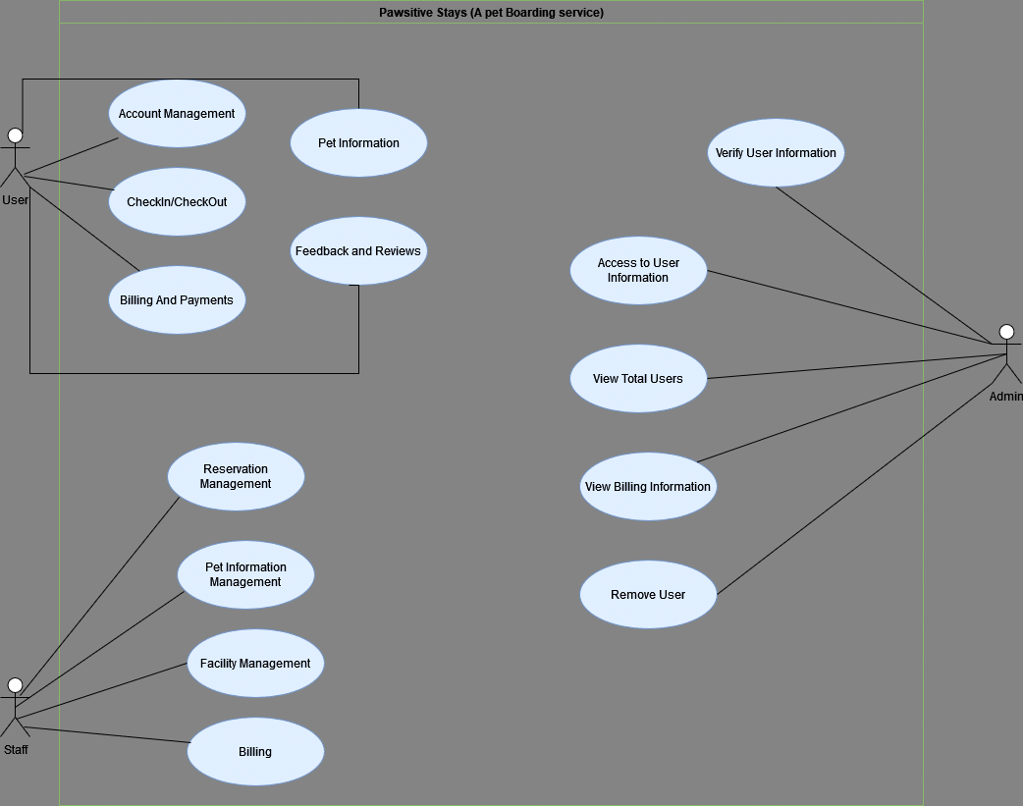

**Activity Diagram for User:**

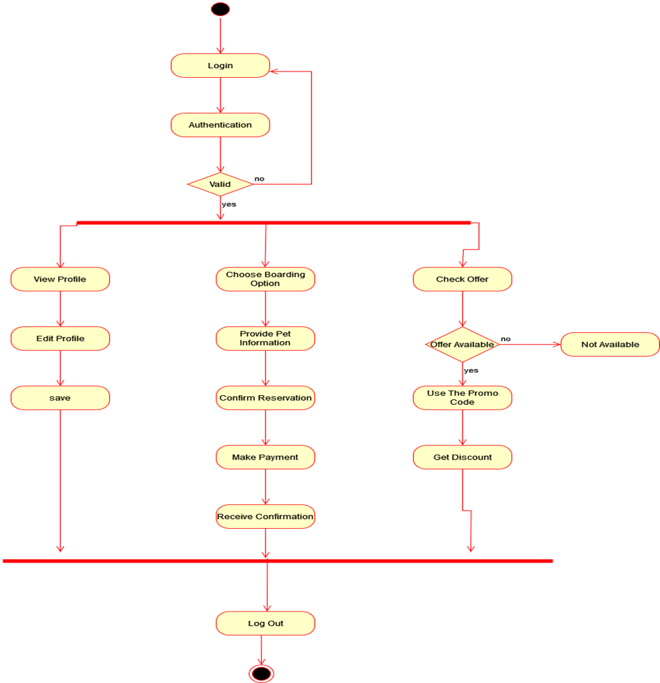

**Activity Diagram for Admin:**

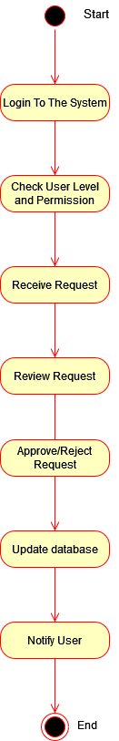

**Activity Diagram for Employee:**

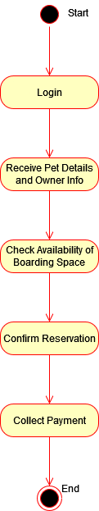

**ER Diagram:**

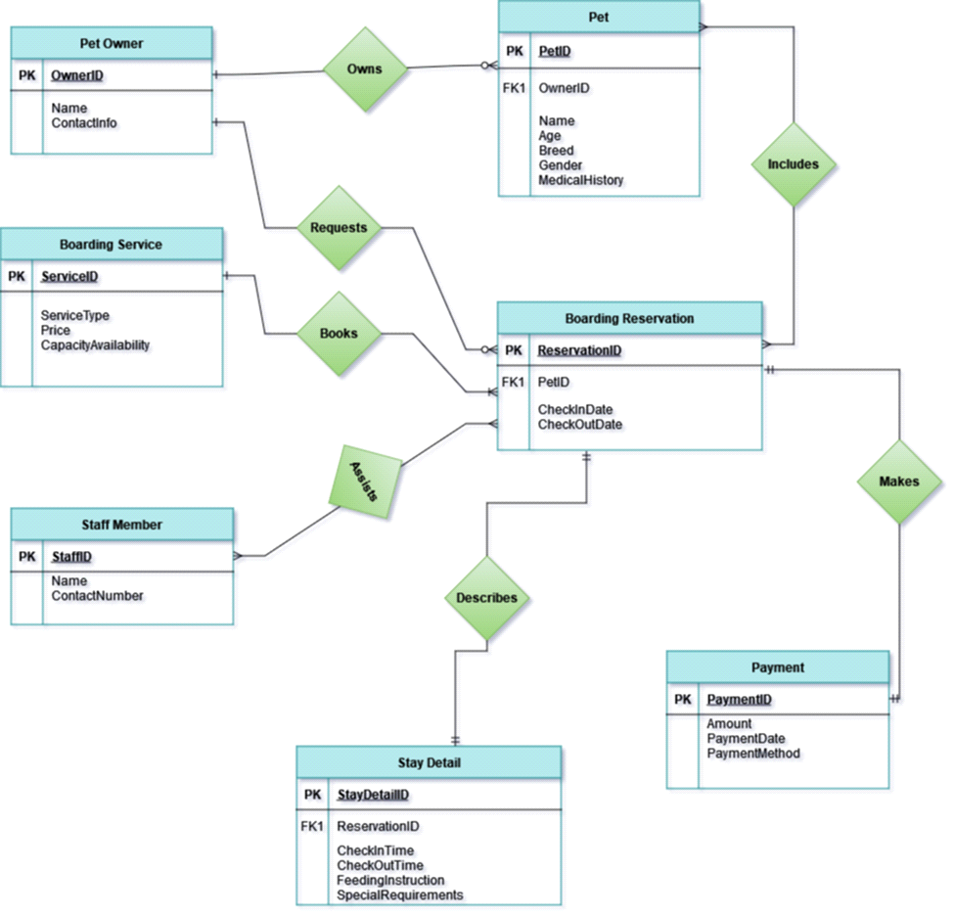

* **Social Impact**

A pet care and adoption project can have a significant positive impact on society in various ways. Here are some potential social benefits:  
  
Mental Health Benefits: Pets can provide companionship, reduce feelings of loneliness, and alleviate symptoms of depression and anxiety. Programs that facilitate pet adoption can improve the mental health of individuals and families.

Physical Health: Caring for pets often involves physical activities such as walking dogs, which can encourage a more active lifestyle and thereby improve physical health.

Decreased Euthanasia Rates: By promoting pet adoption, the project can reduce the number of animals in shelters, leading to lower euthanasia rates and better outcomes for animals.

Controlled Breeding: Adoption programs often include spaying and neutering services, which help control the pet population and prevent the birth of unwanted animals.

Cost Savings for Municipalities: Reducing the number of stray and abandoned animals lowers the costs associated with animal control and sheltering services.

Job Creation: The pet care and adoption industry creates jobs in animal shelters, veterinary services, pet supply stores, and training facilities.

Responsible Pet Ownership: Educational programs associated with pet care projects can teach the community about responsible pet ownership, including proper pet care, health, and training.

Animal Welfare Advocacy: Increased awareness about the importance of animal welfare can lead to better treatment of animals and more support for animal protection laws.

Community Engagement: Pet adoption events and volunteer opportunities at shelters can foster community spirit and engagement, bringing people together for a common cause.

Building Empathy: Interacting with and caring for animals can enhance empathy and compassion, particularly in children, fostering a more empathetic society.

Therapeutic Benefits: Pets are often used in therapeutic settings, such as hospitals, nursing homes, and with veterans, providing comfort and aiding in rehabilitation.

Support for the Homeless and Low-Income Families: Some programs provide support for homeless individuals and low-income families to keep their pets, ensuring that both pets and owners benefit from the companionship and support they provide each other.

Wildlife Protection: By promoting the adoption of domestic animals, the project can help reduce the incidence of people taking in wild animals as pets, thus protecting wildlife populations.

Sustainable Practices: Adoption centers can promote sustainable pet care practices, such as eco-friendly products and responsible waste management, contributing to environmental conservation.

1. Animal Welfare:

Rescue and Rehabilitation: By providing a platform for pet adoption, the project contributes to the rescue and rehabilitation of abandoned or neglected animals. This helps reduce the overall population of stray animals and improves their quality of life.

2. Reducing Stray Population:

Controlled Breeding: Encouraging pet adoption over purchasing from breeders helps control the population of stray animals. This, in turn, reduces the burden on animal shelters and minimizes the number of animals living in unfavorable conditions.

3. Promoting Responsible Pet Ownership:

- Education and Awareness: The project can incorporate educational programs to raise awareness about responsible pet ownership, including proper care, nutrition, and the importance of spaying/neutering. This contributes to creating a more informed and conscientious pet-owning community.

4. Emotional and Physical Health:

-Companionship:Pets provide companionship, emotional support, and unconditional love. By facilitating pet adoptions, the project enhances the mental and emotional well-being of individuals and families.

5. Community Building:

- Social Interaction: Pet ownership fosters social interaction within communities. Dog parks, pet events, and other related activities can bring people together, creating a sense of community and shared responsibility for the well-being of pets.

6. Employment Opportunities:

- Job Creation: The project may create employment opportunities for individuals involved in animal care, veterinary services, adoption counseling, and other related fields. This can contribute to economic development within the community.

7. Reducing Euthanasia Rates:

- Alternative to Euthanasia: By providing a viable alternative to euthanasia for healthy animals, the project helps in reducing euthanasia rates in animal shelters. This aligns with the ethical treatment of animals and promotes a compassionate approach to animal welfare.

8. Environmental Impact

- Reducing Stray Animal Impact: Stray animals can have negative impacts on the environment. By addressing the issue of stray populations through adoption, the project indirectly contributes to environmental preservation.

9. Community Safety:

- Control of Stray Animals: Stray animals can pose risks to public safety. By addressing the issue of stray populations through adoption and responsible pet ownership, the project contributes to community safety.

10. Educational Opportunities for Children:

- Learning Responsibility: Involving children in pet care and adoption processes can teach them important values such as empathy, responsibility, and compassion towards animals. This early education can have long-term positive effects on their attitudes and behaviors.

In summary, a pet care and adoption project can bring about positive changes in animal welfare, community well-being, and societal values by addressing issues related to stray populations, promoting responsible pet ownership, and fostering a sense of compassion and community.

* **Development Plan with Project Schedule**

We use Jira for this typr of project

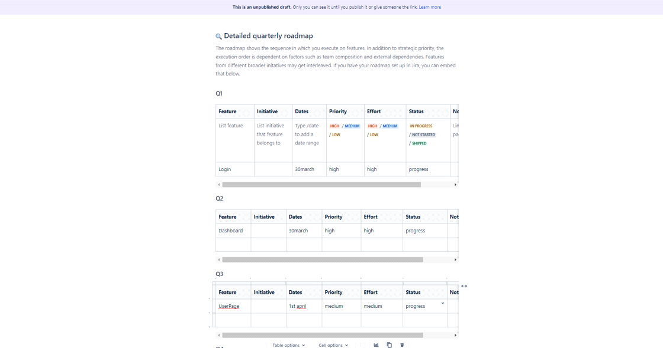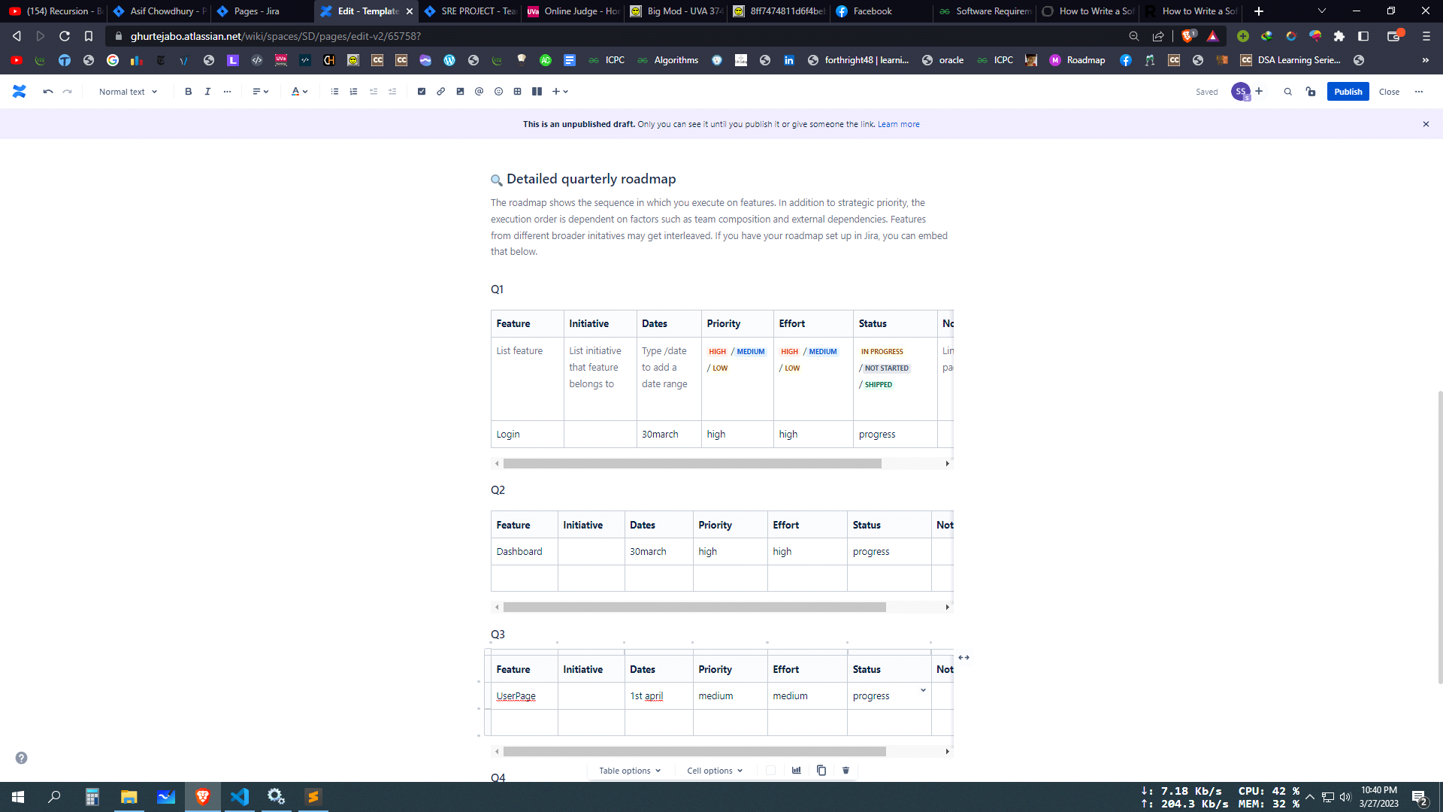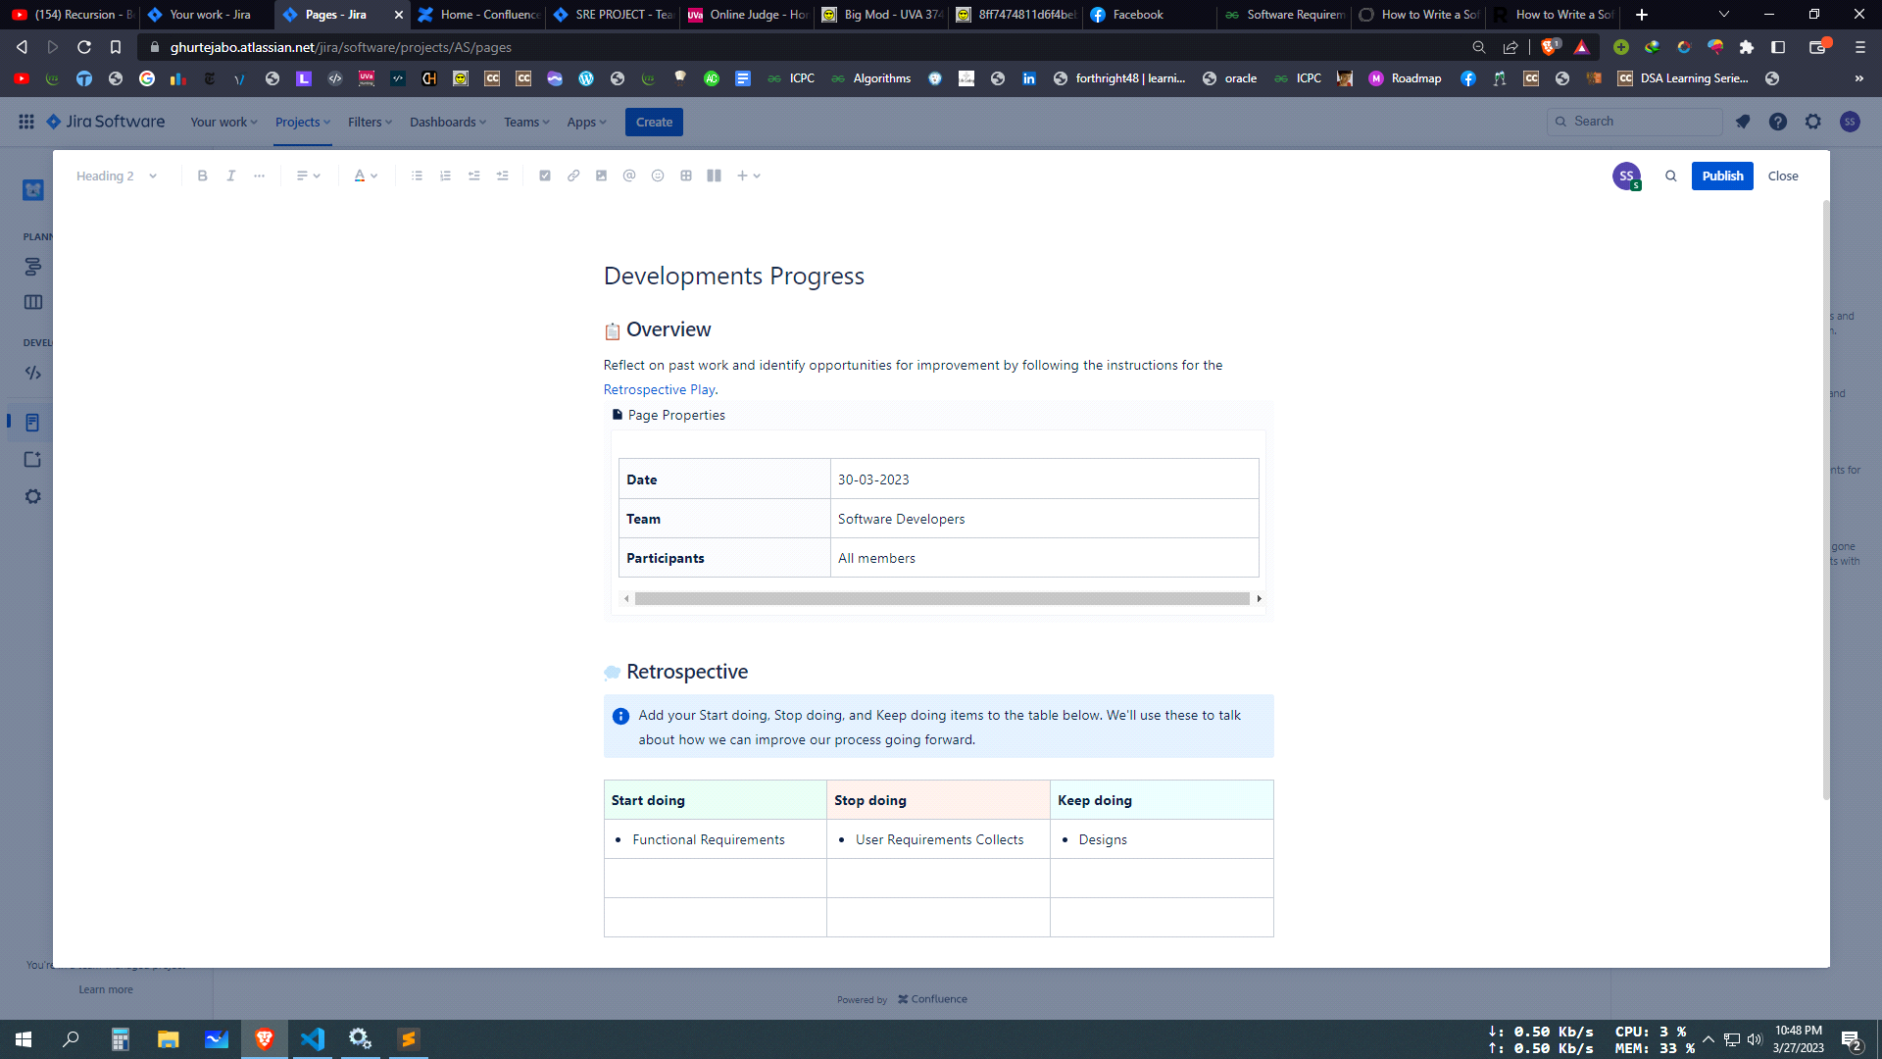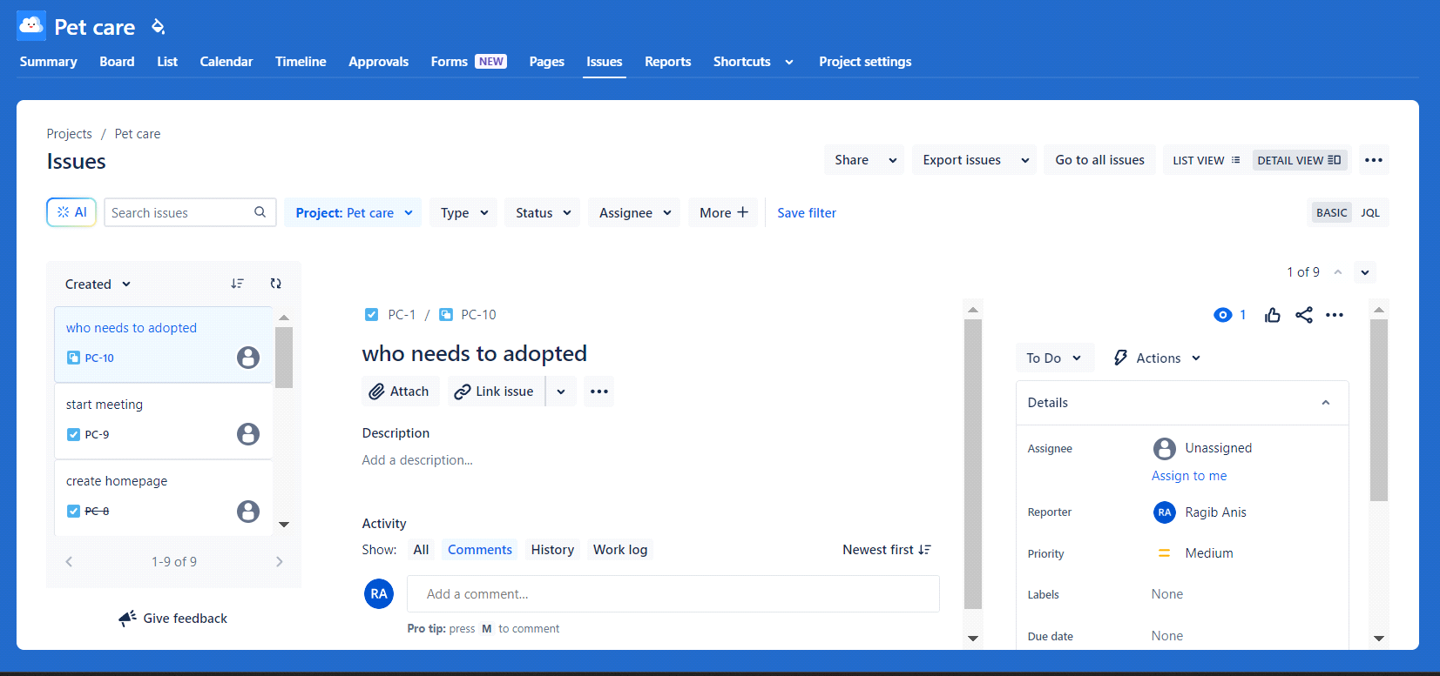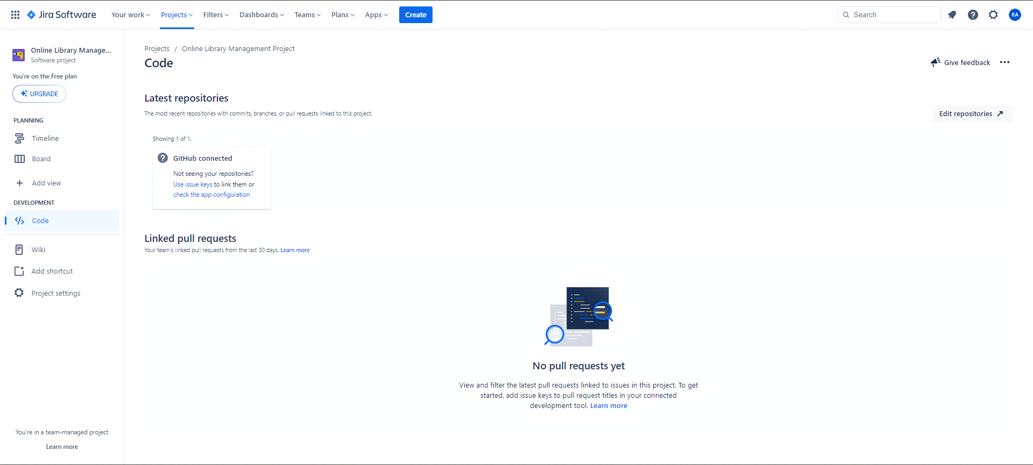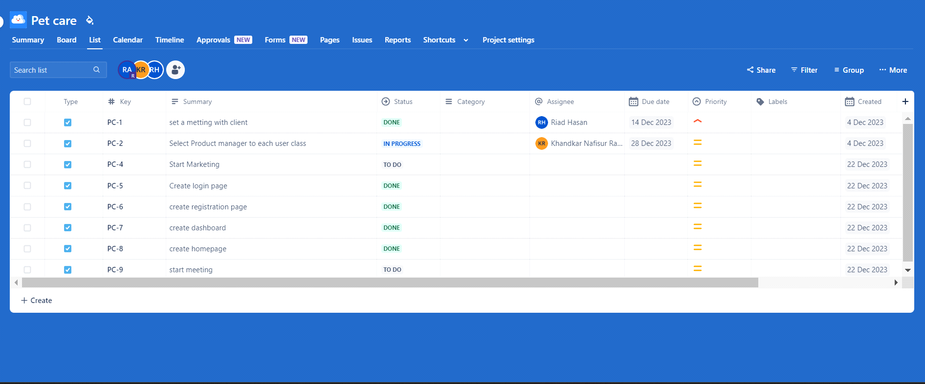

**5.Marketing Plan**

**Brand Awareness:**

**5.1 Social Media Campaigns:** Launch targeted advertising on platforms like Facebook and Instagram to reach pet owners. Utilize visually appealing content, client testimonials, and promotional offers.

**5.2 Local Partnerships:** Collaborate with local veterinary clinics, pet stores, and grooming salons to cross-promote services. Establishing these partnerships will enhance credibility and trust.

**5.3 Launch Event:** Organize a launch event or open house to introduce the centralized management system to the community. Offer exclusive discounts for early adopters.

**Customer Acquisition:**

**5.1.1 Referral Program:** Implement a referral program where existing clients are rewarded for referring new customers. This incentivizes word-of-mouth marketing.

**5.1.2 Limited-Time Promotions:** Introduce limited-time promotions, such as discounted first stays or bundled packages, to encourage pet owners to try the new system.

**Long-Term Marketing Plan :**

**5.2 Community Engagement:**

**5.2.1 Educational Workshops:** Host workshops on pet care, health, and safety. This positions your brand as a knowledgeable and caring entity within the community.

**5.2.2 Community Events Sponsorship:** Sponsor local pet-related events, such as dog shows or charity walks, to strengthen brand presence and community ties.

**Technology Integration:**

**5.3 Mobile App Development:** Invest in a user-friendly mobile app for seamless reservations, real-time updates, and communication with pet owners. Emphasize the convenience and transparency it provides.

**5.3.1 Customer Loyalty Program:** Introduce a loyalty program with rewards for repeat customers, encouraging long-term relationships.

* **Cost and Profit Analysis**

**Identify Stakeholders and Requirements:**

**6.1 Stakeholders:** Pet owners, veterinarians, pet care professionals, and pet care service providers.

**Requirements:**

User authentication and profiles for pet owners and professionals.

Pet profiles with medical history, feeding schedules, and other relevant details.

Appointment scheduling system for veterinary visits, grooming, training, etc.

Payment gateway integration for service fees.

Notification system for reminders, updates, and alerts.

**6.2 Estimate Costs**

**a. Development Costs:**

**Personnel:** Software engineers, UX/UI designers, testers, and project managers.

Tools and Software: Development environments, databases, frameworks, and other necessary software.

**Training:** Any required training for the team.

**b. Operational Costs:**

Hosting and Infrastructure: Costs associated with cloud hosting, server maintenance, and data storage.

Support and Maintenance: Ongoing costs for updates, bug fixes, and customer support.

**c. Marketing and Sales Costs:**

**Advertising:** Digital marketing campaigns, social media promotions, etc.

Sales and Distribution: Costs related to sales personnel, distribution channels, and partnerships.

**6.3 Estimate Revenue and Profit:**

**a. Revenue Streams:**

Subscription Models: Monthly/annual subscriptions for premium features.

**Transaction Fees:** A percentage of each transaction made through the platform.

Advertisement: Partnering with pet care product/service providers for advertisements.

**b. Cost-Volume-Profit (CVP) Analysis:**

Determine the breakeven point where total costs equal total revenues.

Analyze different scenarios to understand the potential profitability under various conditions (e.g., increased subscriptions, higher transaction volumes).

**6.4 Risk Analysis:**

**Identify potential risks such as:**

**Market competition.**

Technological changes.

Regulatory and compliance issues.

Customer adoption and retention rates.

**6.5 Optimization Strategies:**

Based on the analysis, devise strategies to optimize costs, enhance revenue streams, and mitigate **risks. This could include:**

Prioritizing key features based on user feedback and market demand.

Implementing efficient development and deployment practices.

Investing in customer acquisition and retention strategies.

* **Reference**

[https://www.google.co.ukPut](https://www.google.co.ukput/)  
  
[https://www.wikipedia.org](https://www.wikipedia.org/)  
  
<https://en.wikipedia.org/wiki/Social_experiment>  
  
<https://medium.com/@megan.jones38.mj/ui-ux-case-study-petcare-app-bb5fecf389f9>