# What is a CDN?

CDN is a short for Content Delivery Network.

A content delivery network (CDN) is a system of distributed servers ([network](http://www.webopedia.com/TERM/N/Network.html)) that deliver webpages and other Web content to a user based on the geographic locations of the user, the origin of the webpage and a content delivery [server](http://www.webopedia.com/TERM/S/server.html).

A CDN is essentially a network of geographically dispersed servers. Each CDN node (also called Edge Servers) caches the static content of a site like the images, CSS/JS files and other structural components. The majority of an end-user's page load time is spent on retrieving this content, and so it makes sense to provide these "building blocks" of a site in as many server nodes as possible, distributed throughout the world.

When a user requests our site, the node closest in proximity to user will deliver the static content, ensuring the shortest distance for the data to travel (reduced latency), therefore providing the fastest site experience.  
  
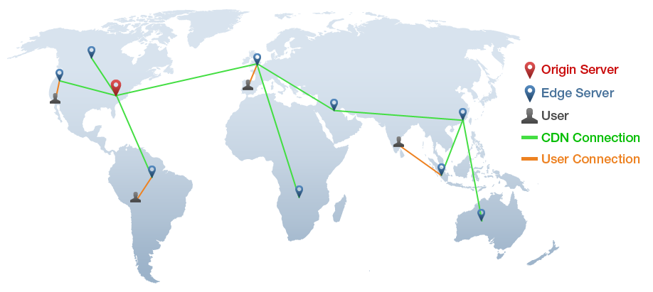  
 Fig. *CDNs ensure users download data from servers that are closest in geographical proximity.*

# What are CDNs Used For?

* CDNs drive sharing of online media such as live and on-demand streaming video for events and entertainment.
* CDNs can deliver web applications for enterprises with users across a wide region or the world.
* CDNs deliver dynamic content for online shopping sites and personalized web experiences.
* CDNs support web performance optimization solutions for online gaming and social media networks.
* CDNs provide a platform for software and application delivery for cloud-based installation and updates.
* CDNs deliver adaptive content for mobile devices and media that will be viewed across a mobile network.

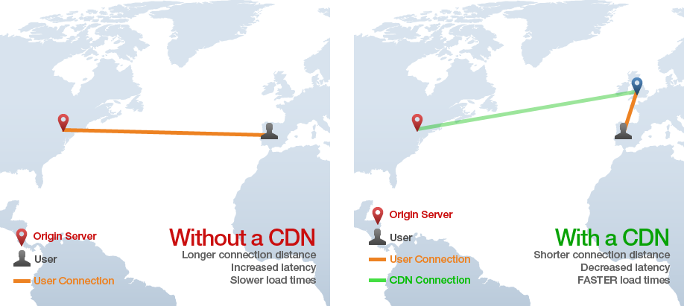

# Operation

Most CDNs are operated as an [application service provider](https://en.wikipedia.org/wiki/Application_service_provider) (ASP) on the Internet (also known as on-demand software or software as a service (SaaS)). An increasing number of Internet network owners have built their own CDNs to improve on-net content delivery, reduce demand on their own telecommunications infrastructure, and to generate revenues from content customers. This might include offering access to media streaming to internet service subscribers. Some larger software companies such as Microsoft build their own CDNs in tandem with their own products. Examples include [Microsoft Azure](https://en.wikipedia.org/wiki/Microsoft_Azure) CDN, [Amazon CloudFront](https://en.wikipedia.org/wiki/Amazon_CloudFront) and Google Cloud CDN.

Here content (potentially multiple copies) may exist on several servers. When a user makes a request to a CDN hostname, DNS will resolve to an optimized server (based on location, availability, cost, and other metrics) and that server will handle the request.

# Implementation and Cost

### Implementation

It might sound like setting up a CDN for your site is a difficult endeavour (sometimes it is, depending on the site size/complexity), but for most websites - **CDNs are easy to implement**. Essentially, you need to tell the CDN which files (typically static resources) it needs to mirror. Then, you need to configure your site to send requests to those files to the CDN for handling.

For anybody using a popular CMS (WordPress, Drupal, Magento, etc), plugins exist to set your site up for to a CDN provider without much difficulty. Other implementations may involve modifying DNS records and changing the name servers of your domain.

### Cost

Most CDNs are third-party paid services and can range from expensive, high-end setups for enterprise websites, to more cost-effective small/medium website oriented solutions.

The cost of a CDN also depends on bandwidth, region reach, and/or security/SSL needs. For example, if we find that most of our users come from North America and Europe, we can omit purchasing server nodes in Asia.

CDNs don't have to be cost prohibitive, and can be accessible to website owners of various budgets.

# Content Delivery Service Providers

### Free CDNs

* BootstrapCDN
* CloudFlare

### Traditional Commercial CDNs

* Akamai Technologies
* Amazon CloudFront
* Aryaka
* Windows Azure CDN
* CacheFly
* CDNetworks
* ChinaCache

# Telco CDNs

* AT&T Inc.
* Bell Canada
* BT Group
* Hibernia Networks
* Level 3 Communications

# Conclusion

**A CDN is a "next-level" optimization.** It is not a self-contained fix like a server configuration change or a small code modification. CDNs are paid, third-party services, and so implementation of one depends on our goals, priorities and budget.

Will a CDN help improve the performance of our website? Yes. Is it absolutely required for all websites? No. We can still provide a decently fast website experience without a CDN - but it would probably be faster with one.

For those with heavy traffic, mission critical websites and that are serious about providing the best possible experience for all their users, a CDN should be a crucial part of their optimization strategy.