**TASK 2 : NS-3**

**Screenshots of the data packets info :**

Packet size = 128 , Throughput = 69.33333333333333

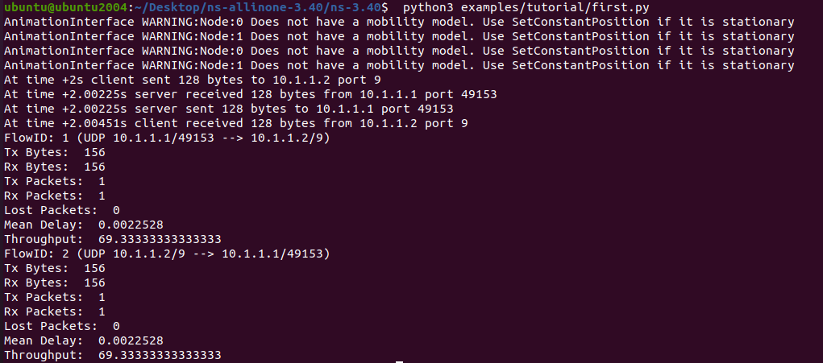

Packet size = 256, Throughput = 126.22222222222223

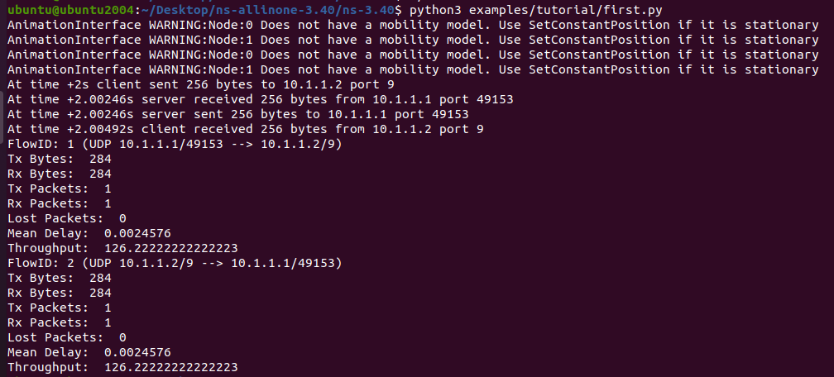

Packet size = 512, Throughput = 240.0

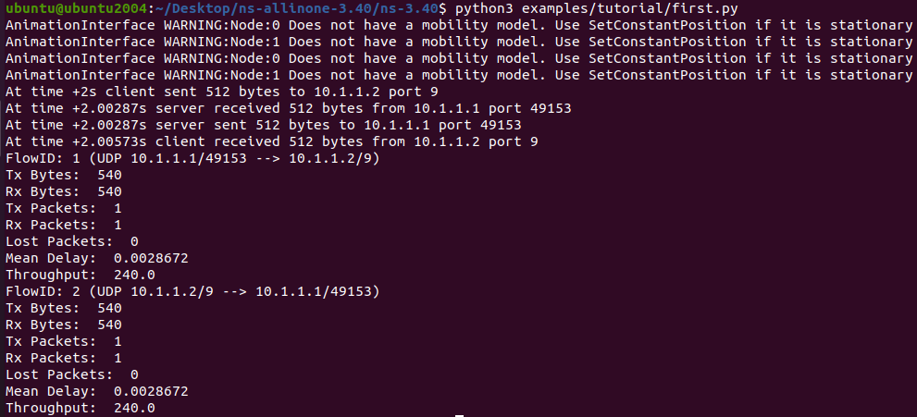

Packet size = 1024, Throughput = 467.55555555555554

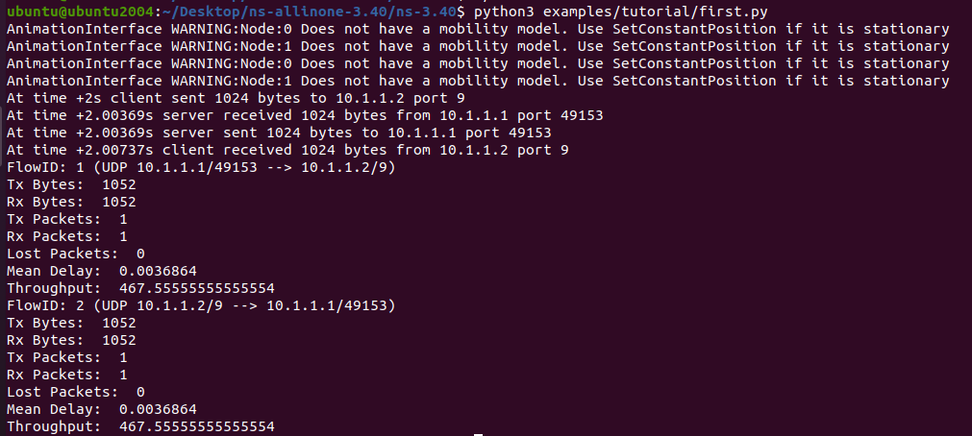

Packet size = 2048, Throughput = 922.66666666666666

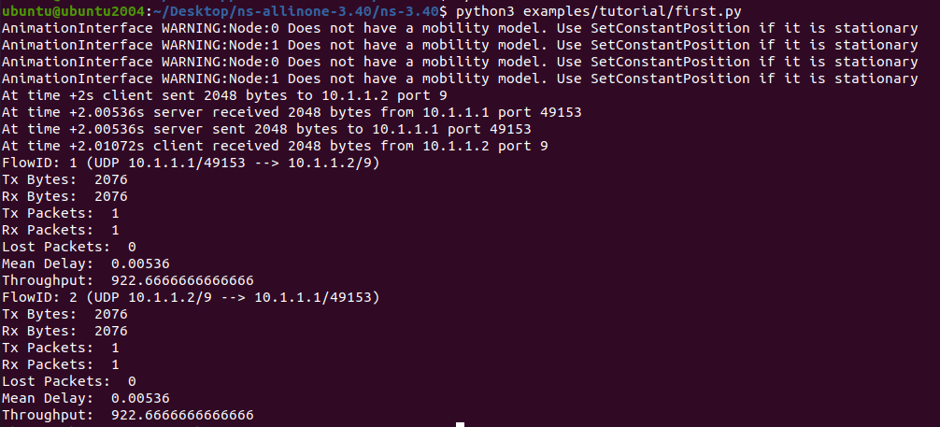

**Packet size v/s throughput graph**

**Data :**

| Packet Size | Throughput |
| --- | --- |
| 128 | 69.33333333333333 |
| 256 | 126.22222222222223 |
| 512 | 240.0 |
| 1024 | 467.55555555555554 |
| 2048 | 922.66666666666666 |

**Graph :**

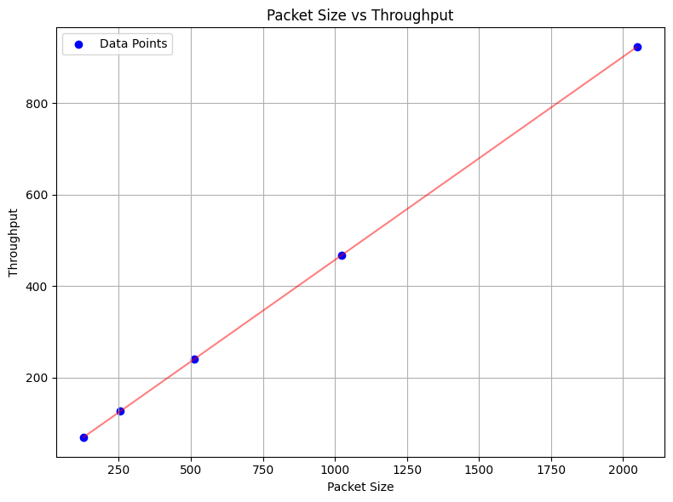

**Graph description:**

Throughput is positively correlated to packet size because as packet size is increasing, throughput is also increasing. Thus, a larger data packet can use the data link’s larger amount of bandwidth for data transmission in comparison to a smaller data packet.