**Ambient Reflection** → Environmental Light

**Diffuse Reflection →** Main Light

**Specular Reflection →** Main Light ( Viewpoint, Shininess)

Ambient →

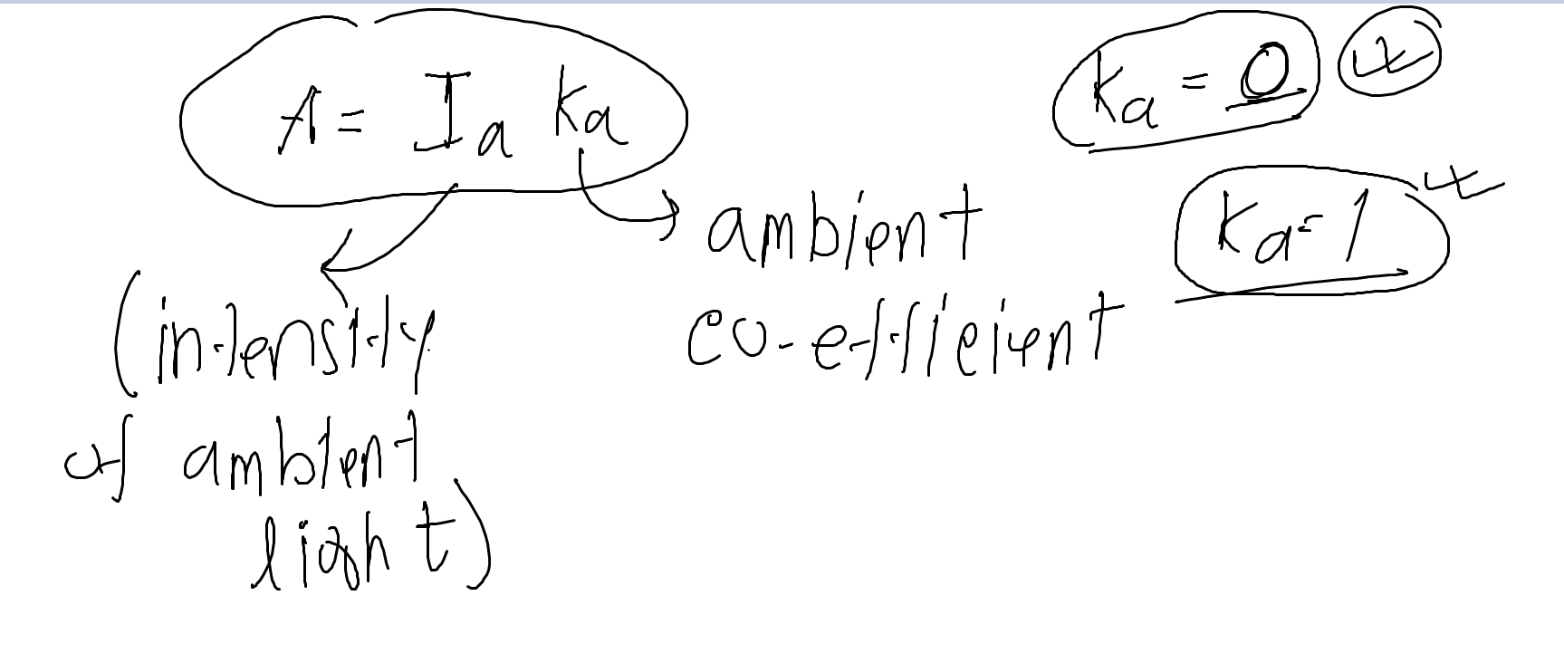

Diffuse →

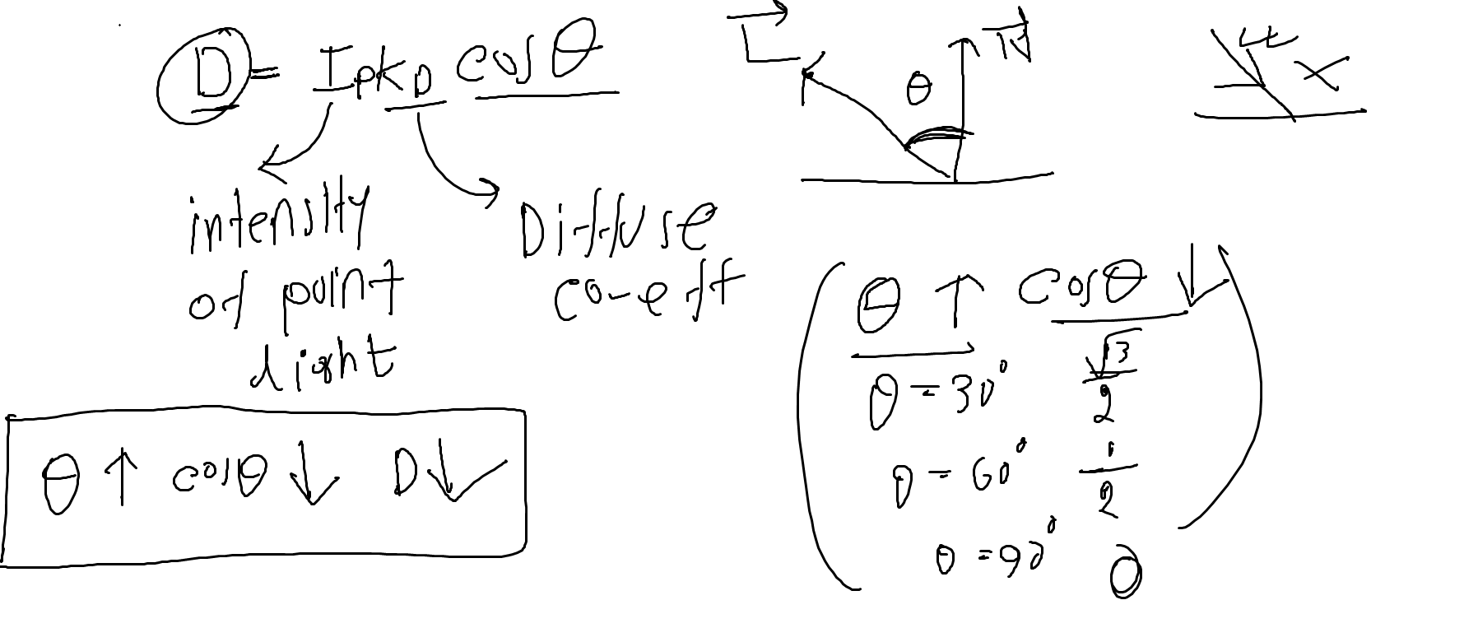

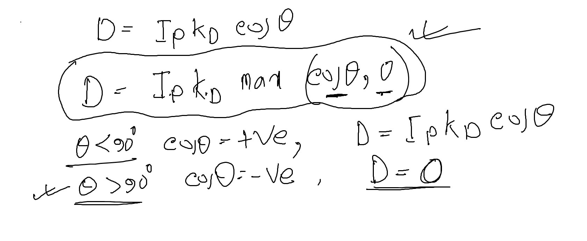

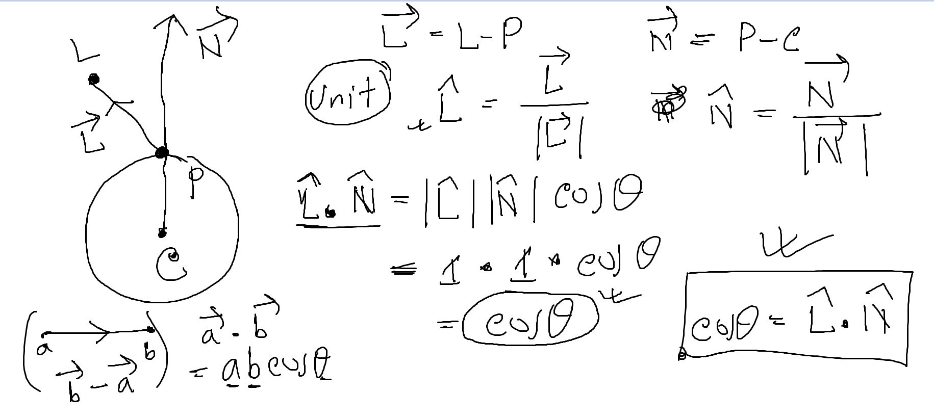



Specular Reflection →

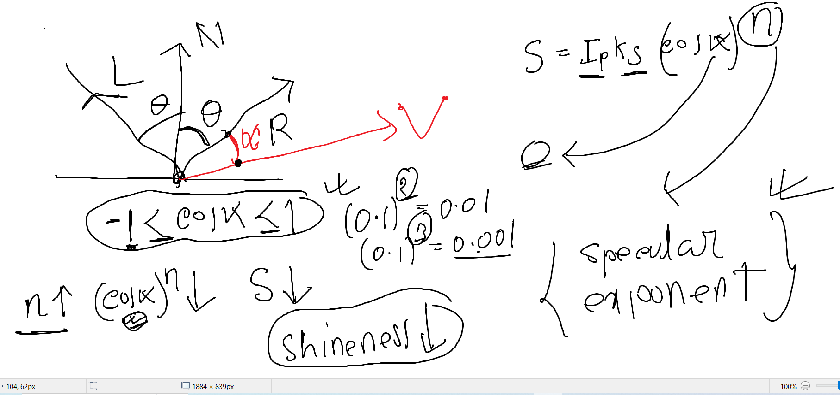

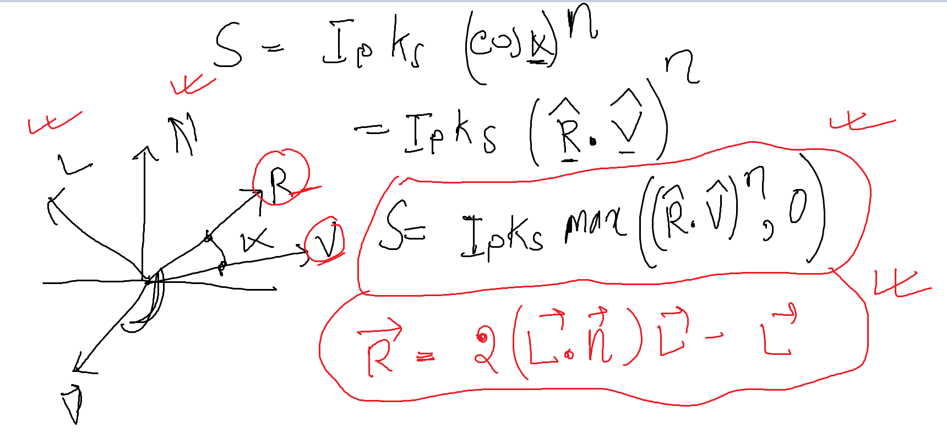

Attenuation → Loss of light energy over space.

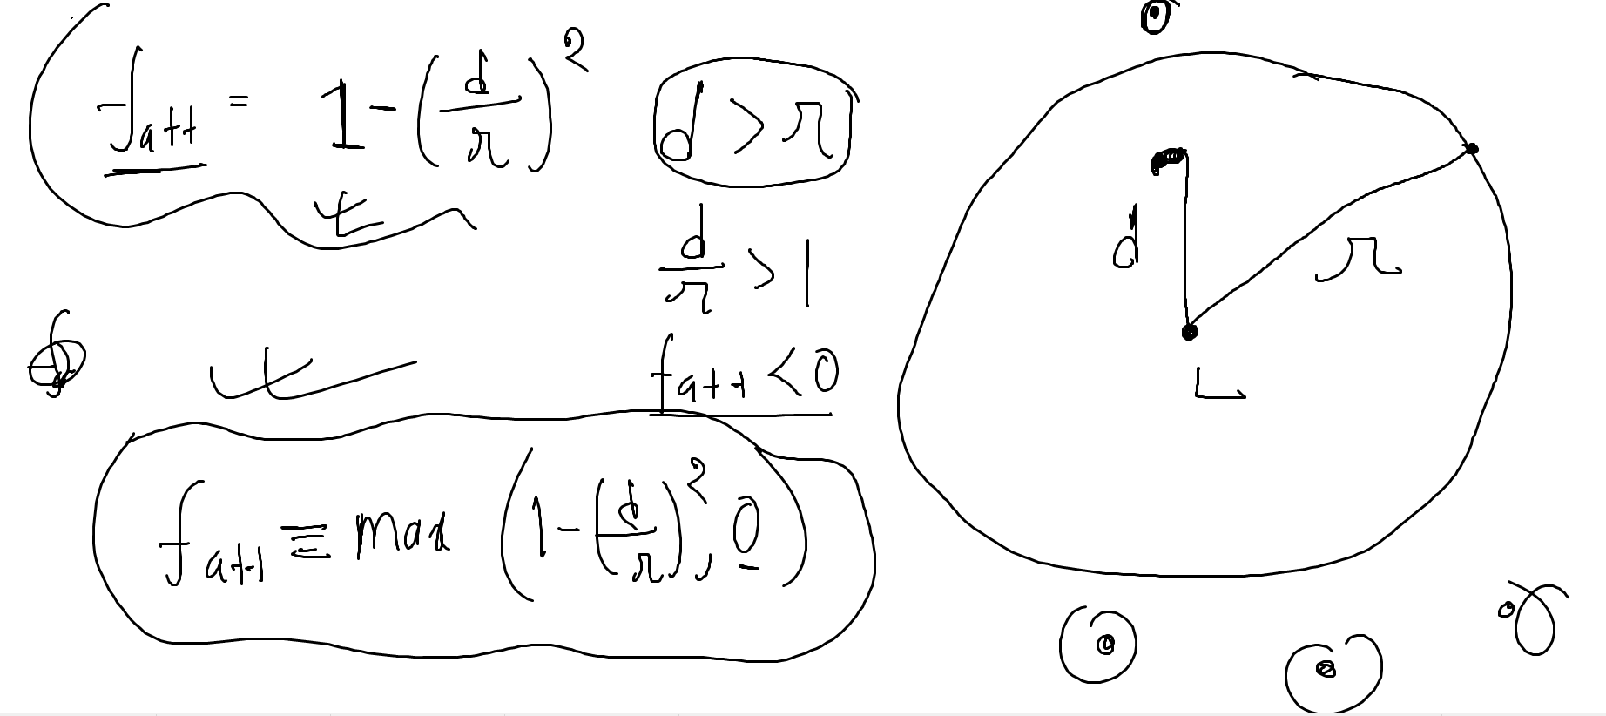

Let (-70, 500, 420) be the coordinate of the light source of intensity Ip= 0.80 unit. The

light is illuminating a point on a sphere with coordinates (-25, 100, 75). Given that the

center of the sphere is at the origin (0, 0, 0) and the absorption coefficient for diffuse

reflection is Kd=0.80 unit. Calculate the intensity of **diffuse reflection for the point**.

L = (-70, 500, 420)

Ip= 0.80 unit

P= (-25, 100, 75)

C= (0,0,0)

Kd=0.80

