**Projection** → Process where a 3d model is converted to 2d model for viewing on a plane.

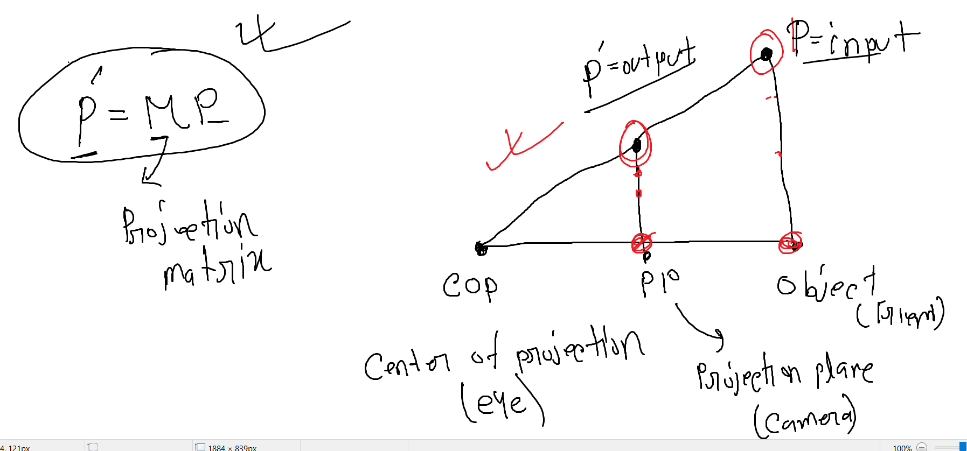

Projection type based on the Projection plane (PP)

Orthographic Projection → Top/front view

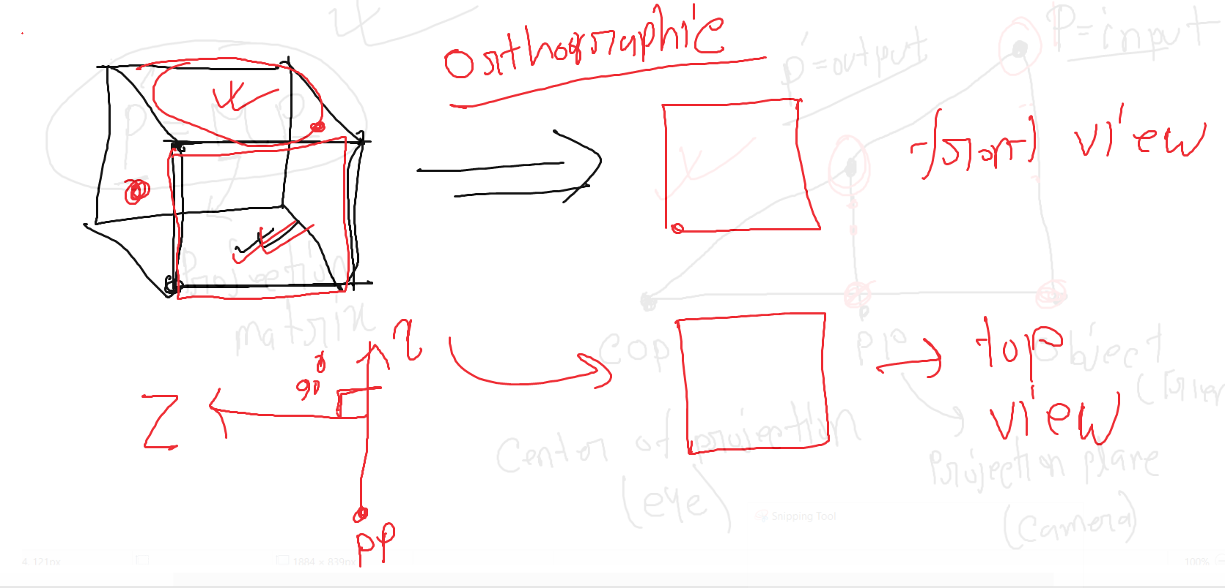

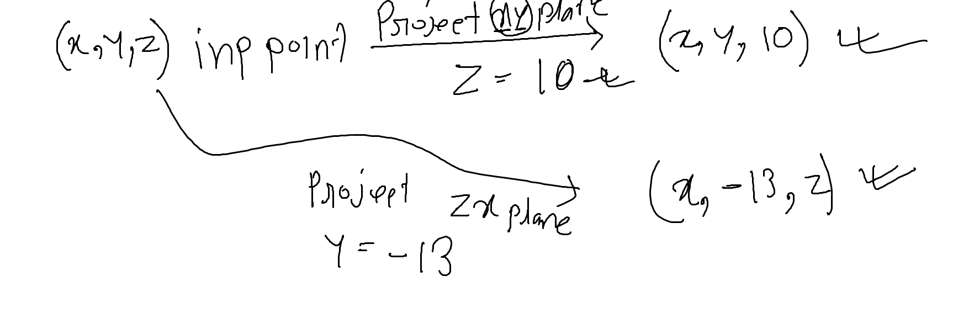

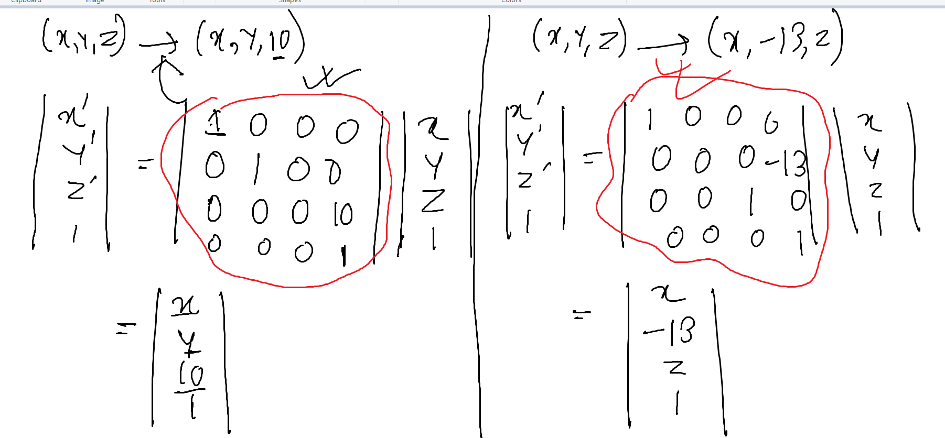

Oblique projection →

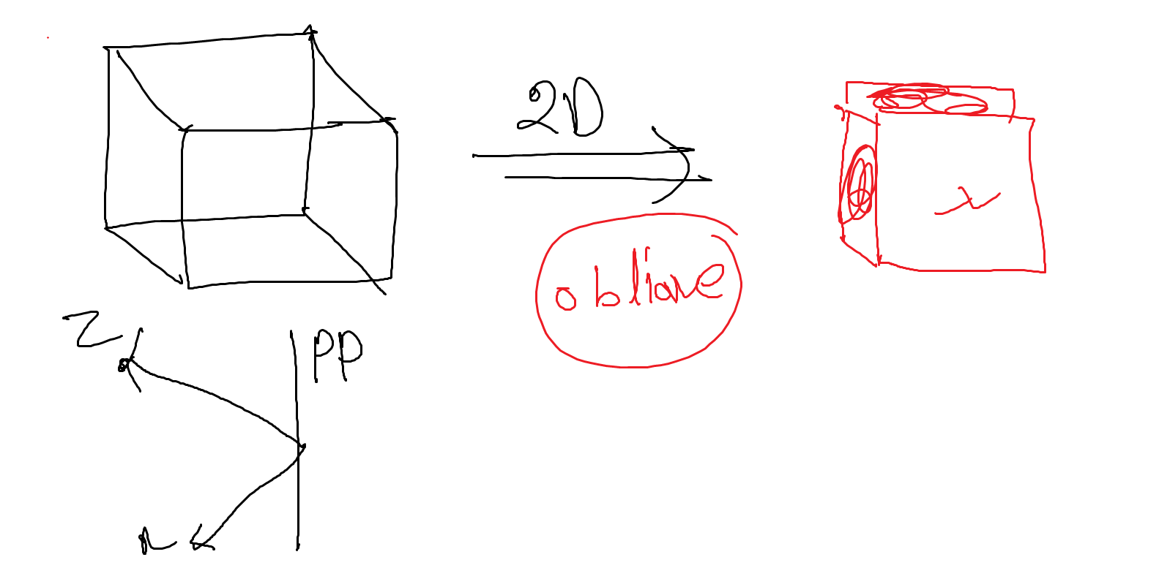

Based on the distance (d) → 1. Perspective projection (d is limited)

2. Parallel projection (d is not limited/finite)

perspective projection

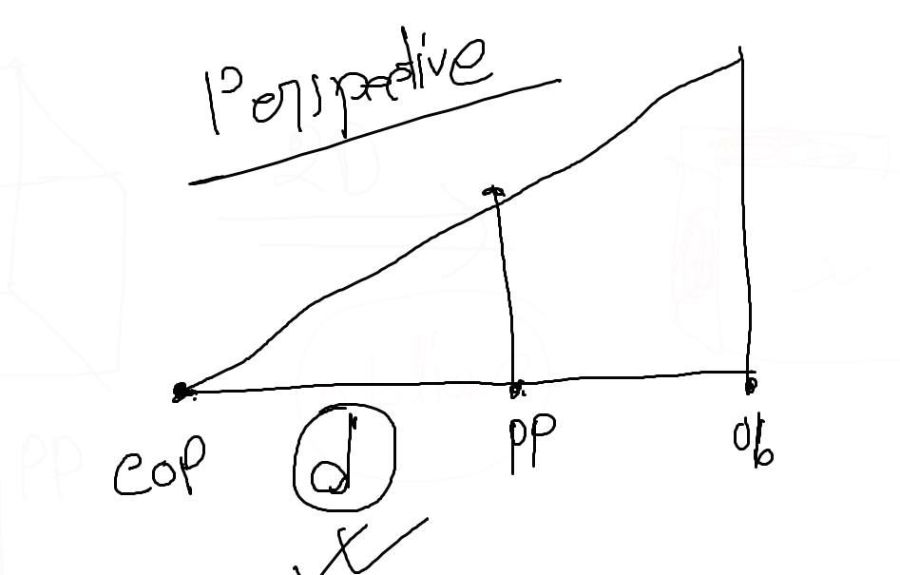

Parallel projection :

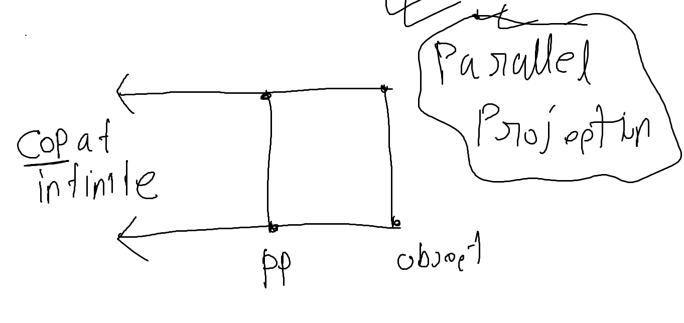

General Projection Matrix → 4*4 shape matrix

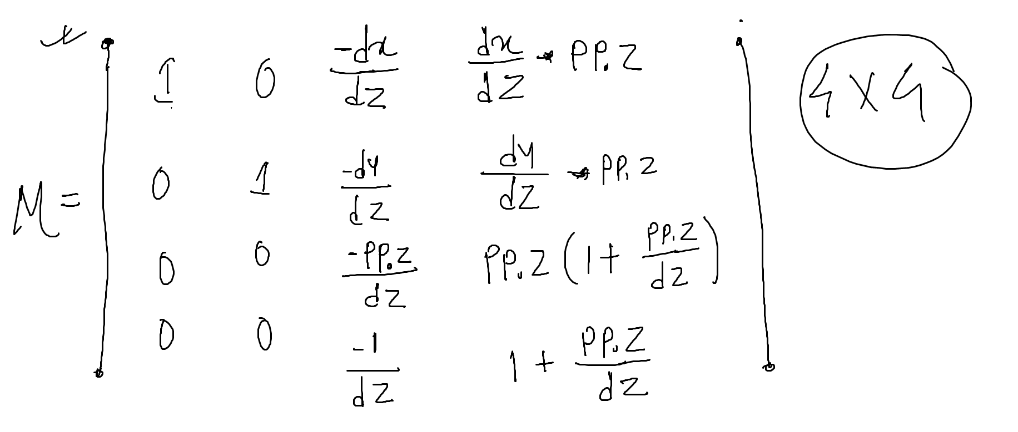

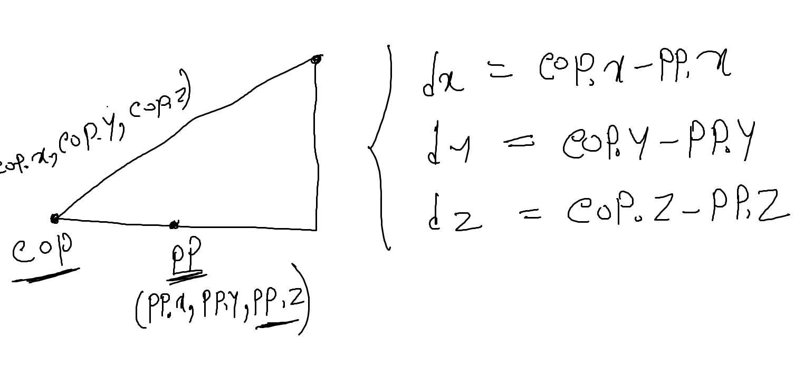

Given COP (50,40,100) and PP(0,0,-200). Find out the projected output point for the given point (30,50,-250).

dx = 50-0 = 50

dy = 40-0 = 40

dz = 100-(-200) = 300

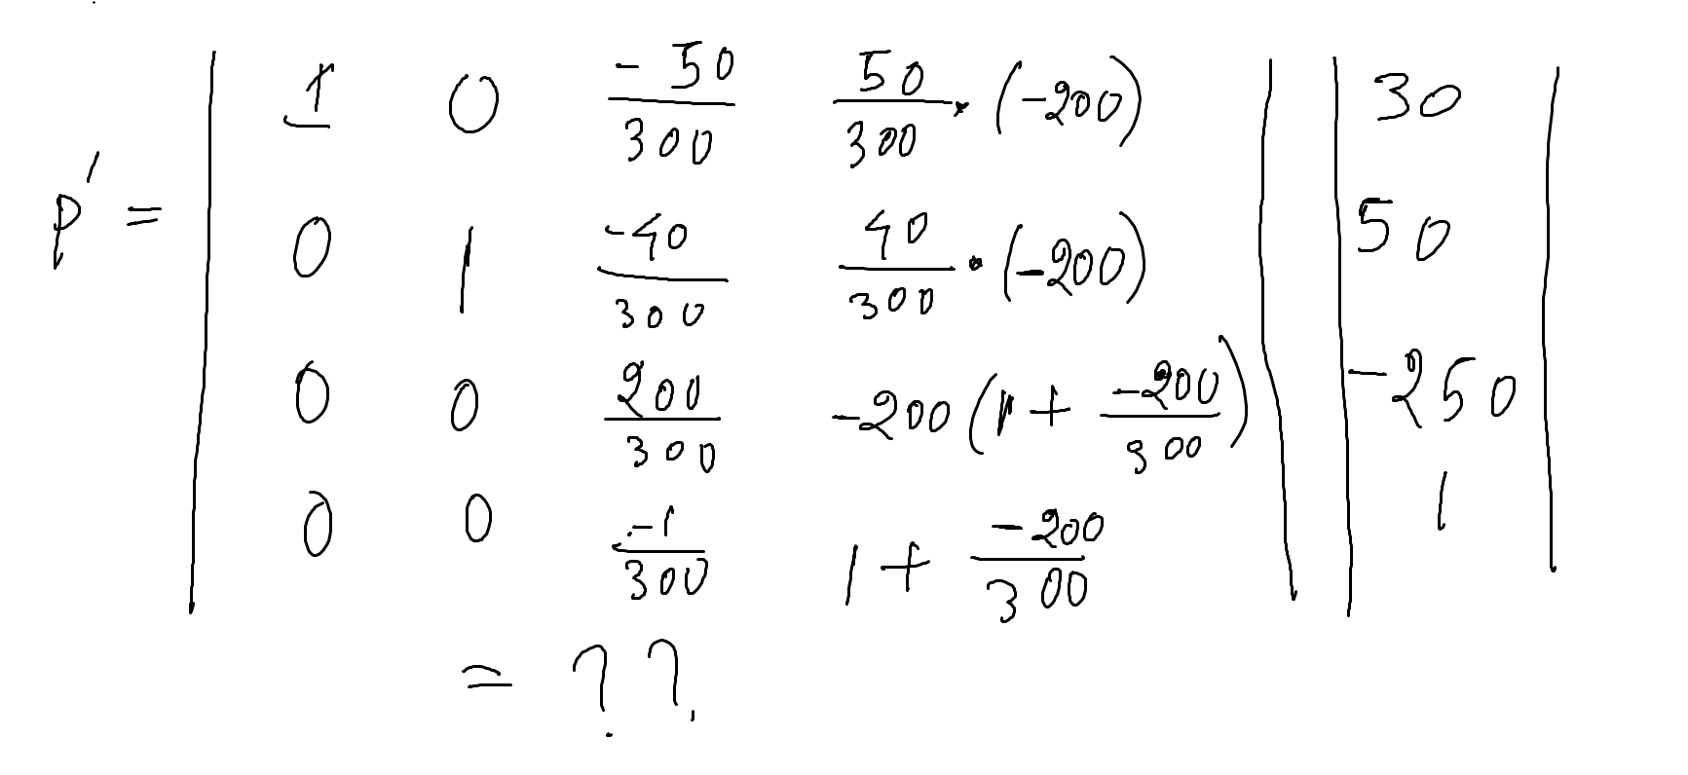

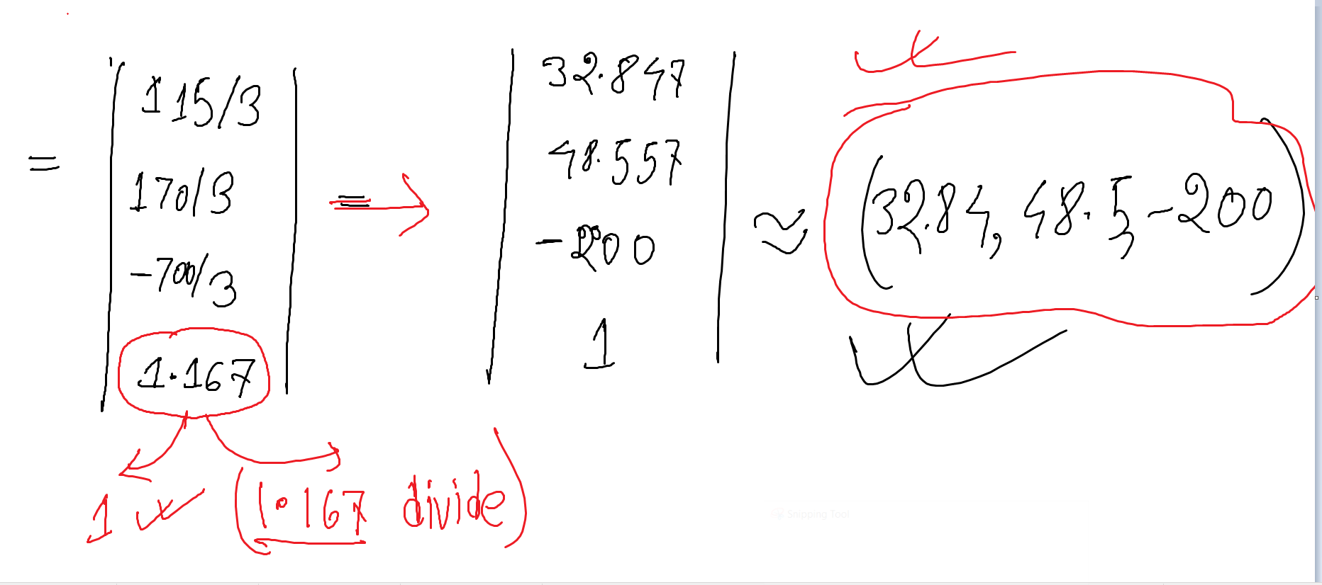

Scenario 1 →

Derive a projection matrix for the xy plane, where the COP is at (0,0,0) and PP is at d distance from the COP.

COP.x = COP.y = COP.z = 0

PP.x=0

PP.y=0

PP.z=d

dx = 0 - 0 = 0

dy = 0 - 0 = 0

dz = 0 - d = -d

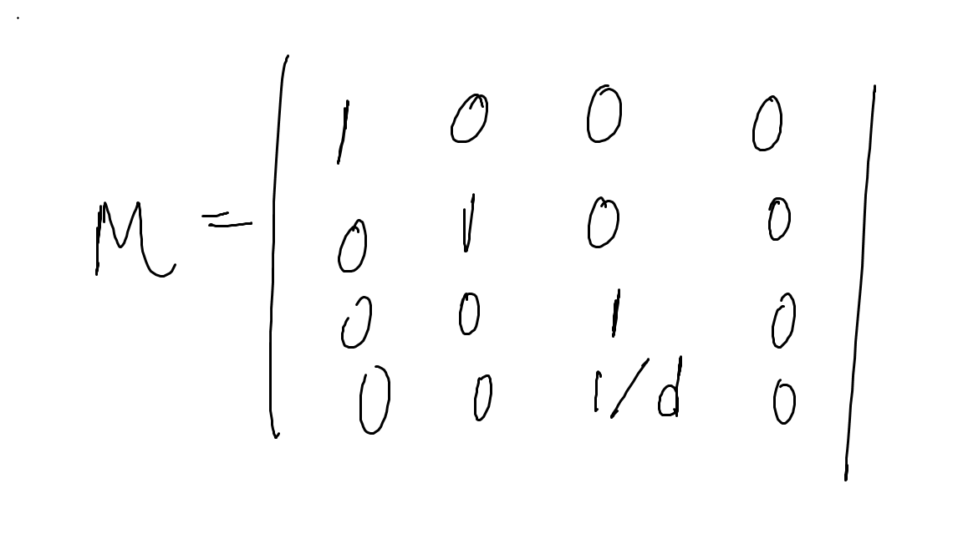

Scenario 2 →

Derive a projection matrix for the xy plane, where the PP is at (0,0,0) and COP is at d distance from the PP.

PP.x=0

PP.y=0

PP.z=0

COP.x=0

COP.y=0

COP.z=d

dx = 0

dy = 0

dz = d-0 = d

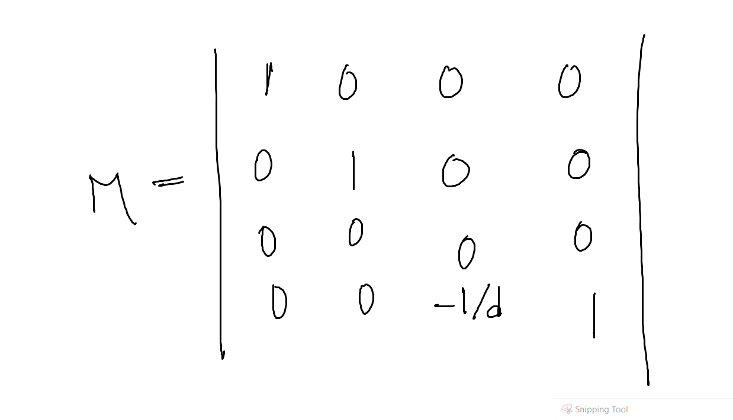

Suppose a perspective projection where the eye is on origin and the camera is on the xy plane and 5 distance away from the eye in the z axis. For the input point (13,12,10) find out the projected output point.

COP = (0,0,0) , PP (0,0,5)

