

CSE461 Lab Report 02

Fall 23

**Group: 01**

**Title**

Measuring distance using Ultrasonic Sensor.

***Prepared by,***

**Name:** Abid Mashrafi

**ID:** 21101075

**Section:** 09

**Introduction:**

In this Lab, we will get a foundational understanding of **Raspberry Pi** & **ultrasonic sensors** and their practical applications. The ultrasonic sensor can be used for **measuring distance**. The goal of the lab is to show how to correctly estimate distance using an ultrasonic sensor and a Raspberry Pi.

**Circuit Diagram:**

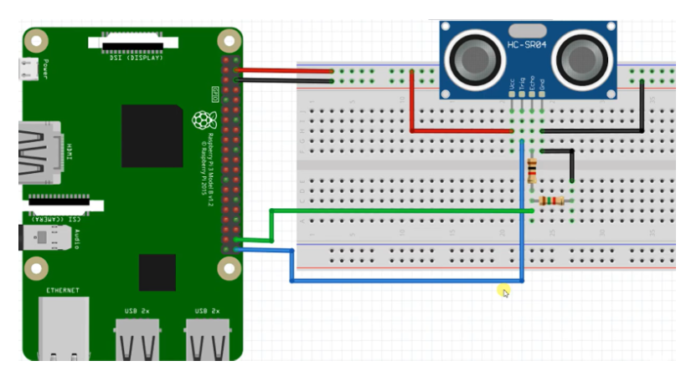

**Results:**

After connecting all the components, we powered on the device and entered the code. Next, when pressing the run button,the ultrasonic sensors will return us an accurate distance value of that moment. For getting the distance value again we have to stop the code then have to run it again to get the distance value again.

**Discussion:**

After finishing this project, we were able to learn about the basic uses of ultrasonic sensors and how to configure and use them on the Raspberry Pi with the help of Thonny software and the Python programming language. One of the issues was that the Raspberry Pi itself was not getting the actual power and it was showing a Low Power Warning. Also, the pins were difficult to understand because of their small size.

**Question Answer:**

**1) Why are the resistors used?**

* Sensors are so sensitive, as they can be easily damaged by power overflow or overheating. To prevent damage to the circuits, a 220 Ohms resistor is used. This resistor will limit the current flow and protect the sensor circuit from overheating.

**Conclusion:**

To wrap it up, this lab provided valuable hands-on experience in working with Raspberry Pi ultrasonic sensors and their practical applications. We successfully understand the basic principle of how the ultrasonic sensors actually work and how to measure an accurate distance by using it and how to get the value from the sensor. All in all, this lab was a valuable learning experience that gave us the fundamental understanding required to fully utilize the Raspberry Pi and use of ultrasonic sensors.