UML Design Answers

Anika Gupta
anikag

Answer 1)

Conceptual Classes
- Extract all the nouns
  - Intelligent Information Systems System itself
  - Data processing operations Included
  - Phase Same as Data Processing operations
  - Data type Included
  - algorithm Included
  - option Same as algorithm
  - Java Class Included
  - configuration parameter Included
  - value Included
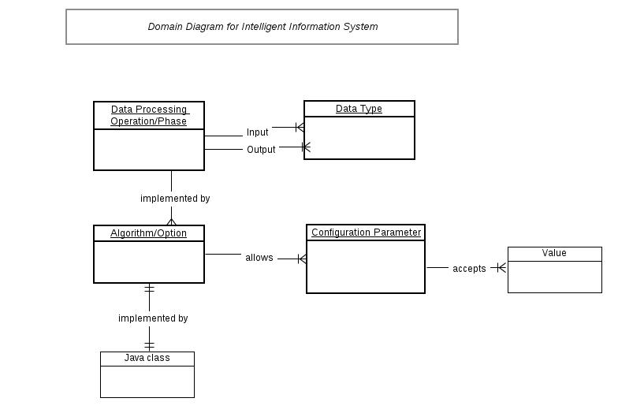

Answer 2)
Conceptual Classes
- AnalysisEngine System itself
- algorithm Included
- option Included
- data type Included
- Java class Included
- configuration parameter Included
- value Attribute
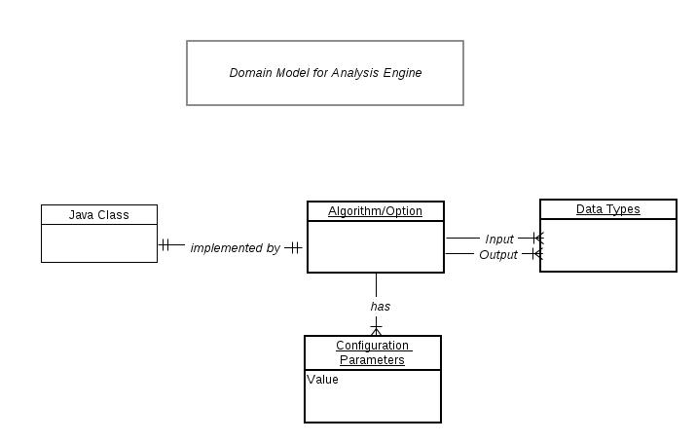

Answer 3) The following sequence of interactions is followed between IIS and any of the AE.
- The IIS instantiates its engine.
- The IIS reads the information stored in its instance. It retrieves the information about the AE as to how many instances of AE is wanted in the list and which type of AE they should be of.
- Initializes a list to store the AE instances which will be created.
- Issues a command to create the required type of AE engine (AE[i]).
- Receives an instance of AE.
- Adds the instance received in its list.
- Repeats 4-6 until all the instances of AE are generated as stored as per required.
- Returns the list of AE instances.
